How to scan and send the receipt with Canon copy machine:

- Turn off the Energy Saving mode, if it is On.
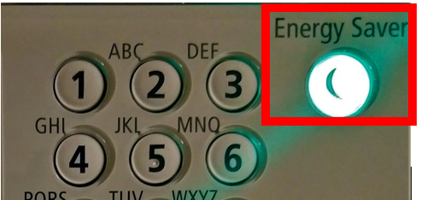
- Press ‘Main Menu’ button on the top left side of the copy machine.
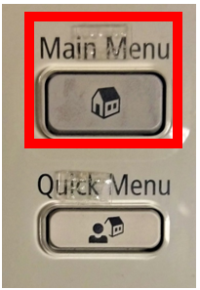
- Click on Scan & Send.
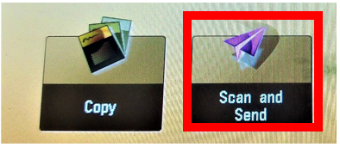
- Place the receipt in the scanner (glassed surface), keep it aligned with top left corner of the scanner.
- Click on ‘Address Book’ option on the screen.
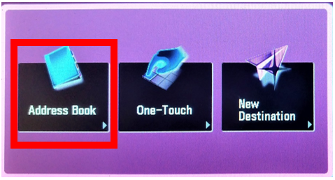
- Select ‘Accessible Media’ and click ‘Ok’.
ss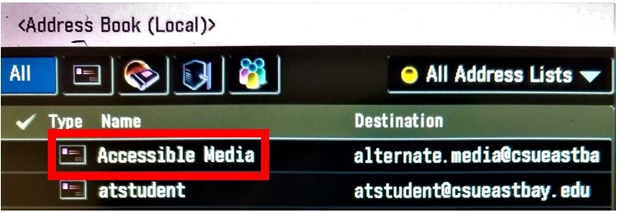

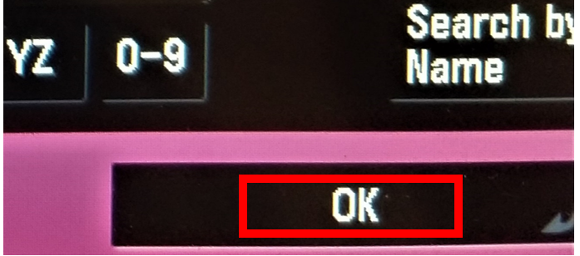
- Then hit ‘Send’, the Green colored button on the bottom right side of the copy machine.
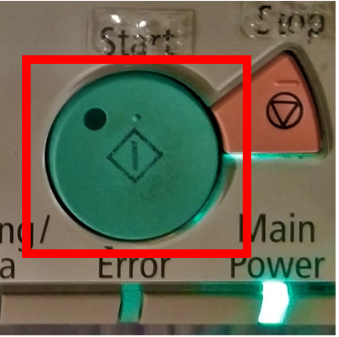
- Wait for few seconds for the receipt to be scanned and the click on ‘Start Sending’ option once it is available to click.
