CFS Data Warehouse
Common Features Guide ver. OAC

Last Revised: | 03/01/2023

REVISION CONTROL
Document Title: | CFS Data Warehouse Common Features Guide for OAC
Author: | Business Intelligence / Data Warehouse (BI/DW)
File Reference: | CFS Data Warehouse Common Features Guide for OAC

Date | By | Action | Pages
1/21/2016 | BI/DW | Published | All
2/17/2016 | BI/DW | Changed name of document to CFS DW Common Features Guide | Cover page, header, and file name
11/29/2017 | BI/DW | Minor edits to screen shots | All
6/6/2018 | BI/DW | Added Class and Program Tree and Chartfield Attributes | All
12/17/2018 | BI/DW | Updated for version 12C | All
01/24/2020 | BI/DW | Added FYI on saved customizations | 25
03/01/2023 | BI/DW | Updated for version OAC

Table of Contents
Page
About this Document 5
1.0 Introduction to the CFS Data Warehouse 6
1.1 Getting Started 6
1.2 The Data Warehouse Home Page and Dashboards Menu 8
1.3 Additional Features on the Home Page 10
2.0 Data Warehouse Features 11
2.1 Setting Dashboard Filters 11
2.1.1 Set Financial Reporting Dashboard Filters 11
2.1.2 Navigating through the Dashboard 13
2.2 Setting Report Filters 13
2.2.1 Choose Filters from a Dropdown List 14
2.2.2 Search for Filters 14
2.2.3 Select Criteria 15
2.3 Using Columns to Format Report Results 16
2.3.1 Show/Hide Columns 17
2.3.2 Show a Column 17
2.3.3 Hide a Column 18
2.4 Adding and Removing Subtotals 19
2.5 Using the NOT Report Filter 20
2.6 Report Views 21
2.7 Drilling into Data 23
2.7.2 Drill Down and Sort 24
2.8 Exporting Reports 25
2.8.1 Print to PDF 25
2.8.2 Export to Excel 25
2.8.3 Export Data 25
2.9 Saving Customizations 25
3.0 Advanced Features 27
3.1 Working with the Business Unit Filter 27
3.2 Advanced Filters 27
3.3 Using the Department Tree 28
3.4 Chartfield Attributes 30
3.4.1 SCO Attributes 31
3.5 Column Values for Pages with Advanced Filters 32
4.0 Advanced Features – Pivots, Sections, and Columns 35
4.1 Using Prompts 35
4.1.1 Move a Column to a Prompt (Using the Columns Menu) 36
4.1.2 Move a Column to a Pivot (Drag and Drop Method) 37
4.2 Changing a Column to Sections 37
4.3 Customizing Drilldowns 38
1.1.1 Creating a Pivot in a Drilldown 38
1.1.2 Creating a Report Section 38
4.3.1 Sort, Include, Exclude Columns 39
4.3.2 Move Column to Columns 40
4.4 Editing Saved Customizations 41
5.0 Additional Features 43
5.1 The Manage My Budget as of Period Report 43
5.2 The Transaction Inquiry Dashboard 43

About this Document
The CFS Data Warehouse Common Features Guide contains overview and step-by-step information for using the features of the CFS Data Warehouse. These features apply to all CFS Data Warehouse dashboards. For more detailed informed about specific dashboards and reports, see the associated [Dashboard Name] Dashboard Guide.
Audience
This document is intended for all campus users of the CFS Data Warehouse.
Related Documentation
    - Financial Reporting Dashboard Guide
    - Transaction Inquiry Dashboard Guide

Introduction to the CFS Data Warehouse
The CFS Data Warehouse is a large, analytical database system containing financial data and interactive reports in support of common, core reporting required by campuses and the Chancellor’s Office. Unlike the Common Finance System transaction system which is designed for the rapid entry and retrieval of transaction data, the CFS Data Warehouse is optimized for reporting. Every night, specific tables from CFS are copied, combined, and simplified. These transformed tables are then loaded into the data warehouse.
The terms CFS Data Warehouse, Finance DW, CFS DW, and data warehouse will be used interchangeably to refer to the CFS Data Warehouse.
On top of these tables is a reporting tool known as Oracle Business Intelligence Enterprise Edition (“OBIEE”), a robust report development and delivery tool that contains a range of reporting features. The CFS Data Warehouse is comprised of dashboards and reporting functionality built on the OBIEE platform.

Getting Started
This section provides a brief overview of accessing the CFS Data Warehouse (sometimes also referred to as the Finance Data Warehouse). For comprehensive information on using the features in the CFS Data Warehouse, go to the CFS Data Warehouse Common Features Guide.
The CFS Data Warehouse can be accessed through CSYou and is available as a button in the Quick Links section.
https://csyou.calstate.edu/Divisions-Orgs/bus-fin/it/BI-DW/CFSDW/Pages/default.aspx
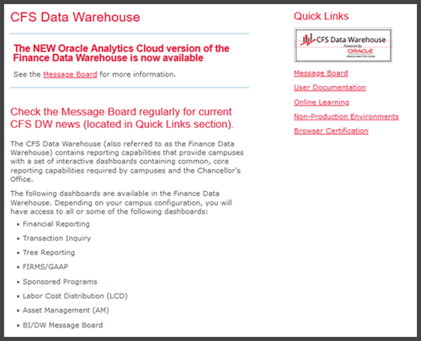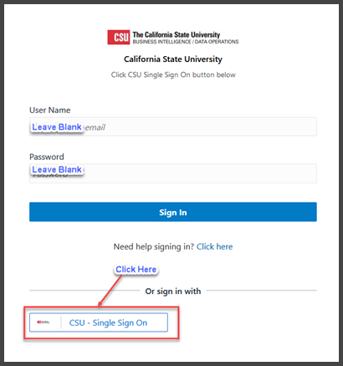
Login to the CFS Data Warehouse
Access to the CFS Data Warehouse is provided via SSO (single sign-on). The steps for accessing the data warehouse at your campus might be different. Follow your campus guidelines to log into the data warehouse.
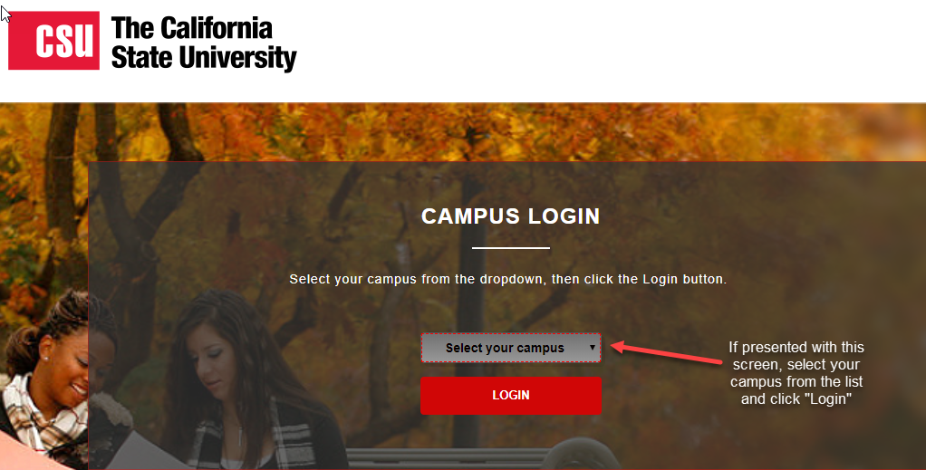
Choose your Campus, if Prompted

The Data Warehouse Home Page and Dashboards Menu
Once you have successfully logged in to the CFS Data Warehouse, you will be directed to the main Home page. This page contains links to the individual dashboards and your most recently accessed reports. The CFS Data Warehouse contains multiple dashboards. A dashboard allows multiple reports to be displayed in a tabbed interface.
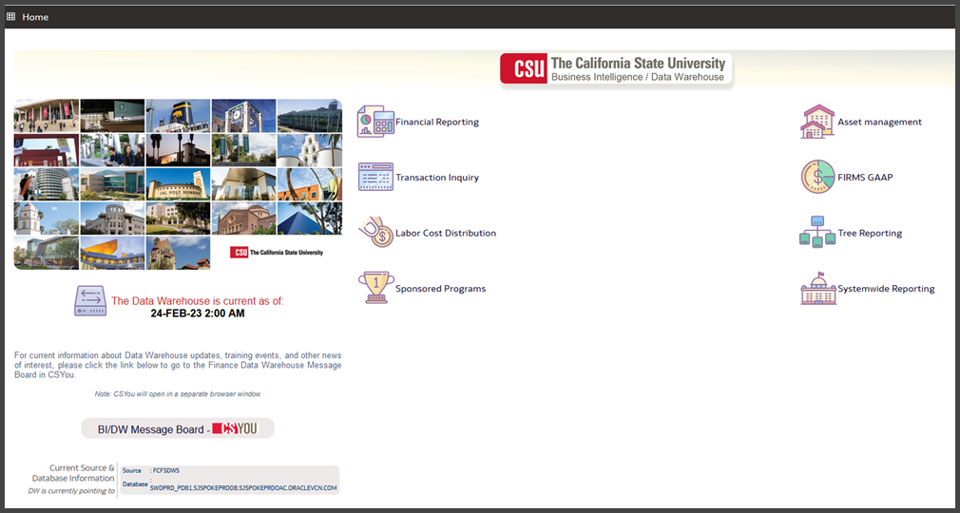
Data Warehouse Main Home Page (Landing Page)
Depending on your security profile, you will have access to some or all of the following dashboards.
- Asset Management
- Financial Reporting
- FIRMS/GAAP
- Labor Cost Distribution
- Sponsored Programs
- Systemwide Reporting (restricted to CO only)
- Transaction Inquiry
- Tree Reporting
Accessing a Dashboard
1. From the Data Warehouse Home page, click on a dashboard button to move to the associated dashboard, for example Transaction Inquiry.
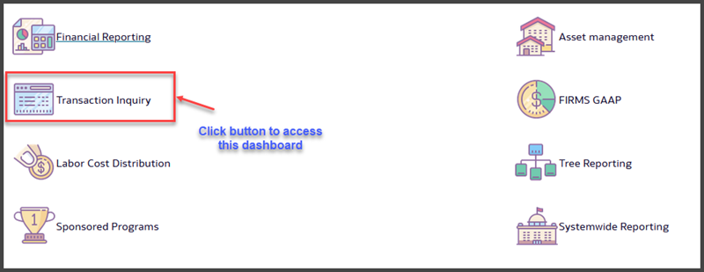
Access a Dashboard by Clicking the Dashboard Button
2. Click on Transaction Inquiry button to go to the Transaction Inquiry dashboard.
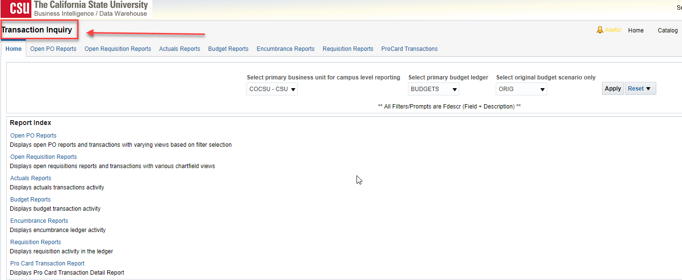
Transaction Inquiry Home Page

Navigating through the Data Warehouse
1. From anywhere in the Data Warehouse, you can click the Home link to return to the main Home page.
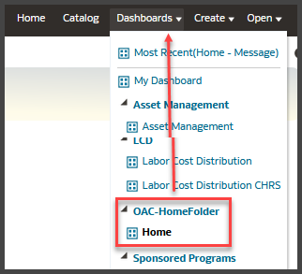
Click the Home Button to return to the Landing Page

The Dashboards Menu is Available Throughout the Data Warehouse
3. Return to the Data Warehouse Home/Landing page.

Additional Features on the Home Page
Additional features on the Data Warehouse Home Page include:
- The CFS Data Warehouse Home page displays the date and time of the current data refresh.
- The BI/DW Message Board button will take you to the Message Board in CSYou.
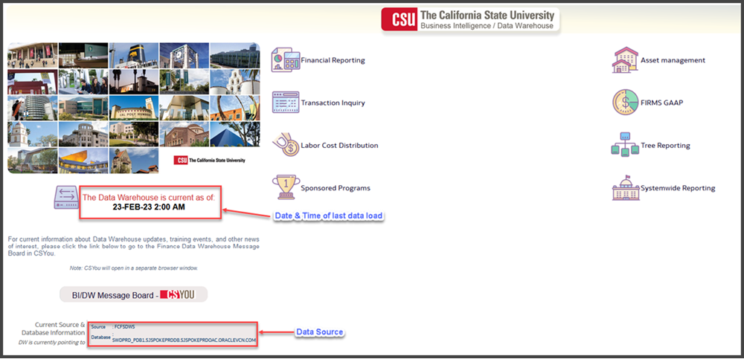
Enhanced Functionality on the New CFS Data Warehouse Home Page

Data Warehouse Features
This section describes how to use the CFS Data Warehouse features that are available throughout the dashboards and reports. For more information about using specific dashboards and reports to meet your business reporting requirements, see the Dashboard Guide for each associated dashboard.

Setting Dashboard Filters
Dashboard content is automatically associated with a user’s login. Within every dashboard, there are settings that control the report criteria used to generate reports. Just like the main data warehouse Home page, each dashboard has a unique Home page.
Filters are used as data search criteria. Filters are located in two locations, on the dashboard home page (dashboard filters) and on each individual report page (report filters / advanced filters). Dashboard filters are located on the dashboard home page in the default settings section. Dashboard filters apply to ALL pages within a dashboard. The dashboard Home page contains the following dashboard filters:
    - Primary business unit for campus level reporting
    - Primary budget ledger
    - Original budget scenario only (optional)
The data warehouse allows you to override Home Page default settings at the individual page level. Because of this flexibility, it is recommended that you set dashboard filters for convenience.
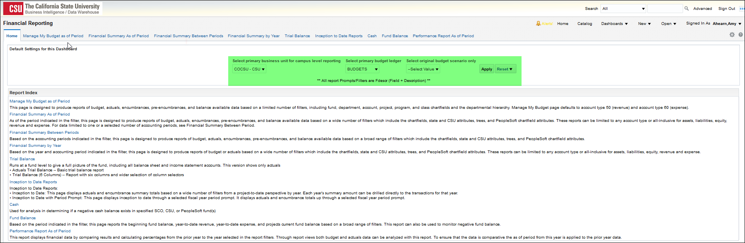
The Financial Reporting Dashboard Settings (“Filters”)

Set Financial Reporting Dashboard Filters
1. From the data warehouse main Home page, go to the Financial Reporting dashboard Home page.
2. In the Default Settings for this Dashboard section, select your primary campus values.
FIELD | DESCRIPTION | EXPLANATION / EXAMPLE
Primary business unit for campus level reporting | The business unit for the PeopleSoft GL Application | COCSU or COFDN or COGAP
Primary budget ledger | The campus budget ledger. | Budget
Original budget scenario | Name of original budget scenario | This filter is used to determine what gets summarized (scenarios) in the original budget column on various reports.

Dashboard Filters Example with Original Budget Scenario
3. Click Apply to apply the dashboard filters.
Save Dashboard Settings as a Default Customization
Using Save Customizations, you can store the dashboard settings as a default so that you do not have to reset them every time you log into the data warehouse.
1. From the Page Options menu, choose Save Current Customization.
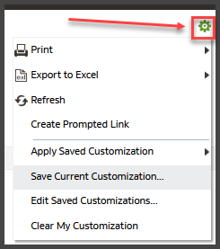
The Page Options Feature
2. Enter a descriptive customization name. You might want to include the name of the business unit (or units) that you entered in your dashboard settings.
3. Choose Make this my default for this page.
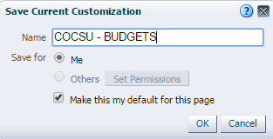
Saving the Dashboard Settings as Default
4. Click OK.
This setting will now apply to all reports within the active dashboard.

Navigating through the Dashboard
After you apply your dashboard default settings, you are ready to select and generate a report. Each dashboard is divided into content areas organized by pages. Click on the page (tab) at the top of any dashboard to go the associated page. Many of the dashboard pages contain only one report. Other pages contain links to multiple reports. For example, the Trial Balance page has two reports.
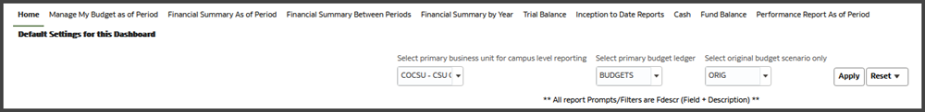
The Financial Reporting Dashboard has 10 Tabs/Pages
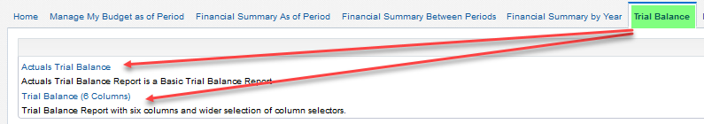
Trial Balance Page has Two Reports

Setting Report Filters
The first step in report creation is to select and apply report filters. Most reports contains two report filters sections: Report Filters and Advanced Filters.
- Report filters contain the most commonly used, or basic filters.
- Advanced filters offer a wider range of report criteria including values for department, fund, account, and project chartfields from trees that are loaded into the CFS Data Warehouse.
- The advanced filters section can be expanded or collapsed by clicking the down arrow icon. By default, this section is collapsed.
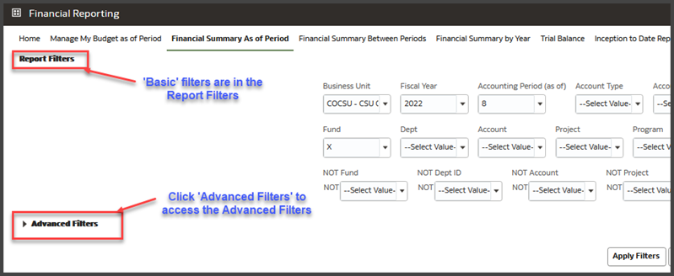
Report Filters and Advanced Filters are Located in Separate Sections
Note: The Financial Reporting as of Period report will be used to illustrate many of the data warehouse features. Go to this page to follow along with the instructions.

Choose Filters from a Dropdown List
The values that display in the drop down list in the Report Filters section are related to the APPLIED business unit(s). In the example below: the APPLIED business unit is COCSU. The values available in the Dept dropdown are applicable to COCSU.
1. From the Financial Reporting dashboard, go to the Financial Reporting as of Period report.
2. Select report filters from the drop down list next to any desired field.

Search for Filters
The values that display when using the search feature represent ALL values available at your campus. It is possible to choose a value that will not produce results based on the APPLIED business unit. Therefore, it is important to be familiar with your own data.
1. To search for a filter value, click the dropdown arrow next to the filter field and select Search (example: Dept field).
2. Contains operator is the default
The two choices you will probably use most often are Starts and Contains.
3. Match Case is unchecked.
This is a more flexible search option that will locate the search string regardless of capitalization.
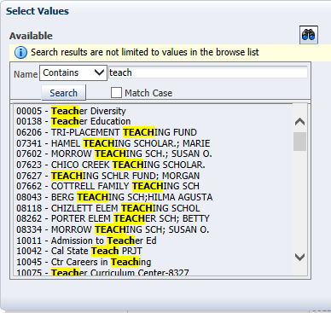
4. Enter your search criteria.
5. Click the Search button.
All available values that contain your search string will display.

Select Criteria
1. Highlight individual values, non-contiguous values, or a range of values. Then use the icons or double-clicking to add desired value(s) into the Selected box.
2. Click OK to return to the report.
Select all items listed
Select highlighted item(s)
De-select highlighted item(s)
De-select all items
- Double-clicking can also be used to move an individual item into or out of the Selected box
- Use the Shift key to select a continuous range of items
- Non-contiguous items can be selected using the Control key (PC) or the Command key (Mac)
3. When you have added a value(s) to the Selected area, click OK to return to the report.
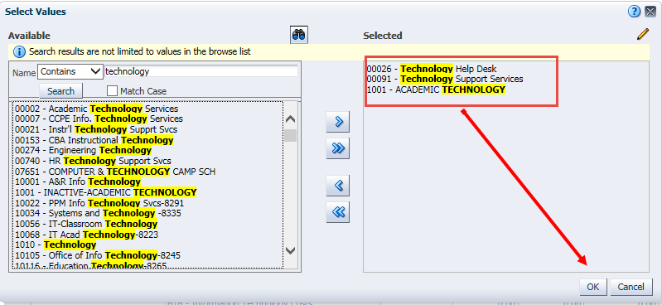
Search and Select Report Criteria
Practice: Search and Select Valid Criteria
1. Select Report Filters using valid campus values to produce report results:
Periods 1-12 equate to the months in the fiscal year (example, period 1 = July and period 12 = June).
REPORT FILTERS | Your Campus Values
Business Unit | Your Primary Campus Business Unit
Budget Ledger | Your Primary Budget Ledger
Fiscal Year | 2016 (example)
Period (as of) | 12 (example)
Account Type | 50, 60
Dept | A Campus Department
Fund | Your General Fund

2. Remove any null values (example: the “x” in Fund field). If the report filter you need is visible in the list, you can click to select it. Or use the Search feature to search and select report filters.
3. When all your report filters are selected, click Apply Filters to generate the report.
The Advanced Filters features will be covered later in this Guide at p. 27

Using Columns to Format Report Results
Once you apply report filters, a report is generated and the results are delivered to your screen based on your search criteria. From the displayed results, you can use column selectors and the Columns menu to get a different perspective of the data.

Show/Hide Columns
The report layout area contains six column selectors. By default, the first three columns display content. Use the column selectors to dynamically change which columns appear in your report by choosing column values from a dropdown list.
The values that are available in the list are related to the filters in the Report Filters and Advanced Filters section. For example, a report that only has a Report Filters section will have fewer column selector choices than a report that has both Report Filters and Advanced Filters.
See Column Values for Pages with Advanced Filters at p. 32.

Show a Column
1. To show (display) a column, click the drop down menu in the column where you want to add column content. Select the desired column value. For example:
COLUMNS SELECTORS | Column Label (Example)
Column 1 | Fund Fdescr
Column 2 | Dept Fdescr
Column 3 | Acct Cat Fdescr
Column 4 | Acct Fdescr
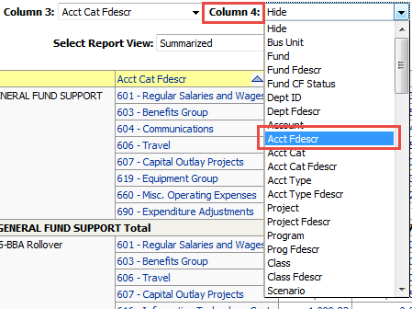
2. Click OK to apply the column values and generate the report.
Any column displaying a yellow heading indicates that the column is formatted as a column selector.
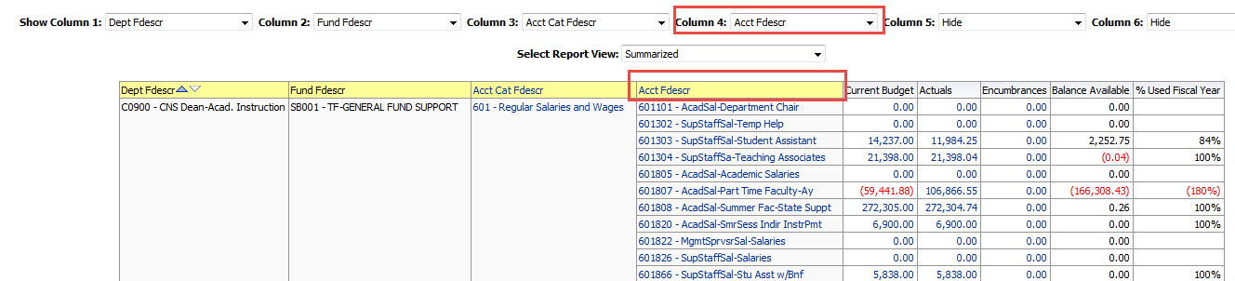
Use Column Selectors to Configure Report Content

Hide a Column
Hide will “hide” the associated column from your report. Hide is the default value for columns 4-6. You can also use Hide to hide any visible columns.
1. To hide a column, place the cursor at the top of the column that contains a column value and click the drop down column-selector menu. Choose Hide.
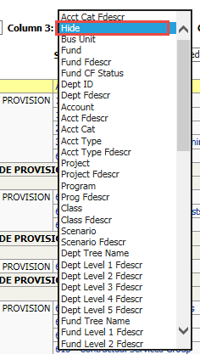
2. Click OK to apply your selection and re-generate the report.
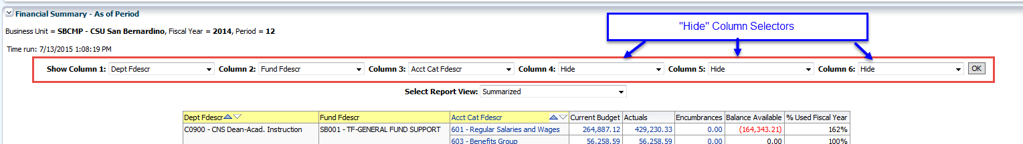
Configure Report Results with the Hide/Show Columns Feature

Adding and Removing Subtotals
The first two columns in every report are formatted to display subtotals. The third column is formatted without a subtotal. To add a subtotal to the third column or to any additional columns, use the Show Subtotal option in the Columns menu.
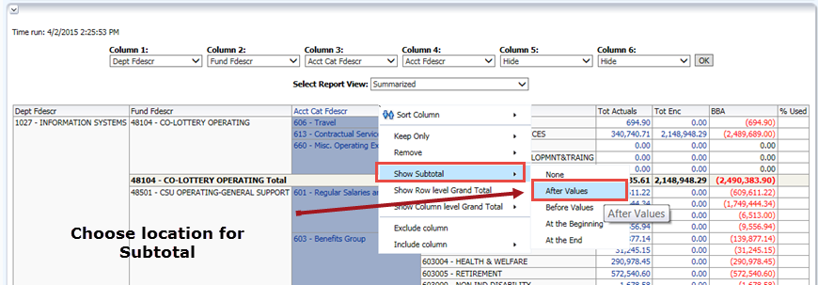
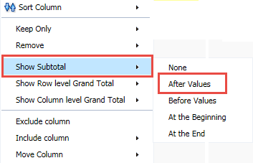
The Show Subtotal Option on the Columns Menu
Show a Subtotal / Remove a Subtotal
1. Place the cursor at the top of the column where you want to add a subtotal.
The Show Subtotal option is available only from columns formatted as column selectors, as indicated by the yellow column heading.
2. Right click on the yellow column heading to access the Columns menu.
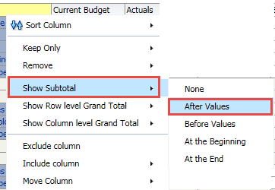
The Show Subtotal Feature
3. Choose Show Subtotal > After Values.
4. To remove a subtotal, choose Show Subtotal > None.
All report configurations and results can be stored as a Saved Customization.

Using the NOT Report Filter
In the CFS Data Warehouse, the NOT functionality is available as a global feature. Unlike the filters that are used to select a chartfield or account category value to be included in the report results, the NOT filter searches against the chartfield or category code only.
The “include” filter searches against the Fdescr (code + description) | The NOT filter searches against the code only
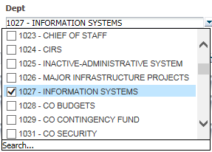 | 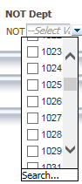
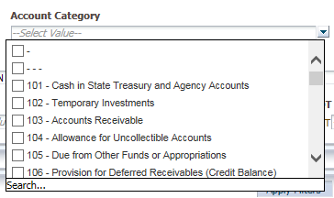 | 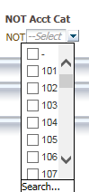
Remove an Account Category
You can use the NOT feature to remove a value from the associated filter type. The NOT fields search against the chartfield CODE only, not against the chartfield Fdescr. For example, use NOT Account Category, to remove a specific Account Category from the search criteria.
1. From the Report Filters section, choose NOT Acct Cat 603.
2. Choose Apply Filters.
Notice that Acct Cat 603 (Benefits Group) is no longer included in the report results.
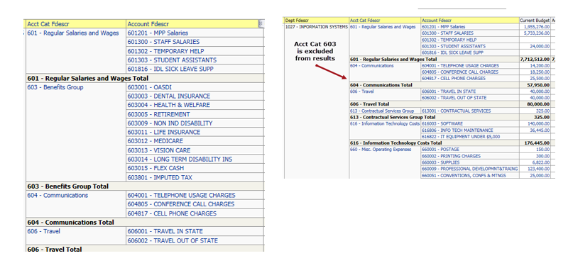
Using the NOT Acct Cat Feature

Report Views
Report views present report results with different columns of information to display data for a specific purpose. Each report has its own set of views to help organize report data.
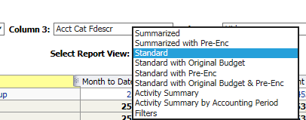
Choose From One of Many Report Views
After you have generated a report, choose a Report View. Each Report View contains a predefined set of columns that will appear in your report results after the column selectors.

Example: Summarized
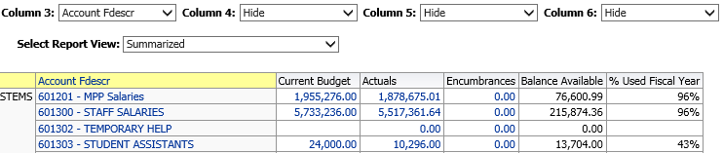
Summarized Report View
Column selectors plus:
- Current Budget
- Actuals
- Encumbrances
- Balance Available
- % Used Fiscal Year

Example: Standard
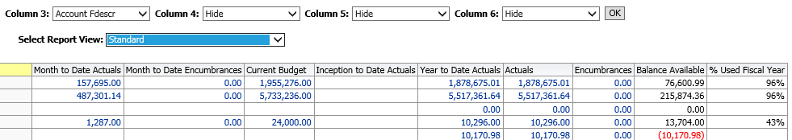
Standard Report View
Column selectors plus:
- Month to Date Actuals
- Month to Date Encumbrances
- Current Budget
- Inception to Date Actuals
- Year to Date Actuals
- Actuals
- Encumbrances
- Balance Available
- % Used Fiscal Year
Example: Filters
The report filters display below the report results area. There is also a Filters report view. Use the Filters report view to see all search criteria associated with your report (including dashboard defaults). The report filter criteria also displays at the bottom of the report results area.
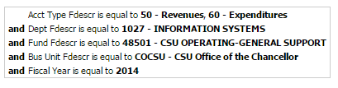
Filters Report View

Drilling into Data
When you place your cursor over an item and it appears as a hyperlink, you are able to drill on that item. Drilling on a hyperlinked numeric value will take you to the details of the selected amount.
Drill downs have been designed with standardized column order across all types of drills. Standardized drill columns improve usability and increase ease of combining data from multiple files when downloading.
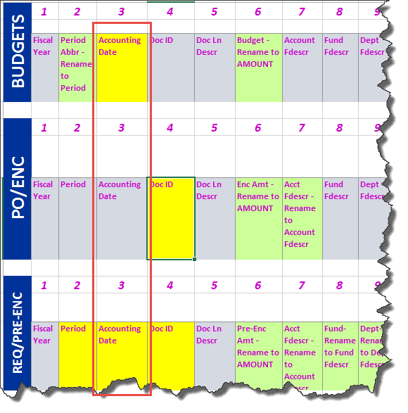
Drilldown Order is Consistent
- Drill down columns display priority columns on the left so they are easier to view.
- Drill down columns align on the left to the extent possible. The highlighted columns are in the same order in both Actuals and Budget drilldowns.
- Scroll to the right to see columns that are specific to the associated drill. The Budget drill down does not include PO or other Actuals specific columns.

Actuals Drill Down Columns
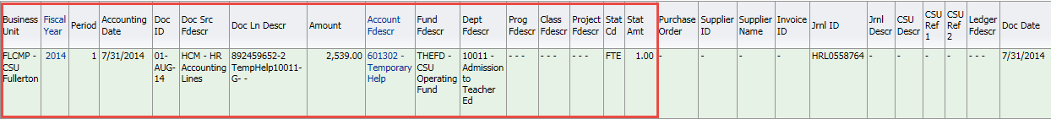

Actuals Drill Down Columns (continued)
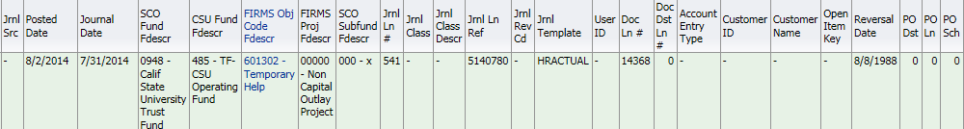

Budget Drill Down Columns

Budget Drill Down Columns (continued)
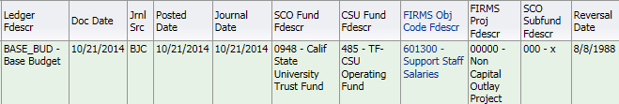

Drill Down and Sort
1. Drill down on a hyperlinked numeric value.
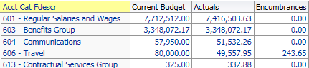
Drill from Summary Data to Transaction Data
2. At the bottom of the screen use the icons to move forward and back through the returned results, 100 rows at a time.
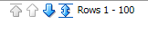
Display 100 Rows at a Time
3. Sort columns in ascending or descending order.
4. Use breadcrumbs to return to the parent report.
Breadcrumbs are located at the bottom of your browser window
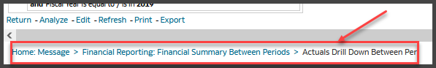

Use Breadcrumbs to Return to the Report

Exporting Reports
The term “action link” is used to apply to the hyperlinks that appear at the bottom of a report. The actions that can be performed using action links include Print and Export.

Print to PDF
1. Click on the Print action link immediately below the report.
2. Select Printable PDF.
All report content, including section headings and report filters, will print to the PDF.
3. Print or save the PDF file.
From the Export menu, you can also choose to Export to PDF.

Export to Excel
1. Generate a report. Below the report area, click Export.
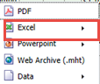
Export to Excel
2. Choose Excel 2007+.
3. Click Save > Save as.
4. Name your Excel file and save it to a local drive.

Export Data
1. Generate a report. Below the report area, click the Export > Data.
2. Choose CSV Format, Tab delimited Format, or XML Format.
Note: XML is used to transport data into a format that can be exported to the web.
3. Click Save > Save as.
4. Name your data file and save it to a local drive.
5. Click on a breadcrumb or the Return link to return to previous screens from a drill down report.

Saving Customizations
Using the Page Options / Save Customizations feature, you can store report criteria and formats. You can save as many different combinations of these items as you want for an individual report. You can also choose a saved selection as the default for a page. Saved customizations can be renamed or deleted, as needed. When you save a customization, all of the following elements are stored:
- Report filters, basic and advanced
- Column selectors
- Report view
All values entered in both the Report Filters and Advanced Filters section are stored in any associated Saved Customization, even if the Advanced Filters section is collapsed.
Create a Saved Customization
1. Generate a report that has the report filter values that you want to store.
2. Select a Report View, for example Standard.
3. Use the Columns Selectors to choose the columns to wish to include in your report results. Click Go to execute your selection.
4. From the Page Options menu, choose Save Current Customization.
5. If you enter a customization name that is already saved, you will get the opportunity to replace the existing customization.
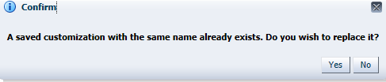
Replace Existing Saved Customization
6. Choose Yes to replace the existing customization or No to enter a unique name.
7. Click OK.
Apply Saved Customization
1. Click Page Options > Apply Saved Customization > Your Selection Name
- Saved selections are specific to an individual dashboard report.
- There is no limit to the number of saved selections per report.
2. Repeat the steps above to apply a different saved selection.
3. Click OK to save your changes.

FYI: Changing chartfield descriptions after a customization has been saved will cause the report to
not run when using the customization. The customization retains the original description so will
not match the updated chartfield description. To fix this – update the report filter with the new
chartfield & description, apply the filters after the update and re-save the customization.

Advanced Features

Working with the Business Unit Filter
The powerful new business unit prompt allows you to change business units at the report level. You can override the business unit on the dashboard Home page by entering a different or an additional business unit(s) in the report filters for any specific report. You don’t have to go back to the dashboard home page to report on a different business unit.
You can also report on multiple business units. When reporting on multiple business units, it is important that you understand your data and the relationships between your business units, funds, budget ledgers, etc. You can only choose one budget ledger at a time, so if you are reporting on multiple business units, those business units must use the same budget ledger for accurate results.
Change Business Unit in Report Filters
1. In the Report Filters section of any report, click the down-down arrow next to the Business Unit filter.
2. Select one or more business units. Click Apply Filters to generate the report.
3. Add Business Unit as a column selector to see the active business unit(s) in the report results.

Advanced Filters
Most reports in the CFS Data Warehouse have an Advanced Filters section. Advanced Filters offer a wider range of report criteria.
- The Advanced Filters section can be expanded or collapsed by clicking the down arrow icon.
- Advanced Filters are in the same order on every page
- All values entered in the Advanced Filters section are stored in any associated Saved Customization whether the Advanced Filters section is open or closed.
- Click on the Advanced Filters section to expand this section.
Chartfield Trees
Trees are a great way to customize a report. The data warehouse now offers tree reporting for the following chartfields:
- Department
- Account
- Fund
- Project
- Class
- Program
All of the chartfield trees and tree levels are located in the Advanced Filters section of all pages except for Manage My Budget on the Financial Reporting dashboard.
There is no advanced filters section on the Manage My Budget page.
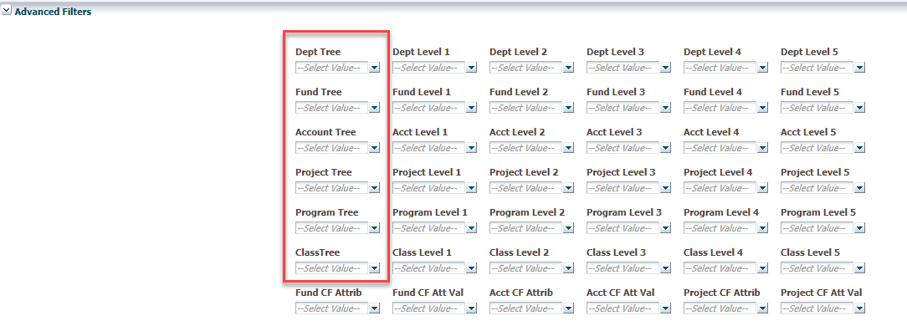
Chartfield Trees are Available in the Advanced Filters Section
All trees configured for reporting in the Data Warehouse are available from the associated chartfield tree filter. Current and historical (effective dated trees) are both available.
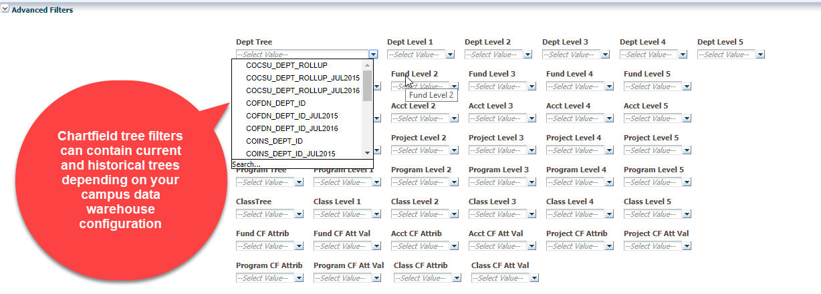
Use Tree Filters to Choose Current or Historical Trees and Levels

Using the Department Tree
When you pick a Department Tree, only values associated with that tree will be available. When you pick a department tree level level, only applicable values will be available at the next lower level.
If you want to use tree levels in your column selectors, you must pick a tree name in the Report Filters or Advanced Filters section.
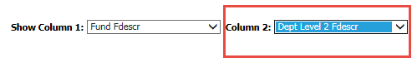
In order to have the department hierarchies available for all reports, it is recommended that you always select department tree as one of your filters. Talk to your Data Warehouse trainer for recommendations at your campus.
If you want to include tree levels in your column selectors (example, Dept Level 2, Dept Level 3, etc.), you must pick a tree name in the Report Filters or Advanced Filters section.
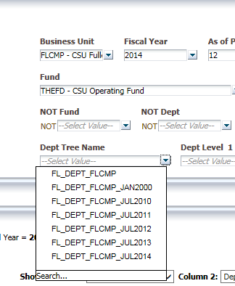
All Available Trees from your Campus will Display in the Dropdown
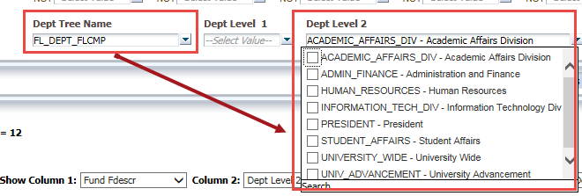
Available Tree Levels are Associated with the Applied Tree
Report Results
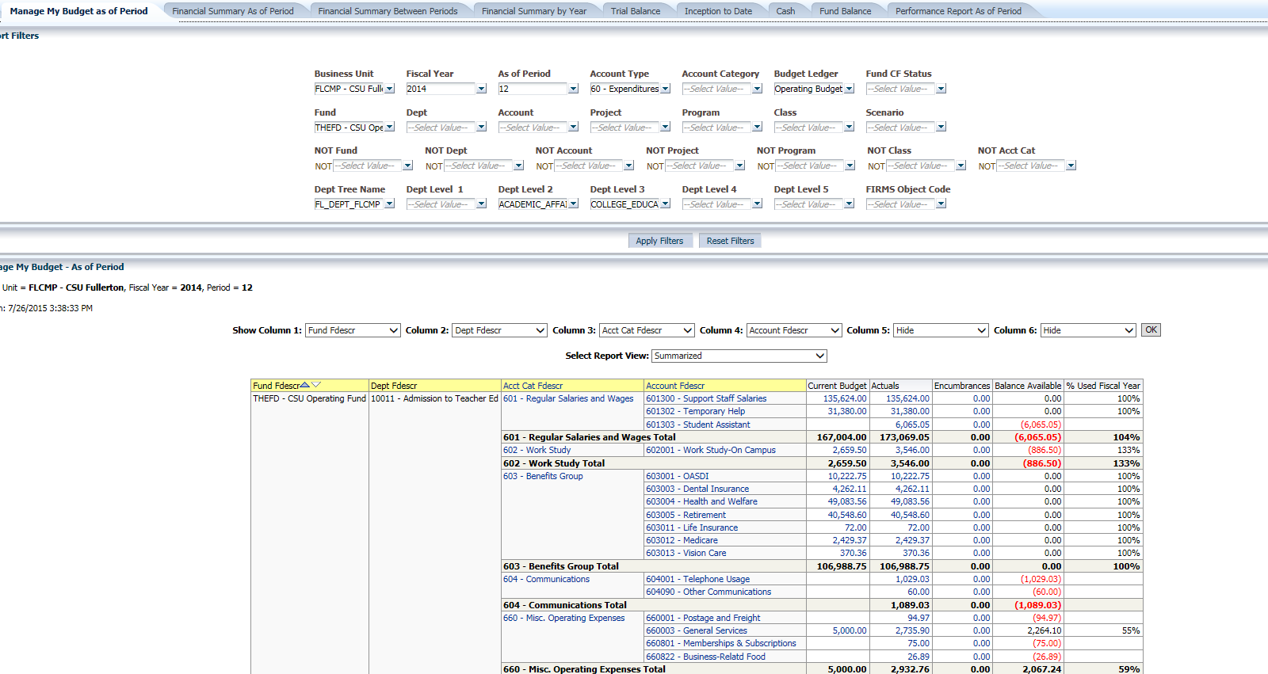
Using the Department Tree to Report on Department Levels

Chartfield Attributes
Chartfield Attributes are codes that can be linked to any chartfield. They are attached “behind the scenes” by specified, trained Chart of Accounts staff and create a commonality between the same type of chartfield. Attributes are used to group the chartfields they are attached to using specific values and can be used in data warehouse reporting.
How you will use the Fund CF Att Type and Fund CF Att Val filters depends on your campus business processes. Check with your Data Warehouse administrator for campus-specific information.
Fund CF Att Type
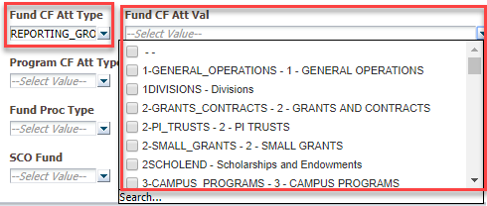
The Fund CF Attribute Filter Cascades to the Right
Chartfield Attributes are available for Fund, Account, Project, Program, and Class. Your campus business process will dictate how to use these advanced filters for your reporting requirements.
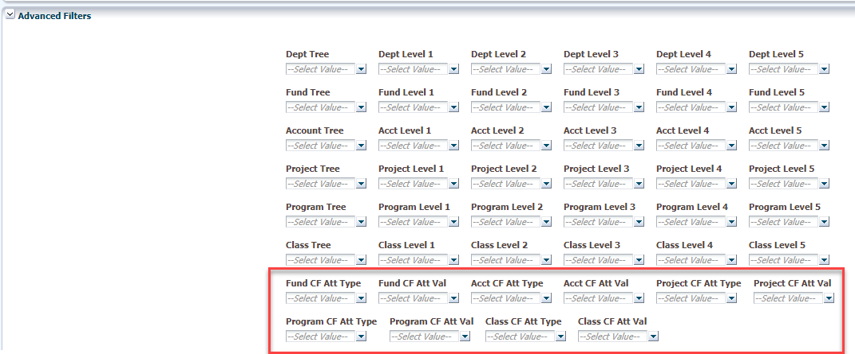
Chartfield Attribute Use is Based on Campus Business Processes

SCO Attributes
The SCO Attributes filters are mainly used for specialized reporting purposes and will not commonly be used by departmental Finance users.
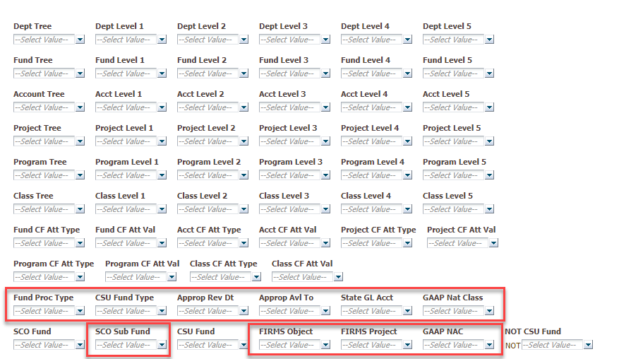
A Cascading Field will Filter all Fields to the Right

Cascading Prompts
Just as the chartfield levels “cascade” based on the selected chartfield tree, the CSU Fund cascades based on the selected SCO Fund.
Example: Filter on a particular SCO Fund (0576)
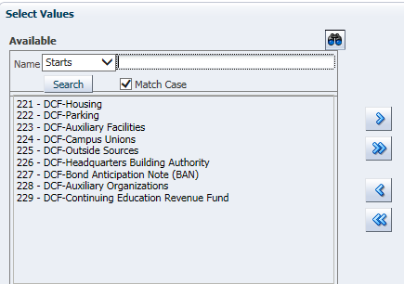
Only CSU Funds related to 0576 will display (“cascade”).

Column Values for Pages with Advanced Filters
The Show Column selection list contains over 70 options. Column selections are arranged in consistent groups for easier reference.
- Commonly used
- Advanced Filter -- Trees
- Advanced Filter – Chartfield Attributes
- Advanced Filter – SCO Attributes
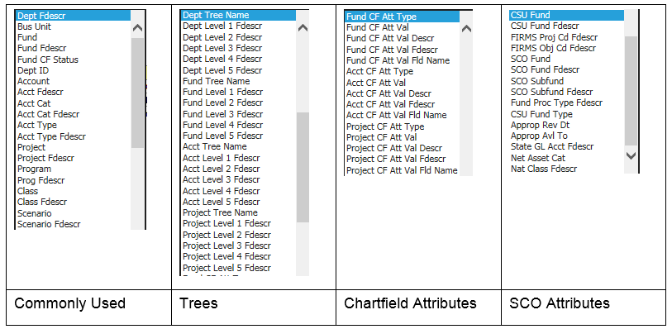
Column Selectors in a Report with Advanced Filters
Separate Fdescr and Code Values
In reports with Advanced Filters sections, the column selectors contain selections for each chartfield Fdescr and the chartfield code. See Fund and Account examples below:
Field | Value
Fund | 48501
Fund Fdescr | 48501 - General Operating Fund
Account | 660003
Acct Fdescr | 660003 – General Supplies & Services
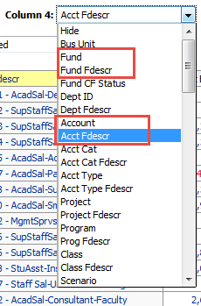
Chartfield Code and Chartfield Fdescr Fields are Available
The dual Fdescr and chartfield code filters are available in any report that has an Advanced Filters section. They are not available from the Manage My Budget as of Period report which has only a Report Filters section.

Advanced Features – Pivots, Sections, and Columns
Most of the reports in the CFS Data Warehouse contain up to six column selectors that allow the user to define report columns and column order. The data warehouse “native” application (OBIEE) also has formatting features that can be used in conjunction with the column selectors to further customize your report layout. These features include:
- Moving a column to a pivot
- Moving a built-in pivot to a column
- Moving a pivot to rows
- Moving a column to sections
- Including / excluding / moving columns
These features can be used in summarized reports and in drill down reports in a variety of combinations. You will want to try them all.

Using Prompts
The Prompts feature resembles the PivotTable feature in Excel. Pivots involve transposing rows into columns or columns into rows.
The terms prompts, pivots, and pivot table prompts are used interchangeably.
There are two methods for reformatting columns, prompts, and sections. One method uses the Columns menu (accessed with a right mouse click). The second method is the “drag-and-drop” method. It can be a little tricky to drag your content into the desired configuration but once you’ve tried it a few times, you’ll get better at it.
Generate a Practice Report
In order to follow along with the step-by-step instructions for using these advanced features, you will need to generate a report. Here’s an example you can follow using the Financial Reporting / Financial Summary as of Period report.
REPORT FILTERS | Your Campus Values
Business Unit | Your Primary Campus Business Unit
Fiscal Year | 2015
Account Type | 60 – Expenditures
As Of Period | 3
CSU Fund Fdescr | 485
Column Selector | Value
Show Column 1 | Dept Fdescr
Show Column 2 | Fund Fdescr
Show Column 3 | Acct Cat Fdescr
Report View
 | Summarized
After you’ve created the report, create a Saved Customization named “Practice” so that you can return to the unmodified practice report as often as you wish.

Move a Column to a Prompt (Using the Columns Menu)
A column formatted as a column selector can be converted to prompts/pivots.
1. Right-click on the column header in Column 1 (Dept Fdescr).
2. Select Move Column > To Prompts.
The Dept Fdescr column is converted to a pivot (prompt).
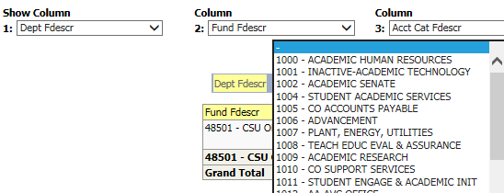
Move Column to Prompts
3. Scroll through the prompts by Department. The report results will correspond to the active department.
Move Prompts to Rows (Column)
1. Right-click in the pivot description (in this example, Dept Fdescr).
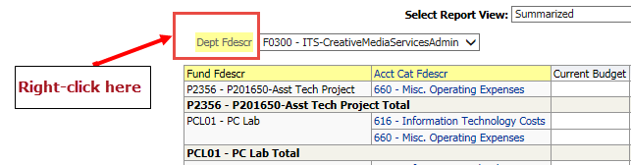
Right-click in the Pivot to Access the Columns Menu
2. Select Move Column > To Rows.
The prompts will return to the columnar format.

Move a Column to a Pivot (Drag and Drop Method)
Apply your Practice customization to display unmodified practice report content.
1. Place the mouse at the top of Column 1 (Dept Fdescr) until a double-headed icon appears.
2. Click and hold the mouse pointer. Drag the mouse until the screen displays a gray bar named Pivot Table Prompts.
3. Release the mouse. Scroll through the individual departments in the pivot.
Return the Prompts to a Column
1. Place the mouse on the small square to the left of the pivot description (in this example, Dept Fdescr).
Click and Drag in the Pivot Field to Move Prompts Back to a Column
2. Click and hold the mouse pointer. Drag the mouse back to the original position of the column you converted to prompts.
3. Release the mouse. The prompts will be returned to columnar format.

Changing a Column to Sections
A column formatted as a column selector can be converted to sections. Apply your Practice customization to display unmodified practice report content.
1. To make a column selector a section, right-click on the column header.
2. Select Move Column > To Sections.
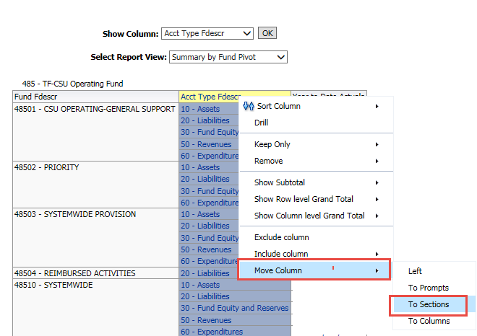
Converting a Column to Sections

Customizing Drilldowns
Columns within drills can be moved either to create Pivots or Report Sections.

Creating a Pivot in a Drilldown
From a drill, you can move a column to create a Table Prompt. Apply your Practice customization to display unmodified practice report content. Drill into an Actuals value that has multiple rows of data.
1. To make a column a Table Prompt, right-click on the column header.
2. Select Move Column > To Prompts.
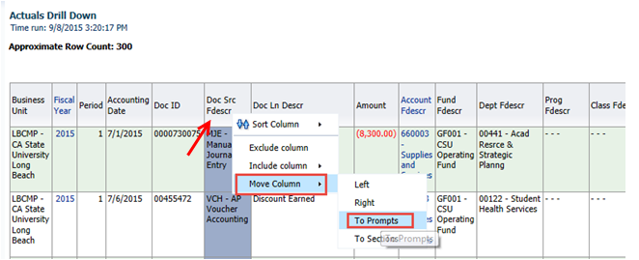
3. Use the prompts to scroll through report data.
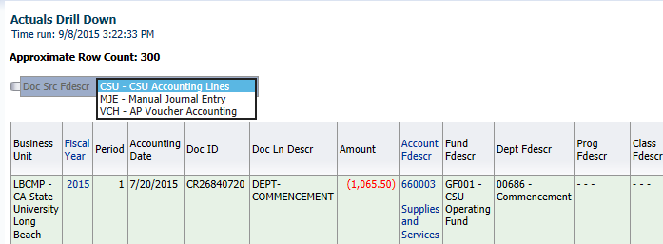

Creating a Report Section
From a drill, you can move a column to a Report Section. This example is using the Transaction Inquiry > Actuals Transactions Report.
1. To make a column a Report Section, right-click on the column header.
2. Select Move Column > To Sections.
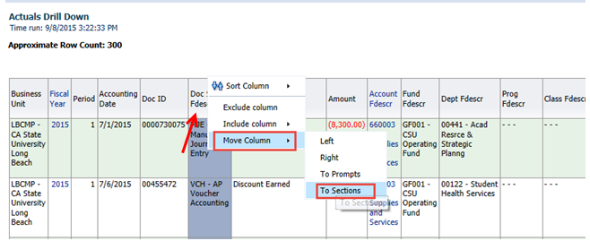
Moving a Column to Sections in a Drill Down

Sort, Include, Exclude Columns
1. Quickly sort a column in ascending or descending order by clicking the up or down arrows.
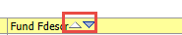
Use Icons for Ascending / Descending Sort
2. The Column menu includes many column-related options, including Sort. Place your cursor over a report results column with a yellow or blue header column until a gray bar appears.
Your cursor will turn into a + sign with arrows on the ends.
3. Right-click to activate the Column menu.
This option gives a variety of sort options for the specific column. The sort selection will affect all data rows related to the values in the selected column.
The Column Menu Options
4. Choose Exclude column. Clicking this option will remove the column from the report. This is useful if you decide you don’t need all the original yellow columns you have selected. There is no verification prompt, so make sure you want to perform this action.
You can only exclude columns with yellow headings (columns that are available from the Show Column list).
TIP: If you delete a column and want to restore it, it is easiest to reapply a saved customization and rerun the original report.
Include Column
The Include Column selection allows you to add additional columns to your report without having to choose a different starting report. The columns that can be added include chartfields, calculated fields, and others.
Add a Project column after the DeptID column to the original report.
1. Re-apply the original customization, if necessary.
2. Place your cursor over the Dept Fdescr column header until a gray bar appears.
3. Right-click. Select Include Column.
NOTE: Do not choose to include a calculated field that you could see by selecting a different Report View. Only add items that would be available in the column selection dropdown list.
4. Click on an item to insert a column.
The column will be added to the right of the Department column.
NOTE: The newly inserted column does not have a yellow column heading like the three columns in the original report format. The new column cannot be changed from the Show Column selectors. To remove it, use the Columns Menu to Exclude Column.
Exclude a Column
Exclude the column that was just added.
1. Place the cursor over the Project column until the gray bar appears.
2. Right-click to activate the Columns menu.
3. Click on Exclude column.

Move Column to Columns
The Move Column to Columns feature allows you to create a report format that displays the values of a selected column horizontally across the top of the report.
Move Column to Columns Feature
1. Place the cursor the column you want to move until the gray bar appears (for example, place the cursor over the Dept Fdescr column).
2. Right click to display the Columns menu.
3. Click Move Column > To Columns.
All values in the selected column will display horizontally across the top of the report.
IMPORTANT: All changes that impact column order and formatting can be saved as a customization in Summarized Reports.
There are NO saved customizations in drilldowns.

Editing Saved Customizations
You can rename customizations, change which customization to use as your default, change permissions for those customizations that have been shared with others, and delete customizations. For more information on customizations, see "What Are Saved Customizations for Dashboard Pages?"
To Edit Saved Customizations
1. Open the page / report in which you want to edit a customization.
2. Click the Page Options button on the page and select Edit Saved Customizations.
Page Options Menu
3. Select Edit Saved Customization.
The Edit Saved Customization dialog is displayed.
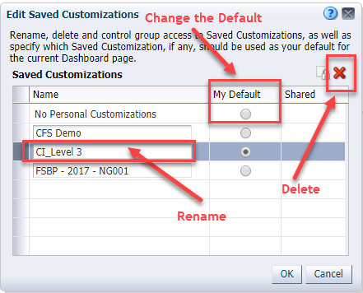
Edit Saved Customizations Dialog
4. From the Edit Saved Customizations dialog box, you can:
- Rename customizations - To rename a customization, overwrite the old name with the new name.
- Change which customization to use as your default - To set a customization as your default, select the button in the My Default column for the customization. To have no personal customizations as your default, select the button in the My Default column for the No Personal Customizations entry.
- Delete customizations - Click the Delete button to delete the selected customization.
5. Click OK when done.
NOTE: There are NO Shared Customizations in the CFS Data Warehouse.

Additional Features

The Manage My Budget as of Period Report
The Manage My Budget as of Period Report is designed to produce reports of budget, actuals, encumbrances, pre-encumbrances, and balance available data.
- The Manage My Budget report contains one Report Filters section.
- Filters include all chartfields and any available department tree. This is the only report that contains the Department Tree in the report filters section.
- The Manage My Budget report defaults to account types 50 and 60. However, you can report on any and all account types.
- You can choose a NOT value in as a report filter.
Create a Manage My Budget Report
1. Go to the Manage My Budget as of Period page and set the report filters.
If desired, you can choose a different business unit than the one set on the Home Page. You can also select multiple business units.
1. Select the Report Filters.
2. Choose the Dept Tree Name to report on department tree levels.
Users must select a tree if they want to return values based on a tree’s hierarchy.
3. Choose Apply Filters.
The report content will appear. Use the Columns Selectors, Report Views, and other formatting features to configure your report content.

The Transaction Inquiry Dashboard
All transaction inquiry pages are now located on the Transaction Inquiry dashboard with a wider range of filters and column selectors. The purpose of the Transaction Inquiry dashboard is to produce detailed reports containing the transaction data found in the summary financial reports.
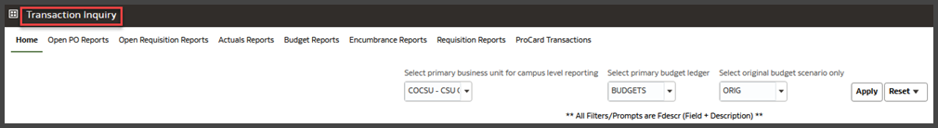
The Transaction Inquiry Dashboard
For detailed information on the Transaction Inquiry reports, see the Transaction Inquiry Dashboard Guide.

For More Information
Additional CFS Data Warehouse documentation can be found at:
https://csyou.calstate.edu/Divisions-Orgs/bus-fin/it/BI-DW/CFSDW/Pages/BI-DW-User-Documentation.aspx
For further information on the features covered in this Guide or other CFS Data Warehouse issues, please open a ServiceNow request or contact: FDW-SUPPORT@LISTS.CALSTATE.EDU,
* * *

