CFS Data Warehouse
Financial Reporting
Dashboard Guide for OAC

Last Revised: | 03/01/2023

REVISION CONTROL
Document Title: | Financial Reporting Dashboard Guide
Author: | Business Intelligence / Data Warehouse (BI/DW)
File Reference: | CFS DW Financial Reporting Dashboard Guide OAC

Date | By | Action | Pages
1/22/2016 | BI/DW | Consolidated Financial Reporting Guide – New Document | All
7/14/2016 | BI/DW | Added new report view to Financial Summary by Year report
7/31/2017 | BI/DW | Updated Appendix A – Data Warehouse Glossary to reflect Project Start Dt and Project End Dt column selectors | 53
11/22/2017 | BI/DW | Added Summarized by Period report view to Financial Summary Between Periods;  Added Inception to Date with Period Prompt Report
2/202018 | BI/DW | Validation and updating of report filters and report views | All
6/6/2018 | BI/DW | Addition of Program and Class Tree content | All
12/17/2018 | BI/DW | Updated for Version 12C | All
03/01/2023 | BI/DW | Updated for Version OAC

Table of Contents
Page
About this Document 5
1.0 Getting Started 6
1.1 Logging in to the Data Warehouse 6
1.2 The Data Warehouse Home Page and Dashboards Menu 7
1.3 Dashboard Filters 10
1.4 Setting Report Filters 11
1.4.1 Choose Filters from a Dropdown List 12
1.4.2 Search for Filters 12
1.4.3 Select Criteria 13
1.5 Using Columns to Format Report Results 14
1.5.1 Show/Hide Columns 14
1.5.2 Show a Column 14
1.5.3 Hide a Column 15
1.6 Adding and Removing Subtotals 16
1.7 Using the NOT Report Filter 16
1.8 Report Views 17
1.9 Chartfield Trees 18
1.10 Using a Chartfield Tree 19
1.11 Drilling into Data 21
1.11.1 Drill Down and Sort 22
1.12 Using Sections and Prompts 22
1.12.1 Move a Column to a Prompt 22
1.13 Changing a Column to Sections 23
1.14 Exporting Reports 24
1.14.1 Print to PDF 24
1.14.2 Export to Excel 24
1.14.3 Export Data 24
1.15 Saving Customizations 25
2.0 The Financial Reporting Dashboard Reports 26
3.0 Manage My Budget as of Period 28
3.1 Report Examples: Manage My Budget as of Period 28
3.1.1 Scenario: One Department and One Fund 28
3.1.2 Scenario: Summary Report 29
3.1.3 Scenario: One-Line Report 29
3.1.4 Scenario: One-Line Report 30
3.1.5 Scenario: One College / One Fund 31
3.2 Report Views 31
4.0 Financial Summary as of Period 37
4.2 Report Examples: Financial Summary as of Period 38
4.2.1 Scenario: Expenditures for One College / One Fund 38
4.2.2 Scenario: Revenue and Expense by Fund 38
4.2.3 Scenario: Travel Report – All Colleges within a Division 39
4.2.4 Scenario: Travel Report – All Colleges within a Division by Department 39
4.2.5 Scenario: Accounting Report 40
4.3 Report Views 40
5.0 Financial Summary Between Periods 45
5.1 Report Examples: Financial Summary Between Periods 45
5.1.1 Scenario: Third Quarter Accounts Payable 45
5.2 Report Views 46
6.0 Financial Summary by Year 49
6.1 Report Examples: Financial Summary by Year 49
6.1.1 Scenario: Spending Trend Analysis for Colleges within a Division 49
6.2 Report Views 50
7.0 Trial Balance > Actuals Trial Balance 52
7.1 Report Examples: Actuals Trial Balance 53
7.1.1 Scenario: Actuals Trial Balance 53
7.2 Actuals Trial Balance Column Selector Values 54
7.3 Report Views 54
7.4 Multi-Tiered Reports 57
7.5 Trial Balance (6 Columns) 58
7.5.2 Report Examples 59
7.5.3 Report Views 60
8.0 Inception to Date Reports 61
8.1 Inception to Date 61
8.1.1 Report Examples 62
8.1.2 Report Views 62
8.2 Inception to Date with Period Prompt 64
8.2.1 Report Example 65
8.2.2 Report Views 65
9.0 Cash 66
9.2 Report Examples: Cash 66
9.2.1 Report Views 67
10.0 Fund Balance 69
10.2 Report Examples: Fund Balance 69
10.3 Report Views 70
11.0 Performance Report as of Period 72
11.2 Report Examples: Performance Report 72
11.2.1 Scenario: Performance Report 73
11.3 Report Views 73
Appendix A – Data Warehouse Glossary 75
Appendix B – Document Sources 82

About this Document
The Financial Reporting Dashboard and Report Guide provides detailed information about the Financial Reporting dashboard reports and features.
Audience
This document is intended for all users of the CFS Data Warehouse.
Related Documentation
    - CFS Data Warehouse Common Features Guide
    - CFS Data Warehouse Transaction Inquiry Dashboard Guide
    - CFS Tree Reporting Configuration and Dashboard Guide
    - CFS Data Warehouse Metadata Guide

Getting Started
This section contains basic information about accessing the CFS Data Warehouse (also referred to as the Finance Data Warehouse). It presents a review of standard CFS Data Warehouse features that are applicable throughout the data warehouse reports, including:
- Setting Dashboard and Report Filters
- Searching for Report Criteria
- Customizing Columns
- Formatting Report Results
- Creating Sections and Pivots
- Exporting Data
- Saving Customizations
For more comprehensive step-by-step instructions for using these and other CFS Data Warehouse features, please to go the CFS DW User Documentation page at:
https://csyou.calstate.edu/Divisions-Orgs/bus-fin/it/BI-DW/CFSDW/Pages/BI-DW-User-Documentation.aspx

Logging in to the Data Warehouse
Access to the CFS Data Warehouse is provided via SSO (single sign-on). If prompted, select your campus and enter your user ID and password.
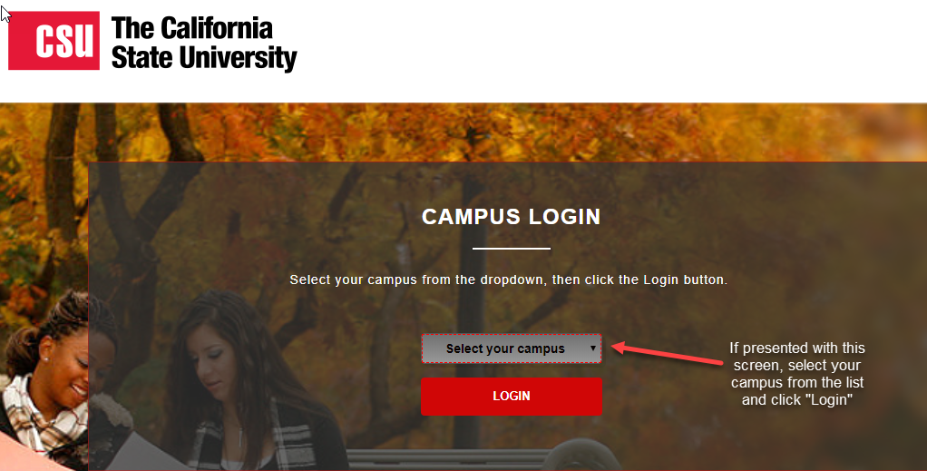
Choose your Campus, if Prompted
The CFS Data Warehouse is also available from other locations within CSYou. The steps for accessing the data warehouse at your campus might be different. Follow your campus guidelines to log into the data warehouse.
The CFS Data Warehouse can be accessed through CSYou and is available as a button in the Quick Links section. Click the CFS Data Warehouse button to access the data warehouse.
https://csyou.calstate.edu/Divisions-Orgs/bus-fin/it/BI-DW/CFSDW/Pages/default.aspx
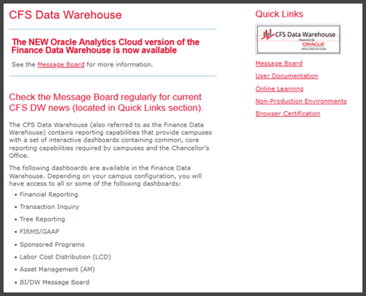
CFS Data Warehouse Quick Link

The Data Warehouse Home Page and Dashboards Menu
Once you have successfully logged in to the CFS Data Warehouse, you will be directed to the main Home page. This page contains links to the individual dashboards and your most recently accessed reports. The CFS Data Warehouse contains multiple dashboards. A dashboard allows multiple reports to be displayed in a tabbed interface.
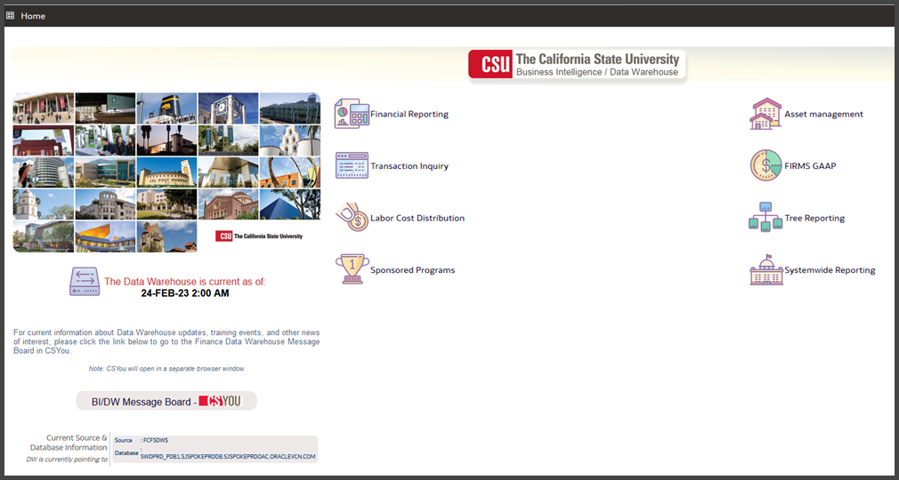
Data Warehouse Main Home Page (Landing Page)
Depending on your security profile, you will have access to some or all of the following dashboards.
- Asset Management
- Financial Reporting
- FIRMS/GAAP
- Labor Cost Distribution
- Sponsored Programs
- Systemwide Reporting (restricted to CO only)
- Transaction Inquiry
- Tree Reporting
Additional Features on the Home Page
Additional features on the Data Warehouse Home Page include:
- The CFS Data Warehouse Home page displays the date and time of the current data refresh.
- The BI/DW Message Board button will take you to the Message Board in CSYou.
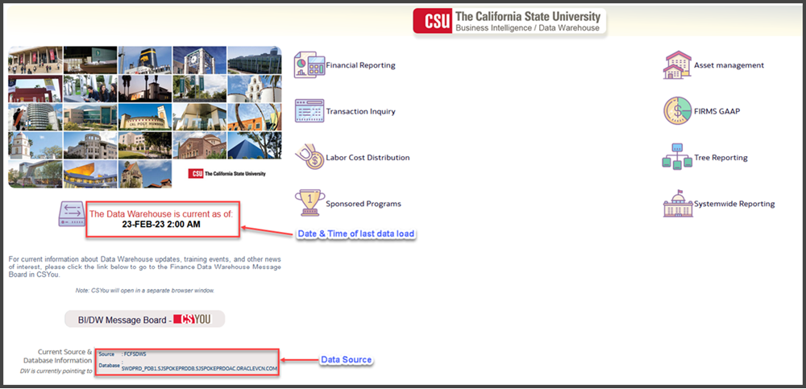
Enhanced Functionality on the New CFS Data Warehouse Home Page
Accessing a Dashboard
1. From the Data Warehouse Home page, click on a dashboard button to move to the associated dashboard.
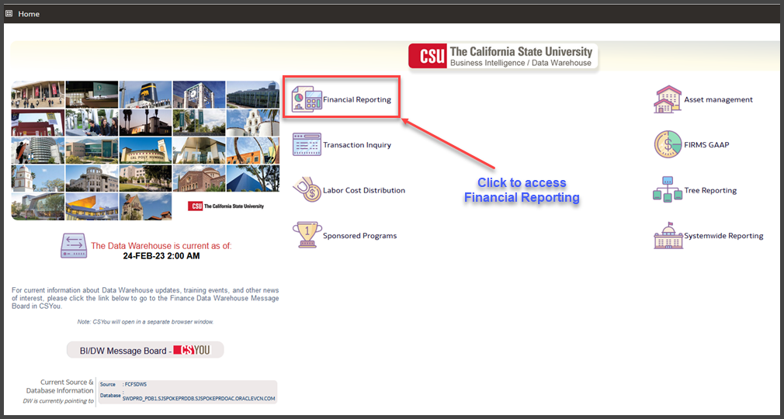
Access a Dashboard by Clicking the Dashboard Button
2. Click on the Financial Reporting button to go to the Financial Reporting dashboard.
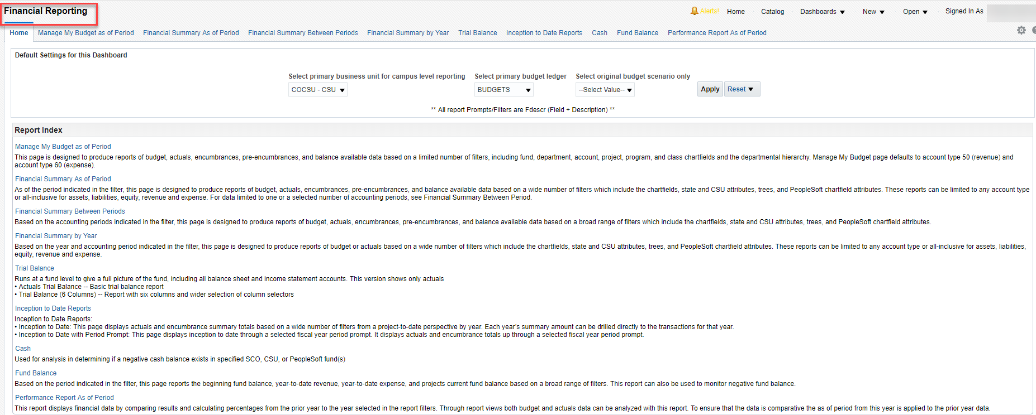
Financial Reporting Home Page
Navigating through the Data Warehouse

1. You can also move through the dashboards by using the drop down menu to display a list of available dashboards.
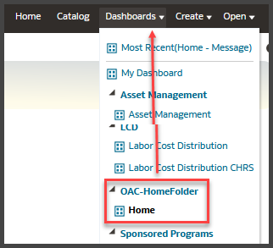
The Dashboards Menu is Available Throughout the Data Warehouse
2. Using the button on the Data Warehouse Home Page or the Dashboard menu, return to the Financial Reporting dashboard.

Dashboard Filters
Dashboard settings are filters that will apply to ALL pages within a dashboard. You can override Home Page default settings at the individual page/report level.
1. In the Default Settings for this Dashboard section, select your primary campus values.
FIELD | DESCRIPTION | EXPLANATION / EXAMPLE
Primary business unit for campus level reporting | The business unit for the PeopleSoft GL Application | COCSU or SBCMP
Primary budget ledger | The campus budget ledger. | Budget
Original budget scenario | Name of original budget scenario | This filter is used to determine what gets summarized (scenarios) in the original budget column on various reports.

Dashboard Filters Example with Original Budget Scenario
2. Click Apply to apply the dashboard filters.
Save your Settings as Default
1. From the Page Options menu, choose Save Current Customization.
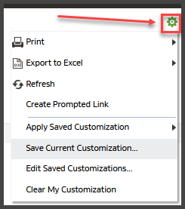
2. Enter a descriptive customization name.
3. Choose Make this my default for this page.
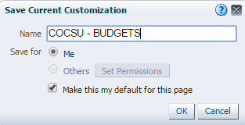
4. Click OK.
5. Return to the Transaction Inquiry dashboard.

Setting Report Filters
The first step in report creation is to select and apply report filters. Most reports contains two report filters sections: Report Filters and Advanced Filters. Report filters contain the most commonly used, or basic filters. Advanced filters offer a wider range of report criteria including values for department, fund, account, and project chartfields from trees that are loaded into the Finance Data Warehouse. The advanced filters section can be expanded or collapsed by clicking the down arrow icon. By default, this section is collapsed.
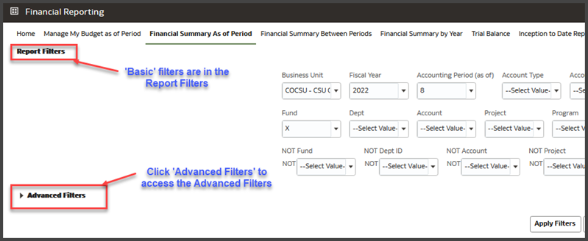
Report Filters and Advanced Filters are Located in Separate Sections
Note: The Financial Reporting as of Period report will be used to illustrate many of the data warehouse features. Go to this page to follow along with the instructions.

Choose Filters from a Dropdown List
The values that display in the drop down list in the Report Filters section are related to the applied business unit(s), for example COCSU.
1. From the Financial Reporting dashboard, go to the Financial Reporting as of Period report.
2. Select report filters from the drop down list next to any desired field.

Search for Filters
The values that display when using the search feature represent ALL values available at your campus. It is possible to choose a value that will not produce results based on the APPLIED business unit. Therefore, it is important to be familiar with your own data.
1. To search for a filter value, click the dropdown arrow next to the filter field and select Search (example: Dept field).
2. Contains is the primary operator.
The two choices you will probably use most often are Starts and Contains.
3. Match Case if you want to do a search that is case-sensitive.
This is a more flexible search option that will locate the search string regardless of capitalization.
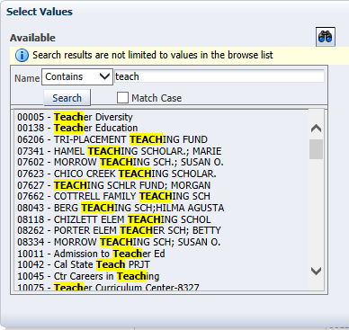
4. Enter your search criteria.
5. Click the Search button.
All available values that contain your search string will display.

Select Criteria
1. Highlight individual values, non-contiguous values, or a range of values. Then use the icons or double-clicking to add desired value(s) into the Selected box.
2. Click OK to return to the report.
Select all items listed
Select highlighted item(s)
De-select highlighted item(s)
De-select all items
- Double-clicking can also be used to move an individual item into or out of the Selected box
- Use the Shift key to select a continuous range of items
- Non-contiguous items can be selected using the Control key (PC) or the Command key (Mac)
3. When you have added a value(s) to the Selected area, click OK to return to the report.
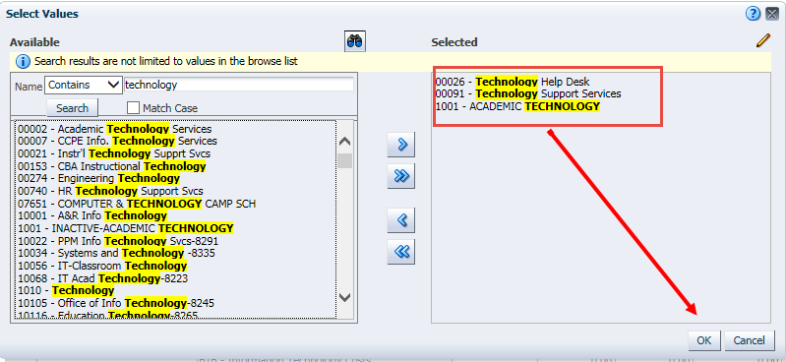
Search and Select Report Criteria
4. Remove any null values (example: the “x” in Fund field). If the report filter you need is visible in the list, you can click to select it. Or use the Search feature to search and select report filters.
5. When all your report filters are selected, click Apply Filters to generate the report.
The Advanced Filters features will be covered later in this Guide at p. 18

Using Columns to Format Report Results
Once you apply report filters, a report is generated and the results are delivered to your screen based on your search criteria. From the displayed results, you can use column selectors and the Columns menu to get a different perspective of the data.

Show/Hide Columns
The report layout area contains six column selectors (user-defined columns). Some reports, for example LCD Dashboard reports, have up to nine column selectors. In most reports, the first three columns display content. Use the column selectors to dynamically change which columns appear in your report by choosing column values from a dropdown list.
The values that are available in the list are related to the filters in the Report Filters and Advanced Filters section. For example, a report that only has a Report Filters section will have fewer column selector choices than a report that has both Report Filters and Advanced Filters.

Show a Column
1. To show (display) a column, click the drop down menu in the column where you want to add column content. Select the desired column value. For example:
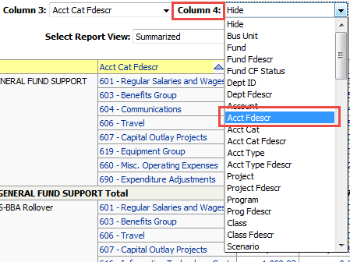
2. Click OK to apply the column values and generate the report.
Any column displaying a yellow heading indicates that the column is formatted as a column selector.
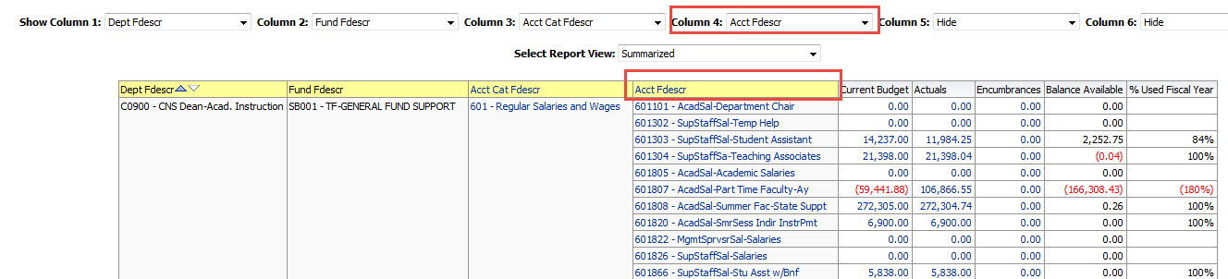
Use Column Selectors to Configure Report Content

Hide a Column
Hide will “hide” the associated column from your report. Hide is the default value for columns 4-6. You can also use Hide to hide any visible columns.
1. To hide a column, place the cursor at the top of the column that contains a column value and click the drop down column-selector menu. Choose Hide.
2. Click OK to apply your selection and re-generate the report.
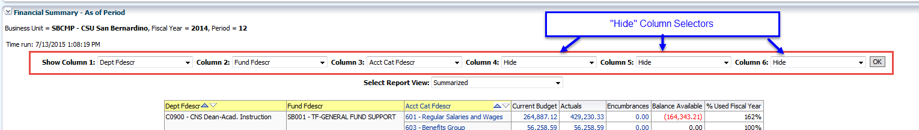
Configure Report Results with the Hide/Show Columns Feature

Adding and Removing Subtotals
The first two columns in every report are formatted to display subtotals. The third column is formatted without a subtotal. To add a subtotal to the third column or to any additional columns, use the Show Subtotal option in the Columns menu.
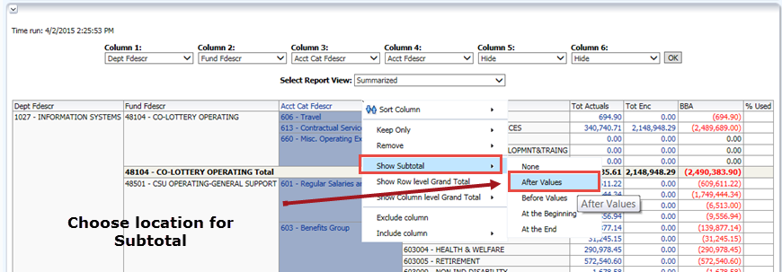
The Show Subtotal Option on the Columns Menu
Show a Subtotal / Remove a Subtotal
1. Place the cursor at the top of the column where you want to add a subtotal.
2. Right click on the yellow column heading to access the Columns menu.
3. Choose Show Subtotal > After Values.
4. To remove a subtotal, choose Show Subtotal > None.
All report configurations and results can be stored as a Saved Customization.

Using the NOT Report Filter
In the CFS Data Warehouse, the NOT functionality is available as a global feature. Unlike the filters that are used to select a chartfield or account category value to be included in the report results, the NOT filter searches against the chartfield or category code only.
The “include” filter searches against the Fdescr (code + description) | The NOT filter searches against the code only
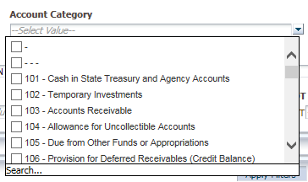 | 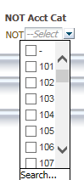
Remove an Account Category
You can use the NOT feature to remove a value from the associated filter type. The NOT fields search against the chartfield CODE only, not against the chartfield Fdescr. For example, use NOT Account Category, to remove a specific Account Category from the search criteria.
1. From the Report Filters section, choose a NOT value (for example Acct Cat 603).
2. Choose Apply Filters.
Acct Cat 603 (Benefits Group) will not be included in the report results.
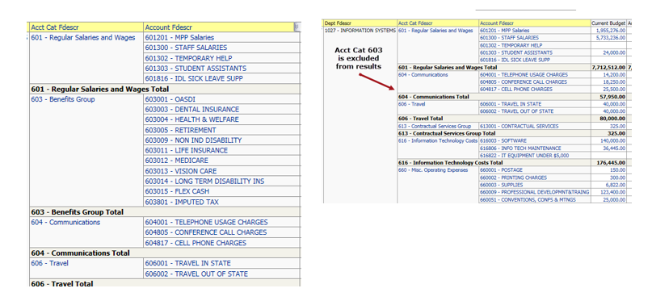
Using the NOT Acct Cat Feature

Report Views
Report views present report results with different columns of information to display data for a specific purpose. Each report has its own set of views to help organize report data.
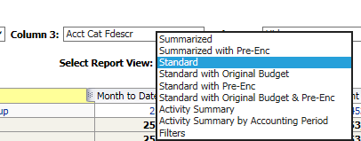
Choose From One of Many Report Views
After you have generated a report, choose a Report View. Each Report View contains a predefined set of columns that will appear in your report results after the column selectors. Every report also contains a Filters view which will display the criteria used to generate the active report.

Example: Summarized
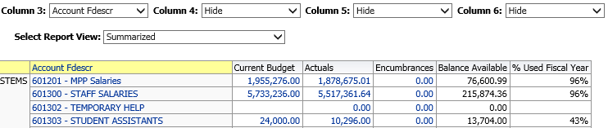
Summarized Report View

Example: Standard
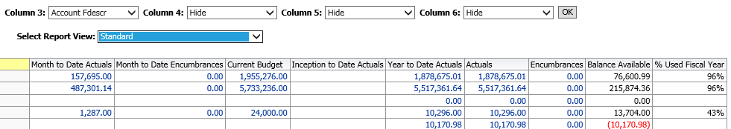
Standard Report View
Example: Filters
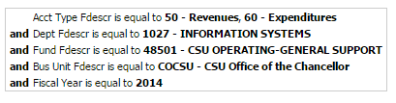
Filters Report View

Chartfield Trees
Trees are a great way to customize a report. The data warehouse supports tree reporting for all six chartfields:
- Department
- Account
- Fund
- Project
- Class
- Program
All of the chartfield trees and tree levels are located in the Advanced Filters section of all pages except for Manage My Budget.
Note: Only the Department Tree and tree levels are available as filters and column selectors in the Manage My Budget report.
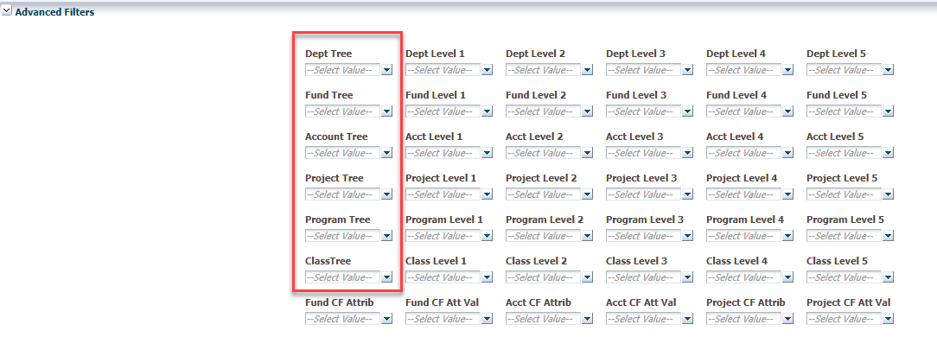
Chartfield Trees are Available in the Advanced Filters Section
All trees configured for reporting in the Data Warehouse are available from the associated chartfield tree filter. Current and historical (effective dated trees) are both available.
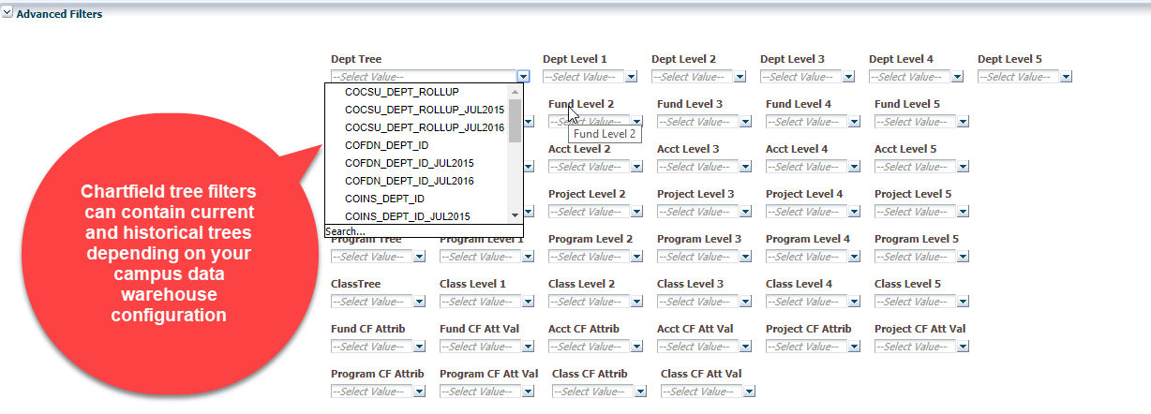
Use Tree Filters to Choose Current or Historical Trees and Levels

Using a Chartfield Tree
When you choose a chartfield tree as a filter, for example, Dept Tree, only values associated with that tree will be available. When you pick a chartfield tree level, for example, Dept Level 2, only applicable values will be available at the next lower level. If you want to use tree levels in your column selectors, you must pick a tree name in the Report Filters or Advanced Filters section.
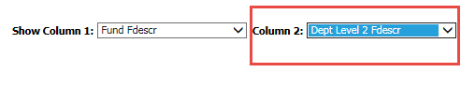
For commonly used chartfield trees, such as Dept Tree, it is recommended that you always select department tree as one of your filters. Talk to your Data Warehouse support analyst for recommendations at your campus.
If you want to include tree levels in your column selectors (example, Dept Level 2, Dept Level 3, etc.), you must pick a tree name in the Report Filters or Advanced Filters section.
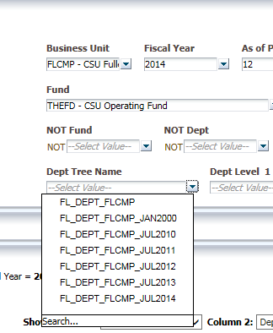
All Available Trees from your Campus will Display in the Dropdown
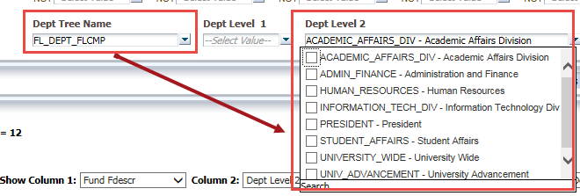
Available Tree Levels are Associated with the Applied Tree
Report Results
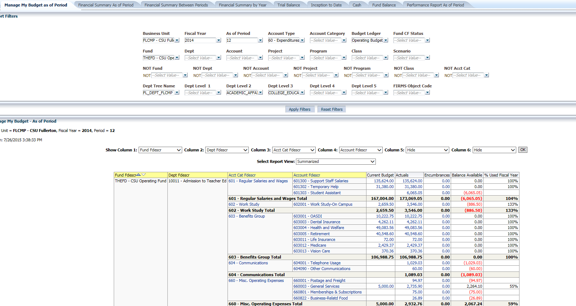
Using the Department Tree to Report on Department Levels

Drilling into Data
When you place your cursor over an item and it appears as a hyperlink, you are able to drill on that item. Drilling on a hyperlinked numeric value will take you to the details of the selected amount.
Drill downs have been designed with standardized column order across all types of drills. Standardized drill columns improve usability and increase ease of combining data from multiple files when downloading.
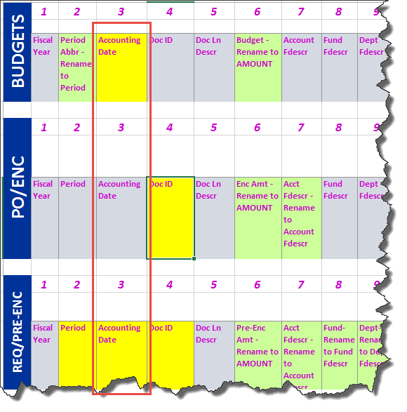
Drilldown Order is Consistent
- Drill down columns display priority columns on the left so they are easier to view.
- Drill down columns align on the left to the extent possible. The highlighted columns are in the same order in both Actuals and Budget drilldowns.
- Scroll to the right to see columns that are specific to the associated drill. The Budget drill down does not include PO or other Actuals specific columns.

Drill Down and Sort
1. Drill down on a hyperlinked numeric value.
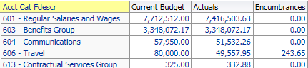
Drill from Summary Data to Transaction Data
2. At the bottom of the screen use the icons to move forward and back through the returned results, 100 rows at a time.
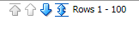
Display 100 Rows at a Time
3. Sort columns in ascending or descending order.
4. Use breadcrumbs to return to the parent report.
Breadcrumbs are located at the bottom of your browser window
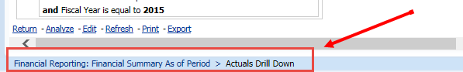
Use Breadcrumbs to Return to the Report

Using Sections and Prompts
The Prompts feature resembles the PivotTable feature in Excel. Pivots involve transposing rows into columns or columns into rows. There are two methods for reformatting columns, prompts, and sections. One method uses the Columns menu (accessed with a right mouse click). The second method is the “drag-and-drop” method. See the CFS Common Features Guide for more instructions on using this method.

Move a Column to a Prompt
A column formatted as a column selector can be converted to prompts/pivots.
1. Right-click on the column header in Column 1 (example: Dept Fdescr).
2. Select Move Column > To Prompts.
The Dept Fdescr column is converted to a pivot (prompt).
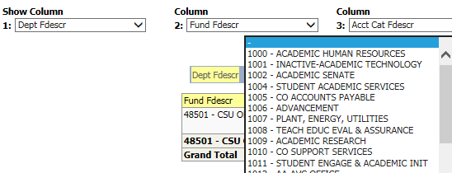
Move Column to Prompts
3. Scroll through the prompts by Department. The report results will correspond to the active department.
Move Prompts to Rows (Column)
1. Right-click in the pivot description (in this example, Dept Fdescr).
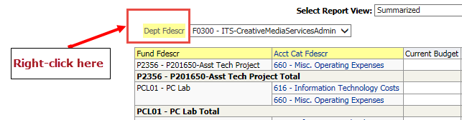
Right-click in the Pivot to Access the Columns Menu
2. Select Move Column > To Rows.
The prompts will return to the columnar format.

Changing a Column to Sections
A column formatted as a column selector can be converted to sections.
1. To make a column selector a section, right-click on the column header.
2. Select Move Column > To Sections.
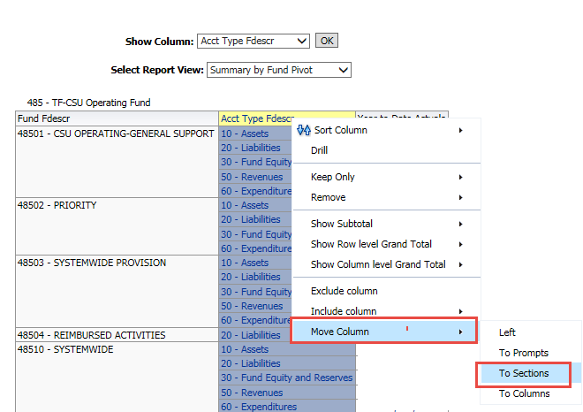
Converting a Column to Sections

Exporting Reports
The term “action link” is used to apply to the hyperlinks that appear at the bottom of a report. The actions that can be performed using action links include Print and Export.

Print to PDF
1. Click on the Print action link immediately below the report.
2. Select Printable PDF.
All report content, including section headings and report filters, will print to the PDF.
3. Print or save the PDF file.
From the Export menu, you can also choose to Export to PDF.

Export to Excel
1. Generate a report. Below the report area, click Export.
2. Choose Excel 2007+.
3. Click Save > Save as.
4. Name your Excel file and save it to a local drive.

Export Data
1. Generate a report. Below the report area, click the Export > Data.
2. Choose CSV Format, Tab delimited Format, or XML Format.
3. Click Save > Save as.
4. Name your data file and save it to a local drive.
5. Click on a breadcrumb or the Return link to return to previous screens from a drill down report.

Saving Customizations
Using the Page Options / Save Customizations feature, you can store report criteria and formats. You can save as many different combinations of these items as you want for an individual report. You can also choose a saved selection as the default for a page. Saved customizations can be renamed or deleted, as needed. When you save a customization, all of the following elements are stored:
- Report filters, basic and advanced
- Column selectors
- Report view
All values entered in both the Report Filters and Advanced Filters section are stored in any associated Saved Customization, even if the Advanced Filters section is collapsed.
Create a Saved Customization
1. Generate a report that has the report filter values that you want to store.
2. Select a Report View, for example Standard.
3. Use the Columns Selectors to choose the columns to wish to include in your report results. Click Go to execute your selection.
4. From the Page Options menu, choose Save Current Customization.
5. If you enter a customization name that is already saved, you will get the opportunity to replace the existing customization.
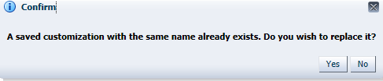
Replace Existing Saved Customization
6. Choose Yes to replace the existing customization or No to enter a unique name.
7. Click OK.
Apply Saved Customization
1. Click Page Options > Apply Saved Customization > Your Selection Name
- Saved selections are specific to an individual dashboard report.
- There is no limit to the number of saved selections per report.
2. Repeat the steps above to apply a different saved selection.
3. Click OK to save your changes.

The Financial Reporting Dashboard Reports
The Financial Reporting dashboard is designed for managing budgets. This dashboard allows the user to filter reports based on selected fund and account attributes and campus unique trees for department, fund, account, and project tree levels.
Financial Reporting Dashboard Reports
Page Name | Page / Report Description
Manage My Budget as of Period | This page is designed to produce reports of budget, actuals, encumbrances, pre-encumbrances, and balance available data based on a limited number of filters, including fund, department, account, project, program, and class Chartfields and the departmental hierarchy. Manage My Budget page defaults to account type 50 (revenue) and account type 60 (expense).
Financial Summary As of Period | As of the period indicated in the filter, this page is designed to produce reports of budget, actuals, encumbrances, pre-encumbrances, and balance available data based on a wide number of filters which include the Chartfields, state and CSU attributes, trees, and PeopleSoft Chatfield attributes. These reports can be limited to any account type or all-inclusive for assets, liabilities, equity, revenue and expense. For data limited to one or a selected number of accounting periods, see Financial Summary Between Periods.
Financial Summary Between Periods | Based on the accounting periods indicated in the filter, this page is designed to produce reports of budget, actuals, encumbrances, pre-encumbrances, and balance available data based on a broad range of filters which include the chart fields, state and CSU attributes, trees, and PeopleSoft Chatfield attributes.
Financial Summary by Year | Based on the year and accounting period indicated in the filter, this page is designed to produce reports of budget or actuals based on a wide number of filters which include the Chartfields, state and CSU attributes, trees, and PeopleSoft Chatfield attributes. These reports can be limited to any account type or all-inclusive for assets, liabilities, equity, revenue and expense.
Trial Balance | Runs at a fund level to give a full picture of the fund, including all balance sheet and income statement accounts. This version shows only actuals  - Actuals Trial Balance -- Basic trial balance report  - Trial Balance (6 Columns) -- Report with six columns and wider selection of column selectors
Inception to Date Reports | This page contains links to the following two reports:  - Inception to Date -- Displays actuals and encumbrance totals based on a wide number of filters from a project-to-date perspective by year. Each year’s summary amount can be drilled directly to the transactions for that year.  - Inception to Date with Period Prompt – This page displays inception-to-date through a selected fiscal year period prompt. It displays actuals and encumbrance totals up through a selected fiscal year period prompt.
Cash | Used for analysis in determining if a negative cash balance exists in specified SCO, CSU, or PeopleSoft fund(s)
Fund Balance | Based on the period indicated in the filter, this page reports the beginning fund balance, year-to-date revenue, year-to-date expense, and projects current fund balance based on a broad range of filters. This report can also be used to monitor negative fund balance.
Performance Report As of Period | This report displays financial data by comparing results and calculating percentages from the prior year to the year selected in the report filters. Through report views both budget and actuals data can be analyzed with this report. To ensure that the data is comparative the as of period from this year is applied to the prior year data.

Manage My Budget as of Period
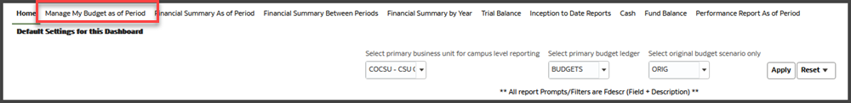
The Manage My Budget as of Period report is designed to produce reports of budget, actuals, encumbrances, pre-encumbrances, and balance available data based on a limited number of filters, including fund, department, account, project, program, and class chartfields and the departmental hierarchy.
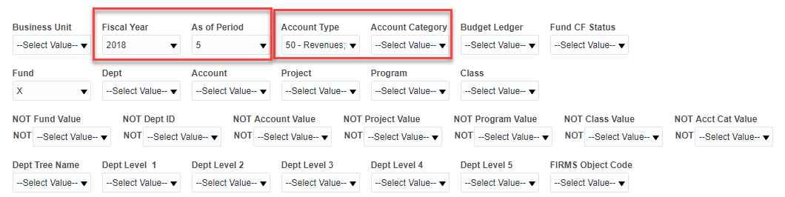
Manage My Budget as of Period Report Filters with Defaults, including Current Fiscal Year and Period
Report Features
- The Manage My Budget as of Period (MMB) report contains one section for report filters.
- The MMB report defaults to account types 50 and 60. However, you can report on any and all account types.
- This report defaults to current fiscal year and period.
- Report filters include NOT chartfields and NOT account category filters.
- There are filters for dept tree and dept tree levels. Dept tree is the only chartfield tree available in this report.
- Chartfield fields on the report filters [Fund, Dept, Account, Project, Program, and Class] display the Fdescr (Field + Description)
- NOT chartfield fields (Fund Value, Dept ID, Account Value, Project Value, Program Value, and Class Value) display the chartfield code only.
- The Accunt Category field displays the Fdescr and the The NOT Acct Cat Value displays the code only.
- In all data warehouse reports, the Business Unit and Budget Ledger filters are inherited from default filters set on the dashboard Home Page. You can override these values and choose new business unit or budget ledger filters at the report level.

Report Examples: Manage My Budget as of Period
Experiment with the scenarios listed below to produce reports for specific business requirements.

Scenario: One Department and One Fund
Set the following report filters, apply the filters, and choose the column selectors.
Description | An expense report for a single department in a single operating fund by account.
Report Filters | Business Unit = Valid Value  Fiscal Year = Valid Value  As of Period = Valid Value  Account Type = 50-Revenues; 60-Expenditures  Budget Ledger = Valid Value  Fund = Valid Value  Dept = Valid Value
Column Selectors | Fund Fdescr  Dept Fdescr  Account Fdescr
Instructions | Set the report filters, apply the filters, and choose the column selectors.
In all the examples in this Guide, if no value is indicated for a report filter, use a valid campus value.

Scenario: Summary Report
Description | Change column selectors to summarize the report at a higher level.
Report Filters | Business Unit  Fiscal Year  As of Period  Account Type = 50-Revenues; 60-Expenditures  Budget Ledger  Fund  Dept
Column Selectors | Column 1: Fund Fdescr  Column 2: Dept Fdescr  Column 3: Acct Cat Fdescr  Column 4: Account Fdescr
Instructions | Set the report filters, apply the filters, and choose the column selectors.

Scenario: One-Line Report
Description | Produce a one row report of Expenditures. The one-row format is designed to produce highly-summarized data for drilling.
Report Filters | Business Unit  Fiscal Year  As of Period  Account Type = 60  Budget Ledger  Fund  Dept
Column Selectors | Column 1: Acct Type Fdescr  Column 2: Acct Type Fdescr  Column 3: Acct Type Fdescr
Instructions | Set the report filters, apply the filters, and choose the column selectors.

Scenario: One-Line Report
Description | Drill on all transactions within a department/fund
Report Filters | Business Unit  Fiscal Year  As of Period  Account Type = 60  Budget Ledger  Fund  Dept
Column Selectors | Column 1: Fund Fdescr  Column 2: Dept Fdescr  Column 3: Acct Cat Fdescr
Instructions | Set the report filters, apply the filters, and choose the column selectors.
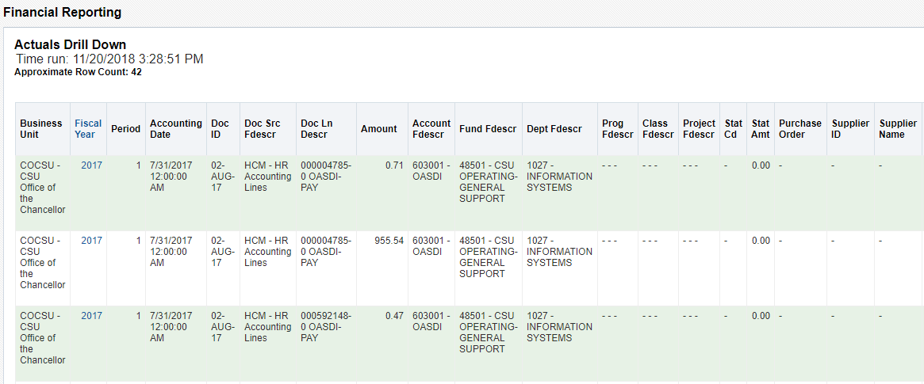
Transaction Drill Down (Partial)

Scenario: One College / One Fund
Description | This report is for one college within a single operating fund.
Report Filters | Business Unit  Fiscal Year  As of Period  Account Type = 60  Budget Ledger  Dept  Dept Tree Name
Column Selectors | Column 1: Dept Level 2 Fdescr  Column 2: Dept Level 3 Fdescr  Column 3: Dept Fdescr
Instructions | Set the report filters, apply the filters, and choose the column selectors.  Remove subtotal from Column 1 and Column 2.  Add subtotal to Column 3.

Report Views
After you have generated a report, you can choose a Report View. Each Report View contains a predefined set of columns that will appear in your report results after the column selectors.
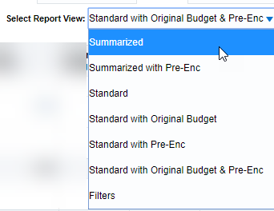
Report Views: Manage My Budget as of Period

Summarized
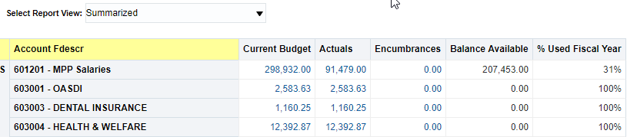
Column selectors plus:
- Current Budget
- Actuals
- Encumbrances
- Balance Available
- % Used Fiscal Year

Summarized with Pre-Enc
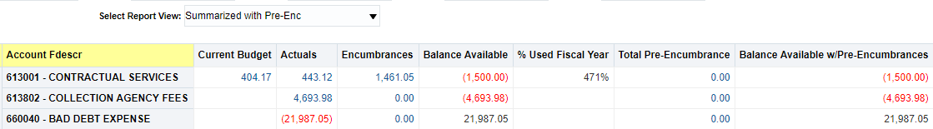
Column selectors plus:
- Current Budget
- Actuals
- Encumbrances
- Balance Available
- % Used Fiscal Year
- Total Pre-Encumbrance
- Balance Available w/Pre-Encumbrances

Standard
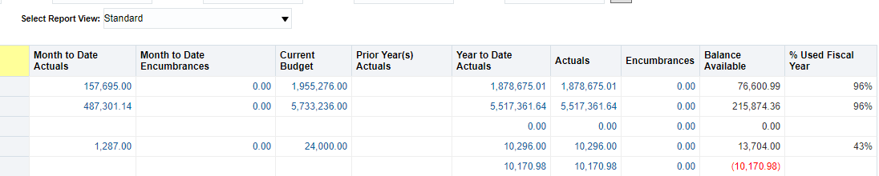
Column selectors plus:
- Month to Date Actuals
- Month to Date Encumbrances
- Current Budget
- Prior Year(s) Actuals
- Year to Date Actuals
- Actuals
- Encumbrances
- Balance Available
- % Used Fiscal Year

Standard with Original Budget
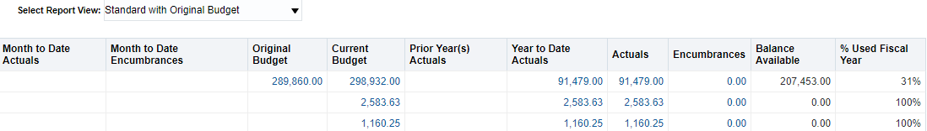
Column selectors plus:
- Month to Date Actuals
- Month to Date Encumbrances
- Original Budget
- Current Budget
- Prior Year(s) Actuals
- Year to Date Actuals
- Actuals
- Encumbrances
- Balance Available
- % Used Fiscal Year

Standard with Pre-Enc
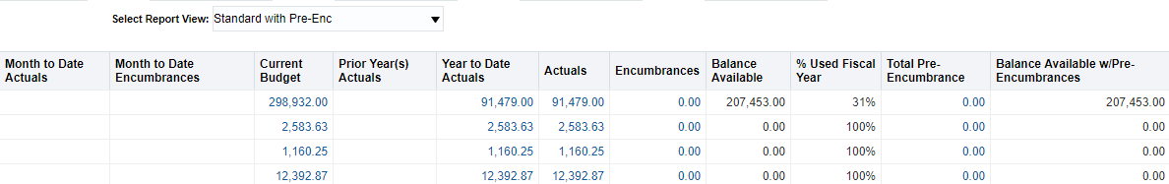
Column selectors plus:
- Month to Date Actuals
- Month to Date Encumbrances
- Current Budget
- Prior Year(s) Actuals
- Year to Date Actuals
- Actuals
- Encumbrances
- Balance Available
- % Used Fiscal Year
- Total Pre-Encumbrance
- Balance Available w/Pre-Encumbrances

Standard with Original Budget & Pre-Enc
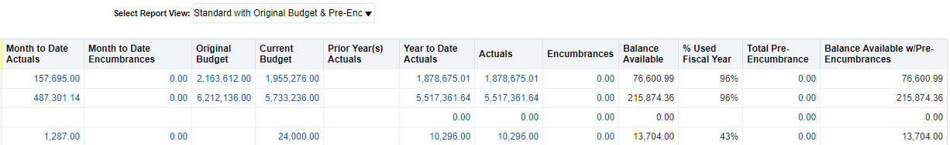
Column selectors plus:
- Month to Date Actuals
- Month to Date Encumbrances
- Original Budget
- Current Budget
- Prior Year(s) Actuals
- Year to Date Actuals
- Actuals
- Encumbrances
- Balance Available
- % Used Fiscal Year
- Total Pre-Encumbrance
- Balance Available w/Pre-Encumbrances

Summarized with Budget Detail
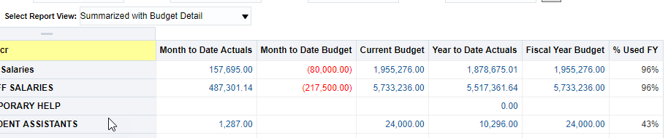
Column selectors plus:
- Month to Date Actuals
- Month to Date Budget
- Current Budget
- Year to Date Actuals
- Fiscal Year Budget
- % Used FY

Filters (Global Feature)
This view is available on all dashboard reports that contain Report Views. On drilldown reports, the report filters criteria is listed in the lower-left hand corner of the report results.

Filters View from the Report View Option
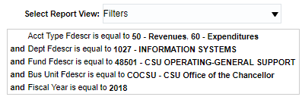

Filters View in a Drilldown
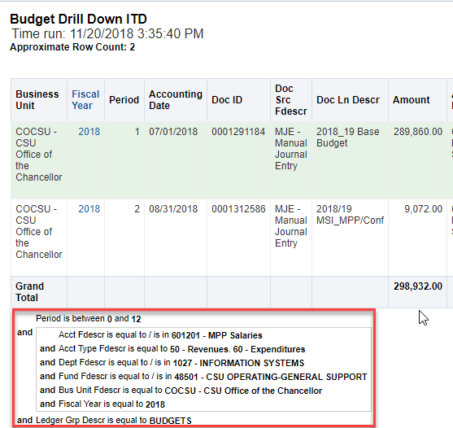

Financial Summary as of Period
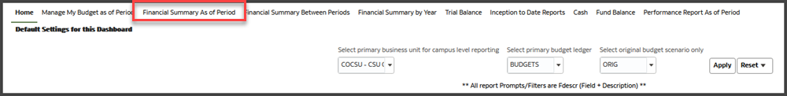
As of the period indicated in the filter, this page is designed to produce reports of budget, actuals, encumbrances, pre-encumbrances, and balance available data based on a wide number of filters which include the chartfields, state and CSU attributes, trees, and PeopleSoft chartfield attributes. These reports can be limited to any account type or all-inclusive for assets, liabilities, equity, revenue and expense. For data limited to one or a selected number of accounting periods, see Financial Summary Between Period.
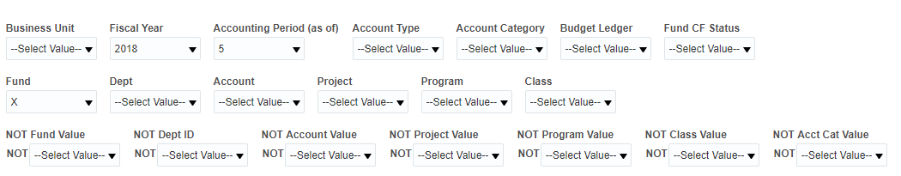
Financial Summary as of Period Report Filters

Report Features
- The Financial Summary as of Period report contains two sections for report filters: Report Filters and Advanced Filters.
- Advanced Filters include chartfield trees and tree levels, chartfield attributes, and SCO attributes. Advanced Filters are identical on any page with an Advanced Filters section.
- The Advanced Filters section can be expanded or collapsed by clicking the down arrow icon.
- Chartfield fields on the report filters [Fund, Dept, Account, Project, Program, and Class] display the Fdescr (Field + Description)
- NOT chartfield fields (Fund Value, Dept ID, Account Value, Project Value, Program Value, and Class Value) display the chartfield code only.
- The Accunt Category field displays the Fdescr and the The NOT Acct Cat Value displays the code only.
- All values entered in the Advanced Filters section are stored in any associated Saved Customization whether the Advanced Filters section is open or closed.
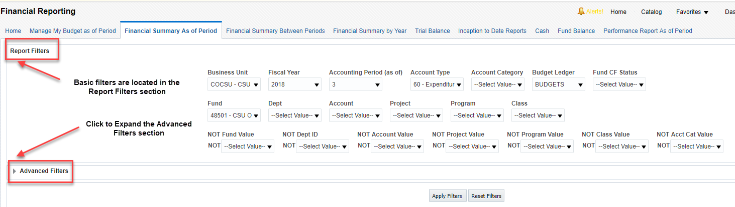
Report Filters and AdvancedFilters Section (Collapsed)

Report Examples: Financial Summary as of Period
Experiment with the scenarios listed below to produce reports for specific business requirements.

Scenario: Expenditures for One College / One Fund
Description | High level report for all expenditures within a college indicating each unique funding source  (CSU Fund Fdescr).
Report Filters | Business Unit  Fiscal Year  As of Period  Budget Ledger  Account Type = 60  Dept Tree  Dept Level 3
Column Selectors | Column 1: Fund Fdescr  Column 2: Dept Fdescr  Column 3: Acct Fdescr
Instructions | Set the report filters, apply the filters, and choose the column selectors.

Scenario: Revenue and Expense by Fund
Description | Generate a report showing revenue and expense for each of the funds.
Report Filters | Campus Business Unit  Budget Ledger  Fiscal Year  Period (as of)  Acct Type = 50, 60
Advanced Filters | Dept Tree  Dept Level 3
Column Selectors | Column 1: Fund Fdescr  Column 2: CSU Fund Descr  Column 3: Fund Fdescr  Column 4: Acct Type Fdescr
Instructions | Set the report filters and the advanced filters, apply the filters, and choose the column selectors.

Scenario: Travel Report – All Colleges within a Division
Description | Generate a report of travel for all colleges within an entire division (for example, Academic Affairs)
Report Filters | Campus Business Unit  Budget Ledger  Fiscal Year  Period (as of)  Acct Type = 50, 60
Advanced Filters | Dept Tree  Dept Level 2
Column Selectors | Column 1: Dept Level 2 Fdescr  Column 2: Dept Level 3 Fdescr  Column 3: Acct Cat Fdescr  Column 4: Acct Fdescr  Column 5: Fund Fdescr
Instructions | Set the report filters and the advanced filters, apply the filters, and choose the column selectors.

Scenario: Travel Report – All Colleges within a Division by Department
Description | Generate a report of travel for all colleges within an entire division (for example, Academic Affairs) by department
Report Filters | Campus Business Unit  Budget Ledger  Fiscal Year  Period (as of)  Acct Type = 50, 60
Advanced Filters | Dept Tree  Dept Level 2
Column Selectors | Column 1: Dept Level 2 Fdescr  Column 2: Dept Level 3 Fdescr  Column 3: Acct Cat Fdescr  Column 4: Acct Fdescr  Column 5: Dept Fdescr
Instructions | Set the report filters and the advanced filters, apply the filters, and choose the column selectors.

Scenario: Accounting Report
Description | This report is used to review the financial activity within a campus business unit by Net Asset Category and Natural Classification.
Report Filters | Campus Business Unit  Budget Ledger  Fiscal Year  Period (as of)  Acct Type = 50, 60
Advanced Filters | Dept Tree  Dept Level 2
Column Selectors | Column 1: Net Asset Cat  Column 2: CSU Fund Fdescr  Column 3: Acct Type Fdescr  Column 4: Net Class Fdescr
Instructions | Set the report filters and the advanced filters, apply the filters, and choose the column selectors.

Report Views
After you have generated a report, you can choose a Report View. Each Report View contains a predefined set of columns that will appear in your report results after the column selectors.
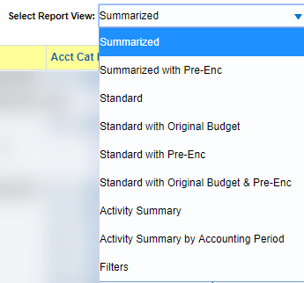
Report Views: Financial Summary as of Period

Summarized
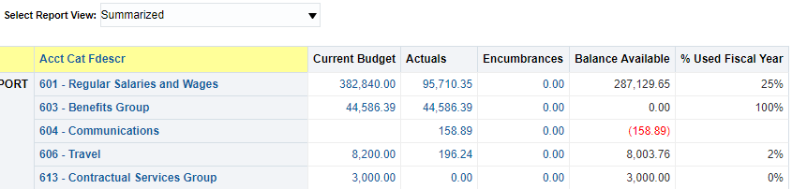
Column selectors plus:
- Current Budget
- Actuals
- Encumbrances
- Balance Available
- % Used Fiscal Year

Summarized with Pre-Enc
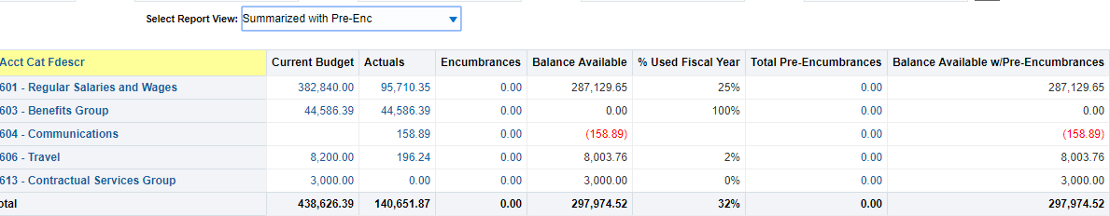
Column selectors plus:
- Current Budget
- Actuals
- Encumbrances
- Balance Available
- % Used Fiscal Year
- Total Pre-Encumbrance
- Balance Available w/Pre-Encumbrances

Standard
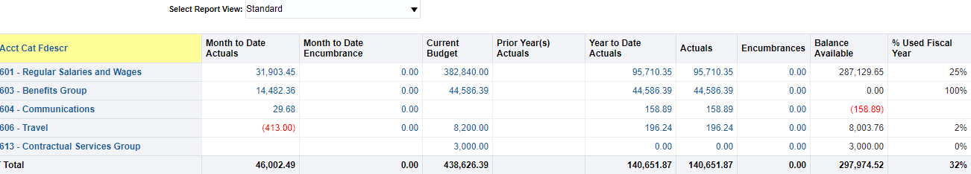
Column selectors plus:
- Month to Date Actuals
- Month to Date Encumbrance
- Current Budget
- Prior Year(s) Actuals
- Year to Date Actuals
- Actuals
- Encumbrances
- Balance Available
- % Used Fiscal Year

Standard with Original Budget
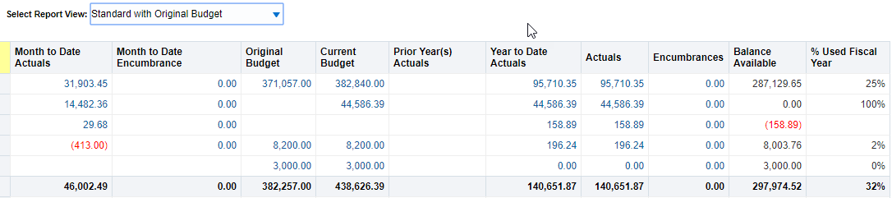
Column selectors plus:
- Month to Date Actuals
- Month to Date Encumbrance
- Original Budget
- Current Budget
- Prior Year(s) Actuals
- Year to Date Actuals
- Actuals
- Encumbrances
- Balance Available
- % Used Fiscal Year

Standard with Pre-Enc
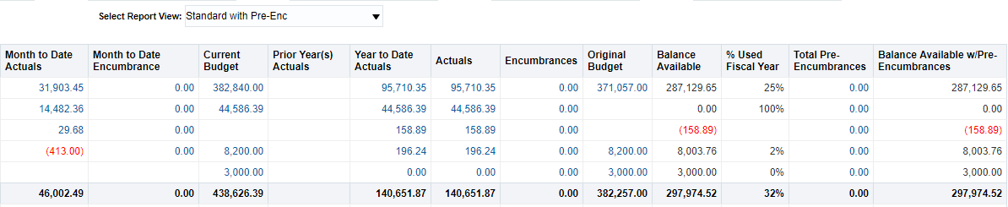
Column selectors plus:
- Month to Date Actuals
- Month to Date Encumbrance
- Current Budget
- Prior Year(s) Actuals
- Year to Date Actuals
- Actuals
- Encumbrances
- Original Budget
- Balance Available
- % Used Fiscal Year
- Total Pre-Encumbrances
- Balance Available w/Pre-Encumbrances

Standard with Original Budget & Pre-Enc
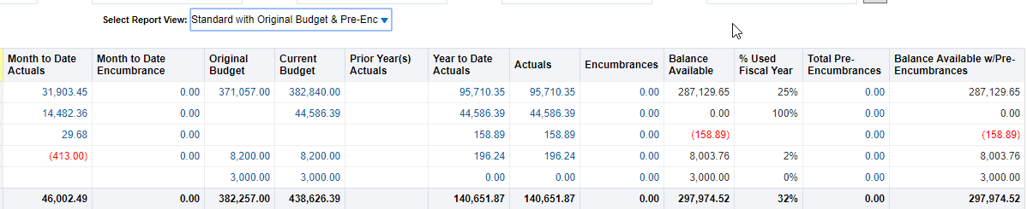
Column selectors plus:
- Month to Date Actuals
- Month to Date Encumbrance
- Original Budget
- Current Budget
- Inception to Date Actuals
- Year to Date Actuals
- Actuals
- Encumbrances
- Balance Available
- % Used Fiscal Year
- Total Pre-Encumbrances
- Balance Available w/Pre-Encumbrances

Activity Summary
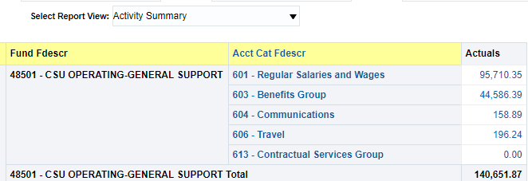
Column selectors plus:
- Actuals

Activity Summary by Accounting Period
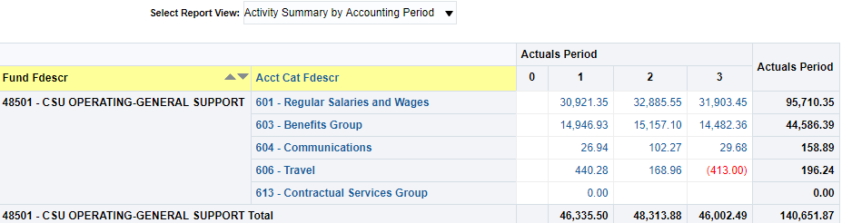
Column selectors plus:
- Actuals Period (from 0 to As of Period)
- Actuals Period (Total)

Financial Summary Between Periods
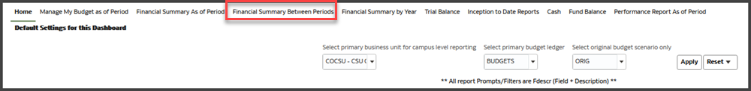
Based on the accounting periods indicated in the filter, the Financial Summary Between Period report is designed to produce reports of budget, actuals, encumbrances, pre-encumbrances, and balance available data based on a broad range of filters which include the chartfields, state and CSU attributes, trees, and PeopleSoft chartfield attributes.
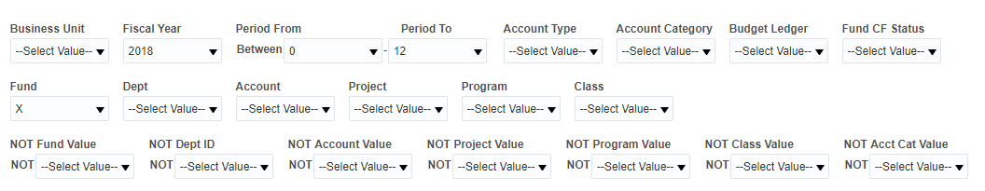
Financial Summary Between Period Report Filters
Report Features
- The Financial Summary Between Periods report has two filters sections: Report Filters and Advanced Filters. Set search criteria used to generate report results.
- Chartfield fields on the report filters [Fund, Dept, Account, Project, Program, and Class] display the Fdescr (Field + Description)
- NOT chartfield fields (Fund Value, Dept ID, Account Value, Project Value, Program Value, and Class Value) display the chartfield code only.
- The Accunt Category field displays the Fdescr and the The NOT Acct Cat Value displays the code only.

Report Examples: Financial Summary Between Periods
Experiment with the scenarios listed below to produce reports for specific business requirements.

Scenario: Third Quarter Accounts Payable
Description | Generate a report that indicates accounts payable activity by fund for the third quarter.
Report Filters | Business Unit  Fiscal Year  Budget Ledger  Period From = 7  Period To = 9  Account Type = 50, 60  Budget Ledger
Advanced Filters | FIRMS Object = 201001
Column Selectors | Column 1: FIRMS Obj Cd Fdescr  Column 2: Acct Fdescr  Column 3: Fund Fdescr
Report Views | Activity Summary by Period
Instructions | Set the report filters and the advanced filters, apply the filters, and choose the column selectors.

Report Views
After you have generated a report, you can choose a Report View. Each Report View contains a predefined set of columns that will appear in your report results after the column selectors.
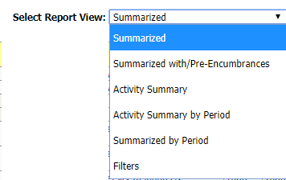
Report Views: Financial Summary Between Periods

Summarized
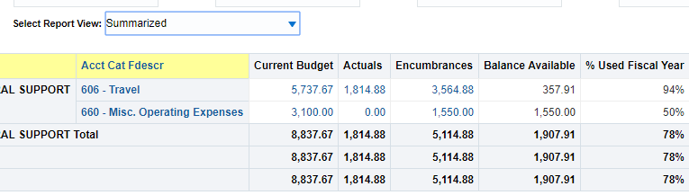
Column selectors plus:
- Current Budget
- Actuals
- Encumbrances
- Balance Available
- % Used Fiscal Year

Summarized with Pre-Encumbrances
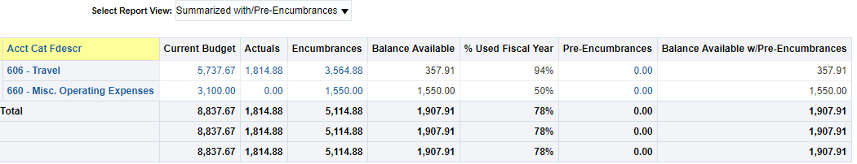
Column selectors plus:
- Current Budget
- Actuals
- Encumbrances
- Balance Available
- % Used Fiscal Year
- Pre-Encumbrances
- Balance Available w/Pre-Encumbrances

Activity Summary
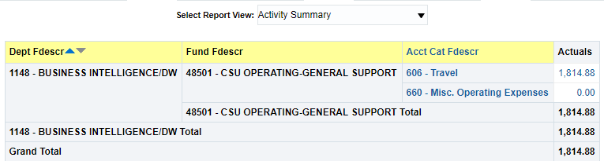
Column selectors plus:
- Actuals

Activity Summary by Period
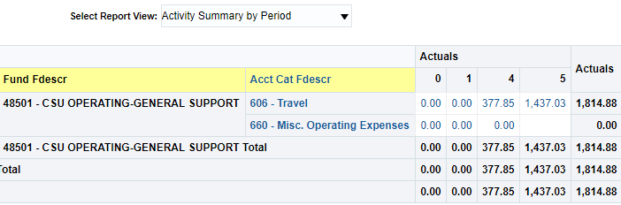
Column selectors plus:
- Actuals (by Period From through Period To)
- Actuals (Total)

Summarized by Period
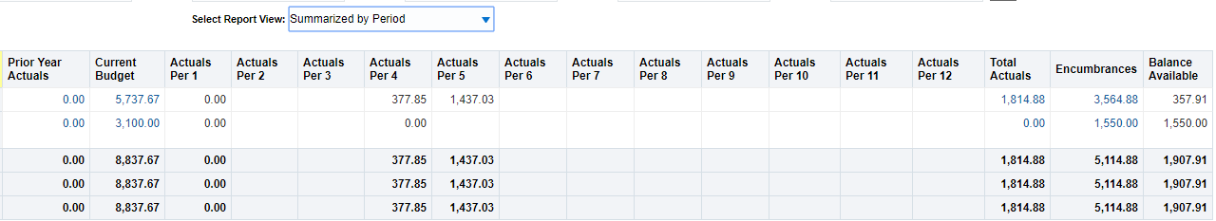
Column selectors plus:
- Prior Year Actuals
- Current Budget
- Actuals
Note: A column for each of the 12 periods will display. However, data will only display in those columns in which Actuals data exists.
- Total Actuals
- Encumbrances
- Balance Available

Financial Summary by Year
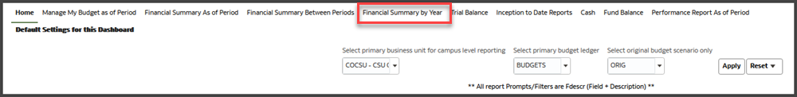
Based on the year and accounting period indicated in the filter, this page is designed to produce reports of budget or actuals based on a wide number of filters which include the chartfields, state and CSU attributes, trees, and PeopleSoft chartfield attributes. These reports can be limited to any account type or all-inclusive for assets, liabilities, equity, revenue and expense. The Financial Summary by Year page is helpful when looking at trends and for variance analysis. The Performance report can also be used for this purpose.
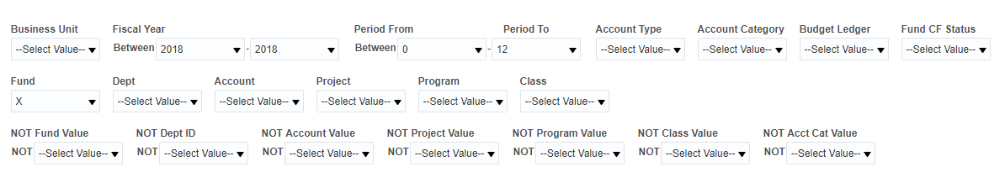
Financial Summary by Year Report Filters
Report Features
- The Financial Summary as of Period report two section for report filters: Report Filters and Advanced Filters.
- Chartfield fields on the report filters [Fund, Dept, Account, Project, Program, and Class] display the Fdescr (Field + Description)
- NOT chartfield fields (Fund Value, Dept ID, Account Value, Project Value, Program Value, and Class Value) display the chartfield code only.
- The Accunt Category field displays the Fdescr and the The NOT Acct Cat Value displays the code only.

Report Examples: Financial Summary by Year
Experiment with the scenarios listed below to produce reports for specific business requirements.

Scenario: Spending Trend Analysis for Colleges within a Division
Description | Spending summary / trend analysis that looks at expenditures over time for the colleges with the Academic Affairs division.
Report Filters | Business Unit  Campus Operating Fund  Fiscal Year Between (Start) = 2010  Fiscal Year Between (End) = 2015  Period From = 0  Period To = 12  Account Type = 60
Advanced Filters | Dept Tree (valid value)  Dept Level 2 (valid value)
Column Selectors | Column 1: Dept Level 2 Fdescr  Column 2: Dept Level 3 Fdescr  Column 3: Acct Cat Fdescr
Instructions | Set the report filters and the advanced filters, apply the filters, and choose the column selectors.

Report Views
After you have generated a report, you can choose a Report View. Each Report View contains a predefined set of columns that will appear in your report results after the column selectors.
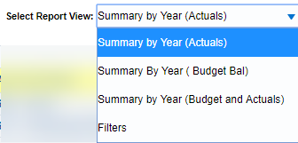
Report Views: Financial Summary by Year

Summary by Year (Actuals)
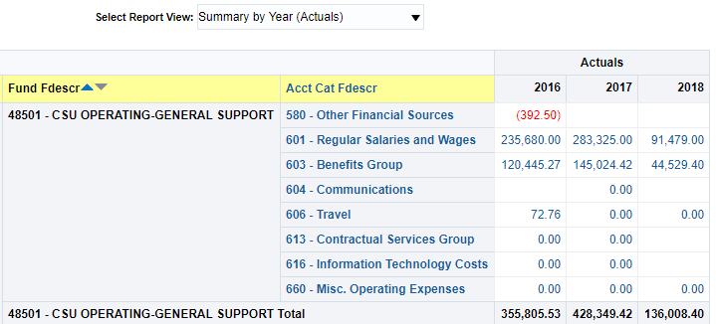
Column selectors plus:
- Actuals (by all years in Fiscal Year to Fiscal Year)

Summary by Year (Budget Bal)
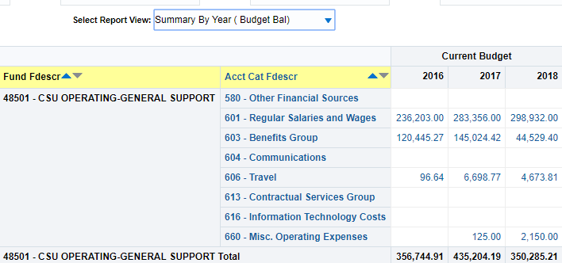
Column selectors plus:
- Current Budgets (by all years in Fiscal Year to Fiscal Year)

Summary by Year (Budget and Actuals)
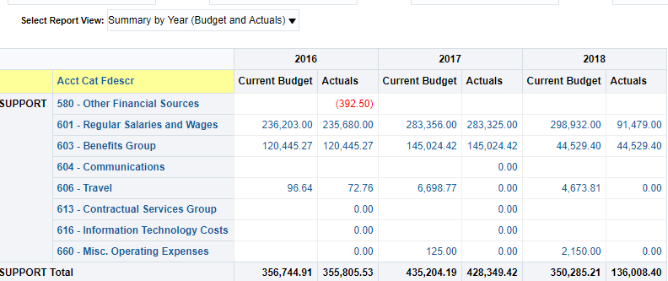
Column selectors plus:
- Current Budget (for all years in Fiscal Year report filter range)
- Actuals (for all years in Fiscal Year report filter range)

Trial Balance > Actuals Trial Balance
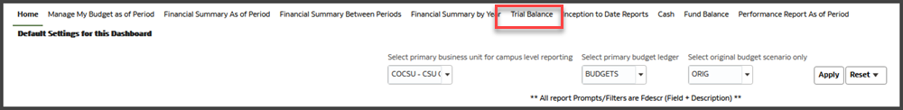
Trial Balance reports run at a fund level to give a full picture of the fund, including all balance sheet and income statement accounts. The Trial Balance page contains two reports:
- Actuals Trial Balance
- Trial Balance (6 Columns)
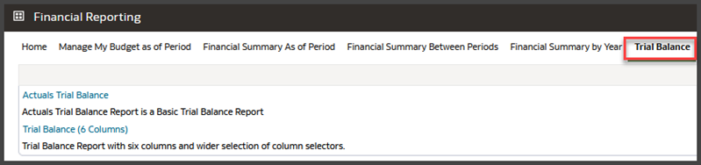
Two Trial Balance Reports on the Trial Balance Page
Report Features
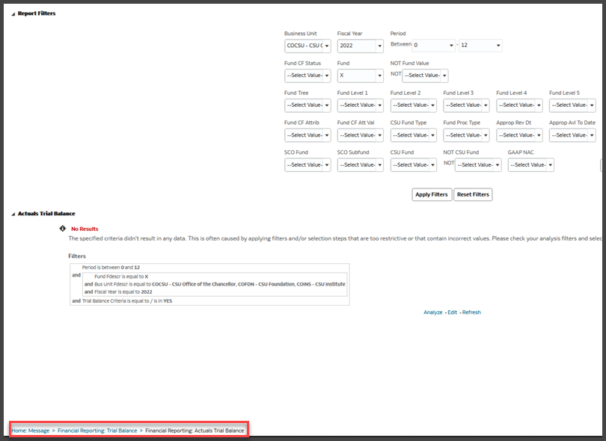
Each Trial Balance Report will Appear on its own Page when Selected
The Actuals Trial Balance report displays balance sheet (trial balance) summary totals only. This report can be used to review the fiscal solvency of either a PS Fund or a CSU Fund. The report contains information such as cash balances, accounts receivable, equity, etc. All summary totals can be drilled on to obtain transaction details.
- The Actuals Trial Balance report contains one section for report filters.
- The Report Filters contains a Period Between range.
- Chartfield fields on the report filters [Fund, Dept, Account, Project, Program, and Class] display the Fdescr (Field + Description)
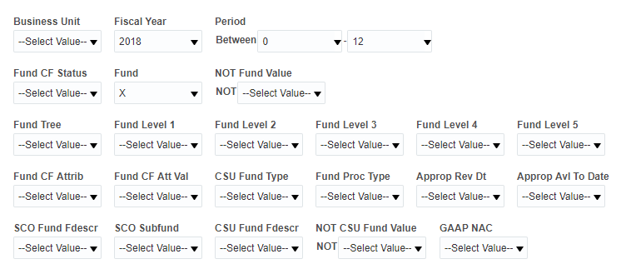
Actuals Trial Balance Report Filters Defaults to Current Fical Year Between Periods 0 and 12

Report Examples: Actuals Trial Balance
Experiment with the scenarios listed below to produce reports for specific business requirements.

Scenario: Actuals Trial Balance
Description | Spending summary / trend analysis that looks at expenditures over time for the colleges with the Academic Affairs division.
Report Filters | Business Unit  Fiscal Year = 2015  Period Between (Start) = 0  Period Between (End) = 12  CSU Fund Fdescr = 485 – TF-Miscellaneous
Column Selectors | Column 1: Acct Type Fdescr
Instructions | Set the report filters, apply the filters, and choose the column selectors.  Try all the Column Selectors and all the Report Views for a different view of the results.

Actuals Trial Balance Column Selector Values
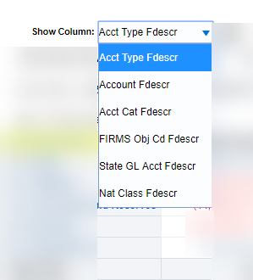
Column Selector Option
There are six choices available for display in the one column selector available in the Actuals Trial Balance Report. Choose one to display values for that field in the user-defined column.
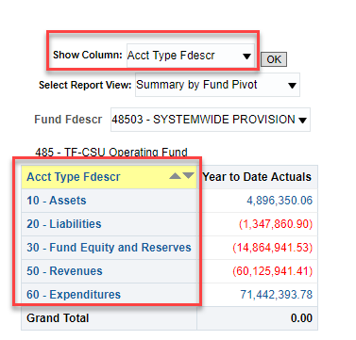
Available Column Selector Choices

Report Views
After you have generated a report, you can choose a Report View. Each Report View contains a predefined set of columns that will appear in your report results after the column selectors.
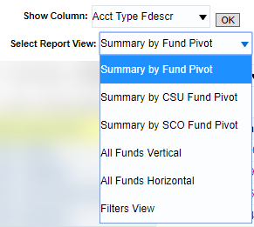
Report Views: Actuals Trial Balance

Summary by Fund Pivot
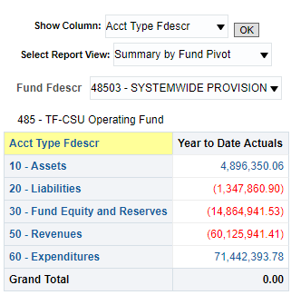
Column selector plus:
- Year to Date Actuals

Summary by CSU Fund Pivot
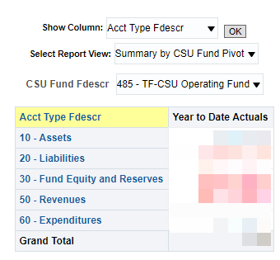
Column selector plus:
- Year to Date Actuals
Shows a trial balance at the CSU Fund level which equates to FIRMS and the SAM7 report.

Summary by SCO Fund Pivot
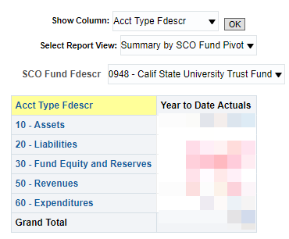
Column selector plus:
- Year to Date Actuals

All Funds Vertical
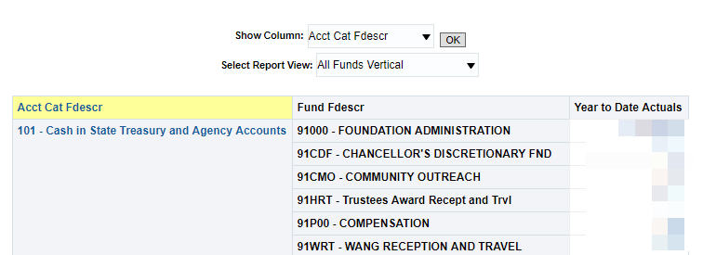
Column selector plus:
- Fund Fdescr
- Year to Date Actuals

All Funds Horizontal
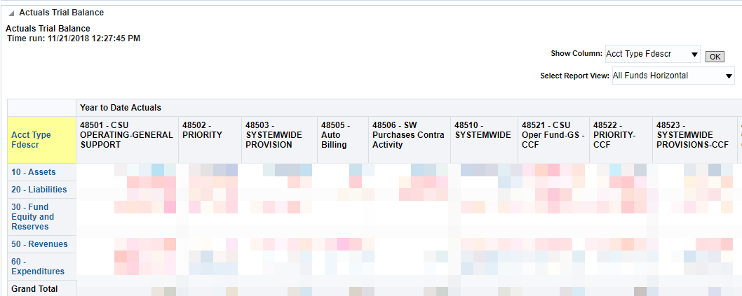
Column selector plus:
- Year to Date Actuals (with all funds displayed horizontally)

Multi-Tiered Reports
Reports on the Actuals Trial Balance page contain “multi-tiered” reports. When you drill on a hyperlinked numeric value from with the Actuals Trial Balance Summary results, a second report tier will appear.
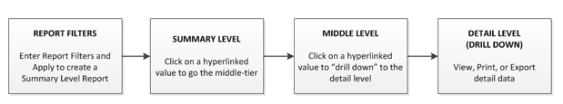

Revenue and Expense Summary by Period – Actuals Trial Balance
This report has two column selectors. It displays Actuals by period for the period range defined in the Actuals Trial Balance page filters.
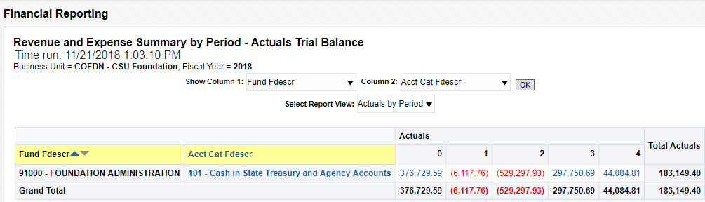
Revenue and Expense Summary by Period – Actuals Trial Balance
- Drill on any hyperlinked number to drill down to the Trial Balance MTD Actuals Drill Down report.
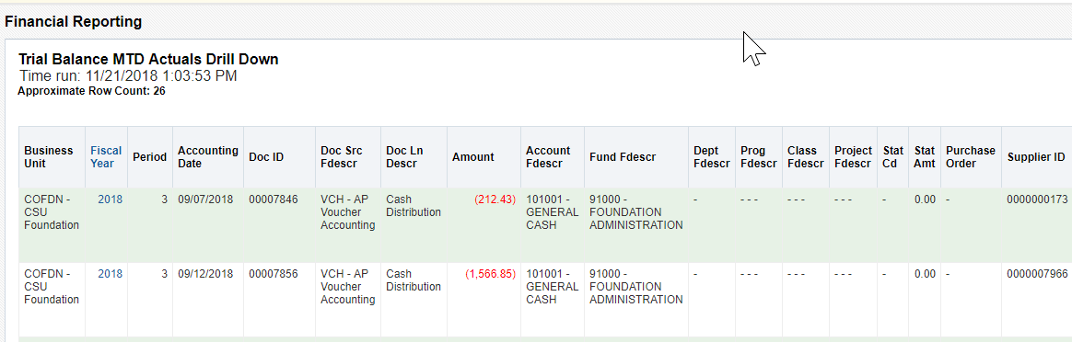
Trial Balance MTD Actuals Drill Down (Partial)

Trial Balance (6 Columns)
From the Trial Balance tab / page, click on the Trial Balance (6 Columns) link to activate the report. The report will appear on its own page / tab next to the parent dashboard page.
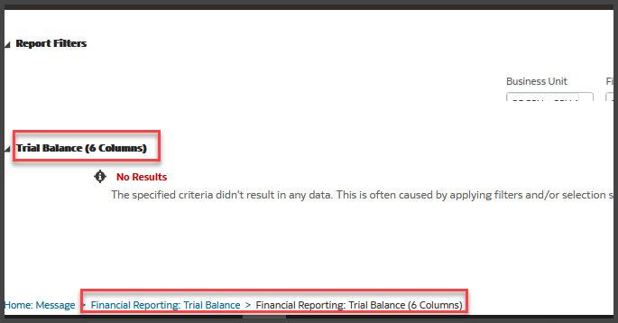
The Trial Balance report contains six column selectors for configuring report results.
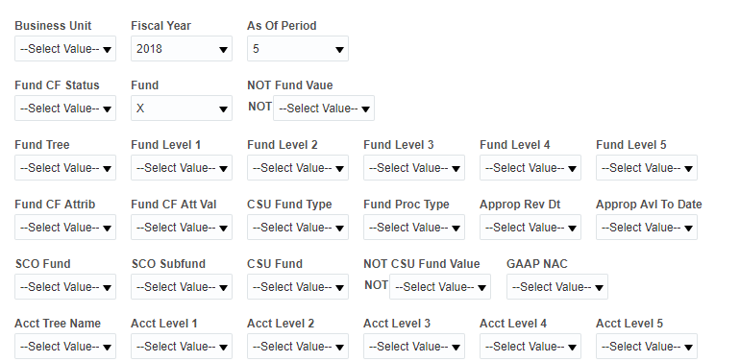
Trial Balance (6 Columns) Report Filters Defaults

Report Features
- The Trial Balance report contains one section for report filters.
- The Report Filters section contains a Period as of filter.
- The Report Filters include Acct Tree and Acct tree levels
- The report results return 100 rows at a time

Report Examples
Experiment with the scenario listed below to produce a report for specific business requirements.
Scenario: Trial Balance
Description | Trial Balance
Report Filters | Campus Business Unit  Fiscal Year = 2015  Period as of = 3  CSU Fund = 485
Column Selectors | Column 1: CSU Fund Fdescr  Column 2: Dept Fdescr  Column 3: Acct Cat Fdescr  Column 4: Acct Fdescr
Instructions | Set the report filters, apply the filters, and choose the column selectors.

Report Views
After you have generated a report, you can choose a Report View. Each Report View contains a predefined set of columns that will appear in your report results after the column selectors.
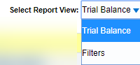
Report Views: Trial Balance (6 Columns)
Trial Balance
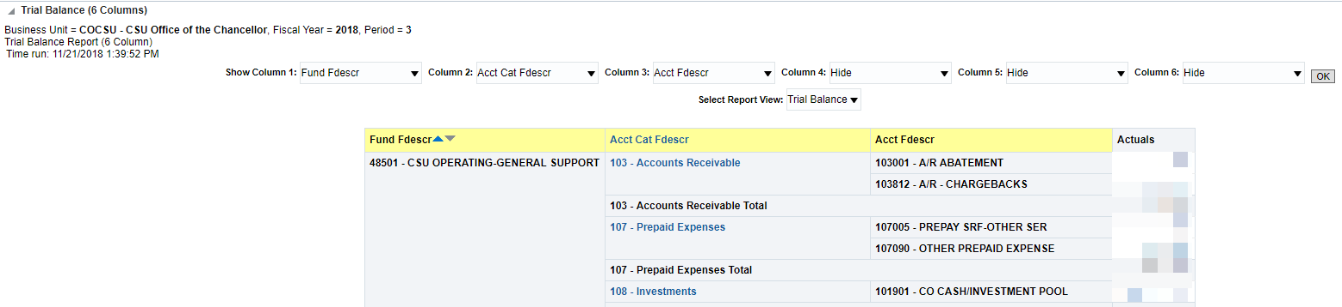
Column selectors plus:
- Actuals

Inception to Date Reports
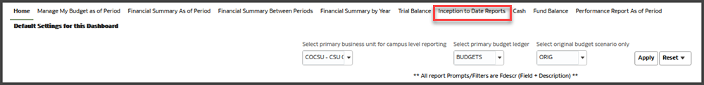
The Inception to Date Reports display actuals and encumbrance summary totals based on a wide number of filters from a project-to-date perspective by year. Each year’s summary amount can be drilled directly to the transactions for that year.
The Inception to Date Reports page contains two reports:
- Inception to Date
- Inception to Date with Period Prompt
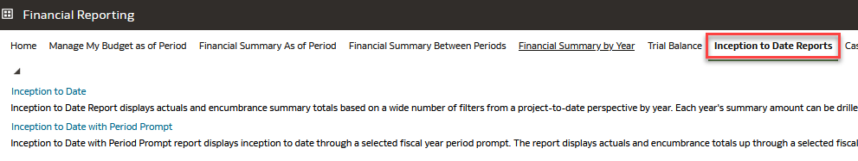
Inception to Date Page / Tab Contains Two Reports
When you click on one of the Inception to Date Reports hyperlinks, the selected report will appear on its own page / tab next to the parent dashboard page:
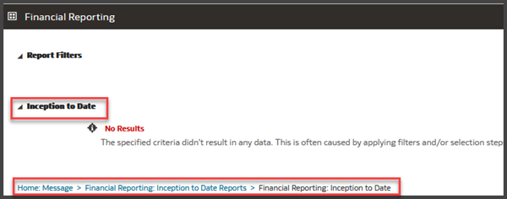
Each Trial Balance Report will Appear on its own Page when Selected

Inception to Date
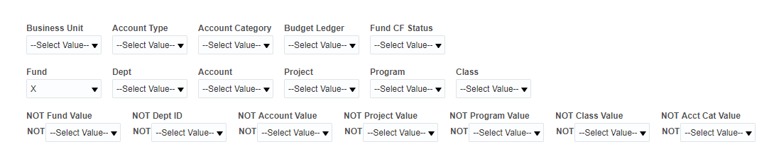
Inception to Date Report Filters
Report Features
- The Inception to Date report contains two sections for report filters: Report Filters and Advanced Filters.
- Use this report to see total project costs by year by fund.

Report Examples
Experiment with the scenario listed below to produce a report for specific business requirements.
Scenario: Report by Year by Fund for an Entire Project
Description | Report by Year by Fund for an Entire Project
Report Filters | Campus Business Unit  Budget Ledger  Project = Valid Project Number
Column Selectors | Column 1: Project Fdescr  Column 2: Fund Fdescr  Column 3: Acct Cat Fdescr  Column 4: Acct Fdescr
Instructions | Set the report filters, apply the filters, and choose the column selectors.

Report Views
After you have generated a report, you can choose a Report View. Each Report View contains a predefined set of columns that will appear in your report results after the column selectors.
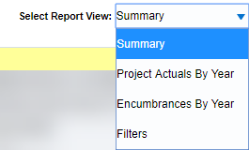
Report Views: Inception to Date

Summary
Column selectors plus:
- Inception to Date Actuals
- Inception to Date Encumbrances
- Summary
- Inception to Date Pre-Encumbrances
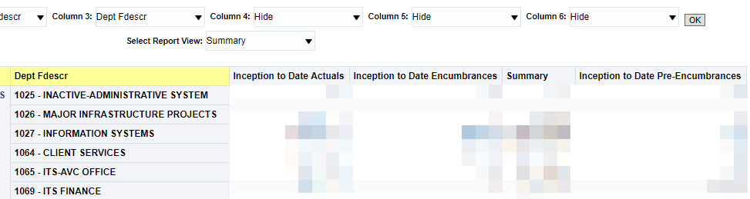

Project Actuals by Year
Column selectors plus:
- Inception to Date Actuals
(by all years)
- Inception to Date Actuals Total
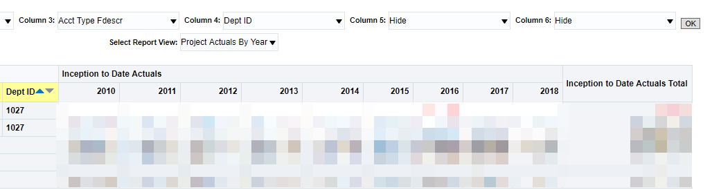

Encumbrances by Year
Column selectors plus:
- Inception to Date Encumbrances
(by all years)
- Inception to Date Encumbrances Total
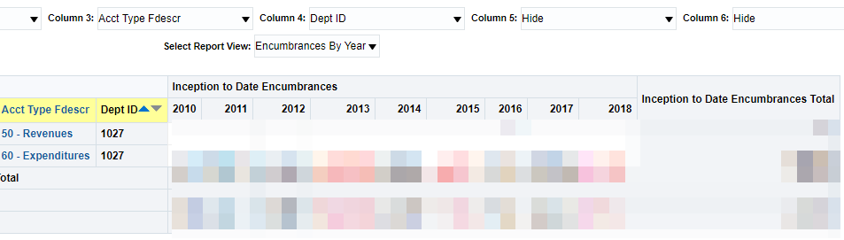

Inception to Date with Period Prompt
The Inception to Date with Period Prompt report users to run the report with an end date. The report contains a concatenated filter that combines fiscal year and period into one value:
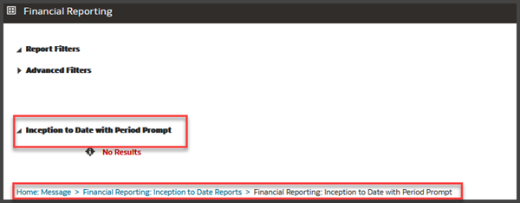
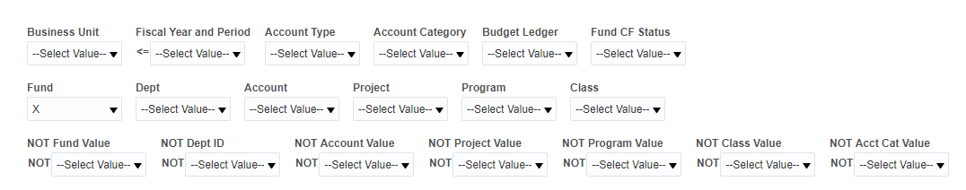
Inception to Date with Period Prompt Report Filters
Report Features
- The Inception to Date report contains two sections for report filters: Report Filters and Advanced Filters.
- Use this report to see total project costs by year by fund by period
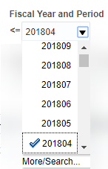
Fiscal Year and Period are Concatenated

Report Example
Experiment with the scenario listed below to produce a report for specific business requirements.
Scenario: Scenario: Report by Year by Fund for an Entire Project
Description | Report by Year by Fund for an Entire Project
Report Filters | Campus Business Unit  Fiscal Year and Period  Budget Ledger  Project = Valid Project Number
Column Selectors | Column 1: Project Fdescr  Column 2: Fund Fdescr  Column 3: Acct Cat Fdescr  Column 4: Acct Fdescr
Instructions | Set the report filters, apply the filters, and choose the column selectors.

Report Views
The Report Views are identical to the Report Views in the Inception to Date Report.
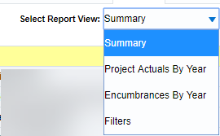
Report Views: Inception to Datewith Period Prompt

Cash
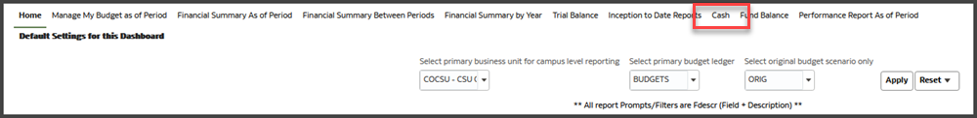
The purpose of this report is to monitor cash balances. Used for analysis in determining if a negative cash balance exists in specified SCO, CSU, or PeopleSoft fund(s). The Cash report includes all cash and fund balance clearing accounts. The purpose of the Cash report is to monitor that each Trust Fund maintains a positive cash balance as required by SUAM 3710.1.
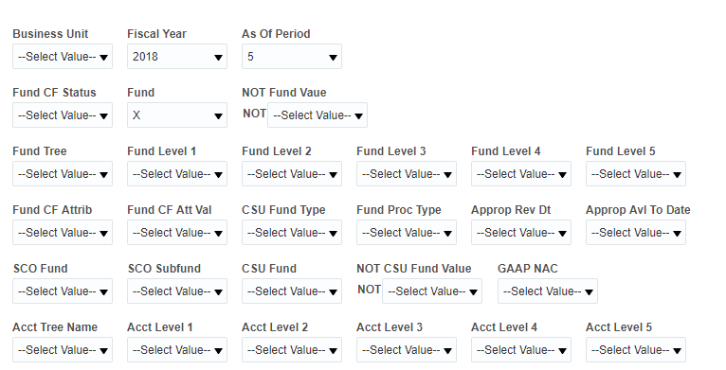
Cash Report Filters

Report Features
- The Trial Balance report contains one section for report filters.

Report Examples: Cash
Experiment with the scenario listed below to produce a report for specific business requirements.
Scenario: Cash
Description | Cash Report
Report Filters | Campus Business Unit  Fiscal Year  Period (as of) = 12  SCO Fund = 0948
Column Selectors | Column 1: Fiscal Year  Column 2: SCO Fund Fdescr  Column 3: CSU Fund Fdescr
Instructions | Set the report filters, apply the filters, and choose the column selectors.

Report Views
After you have generated a report, you can choose a Report View. Each Report View contains a predefined set of columns that will appear in your report results after the column selectors.
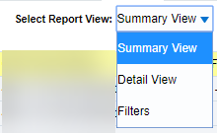
Report Views: Cash
Summary View
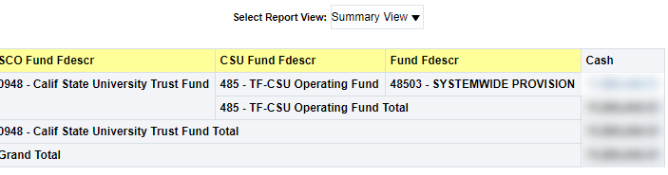
Column selectors plus:
- Cash

Detail View
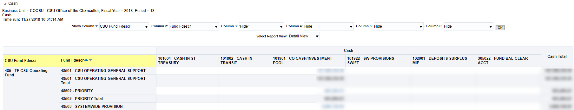
Column selectors plus:
- 101001 – GENERAL CASH
- 101004 – CASH IN TRANSIT
- 101802 – CASH IN TRANSIT
- 101850 – CASH IN BANK CHILE
- 101851 – CASH IN BANK CHINA
- 101852 – CASH IN BANK FRANCE
- 101853 – CASH IN BANK GERMANY
- 101855 – CASH IN BANK ITALY
- 101856 – CASH IN BANK JAPAN
- 101858 – CASH IN BANK SPAIN
- 101859 – CASH IN BANK GHANA
- 101901 – CO CASH/INVESTMENT POOL
- 101917 – SW CLEARING-INVESTMENT POOL
- 101922 – SW PROVISIONS – SWIFT
- 102001 – DEPOSITS SURPLUS MIF
- 305022 – FUN BAL-CLEAR ACCT

NOTE: The above column(s) will appear in report results only if associated data exist.

Fund Balance
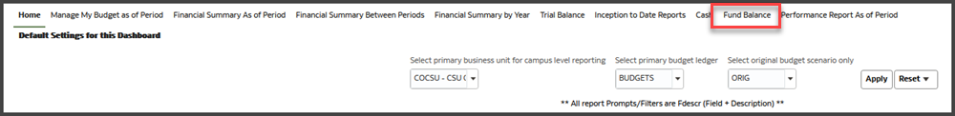
Based on the period indicated in the report filter, the Fund Balance report results include the beginning fund balance, year-to-date revenue, year-to-date expense, and projects current fund balance based on a broad range of filters. This report can also be used to monitor negative fund balance. The Fund Balance page is designed to pull in whatever SCO, CSU, or PeopleSoft fund is chosen to help determine if a negative cash balance exists.
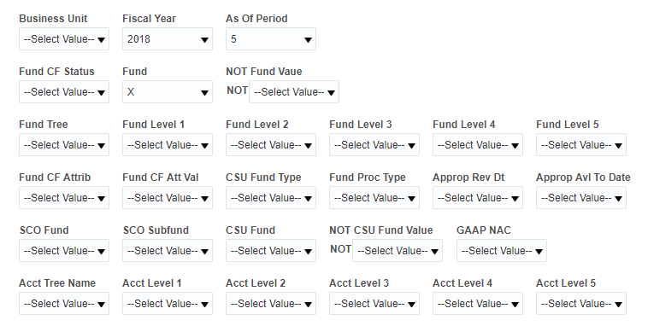
Fund Balance Report Filters

Features
- The Fund Balance report contains one section for report filters.
- The Fund Balance report is the only place to see a projected fund balance.
- Use the Fund Balance report to monitor that each Trust Fund maintains a positive fund balance as required by SUAM 3710.1.
- The Fund Balance report contains the following logic:

Report Examples: Fund Balance
Experiment with the scenario listed below to produce a report for specific business requirements.
Scenario: Projected Fund Balance
Description | Generate a report of a projected fund balance
Report Filters | Campus Business Unit  Fiscal Year  Period (as of) = 12  SCO Fund = 0948
Column Selectors | Column 1: SCO Fdescr  Column 2: CSU Fund Fdescr
Instructions | Set the report filters, apply the filters, and choose the column selectors.  Remove subtotal from Column 2

Report Views
After you have generated a report, you can choose a Report View. Each Report View contains a predefined set of columns that will appear in your report results after the column selectors.

Report Views: Fund Balance

Summary View
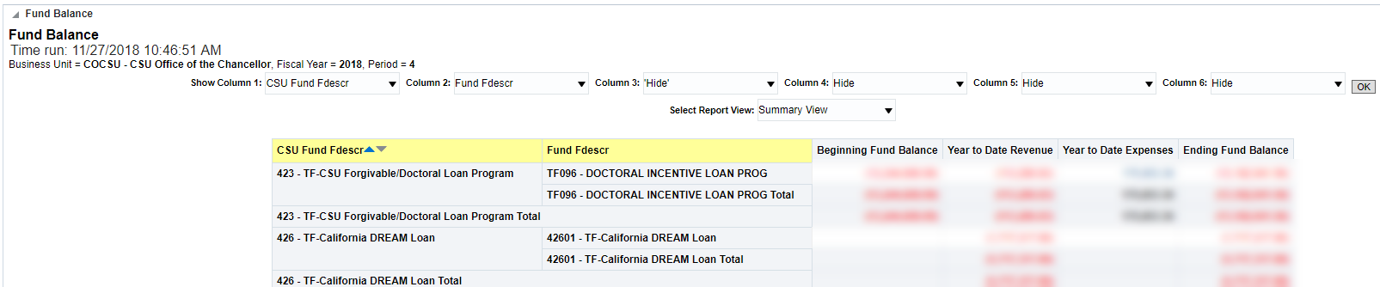
Column selectors plus:
- Beginning Fund Balance
- Year to Date Revenue
- Year to Date Expenses
- Ending Fund Balance

Encumbrance View
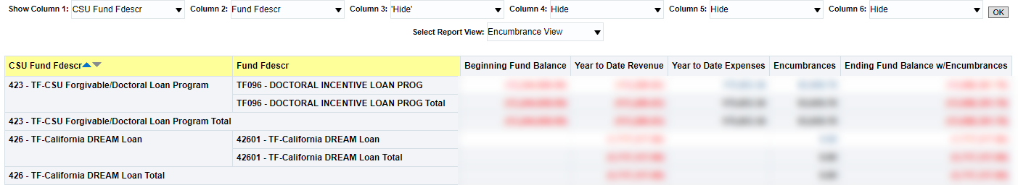
Column selectors plus:
- Beginning Fund Balance
- Year to Date Revenue
- Year to Date Expenses
- Encumbrances
- Ending Fund Balance w/Encumbrances

Restated Fund Balance
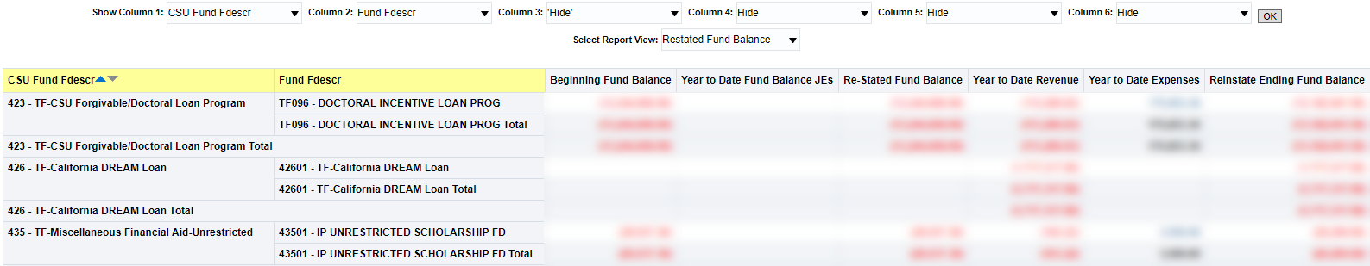
Column selectors plus:
- Beginning Fund Balance
- Year to Date Fund Balance JEs
- Re-Stated Fund Balance
- Year to Date Revenue
- Year to Date Expenses
- Reinstate Ending Fund Balance

Restated w/Encumbrances
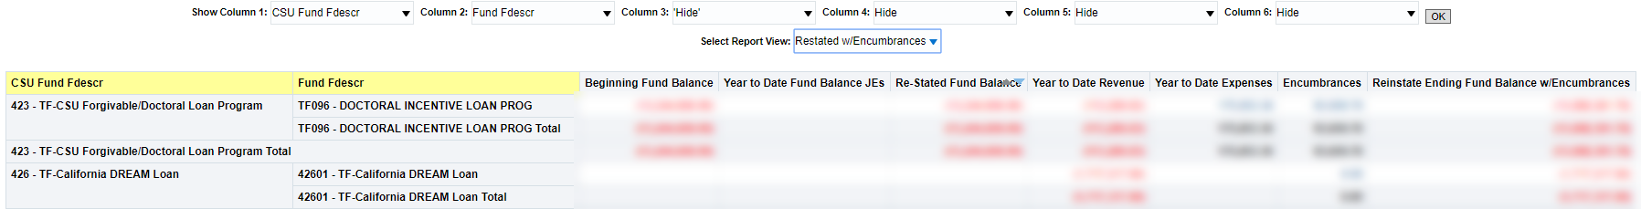
Column selectors plus:
- Beginning Fund Balance
- Year to Date Fund Balance JEs
- Re-Stated Fund Balance
- Year to Date Revenue
- Year to Date Expenses
- Encumbrances
- Reinstate Ending Fund Balance w/Encumbrances

Performance Report as of Period
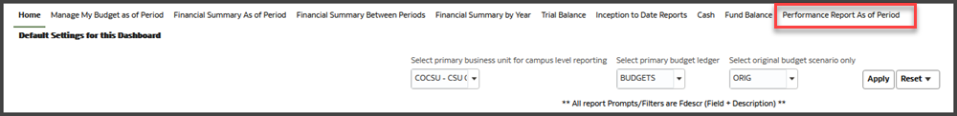
The Performance Report as of Period report displays financial data by comparing results and calculating percentages from the prior year to the year selected in the report filters. Through report views both budget and actuals data can be analyzed with this report. To ensure that the data is comparative the as of period from this year is applied to the prior year data.
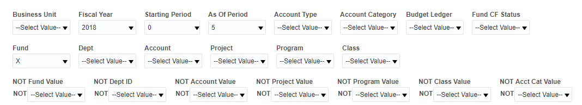
Performance Report as of Period Report Filters

Report Features
- The Performance Report as of Period report contains two sections for report filters: Report Filters and Advanced Filters.
- Chartfield fields on the report filters [Fund, Dept, Account, Project, Program, and Class] display the Fdescr (Field + Description)
- NOT chartfield fields (Fund Value, Dept ID, Account Value, Project Value, Program Value, and Class Value) display the chartfield code only.
- The Accunt Category field displays the Fdescr and the The NOT Acct Cat Value displays the code only.
- The Performance Report is used to compare current year to prior year data by month and YTD balances. The Performance Report is the only report with this capability in the CFS DW.

Starting Period Filter
The ‘Starting Period’ indicates whether or not you want to include period zero transactions. For example, for capital project funds period zero holds the prior year activity and is used to determine how the multi- year project is performing related to budget.
- Select Starting Period = 0 for all Balance Sheet reports
- Select Starting Period = 1 for Income statement reports to see only current year data.
- Select per 0 for reports that will combine both types of Accounts.

Report Examples: Performance Report
Experiment with the scenario listed below to produce a report for specific business requirements.

Scenario: Performance Report
Description | Performance report for one department
Report Filters | Campus Business Unit  Fiscal Year = Valid value  Period (as of) = Valid value  Department = Valid value
Column Selectors | Column 1: Fund Fdescr  Column 2: Account Cat Fdescr  Column 3: Account Fdescr
Instructions | Set the report filters, apply the filters, and choose the column selectors.

Report Views
After you have generated a report, you can choose a Report View. Each Report View contains a predefined set of columns that will appear in your report results after the column selectors.
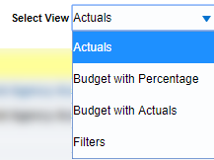
Report Views: Performance Report as of Period

Actuals
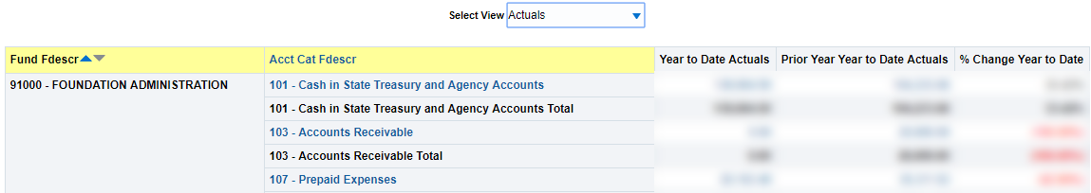
Column selectors plus:
- Year to Date Actuals
- Prior Year Year to Date Actuals
- % Change Year to Date

Budget with Percentage
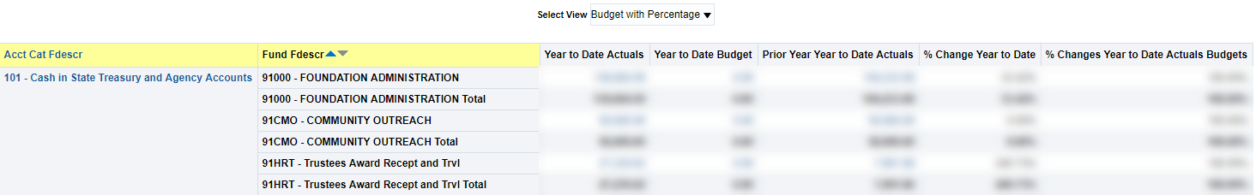
Column selectors plus:
- Year to Date Actuals
- Year to Date Budget
- Prior Year Year to Date Actuals
- % Change Year to Date
- % Changes Year to Date Actuals Budgets

Budget with Actuals
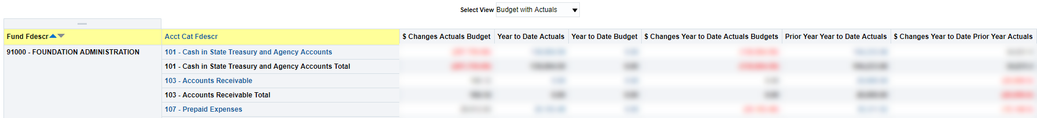
Column selectors plus:
- $ Changes Actuals Budget
- Year to Date Actuals
- Year to Date Budget
- $ Changes Year to Date Actuals Budgets
- Prior Year Year to Date Actuals
- $ Changes Year to Date Prior Year Actuals
For More Information
Additional CFS Data Warehouse documentation can be found at:
https://csyou.calstate.edu/Divisions-Orgs/bus-fin/it/BI-DW/CFSDW/Pages/BI-DW-User-Documentation.aspx
For further information on the features covered in this Guide or other CFS Data Warehouse issues, please open a ServiceNow request or contact: FDW-SUPPORT@LISTS.CALSTATE.EDU,
* * *

Appendix A – Data Warehouse Glossary
Fields: Dashboards – Home Page
FIELD | DESCRIPTION | EXPLANATION / EXAMPLE
Primary business unit for campus level reporting | The business unit for the PeopleSoft GL Application | COCSU or COFDN or COGAP
Primary budget ledger | The campus budget ledger. | Budget
Original budget scenario | Name of original budget scenario | This filter is used to determine what gets summarized (scenario’s) in the original budget column on various reports.  Leave Blank (includes all scenarios).

Fields: Report Filters, Columns, Drill Downs
FIELD | DEFINITION
% Used | Percent Used. Percent of the budget that has been used
% Used Fiscal Year | Percent Used Fiscal Year. Percent of the budget that has been used for the fiscal year. Budget – Actuals - Encumbrances
Approp Rev Dt | Appropriation Reversion Date. Used for SW and State Reporting.
Approp Avl To | Appropriation Available To Date. Used for SW and State Reporting.
Account | Column Selector: Account chartfield value where the payroll was posted to the GL  Filter: Account value and full description
Acct Fdescr | The Account value and full description.
Acct Cat | Account Category value. Summarizes Account Chartfields into higher level categories.
Acct Cat Fdescr | Account Category Value and Description. Summarizes Account Chartfields into higher level categories with description.
Acct Type | Account Type Value. Summarizes Account Chartfields into a higher level type.
Acct Type Fdescr | Account Type value and full description. Summarizes Account Chartfields into a higher level type with description.
Acct CF Att Type | Account Chartfield Attribute Type.
Acct CF Atta Val | Account Chartfield Attribute Value.
Acct CF Att Val Descr | Account Chartfield Attribute Value and Description.
Acct CF Att Val Fdescr | Account Chartfield Attribute Value and full description.
Acct CF Att Val Fld Name | Account Chartfield Attribute Value Field Name.
Account Tree  (Advanced Filter)  Acct Tree Name  (Column Selector) | Account Tree Name.
Acct Level 1  (Acct Level 1 Fdescr) | Account Level 1 value and full description.
Acct Level 2  (Acct Level 2 Fdescr) | Account Level 2 value and full description.
Acct Level 3  (Acct Level 3 Fdescr) | Account Level 3 value and full description.
Acct Level 4  (Acct Level 4 Fdescr) | Account Level 4 value and full description.
Acct Level 5  (Acct Level 5 Fdescr) | Account Level 5 value and full description.
Acct Date  (Accounting Date) | The Accounting Date of the financial transaction. Ie: Req, PO, Voucher or Journal.
Actuals | Amount of actuals recorded.
Balance Available | Budget – Actuals – Encumbrances.
Balance Available w/Pre-Enc | Budget – Actuals – Encumbrances – PreEncumbrances.
Current Budget | Total Budget Amount.
Bus Unit | Business Unit
Bus Unit Fdescr | Business Unit value and full description.
Class  (Advanced Filter)  Class  (Column Selector) | Class value and full description
Class CF Att Type | Class Chartfield Attribute Type.
Class CF Att Val | Class Chartfield Attribute Value.
Class CF Att Val Descr | Class Chartfield Attribute Value and full description.
Class CF Att Val Fdescr | Class Chartfield Attribute Value and full description
Class CF Att Val Fld Name | Class Chartfield Attribute Value Field Name
Class Fdescr | The class value with class full description.
Class Level 1 or  Class Level 1 Fdescr | Class Level 1 code plus description
Class Level 2 or  Class Level 2 Fdescr | Class Level 2 code plus description
Class Level 3  Class Level 3 Fdescr | Class Level 3 code plus description
Class Level 4 or  Class Level 4 Fdescr | Class Level 4 code plus description
Class Level 5 or  Class Level 5 Fdescr | Class Level 5 code plus description
Class Tree Name | The name of the Class Tree
CSU Fund | CSU Fund value. Used for SW Reporting.
CSU Fund Fdescr | CSU Fund value with description. Used for SW Reporting.
CSU Fund Type | CSU Fund value. Used for SW Reporting.
CSU Ref 1 | If the source came from the CSU Accounting lines, this is the value stored in the description (used by campuses for various interfaces)
CSU Ref 2 | If the source came from the CSU Accounting lines, this is the value stored in CSU_REF2 (used by campuses for various interfaces)
Customer ID | If the transaction is from Billing or Accounts Receivable, this is the Customer ID.
Customer Name | If the transaction is from Billing or Accounts Receivable, this is the Name of the Customer.
Date Posted | The date the transaction was posted to the ledger
Department or Dept | Department ID value.
Dept Fdescr | Department ID value and full description.
Dept Tree  Dept Tree Name | The name of the Department Tree.
Dept Level 1 or  Dept Level 1 Fdescr | Department Level 1 code plus description. Top level department based on campus department tree
Dept Level 2 or  Dept Level 2 Fdescr | Department Level 2 code plus description. Division Level.
Dept Level 3 or  Dept Level 3 Fdescr | Department Level 3 code plus description. Sub-Division Level or College
Dept Level 4 or  Dept Level 4 Fdescr | Department Level 4 code plus description. Sub-Sub-Division level or College
Dept Level 5 or  Dept Level 5 Fdescr | Department Level 5 code plus description. Sub-Sub-Division level or College
Doc Date or Document Date | Document Date. The date the transaction within the subsystem. Ie: Invoice, chargeback services.
Doc Dst Ln # | Document Distribution Line Number. The distribution line number of the transaction source document if applicable
Doc ID | Document ID. Regardless of the application, the Document ID that is generated on the transaction is reflected in this field. For example, it could be a voucher number from AP or a journal ID from GL or an item number from AR.
Doc Ln | Document Line. The line number of the transaction source document
Doc Ln # | Document Line Number. The line number of the transaction source document
Doc Ln Descr | Document Line Description. The line description of the transaction source document
Doc Src | Document Source. The source associated with the subsystem where the transaction originated.
Doc Src Fdescr | Document Source full description. The description of the source associated with the subsystem where the transaction originated.
Document Ln Descr | Document Line Description. The line description of the transaction source document
Encumbrance | The amount encumbered from a Purchase Order.
FIRMS Obj Cd Fdescr | FIRMS Object Code and full description.
FIRMS Proj Cd Fdescr | FIRMS Project Code and full description.
Fiscal Year | The fiscal year that the transaction was posted to the ledger
Fiscal Year and Period | Concatenated Fiscal Year and Period filter used in the Inception to Date with Period Prompt report
Fund | Fund value.
Fund Fdescr | Fund value and full description.
Fund CF Att Type | Fund Chartfield Attribute Type.
Fund CF Att Val | Fund Chartfield Attribute Value.
Fund CF Att Value Descr | Fund Chartfield Attribute Value and Description.
Fund CF Att Value Fdescr | Fund Chartfield Attribute Value and full description.
Fund CF Att Value Fld Name | Fund Chartfield Attribute Value Field Name.
Fund Proc Type Fdescr | Fund Processing Type Field and full description. Used for SW reporting.
Fund Tree | The name of the Fund tree.
Fund Level 1 or  Fund Level 1 Fdescr | Fund Level 1 value and full description.
Fund Level 2 or  Fund Level 2 Fdescr | Fund Level 2 value and full description.
Fund Level 3 or  Fund Level 3 Fdescr | Fund Level 3 value and full description.
Fund Level 4 or  Fund Level 4 Fdescr | Fund Level 4 value and full description.
Fund Level 5 or  Fund Level 5 Fdescr | Fund Level 5 value and full description.
Invoice # | If the source transaction came from Accounts Payable, this is the Supplier Invoice #.
Journal Date | Journal date.
Jrnl ID | Journal number.
Jrnl Ln # | Journal line number
Jrnl Ln Ref | Journal Line Reference. A brief description of the journal line.
Jrnl Src | Journal Source. The source associated with the journal.
KK Tran Date | Transaction date in KK Activity Log, budget date.
KK Tran ID | KK Tran ID
KK Tran Ln | Line number in KK Activity Log
Month To Date Actuals | Month-to-Date Actuals. Includes the month net balances for the period (as of) selected in the report filters
Month To Date Budget | Month-to-Date Budget. Includes the month net balances for the period (as of) selected in the report filters
Month To Date Encumbrances | Month-to-Date Encumbrance. Includes the month net balances for the period (as of) selected in the report filters
Nat Class Fdescr | Natural Class Value and Description. Used for SW and State Reporting.
Net Asset Cat | Net Asset Category.
Open Item Key | A key that identifies an open item.
Open PO Amount | The amount remaining on a purchase order.
Orig Budget | The original budget posted.
Period (as of) | The PeopleSoft accounting period that the transaction was posted to the ledger.  0 through the period chosen or 1 through the period chosen for the fiscal year.  (Note: depends on the dashboard.) On some dashboard (other than Manage My Budget), period (as of) may or may not include Period 0.
Period [and] | The beginning period for a Period search.
Period [between] | The ending period for a Period search.
Period Abbr | The fiscal accounting period, abbreviated.
Period Descr | The fiscal accounting period, full description.
PO # | Purchase Order number.
PO Dst Ln # | If the source transaction came from a PO voucher, this is the PO Distribution Line Number that was matched against the voucher.
PO Due Date | The due date set on the purchase order.
PO ID | Purchase Order number.
PO Ln# or Line # | Purchase Order Line number.
PO Ref | If the source transaction came from a PO voucher, this is the PO Number that was matched against the voucher.
PO Sch # | If the source transaction came from a PO voucher, this is the PO Schedule Number that was matched against the voucher.
Posted Date | The date the transaction is posted.
Pre-Enc Amt | The pre-encumbered amount on a requisition.
Prior Year(s) Actuals | Prior Year Actuals. Period 0.
Prog Fdescr | Program value and full description.
Program | Program value.
Program CF Att Type | Project Chartfield Attribute Type.
Program CF Att Val | Project Chartfield Attribute Value.
Program CF Att Val Descr | Program Chartfield Attribute Value and full description.
Program CF Att Val Fdescr | Program Chartfield Attribute Value and full description
Program CF Att Val Fld Name | Program Chartfield Attribute Value Field Name
Program Level 1 or  Program Level 1 Fdescr | Program Level 1 code plus description
Program Level 2 or  Program Level 2 Fdescr | Program Level 2 code plus description
Program Level 3 or  Program Level 3 Fdescr | Program Level 3 code plus description
Program Level 4 or  Program Level 4 Fdescr | Program Level 4 code plus description
Program Level 5 or  Program Level 5 Fdescr | Program Level 5 code plus description
Program Tree Name | The name of the Program Tree
Project | Project ID value.
Project End Dt | Displays Project End Date in project chartfield
Proj Fdescr | Project ID value and full description.
Project Start Dt | Displays Project Start Date in project chartfield
Project Tree Name | Name of the Project Tree.
Project Level 1 or  Project Level 1 Fdescr | Project Level 1 value and full description.
Project Level 2 or  Project Level 2 Fdescr | Project Level 2 value and full description.
Project Level 3 or  Project Level 3 Fdescr | Project Level 3 value and full description.
Project Level 4 or  Project Level 4 Fdescr | Project Level 4 value and full description.
Project Level 5 or  Project Level 5 Fdescr | Project Level 5 value and full description.
Project CF Att Type | Project Chartfield Attribute Type.
Project CF Att Val | Project Chartfield Attribute Value.
Project CF Att Value Descr | Project Chartfield Attribute Value and Description.
Project CF Att Value Fdescr | Project Chartfield Attribute Value and full description.
Project CF Att Value Fld Name | Project Chartfield Attribute Value Field Name.
Req # | Requisition ID.
Req Dst # | The requisition distribution line number.
Req ID | Requisition ID.
Req Ln # | The requisition line number.
Req Sch | The requisition schedule number.
Rev Budget | Revisions to the original budget posted.
Scenario | Scenario value.
Scenario Fdescr | Scenario with Full Description
SCO Fund | SCO Fund Value with description. Used for State Reporting.
SCO Fund Fdescr | SCO Fund Value with description. Used for State Reporting.
SCO Subfund | SCO Subfund. Used for State Reporting.
SCO Subfund Fdescr | SCO Subfund value with description. Used for State Reporting.
Stat Amt | The amount associated with the statistical code used (for example, 1.0 'FTE')
Stat Cd | Primarily used as the value "FTE" on payroll accounts (601XXX). Any other use would be campus-defined.
State GL Acct Fdescr | State GL Account Field and Description. Used for SW and State Reporting.
Total Encumbrances | Total Encumbrance. Includes period 0 if applicable thru period (as of).
Total Pre-Encumbrances | Total Pre-Encumbrance. Includes period 0 if applicable thru period (as of).
Supplier ID | Vendor code plus description. If the source transaction came from a voucher, this is the vendor number on the voucher
Supplier Name | Supplier Name.
Year To Date Actuals | Includes period 1 thru period (as of). Does not include period 0.

Appendix B – Document Sources
When drilling down into the details of a balance, knowing what a Document Source (Doc Src) is can be very beneficial. Below is a road map for identifying what it is you are looking at. All transactions begin in a subsystem (i.e.: Accounts Payable) and end up in the General Ledger as a balance.
Actuals
Doc Src Fdescr: MJE - Manual Journal Entry
DATA WAREHOUSE FIELD | VALUE
Doc ID | Journal ID
Document Date | Journal Date
Doc Ln # | GL Journal Line Number
Doc Ln Descr | Journal Line Description
Jrnl Src | Journal Source – indicates the origination of the Manual JE.
Doc Src Fdescr: CSU - CSU Accounting Lines (Campus Service Providers: Telecom, Copier Program, Postage/Mail Services, Print Shop, Copier Paper, Facilities, Defensive Driving, Live Scan, Staples)
DATA WAREHOUSE FIELD | VALUE
Doc ID | CSU Batch Number
Document Date | Accounting Date
Doc Ln # | Line Number
Doc Ln Descr | CSU Line Description
Doc Src Fdescr: HCM Payroll Accounting Lines (Payroll Entries)
DATA WAREHOUSE FIELD | VALUE
Doc ID | Run Date
Document Date | Accounting Date
Doc Ln # | Line Number
Doc Ln Descr | HR Line Description
Doc Src Fdescr: VCH Voucher Accounting Lines (When Vendor Invoices are processed)
DATA WAREHOUSE FIELD | VALUE
Doc ID | Voucher ID
Document Date | Invoice Date
Doc Ln # | Voucher Line Number
Doc Dst Ln # | Distribution Line
Doc Ln Descr | Description
Doc Src Fdescr: SFJ – Student Financial Journals (Transactions which originated from the Student System)
DATA WAREHOUSE FIELD | VALUE
Doc ID | Journal ID
Document Date | Accounting Date
Doc Ln # | Line Number
Doc Ln Descr | Journal Line Description

Doc Src Fdescr: BIL - Billing Accounting Lines (When customers are invoiced)
DATA WAREHOUSE FIELD | VALUE
Doc ID | Invoice Number
Document Date | Invoice Date
Doc Ln # | Invoice Line Number
Doc Dst Ln # | Distribution Line Number
Doc Ln Descr | Description
Encumbrance
Doc Source Descr: Encumbrance Activity from a PO (the initial activity from a PO)
DATA WAREHOUSE FIELD | VALUE
Doc ID | Purchase Order Number
Document Date | Purchase Order Date
PO Ln # | Purchase Order Line Number
PO Sch | Purchase Order Schedule Number
PO Ln Dst # | Purchase Order Distribution Line
Doc Ln Descr | More Information
Doc Source Descr: AP Voucher Accounting (When a Vendor Invoice is matched to a PO)
DATA WAREHOUSE FIELD | VALUE
Doc ID | Purchase Order
Document Date | Purchase Order Date
PO Ln # | Purchase Order Line Number
PO Sch | Purchase Order Schedule Number
PO Ln Dst # | Purchase Order Distribution Line Number
Doc Ln Descr | More Information
Voucher ID | Voucher Number
Voucher Ln | Voucher Line
Voucher Dist Ln | Voucher Distribution Line
Pre Encumbrance
Doc Src Fdescr: REQ – Pre Encumbrance Activity from a Requisition (The initial Req entry)
DATA WAREHOUSE FIELD | VALUE
Doc ID | Requisition Number
Document Date | Requisition Order Date
Req Ln # | Requisition Line Number
Req Sch | Requisition Schedule Number
Req Dst # | Requisition Distribution Line
Doc Ln Descr | More Information
Doc Src Fdescr: ENC - Encumbrance Activity from a Purchase Orders (Entry occurs when a Req is sourced to a PO)
DATA WAREHOUSE FIELD | VALUE
Doc ID | Purchase Order Number
Document Date | Purchase Order Date
PO Line # | Purchase Order Line Number
PO Dst Ln # | Purchase Order Distribution Line Number
Doc Ln Descr | More Information
Budgets
Doc Src Fdescr: MJE Manual Budget Journals (When Budget Journal Entries are made)
DATA WAREHOUSE FIELD | VALUE
Doc ID | Journal ID
Doc Ln # | Journal Line Number
Doc Ln Descr | Journal Line Description

