CFS Data Warehouse
Transaction Inquiry Dashboard Guide
for v. OAC

Last Revised: | 03/01/2023

REVISION CONTROL
Document Title: | Transaction Inquiry Dashboard Guide for OAC
Author: | Business Intelligence / Data Warehouse (BI/DW)
File Reference: | Transaction Inquiry Dashboard Guide OAC

Date | By | Action | Pages
1/25/2016 | BI/DW | Consolidated Transaction Inquiry Guide – New Document | All
6/30/2016 | BI/DW | Added ProCard Transaction report section; updated screen shots to reflect new page | All
11/29/2017 | BI/DW | Minor edits to screen shots
12/17/2018 | BI/DW | Revised for 12C Upgrade | All
03/01/2023 | BI/DW | Revised for OAC

Review/Approval History
Date | By | Action | Pages

Table of Contents
Page
About this Document 5
1.0 Getting Started 6
1.1 Logging in to the Data Warehouse 6
1.2 The Data Warehouse Home Page and Dashboards Menu 7
1.3 Dashboard Filters 10
2.0 The Transaction Inquiry Dashboard 12
2.1 Transaction Inquiry Report Index 13
3.0 Open PO Reports 15
3.1 Open PO Report 15
3.1.1 Report Example 15
3.1.2 Report Views 16
3.2 Open PO Views 16
3.2.1 Report Views 16
3.3 Open PO Transaction Details 18
Report Views 18
4.0 Open Requisition Reports 20
4.1 Open Requisition Report 20
4.1.1 Report Views 20
4.2 Open Requisition Views 22
4.2.1 Report Views 23
5.0 Actuals Reports 25
5.1 Actuals Transactions 25
5.1.1 Report Example 25
5.1.2 Report Views 26
5.2 Actuals Reporting by Attributes 30
5.2.1 Report Views 30
6.0 Budget Reports 31
6.1 Budget Transactions 31
6.1.1 Report Views 31
6.2 Budget Reporting by Attributes 34
6.2.1 Report Views 35
7.0 Encumbrance Reports 36
7.1 Encumbrance Transactions 36
7.1.1 Report Views 36
7.2 Encumbrance Reporting by Attributes 39
7.2.1 Report Views 39
8.0 Requisition Reports 41
8.1 Requisition Transactions Report 41
8.1.1 Report Views 41
8.2 Requisition Reporting by Attribute 44
8.2.1 Report Views 44
9.0 ProCard Transactions 45
9.1 ProCard Transaction Details 45
9.2 Report Filters 45
9.3 Report Views 47
9.3.1 Filters (Global Feature) 49
9.4 Report Examples 49
Appendix A – Data Warehouse Glossary 51
Fields: Dashboards – Home Page 51
Fields: Report Filters, Columns, Drill Downs 51
Appendix B – Document Sources 57

About this Document
The Transaction Inquiry Dashboard Guide provides detailed information about the Transaction Inquiry dashboard reports and features.
Audience
This document is intended for all users of the Finance Data Warehouse.
Related Documentation
    - Finance Data Warehouse User Guide
    - Finance Data Warehouse Financial Reporting Dashboard Guide

Getting Started
This section provides a brief overview of accessing the CFS Data Warehouse (sometimes also referred to as the Finance Data Warehouse) and the Transaction Inquiry Dashboard. For comprehensive information on using the features in the CFS Data Warehouse, go to the CFS Data Warehouse Common Features Guide.

Logging in to the Data Warehouse
The CFS Data Warehouse can be accessed through CSYou and is available as a button in the Quick Links section.
https://csyou.calstate.edu/Divisions-Orgs/bus-fin/it/BI-DW/CFSDW/Pages/default.aspx
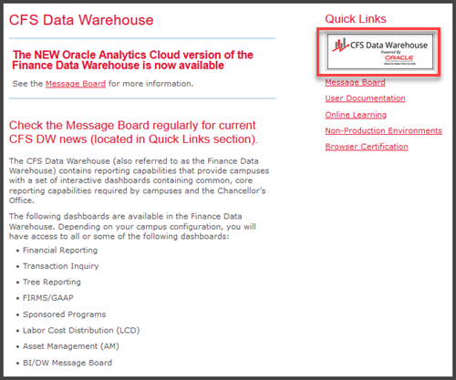
Login to the CFS Data Warehouse
Access to the CFS Data Warehouse is provided via SSO (single sign-on). The steps for accessing the data warehouse at your campus might be different. Follow your campus guidelines to log into the data warehouse.
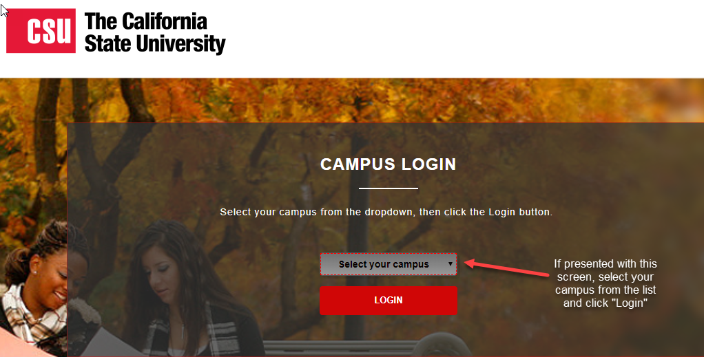
Choose your Campus, if Prompted

The Data Warehouse Home Page and Dashboards Menu
Once you have successfully logged in to the CFS Data Warehouse, you will be directed to the main Home page. This page contains links to the individual dashboards and your most recently accessed reports. The CFS Data Warehouse contains multiple dashboards. A dashboard allows multiple reports to be displayed in a tabbed interface.
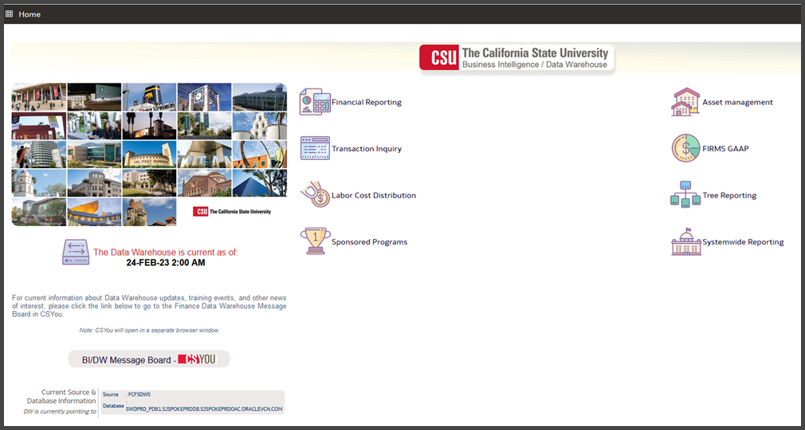
Data Warehouse Main Home Page (Landing Page)
Depending on your security profile, you will have access to some or all of the following dashboards.
- Asset Management
- Financial Reporting
- FIRMS/GAAP
- Labor Cost Distribution
- Sponsored Programs
- Systemwide Reporting (restricted to CO only)
- Transaction Inquiry
- Tree Reporting
Additional Features on the Home Page
Additional features on the Data Warehouse Home Page include:
- The CFS Data Warehouse Home page displays the date and time of the current data refresh.
- The BI/DW Message Board button will take you to the Message Board in CSYou.
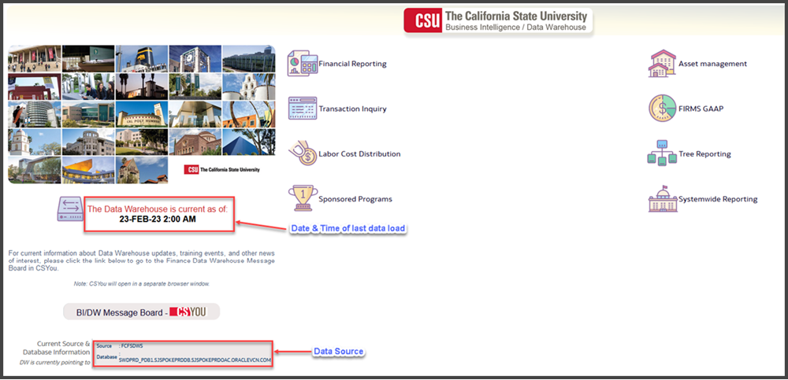
Enhanced Functionality on the New CFS Data Warehouse Home Page
Accessing a Dashboard
1. From the Data Warehouse Home page, click on a dashboard button to move to the associated dashboard.
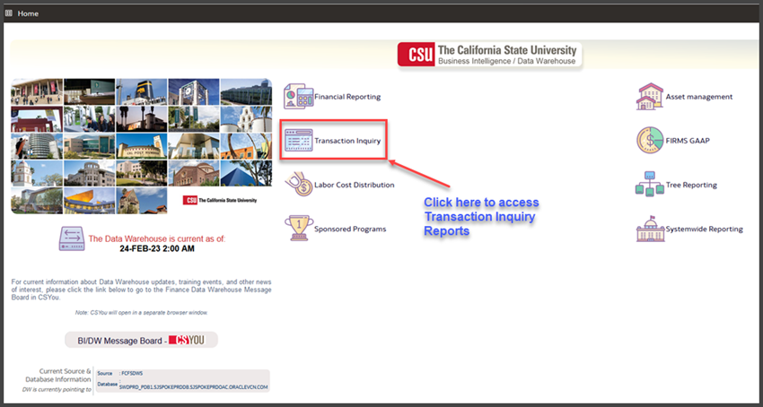
Access a Dashboard by Clicking the Dashboard Button
2. Click on Transaction Inquiry button to go to the Transaction Inquiry dashboard.
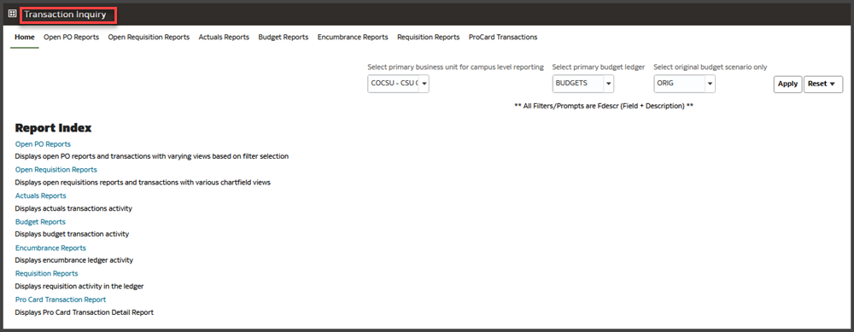
Transaction Inquiry Home Page
Navigating through the Data Warehouse
1. You can also move through the dashboards by using the Dashboards drop down menu to display a list of available dashboards.
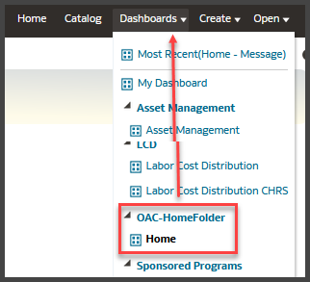
The Dashboards Menu is Available Throughout the Data Warehouse
2. Using the button on the Landing Page or the Dashboard menu, return to the Transaction Inquiry dashboard.

Dashboard Filters
Dashboard settings are filters that will apply to ALL pages within a dashboard. You can override Home Page default settings at the individual page/report level.
1. In the Default Settings for this Dashboard section, select your primary campus values.
FIELD | DESCRIPTION | EXPLANATION / EXAMPLE
Primary business unit for campus level reporting | The business unit for the PeopleSoft GL Application | COCSU or SBCMP
Primary budget ledger | The campus budget ledger. | Budget
Original budget scenario | Name of original budget scenario | This filter is used to determine what gets summarized (scenarios) in the original budget column on various reports.

Dashboard Filters Example with Original Budget Scenario
2. Click Apply to apply the dashboard filters.
Save your Settings as Default
1. From the Page Options menu, choose Save Current Customization.
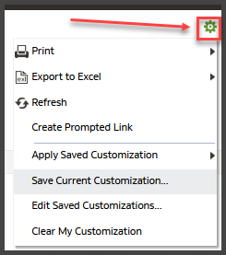
2. Enter a descriptive customization name.
3. Choose Make this my default for this page.
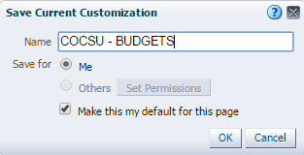
4. Click OK.
5. Return to the Transaction Inquiry dashboard.

The Transaction Inquiry Dashboard
The Transaction Inquiry dashboard Home page displays a report index of all transaction inquiry pages. This dashboard provides lower-level detail reports of financial transactions reports.
1. From the Data Warehouse Home page, click on the Transaction Inquiry button to go to the Transaction Inquiry dashboard.
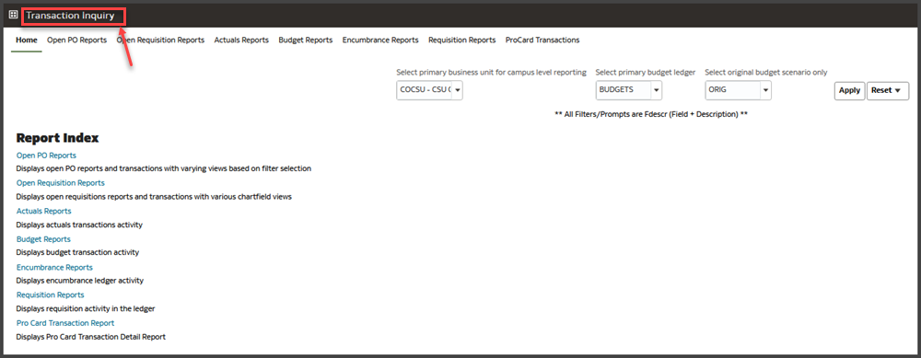
The Transaction Inquiry Home Page
Set Transaction Inquiry Dashboard Filters
1. From the Dashboard filters section, select your primary campus values.
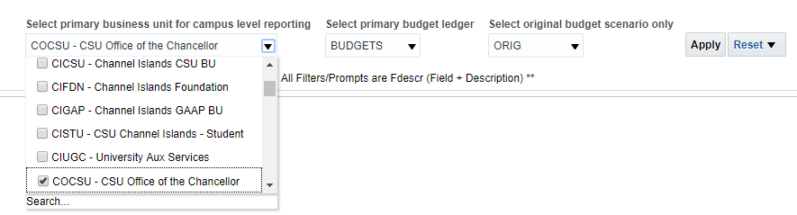
Set Dashboard Filters
2. Click Apply to apply the dashboard filters.
Save Dashboard Settings as a Default Customization
Using saved customizations, you can store the dashboard settings as a default so that you do not have to reset them every time you log into the data warehouse.
1. From the Page Options menu, choose Save Current Customization.
The Page Options Feature
2. Enter a descriptive customization name. You might want to include the name of the business unit (or units) that you entered in your dashboard settings.
3. Choose Make this my default for this page.
Saving the Dashboard Settings as Default
4. Click OK.

Transaction Inquiry Report Index
Page Name / Report Name | Page / Report Description
Open PO Reports | Displays open PO reports and transactions with varying views based on filter selection
Open PO Report | - Open PO listing with six column selectors
Open PO Views | - Open PO listing by various chartfield and supplier (vendor) views
Open PO Transaction Details | - Open PO transaction details based on the selected report filters
Open Requisition Reports | Displays open requisitions reports and transactions with various chartfield views
Open Requisition Report | - Open Requisitions listing with six column selectors
Open Requisition Views | - Open Requisitions listing by various views
Actuals Reports | Displays actuals transactions activity
Actuals Transactions | - Actuals Transactions is a transactional display based on selected filters with several views
Actuals Reporting by Attributes | - Actuals Reporting by Attributes is a transactional display with six column selectors
Budget Reports | Displays budget transaction activity
Budget Transactions | - Budget Transactions is a transactional display based on selected filters with several views
Budget Reporting by Attributes | - Budget Reporting by Attributes is the transactional display with six column selectors
Encumbrance Reports | Displays encumbrance ledger activity
Encumbrance Transactions | - Encumbrance Transactions is a transactional display based on selected filters with several views
Encumbrance Reporting by Attributes | - Encumbrance Reporting by Attributes is the transactional display with six column selectors
Requisitions Reports | Displays requisition activity in the ledger
Requisition Transactions | - Requisitions Transactions is a transactional display based on selected filters with several views
Requisition Reporting by Attributes | - Requisition Reporting by Attributes is a transactional display with six column selectors
ProCard Transactions | Displays ProCard Transaction Detail Report

Open PO Reports
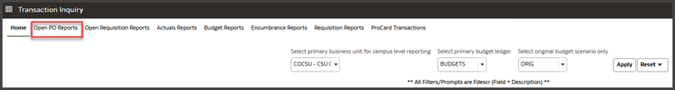
The Open PO Reports page displays open PO reports and transactions with varying views based on filter selection. This page contains three reports:
- Open PO Report
Open PO listing with six column selectors
- Open PO Views
Open PO listing by various chartfield and supplier (vendor) views
- Open PO Transaction Details
Open PO transaction details based on the selected report filters
When you click on one of the Open PO Report links, the selected report will appear on its own page / tab with the other dashboard pages.

Open PO Report
The Open PO Report produces a list of Open POs with six column selectors.
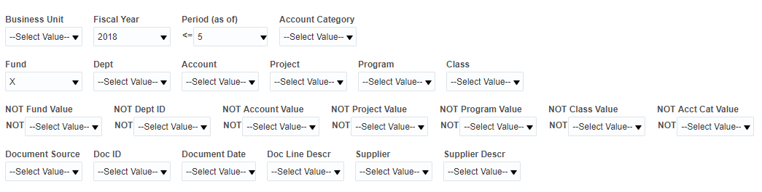
Open PO Report Filters
Features
- The Open PO Report contains two section for filters: Report Filters and Advanced Filters.
- PO information can be retrieved through Open PO Reports or through the Encumbrance Reports.
To display all encumbrances, both those associated with a PO and not associated with a PO, use the Encumbrance Reports.

Report Example
Description | Open PO Report
Report Filters | Business Unit  Fiscal Year  As of Period = 12  Account Type = 60  Budget Ledger  Fund  Dept
Column Selectors | Column 1: Fund Fdescr  Column 2: Dept Fdescr  Column 3: Acct Fdescr  Column 4: Doc Line #  Column 5: Doc Ln Descr
Instructions | Set the report filters, apply the filters, and choose the column selectors.  Add a subtotal to the fixed column “Doc ID” to see a subtotal of all lines within a unique Doc ID

Report Views
This report has no report views. The report results columns are indicated below:
Column selectors plus:
- Open PO Amt

Open PO Views
Open PO Views provides a report of Open POs by various chartfield and supplier (vendor) views
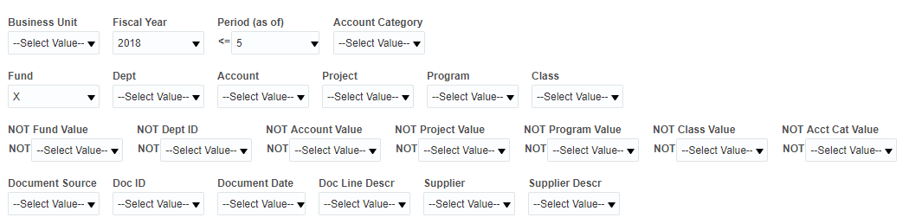
Open PO Views Report Filters
Features
- Open PO Views contains two section for filters: Report Filters and Advanced Filters.
- There are no column selectors in the Open PO Views report.

Report Views
The Open PO Views report contains seven report views.
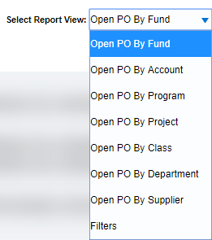
Report Views: Open PO Views
Open PO By Department*
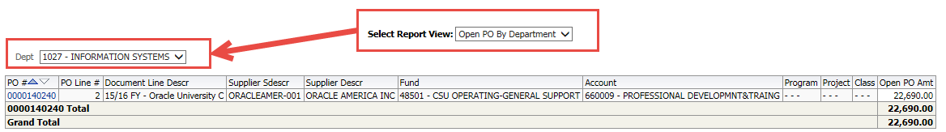
All chartfield views return a pivot on the selected chartfield and display the remaining five chartfields as fixed columns. Report view displays a pivot on Chartfield type plus:
- PO#
- PO Line #
- Document Line Descr
- Supplier Sdescr
- Supplier Descr
- Account*
- Program*
- Project*
- Class*
- Dept* (pivot in Open PO by Department view)
- Open PO Amt
*The Open PO By Department Report View is displayed here. Other Report Views display a pivot by each chartfield. Chartfield columns change order depending on the active chartfield pivot view.

Open PO Transaction Details
The Open PO Transaction Details report displays open PO transactions based on the selected report filters. The Open PO Transaction Details report is designed to support the export of large data sets to Excel or to CSV format.
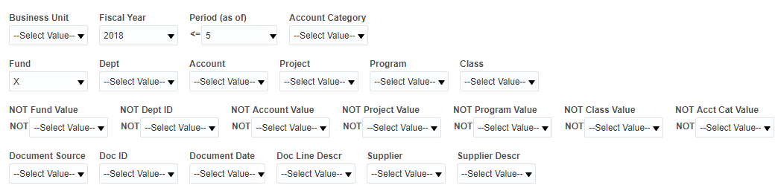
Open PO Transaction Details Report Filters

Report Views
There are no report views in this report. The report results columns are indicated below:
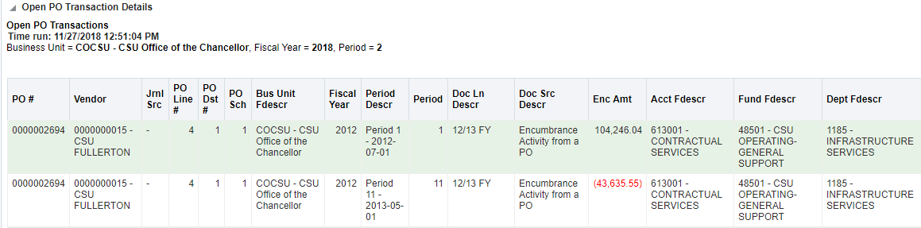
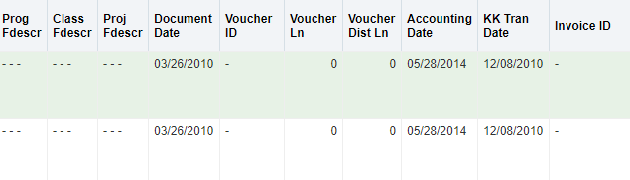
Drill-Down Columns
- PO#
- Vendor
- Jrnl Src
- PO Line #
- PO Dst #
- PO Sch
- Bus Unit Fdescr
- Fiscal Year
- Period Descr
- Period
- Doc Ln Descr
- Doc Src Descr
- Enc Amt
- Acct Fdescr
- Fund Fdescr
- Dept Fdescr
- Prog Fdescr
- Class Fdescr
- Proj Fdescr
- Document Date
- Voucher ID
- Voucher Ln
- Voucher Dist Ln
- Accounting Date
- KK Tran Date
- Invoice ID

Open Requisition Reports
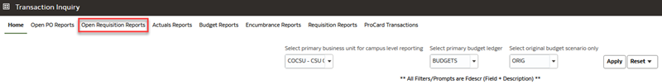
The Open Requisition Reports display open requisitions reports and transactions with various chartfield views. This page contains two reports:
- Open Requisition Report
Open Requisitions listing with six column selectors
- Open Requisition Views
Open Requisitions listing by various chartfield and supplier (vendor) views
When you click on one of the Open Requisition Report links, the selected report will appear on its own page / tab with the other dashboard pages.

Open Requisition Report
The Open Requisition Report produces a list of open requisitions with six column selectors.
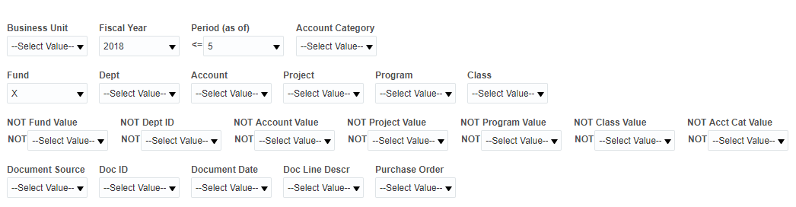
Open Requisition Report Filters
Features
- The Open Requisition Report contains two section for filters: Report Filters and Advanced Filters.
- The Open Requisition Report is designed to support the export of large data sets to Excel or to CSV format.

Report Views
The Open Requisition Report has no report views. It has 6 column selectors and fixed columns:
- Req ID
- Pre-encumbrance
Open Req Detail Drill Down Report
Click on the fixed Req ID field to drill down to Open Req Detail. Scroll to the right to see additional columns.
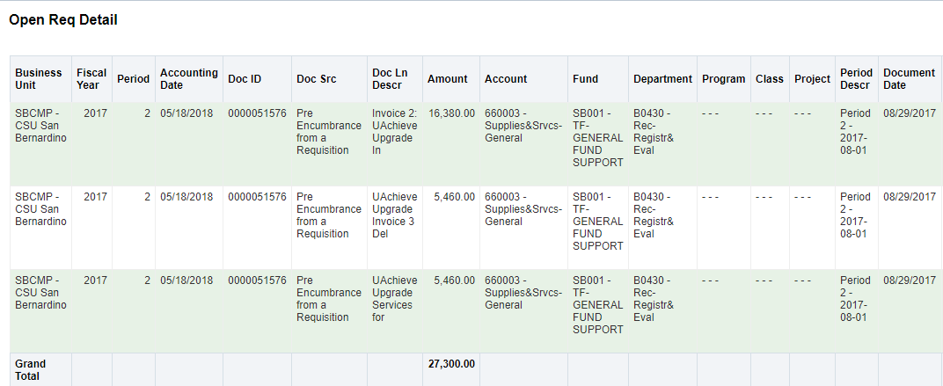
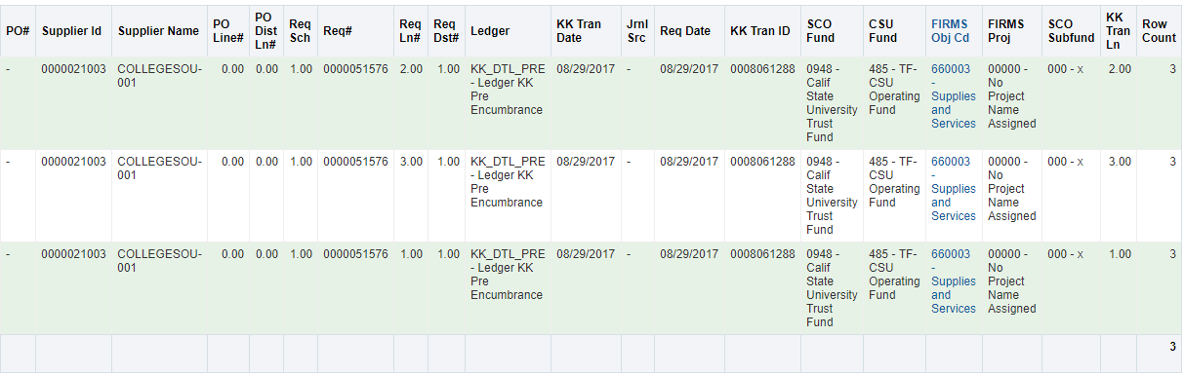
Drill Down Columns
- Business Unit
- Fiscal Year
- Period
- Accounting Date
- Doc ID
- Doc Src
- Doc Ln Descr
- Amount
- Account
- Fund
- Department
- Program
- Class
- Project
- Period Descr
- Document Date
- PO#
- Supplier ID
- Supplier Name
- PO Line#
- PO Dist Ln#
- Req Sch
- Req#
- Req Ln#
- Req Dst#
- Ledger
- KK Tran Date
- Jrnl Src
- Req Date
- KK Tran ID
- SCO Fund
- CSU Fund
- FIRMS Obj Cd
- FIRMS Proj
- SCO Subfund
- KK Tran Ln
- Row Count

Open Requisition Views
Open Requisition Views provides a report of open requisitions by various chartfield and supplier (vendor) views.
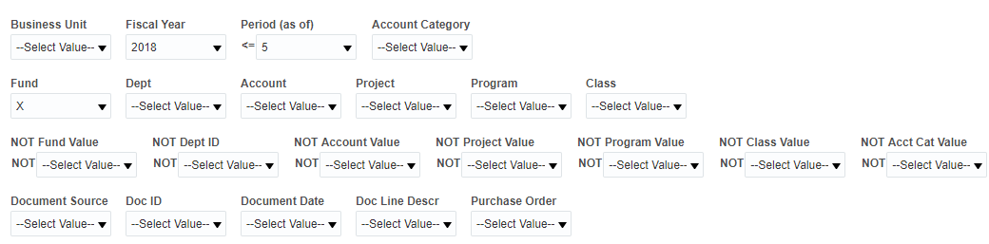
Open Requisition Views Report Filters
Features
- Open Requisition Views contains two section for filters: Report Filters and Advanced Filters.
- There are no column selectors in the Open Requisition Views report. The fixed report fields are listed below. The PO # field is the one drillable field.

Report Views
The Open PO Views report contains six report views.
- Req By Fund
- Req By Account
- Req By Program
- Req By Project
- Req By Class
- Req By Department
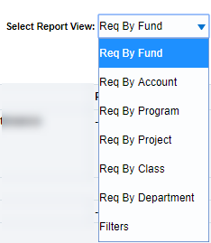
All chartfield views return a pivot on the selected chartfield and display the remaining five chartfields as fixed columns.
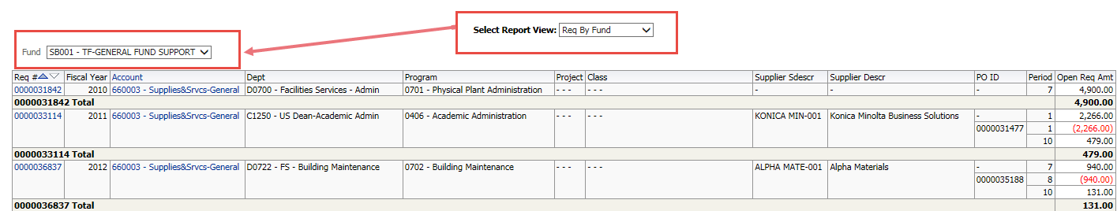
Pivot on chartfield type plus:
- Req#
- Fiscal Year* (only in Req by Fund view)
- Fund* (pivot in Req by Fund view)
- Account
- Dept
- Program
- Project
- Class
- Supplier Descr
- Supplier Sdescr
- PO ID
- Period
- Open Req Amt

Actuals Reports
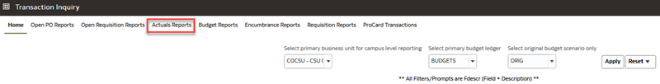
The Actuals Reports page provides reporting on actuals transaction activity based on the selected report filters. This page contains two reports:
- Actuals Transactions
- Actuals Reporting by Attributes
When you click on one of the Actuals Reports links, the selected report will appear on its own page / tab with the other dashboard pages.

Actuals Transactions
The Actuals Transactions report is a transactional display based on selected filters with several views.
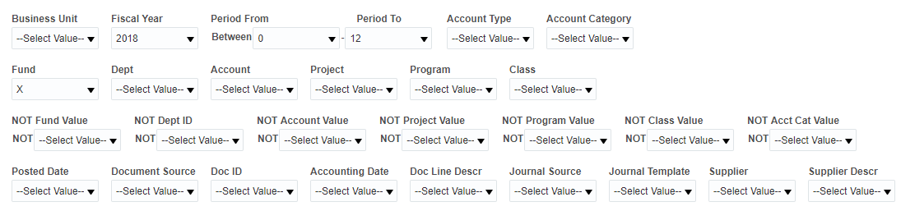
Actuals Transactions Report Filters
Features
- Actuals Transactions contains two section for filters: Report Filters and Advanced Filters.

Report Example
Use this report to create a transaction report.
Description | Open PO Report
Report Filters | Business Unit = Valid Value  Fiscal Year = Valid Value  As of Period = Valid Value  Account Type = 60  Budget Ledger = Valid Value  Fund = Valid Value  Dept = Valid Value
Instructions | Set the report filters and apply the filters.  Try all the Report Views listed below.

Report Views
The Actuals Transactions report contains four report views.
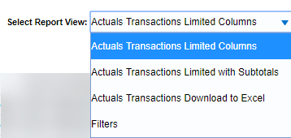
Report Views: Actuals Transactions

Actuals Transactions Limited Columns
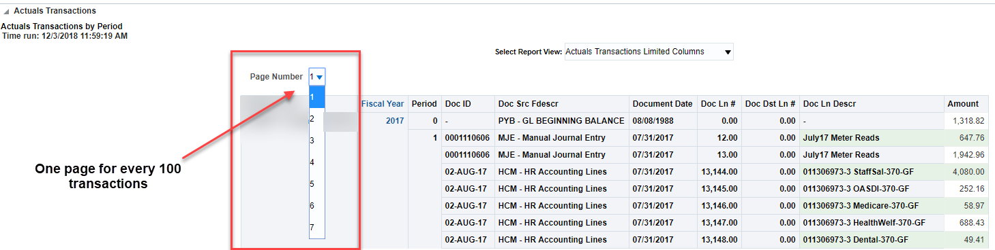
Report View: Actuals Transactions Limited Columns
This report view will display 100 transactions per page. There are no column selectors. The report results displays 10 fixed columns:
- Business Unit
- Fiscal Year
- Period
- Doc ID
- Doc Src Fdescr
- Document Date
- Doc Ln #
- Doc Dst Ln #
- Doc Ln Descr
- Amount

Actuals Transactions Limited with Subtotals
This report view displays the same 10 columns as the Actions Transactions Limited Columns report view, 100 transactions per page. Additionally, the report results have a subtotal in column 4 after every Doc ID group:
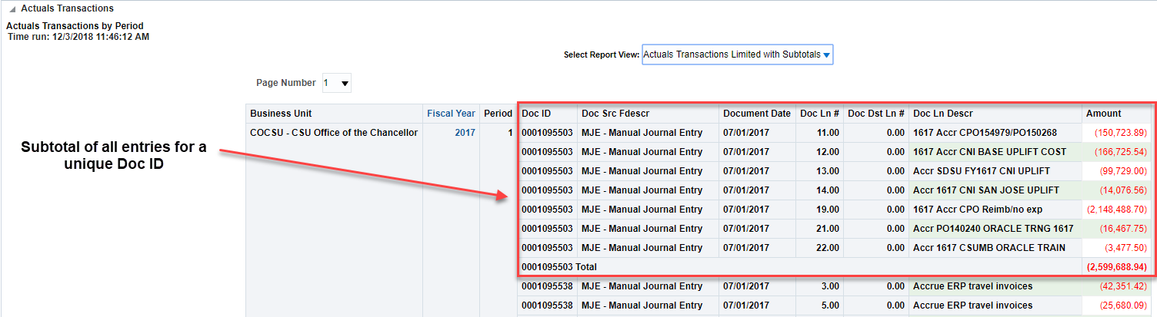
Report View: Actuals Transactins Limited with Subtotals
- Business Unit
- Fiscal Year
- Period
- Doc ID
- Doc Src Fdescr
- Document Date
- Doc Ln #
- Doc Dst Ln #
- Doc Ln Desr
- Amount

Actuals Transactions Download to Excel
The purpose of this view is to format the data for download to Excel. Use the Export > Excel or Export > Data features to export the entire dataset.
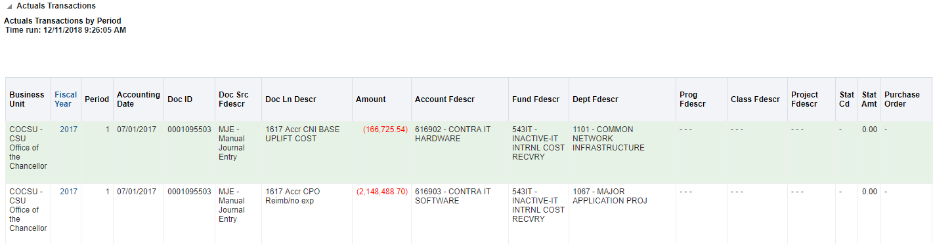
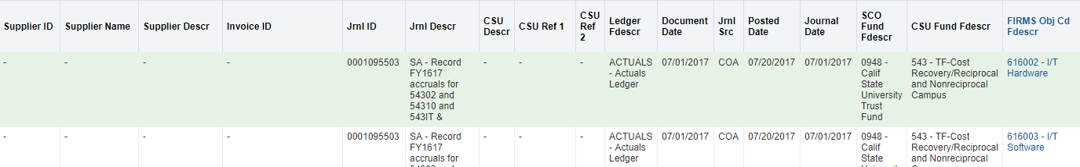
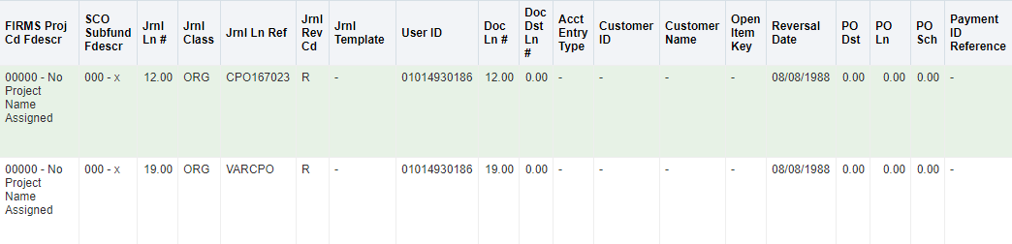
- Business Unit
- Fiscal Year
- Period
- Accounting Date
- Doc ID
- Doc Src Fdescr
- Doc Ln Descr
- Amount
- Account Fdescr
- Fund Fdescr
- Dept Fdescr
- Prog Fdescr
- Class Fdescr
- Project Fdescr
- Stat Cd
- Stat Amt
- Purchase Order
- Supplier ID
- Supplier Name
- Invoice ID
- Jrnl ID
- Jrnl Descr
- CSU Descr
- CSU Ref 1
- CSU Ref 2
- Ledger Fdescr
- Document Date
- Jrnl Src
- Posted Date
- Journal Date
- SCO Fund Fdescr
- CSU Fund Fdescr
- FIRMS Obj Cd Fdescr
- FIRMS Proj Cd Fdescr
- SCO Subfund Fdescr
- Jrnl Ln #
- Jrnl Class
- Jrnl Ln Ref
- Jrnl Rev Cd
- Jrnl Template
- User ID
- Doc Ln #
- Doc Dist Ln #
- Acct Entry Type
- Customer ID
- Customer Name
- Open Item Key
- Reversal Date
- PO Dst
- PO Ln
- PO Sch
- Payment ID Reference

Actuals Reporting by Attributes
The Actuals Reporting by Attributes report is a transactional display with six column selectors.
Features
- The Actuals Reporting by Attributes report contains two section for filters: Report Filters and Advanced Filters.
- Attribute filters are available on Actuals, Budget, Encumbrance, and Requisition transaction reports.
- This report has 6 column selectors containing selections for all filters.

Report Views
The Actuals Reporting by Attributes report contains one report view and a Filters view:
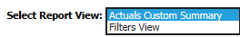

Actuals Custom Summary
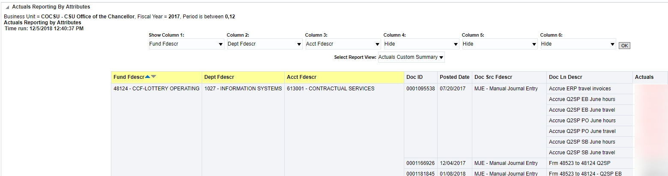
Column selectors plus:
- Doc ID
- Posted Date
- Doc Src Fdescr
- Doc Ln Descr
- Actuals

Budget Reports
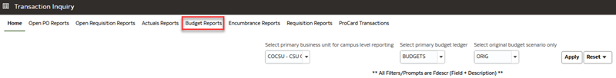
The Budget Reports page provides reporting on budget transaction activity based on the selected report filters. This page contains two reports:
- Budget Transactions
- Budget Reporting by Attributes
When you click on one of the Budget Reports links, the selected report will appear on its own page / tab with the other dashboard pages.

Budget Transactions
The Budget Transactions report is a transactional display based on selected filters with several views.
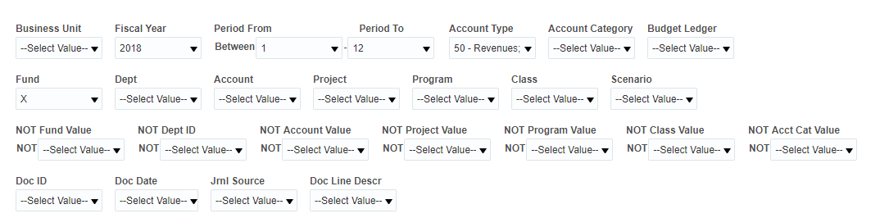
Budget Transactions Report Filters
Features
- Budget Transactions contains two section for filters: Report Filters and Advanced Filters.

Report Views
The Budget Transactions report contains four report views.
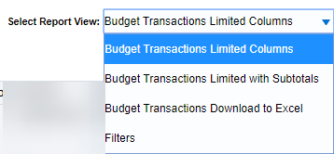
Report Views: Budget Transactions

Budget Transactions Limited Columns
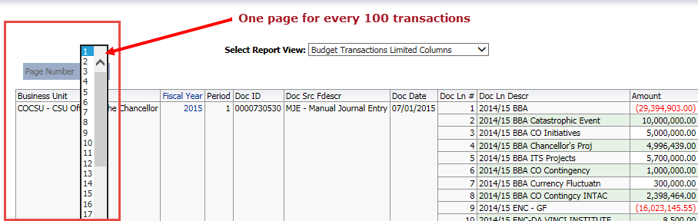
This report view will display 100 transactions per page. There are no column selectors. The report results displays 9 fixed columns:
- Business Unit
- Fiscal Year
- Period
- Doc ID
- Doc Src Fdescr
- Doc Date
- Doc Ln #
- Doc Ln Descr
- Amount

Budget Transactions Limited with Subtotals
This report view displays the same 9 columns as the Budget Transactions Limited Columns report view, 100 transactions per page. Additionally, the report results have a subtotal in column 4 after every Doc ID group:
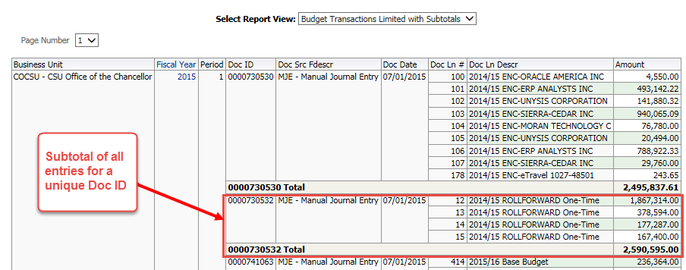

Budget Transactions Download to Excel
The purpose of this view is to format the data for download to Excel. Use the Export > Excel or Export > Data features to export the entire dataset.
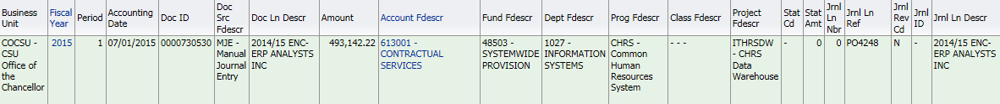
- Business Unit
- Fiscal Year
- Period
- Accounting Date
- Doc ID
- Doc Src Fdescr
- Doc Ln Descr
- Amount
- Account Fdescr
- Fund Fdescr
- Dept Fdescr
- Prog Fdescr
- Class Fdescr
- Project Fdescr
- Stat Cd
- Stat Amt
- Jrnl Ln Nbr
- Jrnl Ln Ref
- Jrnl Rev Cd
- Jrnl ID
- Jrnl Ln Descr
- Jrnl Class
- Jrnl Class Descr
- Doc Ln #
- Scenario
- Ledger Fdescr
- Doc Date
- Jrnl Src
- Posted Date
- Journal Date
- SCO Fund Fdescr
- CSU Fund Fdescr
- FIRMS Obj Cd Fdescr
- FIRMS Proj Cd Fdescr
- SCO Subfund Fdescr
- Reversal Date

Budget Reporting by Attributes
The Budget Reporting by Attributes report is the transactional display with six column selectors.
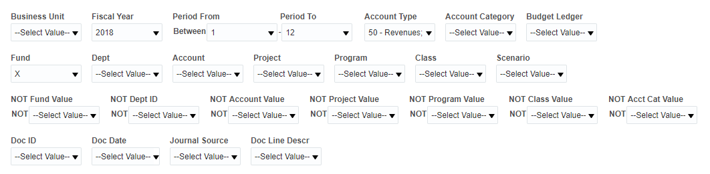Features
- The Budget Reporting by Attributes report contains two section for filters: Report Filters and Advanced Filters.
- This report has 6 column selectors containing selections for all filters.

Report Views
The Budget Reporting by Attributes report contains two report views.
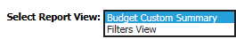
Report Views: Budget Reporting by Attributes

Budget Custom Summary
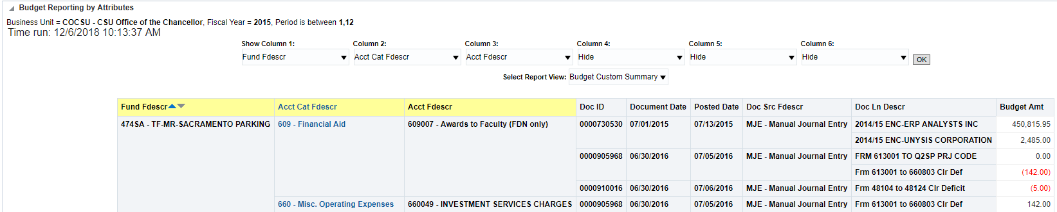
Report View: Budget Custom Summary
The report results display Column Selectors, plus six fixed columns:
- Doc ID
- Document Date
- Posted Date
- Doc Src Fdescr
- Doc Ln Descr
- Budget Amt

Encumbrance Reports
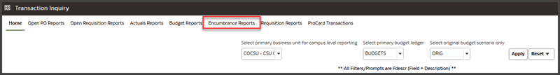
The Encumbrance Reports page provides reporting on encumbrance transaction activity based on the selected report filters. This page contains two reports:
- Encumbrance Transactions
- Encumbrance Reporting by Attributes
When you click on one of the Encumbrance Reports links, the selected report will appear on its own page / tab with the other dashboard pages.

Encumbrance Transactions
The Encumbrance Transactions report is a transactional display based on selected filters with several views.
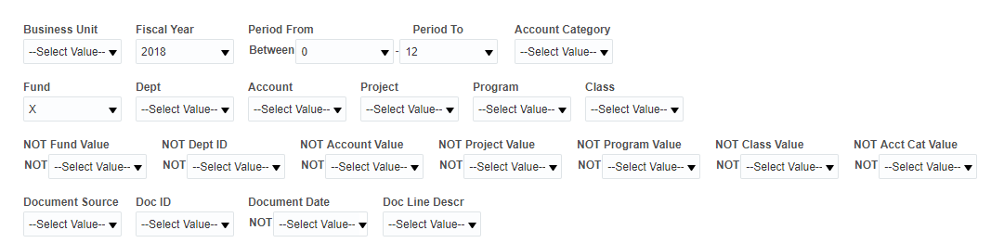
Encumbrance Transactions Report Filters
Features
- Encumbrance Transactions contains two section for filters: Report Filters and Advanced Filters.

Report Views
The Encumbrance Transactions report contains three report views.
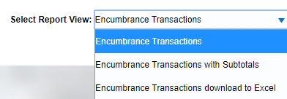
Report Views: Encumbrance Transactions

Encumbrance Transactions
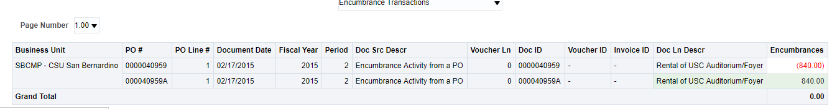
Report View: Encumbrance Transactions
This report view will display 100 transactions per page. There are no column selectors. The report results displays 13 fixed columns:
- Business Unit
- PO #
- PO Line #
- Document Date
- Fiscal Year
- Period
- Doc Src Descr
- Voucher Ln
- Doc ID
- Voucher ID
- Invoice ID
- Doc Ln Descr
- Encumbrances

Encumbrance Transactions with Subtotals
This report view displays the same 13 columns as the Encumbrances Transactions report view, 100 transactions per page. Additionally, the report results have a subtotal in column 2 after every PO # group:
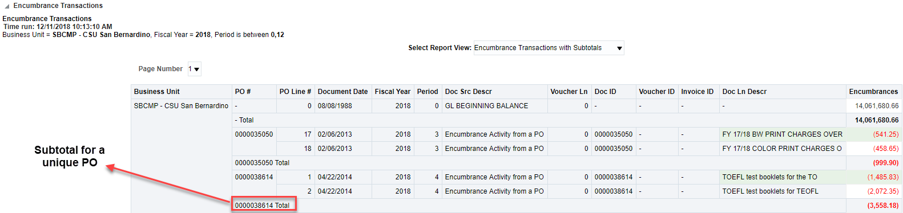
Report View: Encumbrance Transactions with Subtotals

Encumbrance Transactions download to Excel
The purpose of this view is to format the data for download to Excel. Use the Export > Excel or Export > Data features to export the entire dataset.
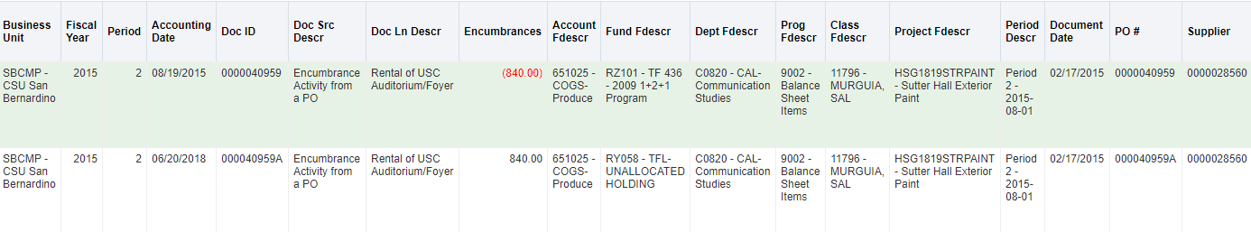
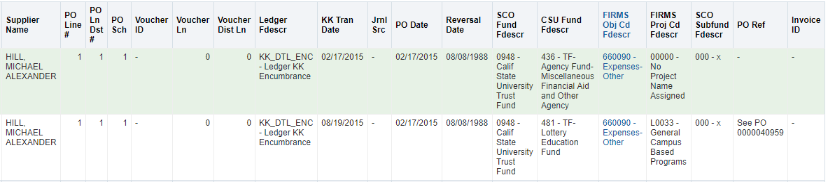
Report View: Encumbrance Transactions Download to Exel
- Business Unit
- Fiscal Year
- Period
- Accounting Date
- Doc ID
- Doc Src Descr
- Doc Ln Descr
- Encumbrances
- Account Fdescr
- Fund Fdescr
- Dept Fdescr
- Prog Fdescr
- Class Fdescr
- Project Fdescr
- Period Descr
- Document Date
- PO #
- Supplier
- Supplier Name
- PO Line #
- PO Ln Dst #
- PO Sch
- Voucher ID
- Voucher Ln
- Voucher Dist Ln
- Ledger Fdescr
- KK Tran Date
- Jrnl Src
- PO Date
- Reversal Date
- SCO Fund Fdescr
- CSU Fund Fdescr
- FIRMS Obj Cd Fdescr
- FIRMS Proj Cd Fdescr
- SCO Subfund Fdescr
- PO Ref
- Invoice ID

Encumbrance Reporting by Attributes
The Encumbrance Reporting by Attributes report is a transactional display with six column selectors.
Features
- The Encumbrance Reporting by Attributes report contains two section for filters: Report Filters and Advanced Filters.
- This report has 6 column selectors containing selections for all filters.

Report Views
The Encumbrance Reporting by Attributes report has one Report View and a Filters View.
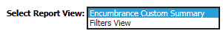
Report Views: Encumbrance Reporting by Attributes

Encumbrance Custom Summary
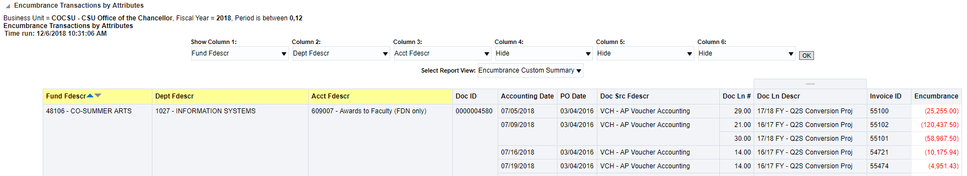
Report View: Encumbrance Custom Summary
The report results display Column Selectors, plus eight fixed columns:
- Doc ID
- Accounting Date
- PO Date
- Doc Src Fdescr
- Doc Ln #
- Doc Ln Descr
- Invoice ID
- Encumbrance

Requisition Reports
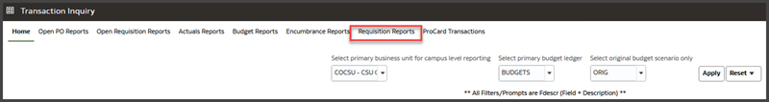
The Requisition Reports page provides reporting on requisition transaction activity based on the selected report filters. This page contains two reports:
- Requisition Transactions
- Requisition Reporting by Attributes
When you click on one of the Requisition Reports links, the selected report will appear on its own page/ tab with the other dashboard pages.

Requisition Transactions Report
The Requisition Transactions report is a transactional display based on selected filters with several views.
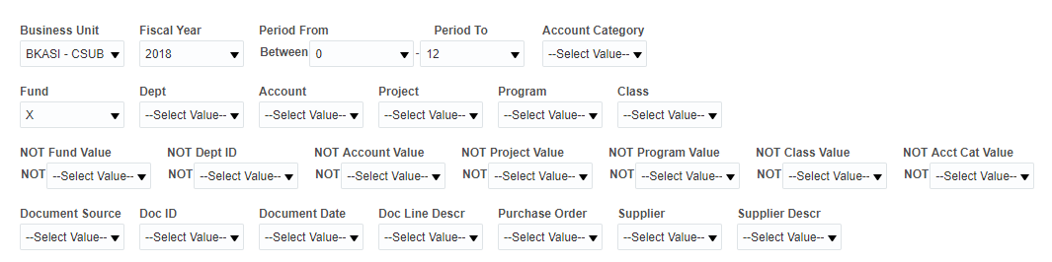
Requisition Transactions Report Filters
Features
- Requisition Transactions report contains two section for filters: Report Filters and Advanced Filters.

Report Views
The Requisition Transactions report contains three Report Views and a Filters View.
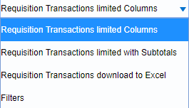
Report Views: Requisition Transactions Report

Requisition Transactions Limited Columns
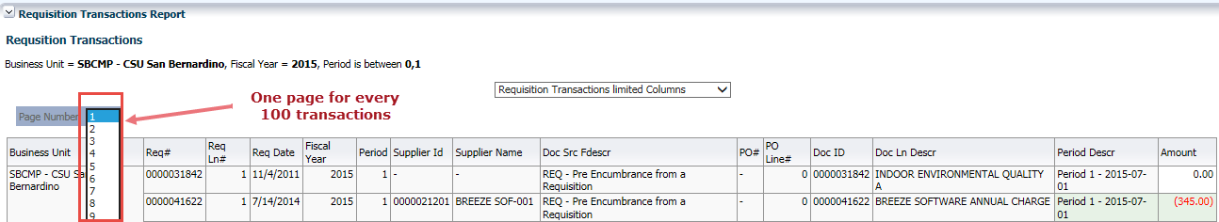
This report view will display 100 transactions per page. There are no column selectors. The report results displays 15 fixed columns:
- Business Unit
- Req #
- Req Ln #
- Req Date
- Fiscal Year
- Period
- Supplier ID
- Supplier Name
- Doc Src Fdescr
- PO #
- PO Line #
- Doc ID
- Doc Ln Descr
- Period Descr
- Amount

Requisition Transactions limited with Subtotals
This report view displays the same 15 columns as the Requisition Transactions report view, 100 transactions per page. Additionally, the report results have a subtotal in column 2 after every Req # group:
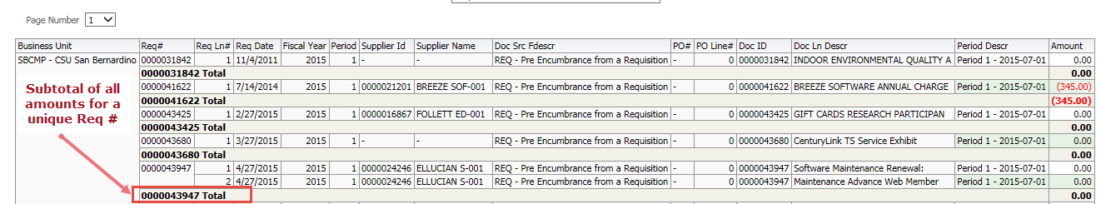

Requisition Transactions download to Excel
The purpose of this view is to format the data for download to Excel. Use the Export > Excel or Export > Data features to export the entire dataset.
- Business Unit
- Fiscal Year
- Period
- Accounting Date
- Doc ID
- Doc Src Fdescr
- Doc Ln Descr
- Amount
- Account Fdescr
- Fund Fdescr
- Dept Fdescr
- Prog Fdescr
- Class Fdescr
- Project Fdescr
- Period Descr
- Document Date
- PO #
- Supplier ID
- Supplier Name
- PO Line #
- PO Ln Dst #
- Req Sch
- Req#
- Req Ln#
- Req Dst#
- Ledger
- KK Tran Date
- Jrnl Src
- Req Date
- KK Tran ID
- SCO Fund
- CSU Fund
- FIRMS Obj Cd
- FIRMS Proj
- SCO Subfund
- KK Tran Ln

Requisition Reporting by Attribute
The Requisition Reporting by Attributes report is a transactional display with six column selectors.
Features
- The Requisition Reporting by Attributes report contains two section for filters: Report Filters and Advanced Filters.
- This report has 6 column selectors containing selections for all filters.

Report Views

Requisition Custom Summary

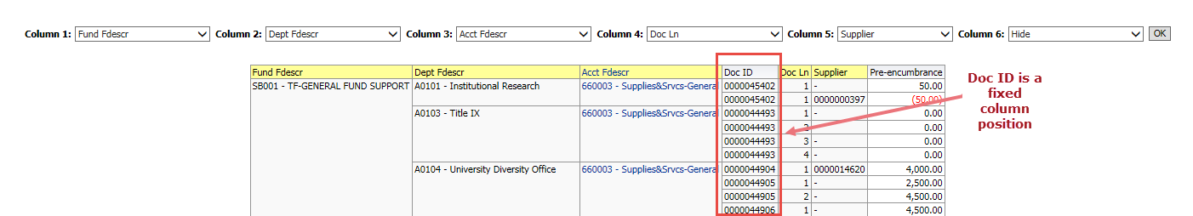
This view contains two fixed columns:
- Doc ID
- Pre-encumbrance
Note that the Doc ID column appears at a fixed position, after columns 1-3 (if exist) and before column 4 (if exists).

ProCard Transactions
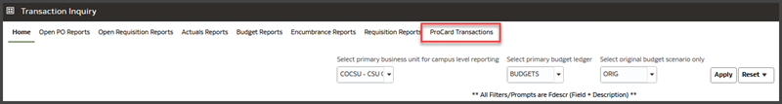

ProCard Transaction Details
Report Features
- The ProCard Transactions page contains one report: ProCard Transaction Details
- The ProCard Transactions Details report contains the standard report filters, advanced filters, and six column selectors.

Report Filters
- There are two business unit filters available as report filters:
- Business Unit—the General Ledger business unit that the transaction is charged to
- PC Business Unit—the business unit that the ProCard account is set up under
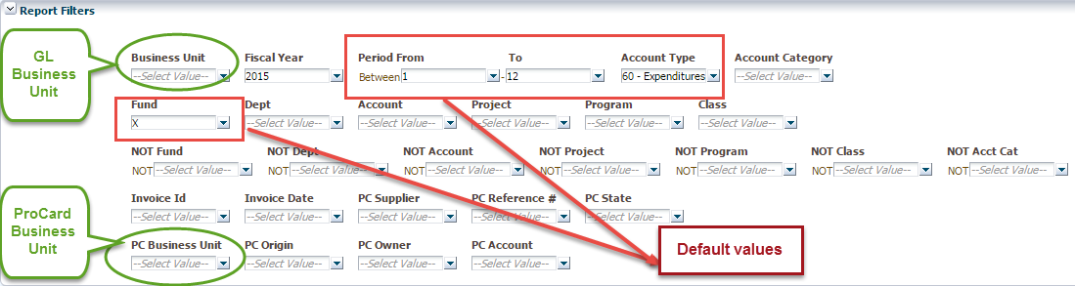
- The report filter defaults are:
- Current fiscal year
- Period From/To: 1 to 12
- Account Type: 60 – Expenditures
- Fund: X
- The data warehouse transforms the Accounting Date on the transaction, into fiscal year and accounting period, allowing a search for transactions using an accounting period range.
ProCard Attributes
There are nine specific ProCard attributes available as filters, column selectors, and/or report view columns.
Invoice ID | The Supplier Invoice # of the source transaction in Accounts Payable
Invoice Date | The original date of the ProCard transaction from the Supplier
PC Supplier | The Supplier associated with the ProCard transaction
PC Reference # | How this field is used in the ProCard module is Campus Specific. An example might be departments use this for internal tracking, a cross reference to their records or a Requisition/Purchase Order Number.
PC State | The state from which the ProCard purchase was made
PC Business Unit | The business unit that the ProCard account is set up under
PC Origin | Defines where the ProCard originated from. For example campuses may have a US Bank PCard Origin (USB) as well as a One Card Origin (USO).
PC Owner | The ProCard account owner (Name)
PC Account | The ProCard Account number assigned to the account owner
Business Units
There are two business unit fields available as report filters and column selectors.
- Business Unit or GL Bus Unit is the GL Business Unit the transaction is charged to.
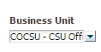 | 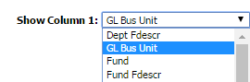
Business Unit (Report Filter Label) | GL Bus Unit (Column Selector Label)

- PC Business Unit or PC Bus Unit is the business unit that the ProCard account is set up under. (If inter-unit has not been implemented at your campus, then this is the same as the GL Business Unit.)
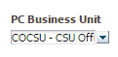 | 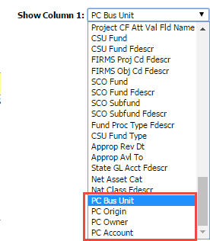
PC Business Unit (Report Filter Label) | PC Bus Unit (Column Selector Label)  Note: The ProCard-specific fields appear  at the bottom of the column selector list:
Inter Unit Processing
Most campuses equate one GL business unit to one ProCard business unit. If your campus has implemented inter-unit business processing, a single ProCard can be used across multiple GL business units. In this case, your ProCard business unit could be different than the GL business unit.

Report Views
After you have generated a report, you can choose a Report View. The ProCard Transactions report contains two report views plus a Filters view:
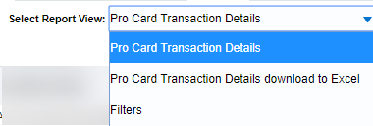
Report Views: ProCard Transactions
When the report is generated, the screen will display 100 rows of data at a time. Click the up/down arrows to move through the report content. Click the double headed arrow to move to the end of the data.
The Report Displays 100 Rows at a Time
ProCard Transaction Details
This report view contains six column selectors and static columns listed below. There are subtotals on Columns 1 and 2.
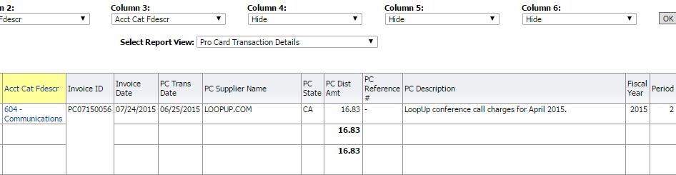
Column selectors plus:
- Invoice ID
- Invoice Date
- PC Trans Date
- PC Supplier Name
- PC State
- PC Dist Amt
- PC Reference #
- PC Description
- Fiscal Year
- Period
ProCard Transaction Details download to Excel
This report view contains the same six column selectors and static columns as the ProCard Transactions Details view. There are no subtotals on Columns 1 and 2.

Filters (Global Feature)
This view is available on all dashboard reports that contain Report Views.

Report Examples
Scenario 1: By (General Ledger) Business Unit
Set the following report filters, apply the filters, and choose the column selectors.
Description | A report of ProCard transactions for a single department by General Ledger Business Unit
Report Filters | Business Unit = Valid Value  Fiscal Year = Valid Value  Period From = Valid Value  To = Valid Value  Account Type = 60-Expenditures  Dept = Valid Value
Column Selectors | Column 1: Dept Fdescr  Column 2: Fund Fdescr  Column 3: Acct Fdescr  Column 4: PC Owner  Column 5: Hide  Column 6: Hide
Instructions | Try different sort order on various columns:  - PC Owner  - Invoice ID
Scenario 2: By PC Attributes
Set the following report filters, apply the filters, and choose the column selectors. You do not have to pick a PC business unit in order to filter on ProCard attributes. ProCard attributes, for example, all campus values for PC Owner, PC Account, etc. are available from the report filter selection/search.
Description | A report of ProCard transactions for a ProCard Owner
Report Filters | Business Unit = Valid Value  Fiscal Year = Valid Value  Period From = Valid Value  To = Valid Value  Account Type = 60-Expenditures  PC Owner = Valid Value
Column Selectors | Column 1: PC Owner  Column 2: Dept Fdescr  Column 3: Fund Fdescr  Column 4: Acct Fdescr  Column 5: Hide  Column 6: Hide
Instructions | Try different sort order on various columns:  - Invoice ID

Scenario 3: Inter-Unit
Set the following report filters, apply the filters, and choose the column selectors. Most campuses equate one GL business unit to one ProCard business unit. If your campus has implemented inter-unit business processing, a single ProCard can be used across multiple GL business units. In this case, your ProCard business unit could be different than the GL business unit.
Description | A report of ProCard transactions for multiple General Ledger Business Units by Department
Report Filters | Business Unit = Valid Values  Fiscal Year = Valid Value  Period From = Valid Value  To = Valid Value  Account Type = 60-Expenditures  Dept = Valid Value  PC Owner = Valid Value
Column Selectors | Column 1: GL Business Unit  Column 2: Dept Fdescr  Column 3: Fund Fdescr  Column 4: Acct Fdescr  Column 5: PC Owner  Column 6: Hide
Instructions | - Change the Report View to ProCard Transaction Details download to Excel  - Export data to CSV format

Appendix A – Data Warehouse Glossary

Fields: Dashboards – Home Page
FIELD | DESCRIPTION | EXPLANATION / EXAMPLE
Primary business unit for campus level reporting | The business unit for the PeopleSoft GL Application | COCSU or COFDN or COGAP
Primary budget ledger | The campus budget ledger. | Budget
Original budget scenario | Name of original budget scenario | This filter is used to determine what gets summarized (scenario’s) in the original budget column on various reports.  Leave Blank (includes all scenarios).

Fields: Report Filters, Columns, Drill Downs
FIELD | DEFINITION
% Used | Percent Used. Percent of the budget that has been used
% Used Fiscal Year | Percent Used Fiscal Year. Percent of the budget that has been used for the fiscal year. Budget – Actuals - Encumbrances
Approp Rev Dt | Appropriation Reversion Date. Used for SW and State Reporting.
Approp Avl To | Appropriation Available To Date. Used for SW and State Reporting.
Account | Account value.
Acct Fdescr | The Account value and full description.
Acct Cat | Account Category value. Summarizes Account Chartfields into higher level categories.
Acct Cat Fdescr | Account Category Value and Description. Summarizes Account Chartfields into higher level categories with description.
Acct Type | Account Type Value. Summarizes Account Chartfields into a higher level type.
Acct Type Fdescr | Account Type value and full description. Summarizes Account Chartfields into a higher level type with description.
Acct CF Att Type | Account Chartfield Attribute Type.
Acct CF Atta Val | Account Chartfield Attribute Value.
Acct CF Att Val Descr | Account Chartfield Attribute Value and Description.
Acct CF Att Val Fdescr | Account Chartfield Attribute Value and full description.
Acct CF Att Val Fld Name | Account Chartfield Attribute Value Field Name.
Acct Tree Name | Account Tree Name.
Acct Level 1 | Account Level 1 value and full description.
Acct Level 2 | Account Level 2 value and full description.
Acct Level 3 | Account Level 3 value and full description.
Acct Level 4 | Account Level 4 value and full description.
Acct Level 5 | Account Level 5 value and full description.
Acct Date or Accounting Date | The Accounting Date of the financial transaction. Ie: Req, PO, Voucher or Journal.
Actuals | Amount of actuals recorded.
Balance Available | Budget – Actuals – Encumbrances.
Balance Available w/Pre-Enc | Budget – Actuals – Encumbrances – PreEncumbrances.
Current Budget | Total Budget Amount.
Bus Unit | Business Unit.
Bus Unit Fdescr | Business Unit value and full description.
Class | Class value
Class Fdescr | The class value with class full description.
CSU Fund | CSU Fund value. Used for SW Reporting.
CSU Fund Fdescr | CSU Fund value with description. Used for SW Reporting.
CSU Fund Type | CSU Fund value. Used for SW Reporting.
CSU Ref 1 | If the source came from the CSU Accounting lines, this is the value stored in the description (used by campuses for various interfaces)
CSU Ref 2 | If the source came from the CSU Accounting lines, this is the value stored in CSU_REF2 (used by campuses for various interfaces)
Customer ID | If the transaction is from Billing or Accounts Receivable, this is the Customer ID.
Customer Name | If the transaction is from Billing or Accounts Receivable, this is the Name of the Customer.
Date Posted | The date the transaction was posted to the ledger
Department or Dept | Department ID value.
Dept Fdescr | Department ID value and full description.
Dept Tree Name | The name of the Department Tree.
Dept Level 1 or  Lvl 1 Fdescr | Department Level 1 code plus description. Top level department based on campus department tree
Dept Level 2  Lvl 2 Fdescr | Department Level 2 code plus description. Division Level.
Dept Level 3 or  Lvl 3 Fdescr | Department Level 3 code plus description. Sub-Division Level or College
Dept Level 4 or  Lvl 4 Fdescr | Department Level 4 code plus description. Sub-Sub-Division level or College
Dept Level 5 or  Lvl 5 Fdescr | Department Level 5 code plus description. Sub-Sub-Division level or College
Doc Date or Document Date | Document Date. The date the transaction within the subsystem. Ie: Invoice, chargeback services.
Doc Dst Ln # | Document Distribution Line Number. The distribution line number of the transaction source document if applicable
Doc ID | Document ID. Regardless of the application, the Document ID that is generated on the transaction is reflected in this field. For example, it could be a voucher number from AP or a journal ID from GL or an item number from AR.
Doc Ln | Document Line. The line number of the transaction source document
Doc Ln # | Document Line Number. The line number of the transaction source document
Doc Ln Descr | Document Line Description. The line description of the transaction source document
Doc Src | Document Source. The source associated with the subsystem where the transaction originated.
Doc Src Fdescr | Document Source full description. The description of the source associated with the subsystem where the transaction originated.
Document Ln Descr | Document Line Description. The line description of the transaction source document
Encumbrance | The amount encumbered from a Purchase Order.
FIRMS Obj Cd Fdescr | FIRMS Object Code and full description.
FIRMS Proj Cd Fdescr | FIRMS Project Code and full description.
Fiscal Year | The fiscal year that the transaction was posted to the ledger
Fund | Fund value.
Fund Fdescr | Fund value and full description.
Fund CF Att Type | Fund Chartfield Attribute Type.
Fund CF Att Val | Fund Chartfield Attribute Value.
Fund CF Att Value Descr | Fund Chartfield Attribute Value and Description.
Fund CF Att Value Fdescr | Fund Chartfield Attribute Value and full description.
Fund CF Att Value Fld Name | Fund Chartfield Attribute Value Field Name.
Fund Proc Type Fdescr | Fund Processing Type Field and full description. Used for SW reporting.
Fund Tree | The name of the Fund tree.
Fund Level 1 | Fund Level 1 value and full description.
Fund Level 2 | Fund Level 2 value and full description.
Fund Level 3 | Fund Level 3 value and full description.
Fund Level 4 | Fund Level 4 value and full description.
Fund Level 5 | Fund Level 5 value and full description.
Invoice # | If the source transaction came from Accounts Payable, this is the Supplier Invoice #.
Journal Date | Journal date.
Jrnl ID | Journal number.
Jrnl Ln # | Journal line number
Jrnl Ln Ref | Journal Line Reference. A brief description of the journal line.
Jrnl Src | Journal Source. The source associated with the journal.
KK Tran Date | Transaction date in KK Activity Log, budget date.
KK Tran ID | KK Tran ID
KK Tran Ln | Line number in KK Activity Log
Month To Date Actuals | Month-to-Date Actuals. Includes the month net balances for the period (as of) selected in the report filters
Month To Date Budget | Month-to-Date Budget. Includes the month net balances for the period (as of) selected in the report filters
Month To Date Encumbrances | Month-to-Date Encumbrance. Includes the month net balances for the period (as of) selected in the report filters
Nat Class Fdescr | Natural Class Value and Description. Used for SW and State Reporting.
Net Asset Cat | Net Asset Category.
Open Item Key | A key that identifies an open item.
Open PO Amount | The amount remaining on a purchase order.
Orig Budget | The original budget posted.
Payment ID Reference | Check number
Period (as of) | The PeopleSoft accounting period that the transaction was posted to the ledger.  0 through the period chosen or 1 through the period chosen for the fiscal year.  (Note: depends on the dashboard.) On some dashboard (other than Manage My Budget), period (as of) may or may not include Period 0.
Period [and] | The beginning period for a Period search.
Period [between] | The ending period for a Period search.
Period Abbr | The fiscal accounting period, abbreviated.
Period Descr | The fiscal accounting period, full description.
PO # | Purchase Order number.
PO Dst Ln # | If the source transaction came from a PO voucher, this is the PO Distribution Line Number that was matched against the voucher.
PO Due Date | The due date set on the purchase order.
PO ID | Purchase Order number.
PO Ln# or Line # | Purchase Order Line number.
PO Ref | If the source transaction came from a PO voucher, this is the PO Number that was matched against the voucher.
PO Sch # | If the source transaction came from a PO voucher, this is the PO Schedule Number that was matched against the voucher.
Posted Date | The date the transaction is posted.
Pre-Enc Amt | The pre-encumbered amount on a requisition.
Prior Year(s) Actuals | Prior Year Actuals. Period 0.
Program | Program value.
Prog Fdescr | Program value and full description.
Project | Project ID value.
Proj Fdescr | Project ID value and full description.
Project Tree Name | Name of the Project Tree.
Project Level 1 Fdescr | Project Level 1 value and full description.
Project Level 2 Fdescr | Project Level 2 value and full description.
Project Level 3 Fdescr | Project Level 3 value and full description.
Project Level 4 Fdescr | Project Level 4 value and full description.
Project Level 5 Fdescr | Project Level 5 value and full description.
Project CF Att Type | Project Chartfield Attribute Type.
Project CF Att Val | Project Chartfield Attribute Value.
Project CF Att Value Descr | Project Chartfield Attribute Value and Description.
Project CF Att Value Fdescr | Project Chartfield Attribute Value and full description.
Project CF Att Value Fld Name | Project Chartfield Attribute Value Field Name.
Req # | Requisition ID.
Req Dst # | The requisition distribution line number.
Req ID | Requisition ID.
Req Ln # | The requisition line number.
Req Sch | The requisition schedule number.
Rev Budget | Revisions to the original budget posted.
Scenario | Scenario value.
Scenario Fdescr | Scenario with Full Description
SCO Fund | SCO Fund Value with description. Used for State Reporting.
SCO Fund Fdescr | SCO Fund Value with description. Used for State Reporting.
SCO Subfund | SCO Subfund. Used for State Reporting.
SCO Subfund Fdescr | SCO Subfund value with description. Used for State Reporting.
Stat Amt | The amount associated with the statistical code used (for example, 1.0 'FTE')
Stat Cd | Primarily used as the value "FTE" on payroll accounts (601XXX). Any other use would be campus-defined.
State GL Acct Fdescr | State GL Account Field and Description. Used for SW and State Reporting.
Total Encumbrances | Total Encumbrance. Includes period 0 if applicable thru period (as of).
Total Pre-Encumbrances | Total Pre-Encumbrance. Includes period 0 if applicable thru period (as of).
Supplier ID | Vendor code plus description. If the source transaction came from a voucher, this is the vendor number on the voucher
Supplier Name | Supplier Name.
Year To Date Actuals | Includes period 1 thru period (as of). Does not include period 0.

Appendix B – Document Sources
When drilling down into the details of a balance, knowing what a Document Source (Doc Src) is can be very beneficial. Below is your road map for identifying what it is you are looking at. All transactions begin in a subsystem (i.e.: Accounts Payable) and end up in the General Ledger as a balance.
Actuals
Doc Src Fdescr: MJE - Manual Journal Entry
DATA WAREHOUSE FIELD | VALUE
Doc ID | Journal ID
Document Date | Journal Date
Doc Ln # | GL Journal Line Number
Doc Ln Descr | Journal Line Description
Jrnl Src | Journal Source – indicates the origination of the Manual JE.
Doc Src Fdescr: CSU - CSU Accounting Lines (Campus Service Providers: Telecom, Copier Program, Postage/Mail Services, Print Shop, Copier Paper, Facilities, Defensive Driving, Live Scan, Staples)
DATA WAREHOUSE FIELD | VALUE
Doc ID | CSU Batch Number
Document Date | Accounting Date
Doc Ln # | Line Number
Doc Ln Descr | CSU Line Description
Doc Src Fdescr: HCM Payroll Accounting Lines (Payroll Entries)
DATA WAREHOUSE FIELD | VALUE
Doc ID | Run Date
Document Date | Accounting Date
Doc Ln # | Line Number
Doc Ln Descr | HR Line Description
Doc Src Fdescr: VCH Voucher Accounting Lines (When Vendor Invoices are processed)
DATA WAREHOUSE FIELD | VALUE
Doc ID | Voucher ID
Document Date | Invoice Date
Doc Ln # | Voucher Line Number
Doc Dst Ln # | Distribution Line
Doc Ln Descr | Description

Doc Src Fdescr: SFJ – Student Financial Journals (Transactions which originated from the Student System)
DATA WAREHOUSE FIELD | VALUE
Doc ID | Journal ID
Document Date | Accounting Date
Doc Ln # | Line Number
Doc Ln Descr | Journal Line Description

Doc Src Fdescr: BIL - Billing Accounting Lines (When customers are invoiced)
DATA WAREHOUSE FIELD | VALUE
Doc ID | Invoice Number
Document Date | Invoice Date
Doc Ln # | Invoice Line Number
Doc Dst Ln # | Distribution Line Number
Doc Ln Descr | Description
Encumbrance
Doc Source Descr: Encumbrance Activity from a PO (the initial activity from a PO)
DATA WAREHOUSE FIELD | VALUE
Doc ID | Purchase Order Number
Document Date | Purchase Order Date
PO Ln # | Purchase Order Line Number
PO Sch | Purchase Order Schedule Number
PO Ln Dst # | Purchase Order Distribution Line
Doc Ln Descr | More Information
Doc Source Descr: AP Voucher Accounting (When a Vendor Invoice is matched to a PO)
DATA WAREHOUSE FIELD | VALUE
Doc ID | Purchase Order
Document Date | Purchase Order Date
PO Ln # | Purchase Order Line Number
PO Sch | Purchase Order Schedule Number
PO Ln Dst # | Purchase Order Distribution Line Number
Doc Ln Descr | More Information
Voucher ID | Voucher Number
Voucher Ln | Voucher Line
Voucher Dist Ln | Voucher Distribution Line
Pre Encumbrance
Doc Src Fdescr: REQ – Pre Encumbrance Activity from a Requisition (The initial Req entry)
DATA WAREHOUSE FIELD | VALUE
Doc ID | Requisition Number
Document Date | Requisition Order Date
Req Ln # | Requisition Line Number
Req Sch | Requisition Schedule Number
Req Dst # | Requisition Distribution Line
Doc Ln Descr | More Information
Doc Src Fdescr: ENC - Encumbrance Activity from a Purchase Orders (Entry occurs when a Req is sourced to a PO)
DATA WAREHOUSE FIELD | VALUE
Doc ID | Purchase Order Number
Document Date | Purchase Order Date
PO Line # | Purchase Order Line Number
PO Dst Ln # | Purchase Order Distribution Line Number
Doc Ln Descr | More Information
Budgets
Doc Src Fdescr: MJE Manual Budget Journals (When Budget Journal Entries are made)
DATA WAREHOUSE FIELD | VALUE
Doc ID | Journal ID
Doc Ln # | Journal Line Number
Doc Ln Descr | Journal Line Description

