ACADEMIC SENATE
Committee on Academic Planning and Review

ANNUAL PROGRAM REPORT
College | CEAS
Department | University Extension
Program | M.S. Ed., Concentration in Online Teaching and Learning
Reporting for Academic Year | 2017-2018
Last 5-Year Review | 2016
Next 5-Year Review | 2021-2022
Department Chair | Anne Guptill
Date Submitted | 10/15/2018

SELF-STUDY (suggested length of 1-3 pages)

Five-Year Review Planning Goals
Present your planning goals from your last 5-year plan.
1. Quality Matters (QM) certification of all courses in program. (QM is a national standard higher education rubric with design standards for online courses)
2. Update technical elective courses with current technology instruction.
3. Update instructional materials to keep current with best practices in online teaching and learning and emerging instructional design models.
4. Create “master” courses for multiple instructors where appropriate.
5. Develop and implement creative ways to market program.

Progress Toward Five-Year Review Planning Goals
Report on your progress toward achievement of the 5-Year Plan. Include discussion of problems reaching each goal, revised goals, and any new initiatives taken with respect to each goal.
1. An additional 4 courses received Quality Matters certification, bringing the total to 10 QM certified courses.
2. Responding to the demand of the market and students, all 4 technical elective courses were revised with current technology instruction.
3. Courses were updated during the university quarter to semester conversion. Newer and emerging instructional design and delivery models were added to the curriculum. The LMS course and module layout was redesigned to ensure readability and usability. The focus this past year was on course conversions to the semester format. Online courses need to be developed and built before delivery and it is a time-consuming process.
Courses in the program give in-depth knowledge of the pedagogy of online teaching and technical skills for online course development. Each course builds on the previous to lead to the capstone. The capstone course was converted from 10 weeks to 16 weeks and was revised by adding 10 components to reach the capstone conclusion. The capstone consists of the design and development of an online course with a supporting 5-chapter paper: Introduction, Literature Review, Theory to Practice, Usability Testing, and Continuing Improvement.
The anonymous student evaluation surveys completed by students toward the end of a course helped to modify courses in the following ways:
- Adjusted flow of assignments
- Increased frequency of feedback provided to students regarding their performance
- Modified assignments to include group work, presentations, and/or screencasts
- Increased use of collaborative authoring tools to share material with classmates
- Increased use of video lectures by faculty, to supplement audio lectures or written lectures
- Revised course readings
- Incorporated new technology tools into assignments, so students are introduced to emerging technology and required to explore the technology
- Added optional web conferencing drop in sessions, where faculty and students interact and discuss course activities
- Offered assignment alternatives to accommodate diverse learning interests
- Updated assignment instructions, and provided those instructions via written documents, as well as screencasts and podcasts
4. Two master courses have been created out of 15 courses.
5. Marketing-
a.) We have started tracking the conversion rate of leads for the degree admittance.
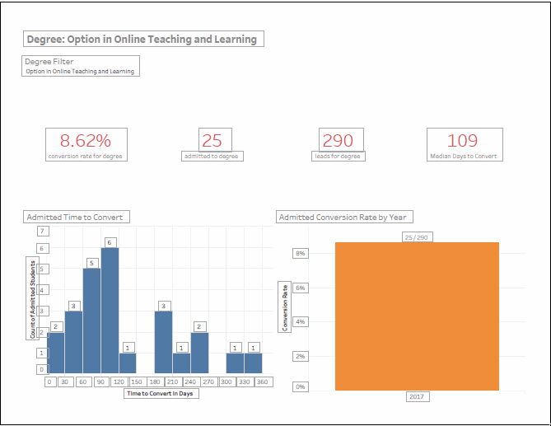
Conversion rates for 2017-2018
b.) We are encouraging the OTL Certificate students to continue by applying for the master’s program.
c.) Marketing webinars were hosted for Fall 2017 and Spring 2018 admission cycle
d.) Marketing communication funnel (aka “drip campaign”) started for Fall 2017 admission cycle. The marketing campaign consists of 15 emails within a 6-month timespan. Emails are sent to leads every 4 – 14 days, depending on how long they’ve been on the list. For example,
- Email #1 - Day 1 – general info about MS OTL
- Email #2 - Day 4 – overview of the profession
- Email #3 – Day 9 – Student Success Story #1
- Email #4 – Day 16 – Program Benefit #1

e.) Various automated emails are sent based on action from the lead. For example, once they have submitted an application in Cal State Apply, they get a “thank you for applying” email. Once they’ve applied they are sent various email reminders to submit documents or if they are finally admitted to the program, they get a generic “welcome to the program” email from Program Director.

f.) There are two different types of “eblasts” for MSEd-OTL
- Applying to the program: 4 weeks and 1 week before the application period ends
- Registration: 1 – 2 weeks after the registration period starts and 1 week before registration period ends
g.) Information requests with additional questions are answered by the program coordinator within 1 – 2 business days
h.) A program Facebook page was established 11/2017 where we post online teaching and learning related articles 1-2 times per week.

Program Changes and Needs
Report on changes and emerging needs not already discussed above. Include any changes related to SB1440, significant events which have occurred or are imminent, program demand projections, notable changes in resources, retirements/new hires, curricular changes, honors received, etc., and their implications for attaining program goals. Organize your discussion using the following subheadings.
Overview:
The M.S. Education, Concentration in Online Teaching and Learning (MSEd-OTL) is self-supporting Special Program administered through University Extension.
Curriculum:
The curriculum was updated and conversions made to the courses for semester delivery.
Students:
MSEd-OTL is generally a professional development program that accepts students with prior teaching experience.
Term | Enrollment by Term
2174 Fall Qtr 17 | 39
2181 Win Qtr 18 | 33
2182 Spr Qtr 18 | 48
2183 Sum Qtr 18 | 20
Total | 140

Since this is a self-support program through University Extension, enrollment numbers are always carefully tracked. Multiple marketing campaigns have been successful and enrollment has increased since 2012-2013. The last three years have been steady.
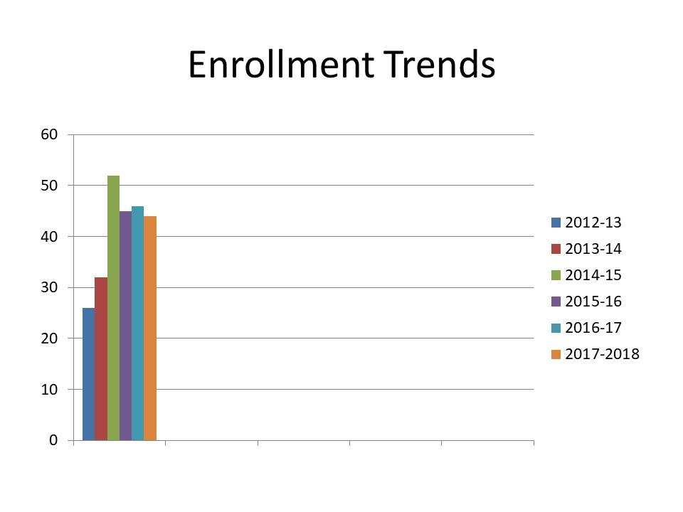
Enrollment Trends
During the year, 21 students graduated with the M.S. Ed, Concentration in Online Teaching and Learning degree. There were 18 female students and 3 male students. The age range was 23 – 72 years old with the average age being 37 years old at graduation. Ethnicity: European-7, Chinese-1, Salvadoran-3, Filipino-1, Black/African American-1, Asian-2, Other or Declined to state-6.
Years to Graduate | Count
1 | 2
2 | 17
9 | 2

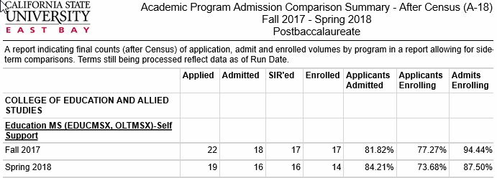Admitted applicants during open enrollment terms (Fall and Spring)
Faculty:
There were 4 new instructors this past year. Previously, all instructors who taught in the program had been teaching the same courses for over 10 years. The changes were due to retirement and health issues. Our online instructors work remotely and are located in Colorado, England, Washington, DC, Palo Alto, CA, and Texas. Our instructors are hired through University Extension with a temporary contract for each course. Each instructor teaches two courses each year on the average. The salary schedule is “Instructional Faculty, Special Programs,” class code 2322. The salary is determined by the number of students in the particular course taught.
One instructor will be retiring at the end of January, 2019 and four courses (including the Capstone Project course) will need new instructors.
Staff:
Staff includes a full-time Director and Program Manager. The program director will be retiring at the end of January, 2019 and she also teaches the Capstone Project course. A replacement for the Spring 2019 semester is currently under review by Academic Affairs.
Resources:
The MSEd-OTL program uses the University Extension facilities and equipment.

SUMMARY OF ASSESSMENT (suggested length of 1-2 pages)

  - Program Learning Outcomes (PLO)
List all your PLO in this box. Indicate for each PLO its alignment with one or more institutional learning outcomes (ILO). For example: “PLO 1. Apply advanced computer science theory to computation problems (ILO 2 & 6).”
PLOs
- Create a high quality, interactive online course in their discipline that demonstrates knowledge of learning theory and instructional design.
- Create a high quality, interactive online course in their discipline that applies understanding of recent technologies.
- Incorporate recommendations of recent research in online teaching and learning in the online course.
- Apply knowledge of learning differences and disabilities.
- Describe a rationale for the design features of the online course created, citing specific supporting research and best practices based on a comprehensive review of the literature related to online teaching and learning in their disciplines.

Institutional Learning Outcomes | PLO 1 | PLO 2 | PLO 3 | PLO 4 | PLO 5
Thinking and Reasoning: think critically and creatively and apply analytical and quantitative reasoning to address complex challenges and everyday problems. | X | X | X | X | X
Communication: communicate ideas, perspectives, and values clearly and persuasively while listening openly to others. | X | X | X | X | X
Diversity: apply knowledge of diversity and multicultural competencies to promote equity and social justice in our communities. | X | X | X | X | X
Collaboration: work collaboratively and respectfully as members and leaders of diverse teams and communities. | X | X | X | X | X
Sustainability: act responsibly and sustainably at local, national, and global levels. | X | X | X | X | X

ILO 1: Thinking and reasoning – Critical thinking is required on all assignments.
ILO 2: Communication - Peer to peer communication is required on the discussion board. Instructor to student communication is required.
ILO 3: Diversity – The course is accessible to people with disabilities. The nature of the fully online environment lends itself to anonymity. Students do not know the race or class of other students and sometimes don’t know the gender if a name is unisex and used by both males and females.
ILO 4: Collaboration – Peer to peer collaboration is required on the discussion board.
ILO 5: Sustainability – all learning activities, lessons, and assessments are online, saving paper. “Paper production, distribution, use and disposal require large amounts of energy and raw materials. Wise use suggests streamlining systems through efficient tools (i.e. online platforms) to minimize unnecessary use and waste. “(Yale Office of Sustainability, http://sustainability.yale.edu/participate/guide-going-green/paper-reduction-toolkit). Students are encouraged to take notes and collaborate electronically, saving paper and saving energy (gas for travel). This is an alternative to driving and avoids carbon emissions.
ILO 6: Specialized Discipline – online teaching and learning

Program Learning Outcome(S) Assessed
List the PLO(s) assessed. Provide a brief background on your program’s history of assessing the PLO(s) (e.g., annually, first time, part of other assessments, etc.)

The M.S. Ed, Concentration in Online Teaching and Learning program student learning outcomes are assessed using rubrics during the capstone courses. The capstone is the culmination of learning in the program, and measures what learners know, understand, apply, analyze, synthesize and evaluate the fundamental theory and practice in the discipline. The capstone has two components: a supporting paper consisting of 5 chapters and a developed online course. The paper entails a literature review, introduction of the learners, content, teaching/training experience, institutional constraints and opportunities, why the course was designed, and particularly an online course. The paper also is the supporting document for bringing theory to practice and explains the decisions made in the actual online course design process. The online course project demonstrates best practices in online teaching and learning.
This year, the design and development of the capstone online course was assessed. The first 2 PLOs relate to the online course development:
1. Create a high quality, interactive online course in their discipline that demonstrates knowledge of learning theory and instructional design.
2. Create a high quality, interactive online course in their discipline that applies understanding of recent technologies.

Summary of Assessment Process
Summarize your assessment process briefly using the following sub-headings.
Instrument(s): (include if new or old instrument, how developed, description of content)
The assessment instrument was the Quality Matters rubric, fifth edition. This was the first time this rubric was used. It was selected because CSUEB added a student license to use this rubric for course development. Quality Matters (QM) is an international, U.S.-based, non-profit organization specializing in standards, processes and professional development for quality assurance in online and blended learning. The rubric is based on research-supported and published best practices and uses a set of standards to review the design of online courses. The standards are listed in the Data Analysis chart below.
Sampling Procedure:
There were 22 capstone courses in the year. All capstone papers were included in the sample since the number is small.
Data Collection: Data was collected from the capstone rubrics at the end of each capstone course by the director of the program and instructor for the course. The capstone course is offered every term.
Data Analysis:
Category | Missing | Unacceptable | Meets Expectations | Exceeds Expectations
Introduction and Overview |  |  | 5 | 17
Learning Objectives |  |  | 5 | 17
Assessment and Measurement |  |  |  | 17
Instructional Materials |  |  | 3 | 19
Learning Activities and Learner Interaction |  |  |  | 22
Course Technology |  |  |  | 22
Learner Support |  |  | 17 | 5
Accessibility and Usability |  |  | 5 | 17

Summary of Assessment Results
Summarize your assessment results briefly using the following sub-headings.
Main Findings:
The online course development by capstone students met expectations or exceeded expectations.
Recommendations for Program Improvement: (changes in course content, course sequence, student advising)
Continue the capstone process of iterative peer-reviews, live video conferencing with instructor and update with the Quality Matters, 6th edition. Consider including a practicum in the capstone course for students to gain experience in online facilitation.
Next Step(s) for Closing the Loop: (recommendations to address findings, how & when)
Continue updating courses on an 18-month basis to reflect the latest research on online teaching and learning and technical development skills.

Assessment Plans for Next Year
Summarize your assessment plans for the next year, including the PLO(s) you plan to assess, any revisions to the program assessment plan presented in your last five-year plan self-study, and any other relevant information.
Next year PLO 3 and 4 will be assessed:
- 1. Incorporate recommendations of recent research in online teaching and learning in the online course.
- 2. Apply knowledge of learning differences and disabilities.

DISCUSSION OF PROGRAM DATA & RESOURCE REQUESTS
Each program should provide a one-page discussion of the program data available through CAPR. This discussion should include an analysis of trends and areas of concern. Programs should also include in this discussion requests for additional resources including space and tenure-track hires. Resource requests must be supported by reference to CAPR data only. Requests for tenure-track hires should indicate the area and rank that the program is requesting to hire. If a program is not requesting resources in that year, indicate that no resources are requested.
No resources are requested.

Discussion of Trends & Reflections
Notable Trends:
Summarize and discuss any notable trends occurring in your program over the past 3-5 years based on program statistics (1-2 paragraphs). You may include 1-2 pages of supplemental information as appendices to this report (e.g., graphs and tables).
A notable trend is the demand of the market and students for advanced courses in course development tools.
Reflections on Trends and Program Statistics:
Provide your reflections on the trends discussed above and statistics and supplemental information presented in this report.

Request for Resources (suggested length of 1 page)

Request for Tenure-Track Hires - none

Request for Other Resources - none

Appendix A

Course Grade Distribution by Course
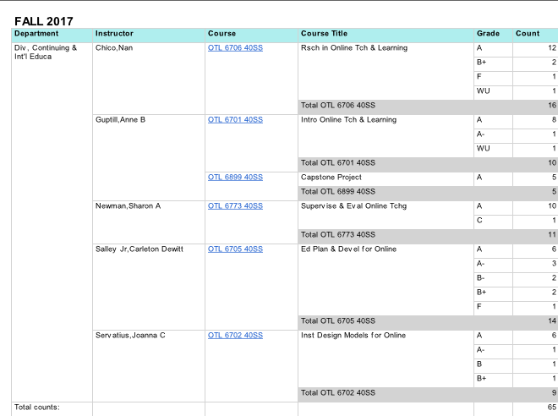
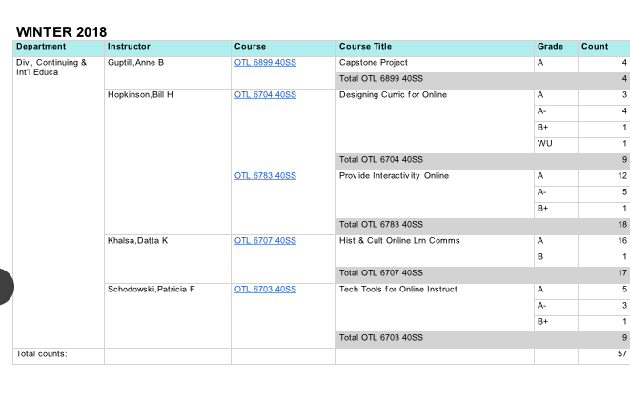

SPRING 2018
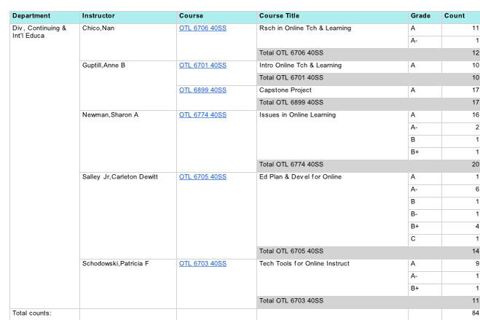

SUMMER 2018
