ACADEMIC SENATE
Committee on Academic Planning and Review

ANNUAL PROGRAM REPORT
College | CEAS
Department | Teacher Education
Program | M.S. in Education, Option in Educational Technology Leadership
Reporting for Academic Year | 2017-2018
Last 5-Year Review | 2015
Next 5-Year Review | 2019-2020
Department Chair | Eric Engdahl
Date Submitted | 10/10/2018

- SELF-STUDY

  - Five-year Review Planning Goals

The following outlines the status of items from the Educational Technology Graduate Program's current 5-year Plan (2015-2020). The five-year plan focuses on re-visioning and enhancing the academic quality of the Program.

- Instituting a three-tiered admission review process.
Applicants to our program were reviewed in a three-tier process:
    - initial screening with their GPA qualification and completeness of required document submission by the program secretary,
    - the program coordinator’s review,
    - program admission committee review.

- Digitalizing application process.
Since November 2016, we have implemented department application form from hard-copy to digital format. Prospective applicants submit their application data via google forms and the department collects their data via google spreadsheet.

- Elevating Educational Technology Graduate Program from an option in education to a standalone graduate program.

- Increasing the quality of Educational Technology courses by re-designing some courses contents and submitting for Quality Matters (QM) National Online/Hybrid review.

- Smoothing the transition from semester to quarter by re-designing all Educational Technology courses.

- Increasing candidate’s use of tablet or handheld devices and candidate’s application of such devices to comply with STEM and NGSS standards.

- Helping candidates to develop and demonstrate analytical skills in reviewing literature and interpreting informational data.

- Hiring qualified faculty for the program to support the program’s curricular needs.
Although we have already had two highly qualified full-time faculty members, one adjunct faculty with extensive experiences and skills in the field of educational technology was hired to teach a few courses in our program. The adjunct faculty, Ms. Arrash Jaffarzardeh, has been well accepted by our students and regularly taught in our program in the past four years. With one of the two full-time faculty, Dr.
Bijan Gillani, will start FERPing in Fall 2018, we hope we will have a tenure-track faculty position open in the near future to maintain the quality of our teaching.

- Increasing funding for updating instructional equipment, hardware and software.
Funding for equipment, hardware, and software has been addressed with the implementation of the university-wide student fee and funding system from the college. It has been a great relief to see faculty able to teach with the most cutting edge equipment, such as Mondopad and Panopto technology.

Five-year Review Planning Goals Progress
In 2017-18, the program made the following tremendous progress.

- Instituted a three-tiered admission review process. In the academic year, 2017-2018, we implemented
a three-tiered admission review process to review all program applicants:
a. Initial screening with their GPA qualification and completeness of the required documents by the program secretary. Only those applicants who met the basic GPA requirements and completed the submission of all required documents were forwarded to the program coordinator for further review.
- The 2nd stage of admission review was carried out by the program coordinator. For highly qualified applicants, such as applicants with a high GPA, good recommendation letters, and demonstrated passion for our program, the program coordinator would admit without a provision.
- The 3rd tier of admission review process was conducted by the program admission committee which consists of two full-time faculty members and one adjunct faculty. The committee reviews applicants whose GPA and technological skills were on the borderline.
The three-tiered admission review process has been implemented and has successfully addressed the quality of applicants. Due to the organized admission review process, we admitted 22 applicants from the 38 applications submitted in Spring 2018.

- Elevating the program from an option in education to a stand-alone graduate program in the Department of Teacher Education: The M.S. in Education, Option in Education Technology Leadership was approved by the Chancellor’s Office and this campus to become to an M.S. in Educational Technology starting Fall 2018. To enhance the quality of the program and to provide maximum degree benefits for our candidates, the program coordinator prepared documents required by the Chancellor’s Office to justify the need and benefit of such an elevation. The Chancellor’s Office approved the elevation for fall 2018.

- Increasing the quality of our Educational Technology courses by re-designing some course content and submitting the courses for Quality Matters (QM) National Online/Hybrid review.
By the end of academic year 2017-2018, three courses had been redesigned, submitted for QM review, and received QM certificates. They are EDUI 610 Web as an Interactive

Educational Tool, EDUI 640 Research in Educational Technology, and EDUI 670 Principles of Instructional Design. Both EDUI 610 and EDUI 640 are core courses and EDUI 670 is an elective. With the receiving of national online/hybrid course review certificates, we are proud to say that 50% of the core courses in our Educational Technology program meet national online/hybrid courses standards.

- Smoothing the transition from quarter to semester by re-designing all Educational Technology courses.
The year of 2017 -2018 was a busy year for us because we have to make sure all courses are re-designed and ready for the transition from quarter to semester. Faculty successfully participated in several workshops held by the Office of Online Campus and Faculty Development Center and are able to apply what they learned in the workshops to re-design courses to meet semester needs.

- Increasing candidate’s use of tablet or handheld devices and candidate’s application of such devices to comply with STEM and NGSS standards.
A proposed course and projects were accepted and we have implemented them in our program in the past five years. EDUI 6250 iPad Application development proved to be highly successful. Students who learn to develop iPad/iPhone application have become much more marketable toward their career goals. A STEM course, EDUI 6240 Math Science and Technology, takes an integrated, interdisciplinary, and collaborative complimentary approach. This approach has been highly successful. Through the course, we also have integrated the Next Generation Science Standard (NGSS) in curriculum.
Furthermore in our interdisciplinary approach we have connected to Common Core Standard, as well as Mathematics Standards. According to students’ input, they highly enjoy such approach and they think it is the most practical and useful approach to teach STEM.

- Helping candidates to develop and demonstrate analytical skills in reviewing literature and interpreting informational data.
To reach the goal, the instructor designs and develops new course contents, activities, research tools, assignments, and assessments for EDUI 640, Research in Educational Technology class to help improving candidate’s analytical skills in reviewing literature and analyzing research data. New online research tools, such as diigo, google forms, and spreadsheets, are introduced in the research class. A new assignment, such as online bibliography collection with Zotero has been implemented.

- Hiring qualified adjunct faculty in the program to support the program’s curricular needs.
Although we have already had two highly qualified full-time faculty, one adjunct faculty with extensive experiences and skills in the field of educational technology was hired to teach a few courses in our program. The adjunct faculty, Ms. Arrash Jaffarzardeh, has been well accepted by our students and regularly teaches in our program in the past four years. With one of the two full-time faculty, Dr. Bijan Gillani, will start FERPing in Fall 2018, we hope we will have a tenure-track faculty position open in the near future to maintain the quality of our teaching.

- Increasing funding for updating instructional facilities, equipment, hardware and software.a. Working hard with the professional staff at CSUEB to solve the technical problems in the classroom of VBT136.
- Since Fall 2011, we have been able to apply Panopto technology, the technology with lecture capture capability also called East Bay Replay, to record our face-to-face teaching sessions so that students are able to review the course contents at any time they wish.
- Since Fall 2015, we have applied Mondopad and Mikogo technologies to live broadcasting between Hayward and Concord campuses. With the integration of Mondopad and Mikogo technology, we are also to connect our students at both Hayward and Concord campuses.
- Starting from Spring 2016, we have Zoom (Professional Edition) for faculty to carry out online synchronous instruction regularly.

Program Changes and Needs

In order to continue our success in preparing our students for the current job market demands, the Educational Technology Graduate Program has made several successful changes, yet we are also in need of new faculty, facilities, and latest technological equipment. In the academic year of 2017-2018, the changes and updates that our program has made from last year’s report include curriculum, faculty, resources, and assessment.

Program Changes

- Starting Fall 2018, the M.S. in Education, Option in Educational Technology Leadership was elevated as a standalone graduate program, M.S. in Educational Technology. Before being approved by the Chancellor’s Office and CSUEB, the graduate program in Educational Technology was an option in education. To enhance the quality of program and to provide maximum degree benefits for our candidates, the program coordinator prepared documents to justify the benefits and needs of such elevation.
- Curriculum:
By the end of academic year 2017-2018, three Educational Technology courses had been redesigned, submitted for QM review, and received QM certificates: EDUI 610 Web as an Interactive Educational Tool, EDUI 640 Research in Educational Technology, and EDUI 670 Principles of Instructional Design. Both EDUI 610 and EDUI 640 are core courses and EDUI 670 is an elective. With receiving certificates for national online/hybrid course review, we are proud to say that 50% of the core courses in our Educational Technology program meet national standards.

- Resources:
We worked hard with the professional staff at CSUEB to solve the technical problems in the classroom of VBT136. Since Fall 2011, we have been able to apply Panopto technology, the technology
with lecture capture capability also called East Bay Replay, to record our face-to-face teaching sessions so that students are able to review the course contents at any time they wish. Since Fall 2015, we have applied Mondopad and Mikogo technologies to live broadcasting between Hayward and Concord campuses. Since Spring 2016, we have started to use the Zoom profession version for our online synchronous instruction. As technology has advanced rapidly, our program needs to purchase new facilities, such as a 3D printer for EDUI 620 Math, Science, and Technology class, and Google cardboard for students to explore virtual reality and augmented reality.

- Assessment:
We have built a holistic 5-year assessment plan with rubric for all assignments in the courses we offered.
In the past year, we changed the assessment data collection tool from TaskStream to Blackboard. Students performance assessment data on signature assignments was collected in Blackboard. Such a
change helps us to synchronize performance data for all students on one platform and also helps to reduce additional subscription costs to TaskStream for students.

Starting in Fall 2018, we have chosen two PLO’s to align with CSUEB ILO’s with detailed assessment strategies and plans. Specification can be found in the appendix.

Program Needs

- Application Process:
Since November 2016, we have implemented new student’s application data submission via google forms and data collection via google spreadsheet. Although we still accept hard-copy applications, we hope to move toward all electronic collection in the future. We also need some training for faculty and staff in getting familiar with the data collection systems to better serve our students.

- Curriculum:
Although a few new apps and new research tools have been added to our curriculum to enhance student learning, our program needs a curriculum budget for faculty to purchase or subscribe to updated, emerging, and needed curriculum tools to keep up to date with current technology.

- Faculty:
Although we possess a superior faculty group which makes it possible to run an extremely
complex curriculum and information technology environment, one full-time faculty, Dr. Bijan Gillani, will take Faculty Early Retirement Program (FERP) starting Fall 2018. Our program is in desperate need to hire a new full-time faculty member soon.

SUMMARY OF ASSESSMENT
  - Program Student Learning Outcomes

Educational Technology Master Program, Program Student Learning Outcomes (PLOs) include:

- Assess the importance and use of technology to support diverse student’s learning.
- Identify and investigate educational technology theories and instructional design principles to generate new ideas, projects, and materials for diverse students.
- Create and develop effective instructional or e-learning materials by choosing and applying appropriate tools and design theories individually and collaboratively.
- Gather, use, and analyze data, bibliographic and other resources of materials extensively and critically.
- Write and present scholarly findings and projects independently.

Our program curriculum map shows alignment of the Program Student Learning Outcomes (PLOs) and CSUEB ILOs. You can find the matrix in the appendix at the end of the document.

Starting from Fall 2018, we have specifically chosen the following two PLO’s to align with two CSUEB ILO’s with assessment strategies and plans.

PLO 3: Create and develop effective instructional or e-learning materials by choosing and applying appropriate tools and design theories individually and collaboratively.
--- to be aligned with CSUEB ILO: Thinking and Reasoning > Creative Thinking.
--- Aligned Courses: EDUI 610, EDUI 620, and EDUI 693.
--- Aligned Assignments/Assessment: Project, Website project, Exit project/ rubric

PLO 4: Gather, use, and analyze data, bibliographic and other resources of materials extensively and critically.
--- to be aligned with CSUEB ILO: Communication > Information Literacy
--- Aligned Courses: EDUI 640 and EDUI 693.
--- Aligned Assignments/Assessment: Zotero bibliography collection, literature review, Project proposal/ rubric

The alignment matrix is also attached as an appendix at the end of the document.

Program Student Learning Outcome(s) Assessed

All of the five Program Student Learning Outcomes (PLOs) have been assessed in the past academic year. The specific course numbers that used to assess each PLO are listed below:

- Assess the importance and use of technology to support diverse student’s learning. (EDUI 6110, EDUI 6200, EDUI 6350, EDUI 6600, EDUI 6899)
- Identify and investigate educational technology theories and instructional design principles to generate new ideas, projects, and materials for diverse students. (EDUI 610, EDUI 6200, EDUI 6350, EDUI 6240, EDUI 6600, EDUI 6210)

Create and develop effective instructional or e-learning materials by choosing and applying appropriate tools and design theories individually and collaboratively. (EDUI 6200, EDUI 6350, EDUI 6600, EDUI 6210, EDUI 6005, EDUI 6250, EDUI 6899)
  - Gather, use, and analyze data, bibliographic and other resources of materials extensively and critically. (EDUI 6500, EDUI 6350, EDUI 6899, EDUI 6909)
  - Write and present scholarly findings and projects independently. (EDUI 6500, EDUI 6899, EDUI 6909)

- In response to our Program Learning Objective #3, we add new course contents and redesign activities, assignments, and assessments for EDUI 6110, Web as an Interactive Educational Tool class to help improving candidate’s creativity and designing skills in developing effective instructional or e-learning materials by choosing and applying appropriate tools and design theories individually and collaboratively. One of the required assignments in the class is the final website development. Students are required to evaluate various learning theories and to identify and apply a sounded theory to support their design of an effective instructional website. Our collected data has shown that our students’ creativity and designing skills in developing an effective instructional website have been improved with the integration of the redesigned activities and assignment.

Our Program Learning Objective #3 can also be assessed in the E-textile assignment in EDUI 6240, Math, Science, and Technology class. In the class, students explore various tools to design and develop effective instructional materials. The E-Textile assignment requires students to “create and develop effective instructional or e-learning materials by choosing and applying appropriate tools and design theories individually and collaboratively.”

- In response to our Program Learning Objective #4 particularly, we design and develop new course contents, activities, research tools, assignments, and assessments for EDUI 6500, Research in Educational Technology class to help improving candidate’s analytical skills in reviewing literature and analyzing research data. New online research tools, such as Zotero, diigo, google forms, and google spreadsheet, are introduced and exercised in the class. A new assignment, online bibliography collection with Zotero has been implemented since Fall 2016. Our collected data has shown that our students’ analytical skills in reviewing literature and analyzing information data have been improved with the integration of the new tools and new assignment.

Our Program Learning Objective #4 can also be assessed in the project proposal assignment in EDUI 6899, Master Project. This is a capstone class which all students are required to complete in order to graduate. The project proposal assignment requires students to “gather, use, and analyze data, bibliographic and other resources of materials extensively and critically” following a systematic approach to support and propose the design and development of their master projects.

  - Summary of Assessment Process

Our program assessment system has been developed and confirmed by faculty in the program,

the department chair of Teacher Education, University Curriculum Committee, and the University Senate in Spring 2016. The specific system includes initial, midpoint and pre- culminating, and culminating assessment: Decisions about candidate performance are based on multiple assessments made at multiple points before program completion. The models focus on student performance; with early, mid-point and summative measures. Authentic assessments are a focal point for program assessment.

The assessment tools and data source that we use for the assessment process include:
- Signature assignments including paper, proposal, project, case study analysis, and artifacts.
- Assignment rubrics
- Student course evaluation
- Informal student’s email feedback
- Course award and certificate
- Exit survey

The evidence that we have used to document changes include syllabi, course lectures, Panopto recordings, online session recordings, student’s projects, course evaluation, Blackboard online course materials, etc.

  - Summary of Assessment Results

- In response to our Program Learning Objective #3, we add new course contents and redesign activities, assignments, and assessments for EDUI 6110, Web as an Interactive Educational Tool class to help improving candidate’s creativity and designing skills in developing effective instructional or e-learning materials by choosing and applying appropriate tools and design theories individually and collaboratively. One of the required assignments in the class is the final website development. Students are required to apply sounded learning theories to design an effective instructional website. Our collected data has shown that our students’ creativity and designing skills in developing an effective instructional website have been improved with the integration of the redesigned activities and assignment. According to the data collected by the University at https://data.csueastbay.edu, we found that an overall course outcomes increase in EDUI 6110 from 77% in Fall 2016 to 100% in Fall 2017. (See Figures 1, 2, and 4.)

- Our Program Learning Objective #3 can also be assessed in the E-textile assignment in EDUI 6240, Math, Science, and Technology class. In the class, students explore various tools to design and develop effective instructional materials. The E-Textile assignment requires
students to “create and develop effective instructional or e-learning materials by choosing and applying appropriate tools and design theories individually and collaboratively.” According to the data collected by the University at https://data.csueastbay.edu, we found that an overall course outcomes increase in EDUI 6110 from 87% in Fall 2016 to 100% in Fall 2017. (See Figures 5, 6, and 8.)

- In response to our Program Learning Objective #4 particularly, we design and develop new

course contents, activities, research tools, assignments, and assessments for EDUI 6500,
Research in Educational Technology class to help improving candidate’s analytical skills in reviewing literature and analyzing research data. New online research tools, such as Zotero, diigo, google forms, and google spreadsheet, are introduced and exercised in the class. A new assignment, online bibliography collection with Zotero has been implemented since Fall 2016. With the addition of applying the research tool, Zotero, and the incorporation of learning activities of Google Forms, literature review analysis, and critique, we found an overall course outcomes increase in EDUI 6500 from 91% in Fall 2016 to 95% in Fall 2017. (See Figures 1, 2, and
3.)

- Our Program Learning Objective #4 can also be assessed in the project proposal assignment in EDUI 6899, Master Project. The project proposal assignment requires students to “gather, use, and analyze data, bibliographic and other resources of materials extensively and critically” following a systematic approach to support and propose the design and development of their master projects. The project proposal is one of the two major assignments in EDUI 6899 class. According to the data collected by the University at https://data.csueastbay.edu, we found that an overall course outcomes increase in EDUI 6899 from 87% in Spring 2017 to 100% in Spring 2018. (See Figures 5, 6, and 7.)

- With the successful course contents redesign for EDUI 6210 Principles of Instructional Design from a hybrid to a totally online format, the course received a QM (Quality Matters) online course certificate in Spring 2017.

- The course, EDUI 6500 Research in Educational Technology, was also successfully redesign in course contents and format from quarter to semester and from hybrid to totally online, the course also received a QM (Quality Matters) online course certificate in December 2017.

- With successful planning, our educational Technology master program has been elevated as a standalone graduate program instead of an option in education. Before Spring 2017, our Educational Technology program was an option in education. To enhance the quality of program and to provide maximum degree benefits for our candidates, we prepared tons of documents to justify the benefits and needs of such elevation and then finally approved by CSUEB Senate Committee. With such elevation, we were happy to issue 20 M.S. Degree in Educational Technology in Spring 2017.

- STATISTICAL DATA

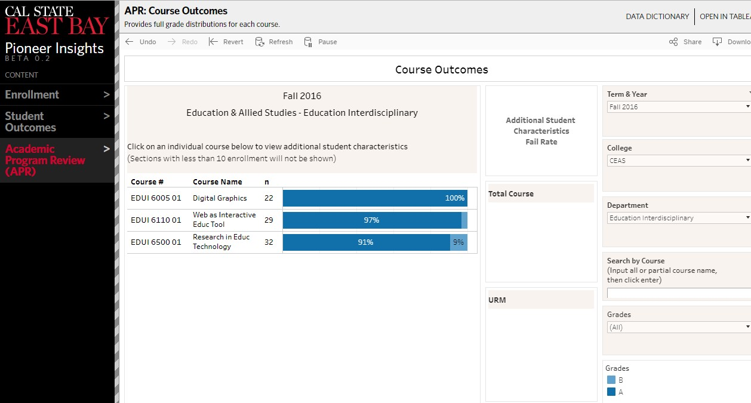Below are the data screen shots and charts that show the summary of our assessment results: Figure 1: Fall 2016 Course Outcomes Data screen shot from https://data.csueastbay.edu

Figure 2: Fall 2017 Course Outcomes Data screen shot from https://data.csueastbay.edu
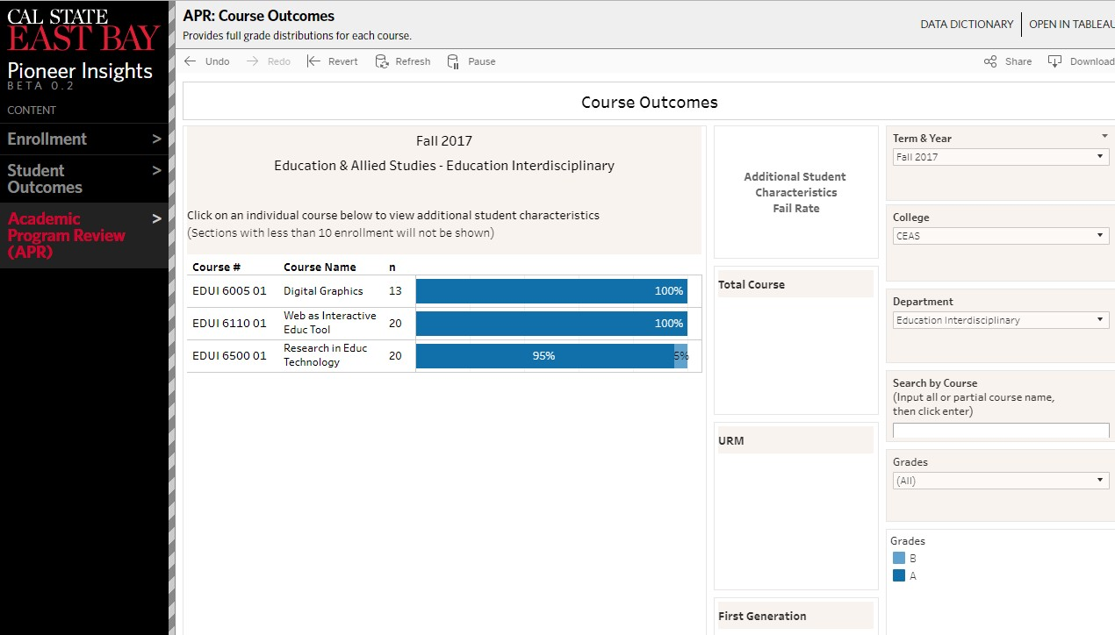

Figure 3: Fall 2016 and Fall 2017, EDUI 6500 Course Outcomes Comparison Chart
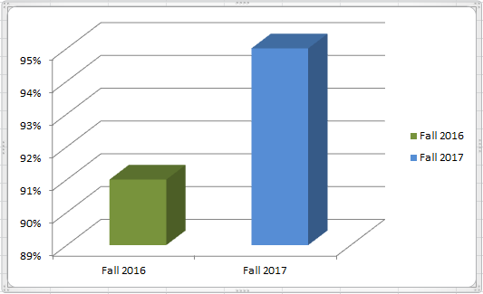

Figure 4: Fall 2016 and Fall 2017, EDUI 6110 Course Outcomes Comparison Chart
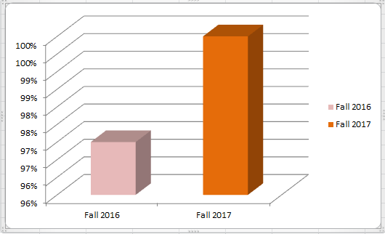

Figure 5: Spring 2017 Course Outcomes Data screen shot from https://data.csueastbay.edu
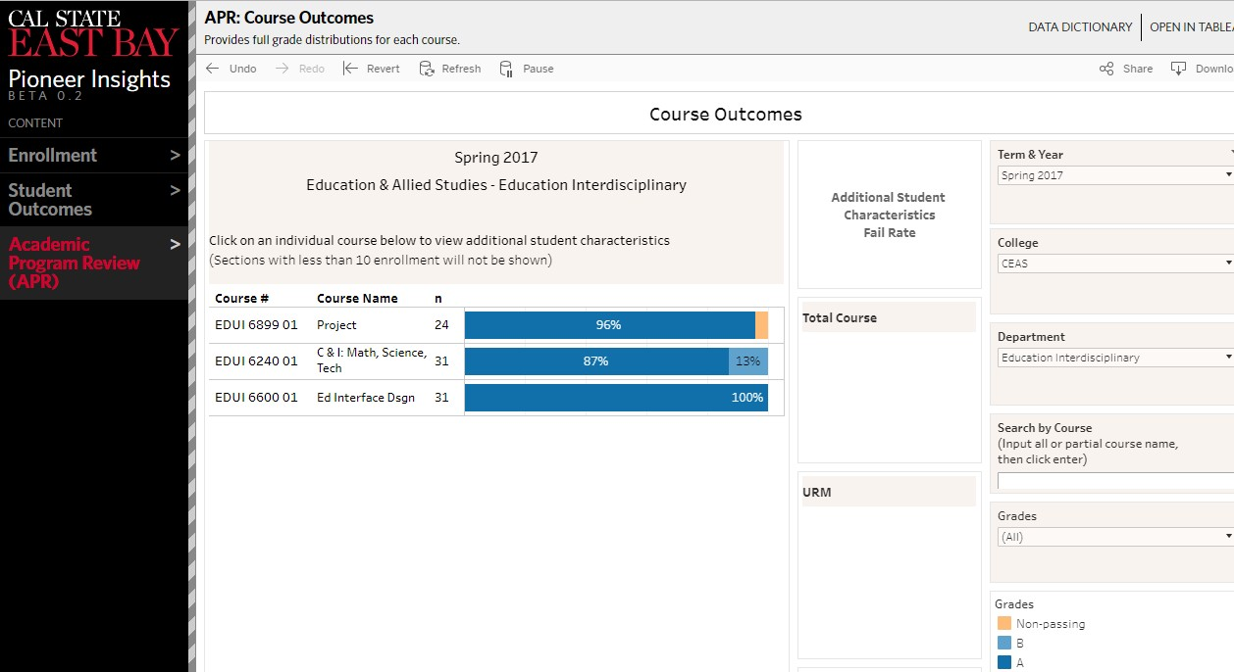

Figure 6: Winter 2018 Course Outcomes Data screen shot from https://data.csueastbay.edu
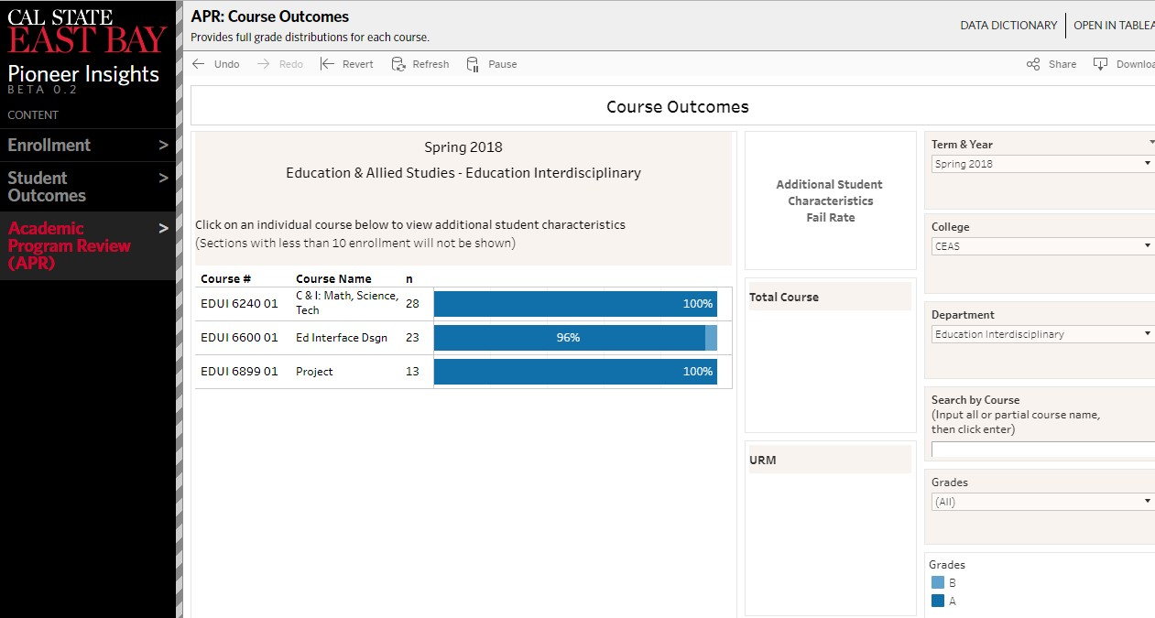

Figure 7: Spring 2017 and Spring 2018, EDUI 6899 Course Outcomes Comparison Chart
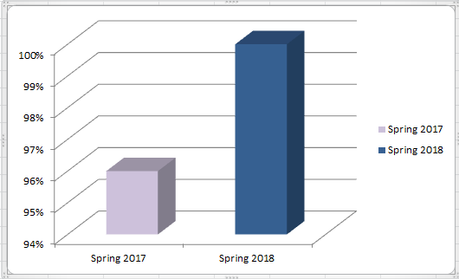

Figure 7: Spring 2017 and Spring 2018, EDUI 6240 Course Outcomes Comparison Chart
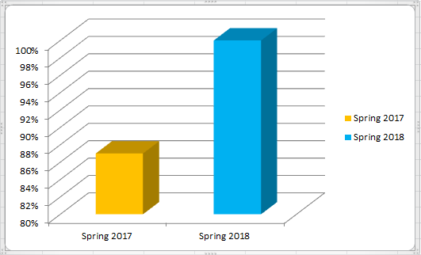

Appendix

Curriculum Map #1:
PSLOs Aligned to Required and Elective Courses in MS in Educational Technology
  - Provide a course title and new number for all required and elective courses. Indicate if required
(R) or elective (E) course
  - For all required courses, use I = Introduce, D = Develop, M = Master, A= Assess.
PLOs | R/E | PSLO 1 | PSLO 2 | PSLO 3 | PSLO 4 | PSLO 5
EDUI 6110,  Web as an Interactive Edu Tool | R | I | I | I | I | I
EDUI 6200,  Theories & Design of E-  learning | R | D | D | D |  | I
EDUI 6240,  Math, Science, &  Tech | R | M | M | D |  | I
EDUI 6500,  Research in  Educational Technology | R | M | M | M | D | M
EDUI 6250,  Mobile Applications for Educators | E | I | D | D
EDUI 6005,  Digital Graphics | E | D | D | D
EDUI 6210,  Principles of Instructional Design | E | I | D | M |  | D
EDUI 6315  Current Technologies | E | D | D | D
EDUI 6900,  Independent  Study | E | A | A | A | A | A
EDUI 6899,  Project | R | M | M | M | M | M
EDUI 6420,  Technology Internship | E | A | D | A
EDUI 6909,  Dept. Thesis | E | A | A | A | M | M

Curriculum Map #2: CSUEB, ILOs Aligned to PSLOs for Educational Technology Master Program

Institutional Learning Outcomes | PSLO 1 | PSLO 2 | PSLO 3 | PSLO 4 | PSLO 5
Thinking and Reasoning: think critically and creatively and apply analytical and quantitative reasoning to address complex challenges and everyday problems. |  | √ | √ | √ | √
Communication: communicate ideas, perspectives, and values clearly and persuasively while listening openly to others. |  | √ |  | √ | √
Diversity: apply knowledge of diversity and multicultural competencies to promote equity and social justice in our communities. | √
Collaboration: work collaboratively and respectfully as members and leaders of diverse teams and communities. |  |  | √ | √ | √
Sustainability: act responsibly and sustainably at local, national, and global levels. |  |  |  |  | √

CSU East Bay ILO-PLO Assessment Alignment

Name of College: CEAS

Name of Program: Educational Technology, M.S.

PLO 1: Create and develop effective instructional or e-learning materials by choosing and applying appropriate tools and design theories individually and collaboratively.

PLO 2: Gather, use, and analyze data, bibliographic and other resources of materials extensively and critically.

Institutional Learning Outcomes (Definitions pg.2) |  | PLO 1 | PLO 2 | Course # | Fall | Spring | Assignment/ Assessment (use legend, page 2)
Thinking and Reasoning | Critical Thinking
 | Quantitative Reasoning
 | Creative Thinking | X |  | EDUI 610 EDUI 620 EDUI 693 | X | X X | - Project / rubric  - Website project/ rubric  - Exit project/ rubric
Communication | Written Communication
 | Oral Communication
 | Information Literacy |  | X | EDUI 640  EDUI 693 | X | X | - Zotero bibliography collection/ Rubric  - Write a literature review/ rubric  - Project proposal/  rubric
Diversity | Diversity
 | Social Justice
Collaboration | Collaboration and Teamwork
 | Leadership
Sustainability | Sustainability
 | Social Responsibility Citizenship
 | Ethics

