Professional Development & Training Opportunities
April 2024
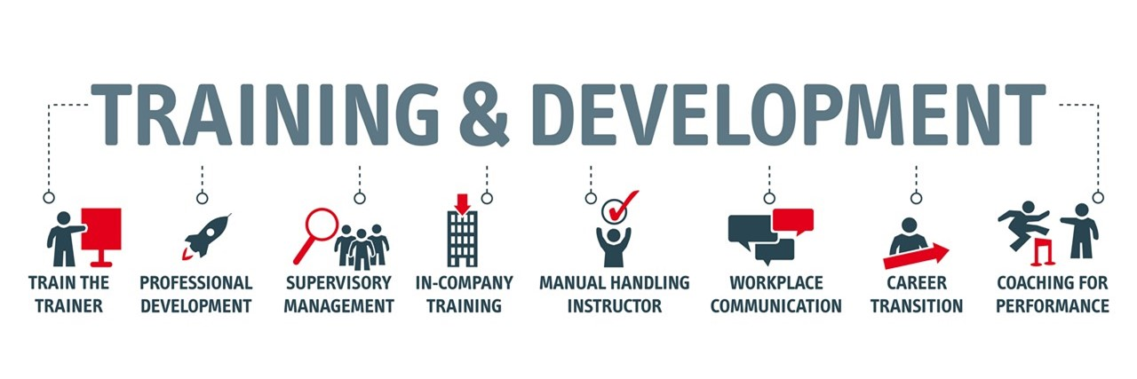
Human Resources & Payroll Services is proud to offer professional development webinars, online resources and training classes for March 2024. These resources are aimed at providing opportunities for employees to gain, develop and enhance professional skills to assist in their everyday work environment. All sessions are free of charge. All staff members are encouraged to participate with your MPP manager’s approval.

Adult CPR/First Aid
University Union– Thursday, 4/4 9:00AM-1:00PM REGISTER HERE Adult CPR/ AED course trains participants to give basic CPR and use an automated external defibrillator (AED) in a safe, timely, and effective manner. Upon completion of course requirements, participants receive a CPR/AED course completion certification which is valid for two years.

Social Security and Medicare
(Zoom) - Tuesday, 4/16 2:00PM-3:00PM Register here Social Security is part of the retirement plan of almost every American worker. Know how the system works and how much you will receive from Social Security when you retire. Registration is open to spouses.

CalPERS
(Zoom) – Tuesday, 4/17 at 1:00PM REGISTER HERE It is important to review your CalPERS benefits to know if you are on the right path. Learn about retirement, health benefits, and your retirement options.

1St United Credit Union
Teens & Money (Zoom) - REGISTER HERE Guide young adults to money management techniques that can last a lifetime. Attendees will learn effective money management, how to prepare for common bills, checking and savings account requirements, credit building (and using it wisely), and investment options.
Session 1: Tuesday, April 9, 2024 | 10:30 - 11:30 a.m.
Session 2: Thursday, April 18, 2024 | 5:30 - 6:30 p.m.

Life Matters
Dealing with Triggers-Tuesday, 4/23 2:00PM-3:00PM Register Here A trigger is when we react to a current situation with feelings and emotions from a prior negative experience. Learn how to overcome your triggers by addressing, processing, and resolving them. Content includes:
- The nine categories of triggers
- How triggers impact the brain and thus our behavior
- Three personal areas triggers target
- Three common feelings that triggers activate
- The role relationships play in activating triggers
- Tools for handling triggers

Cross-Campus Collaboration
Diversity, Inclusion and Equity 101 4/10 11:00am-12:00pm Register Here

Decisions, Decisions! Creative
Problem Solving and Decision
Making Techniques 4/11 9:30am-11:30am Register Here

Virtual Stepping Beyond-
Customer Service 4/16 10:00am-11:30am Register Here

Impact of Learning Styles in
the Workplace 4/18 2:00pm-3:00pm Register Here

Facilitating Challenging Conversations:
Managing Hot Moments 4/19 9:30am-12:00pm Register Here

S.M.A.R.T. Goals 4/19 1:00pm-2:00pm Register Here

Exposing Hidden Bias 4/25 10:00am-11:30am Register Here

If you have any questions, please contact Training and Professional Development 5-4024

