Enrolling for Classes
The process of enrolling for classes and choosing a great schedule can seem daunting. But once you know the process, you’ll fly through it in no time! We do recommend meeting with your major adviser and Project IMPACT’s Academic Adviser at least once a year to make sure you are on track to graduation.
Step One – When to Enroll?
Check the Important Dates on the main CSU East Bay website. You can just type ‘important dates’ into the search bar and it will take you to the page. Select the term you plan to enroll for and you will see the dates for the ‘First Enrollment Period.’ As a member of Project IMPACT you automatically have priority registration and first pick of classes. Make sure to use this perk!
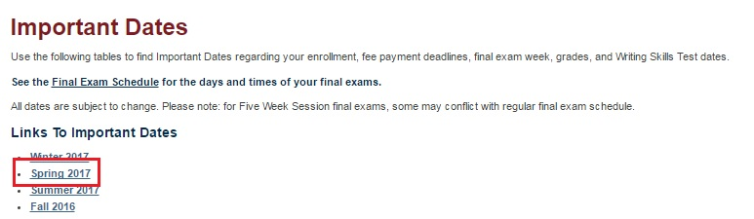
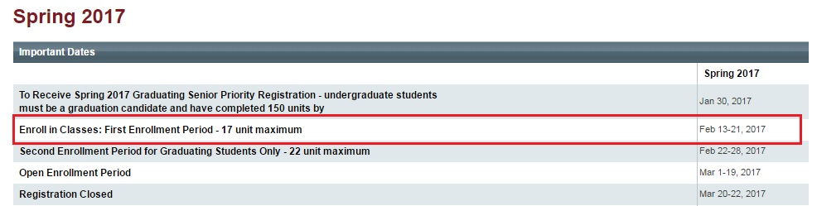
Put this date in your calendar to remind you!

Checking your enrollment date
You should have access to the first enrollment period each term. How do you know if you DO? In your student center you will see a section that lists enrollment dates and times – check to make sure that the date listed is in the first enrollment range.
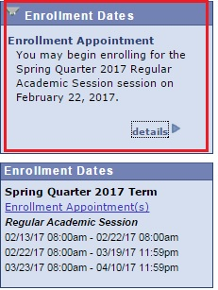

Step Two – What Classes Do I Need?
Every Student needs to complete two sets of course requirements to get their degree, their Major Requirements and their General Education Requirements. You will find the classes you may need in a few different places. It helps to have a blank sheet of paper for this process so you can take note of courses you need.
General Education (or GE) Requirements are divided into categories and there are many different classes that will meet each requirement. As you complete each category – or when your transfer credit is reviewed and applied to GE – you will see the sections marked as complete on your Degree Audit Report.
Check your Degree Audit Report for Needed Areas of GE (see Reviewing your Degree Audit Report handout for details) take note of the GE areas needed (B2, C3 etc)
Major Requirements are available in the University Catalog or on sheets that may be provided by your major adviser or department. For many majors, they are also available in your Degree Audit Report – just like GE requirements.
If they are not available in your Degree Audit report, you can check them any time online. See details below:
Typically, it’s a good idea to take major courses in order (the 1000 level courses first, then the 2000 courses, 3000 courses etc.) Generally, this means you will complete any prerequisite lower division courses before attempting to take upper division courses. You can see if courses have prerequisites in the course details (see Searching for Classes handout)

University Catalog
To access the university catalog, first click the menu option from the CSU East Bay homepage and select University Catalog
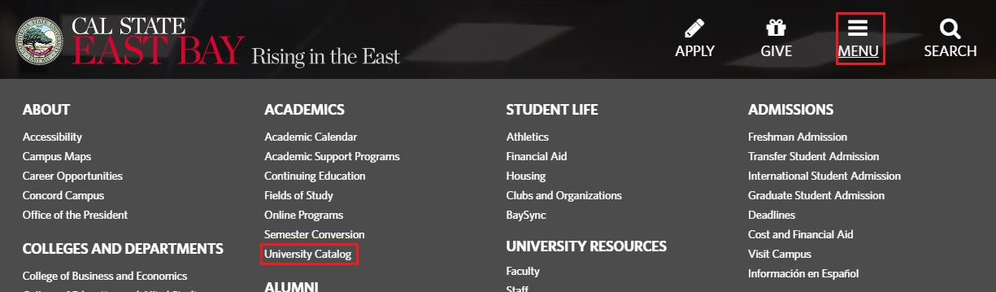
Next, select Programs of Study by Degree Type from the left hand menu.
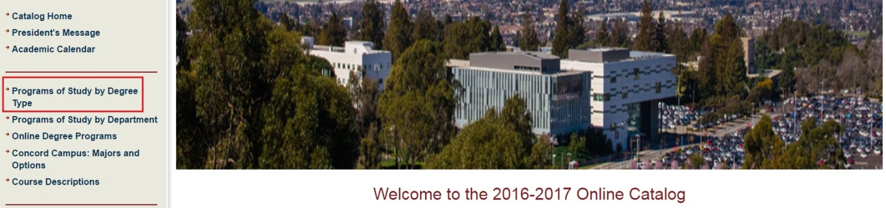
Then, select your major and option from the list. All of the BA degrees are listed first, followed by the BS degrees, the Minors and the Masters degrees.
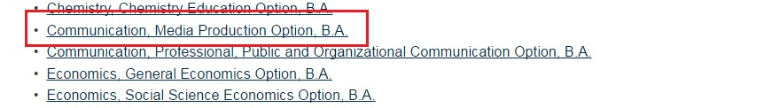
Lastly, you will see all of the course requirements for your major. Click on any course to read a description and see any prerequisite courses.
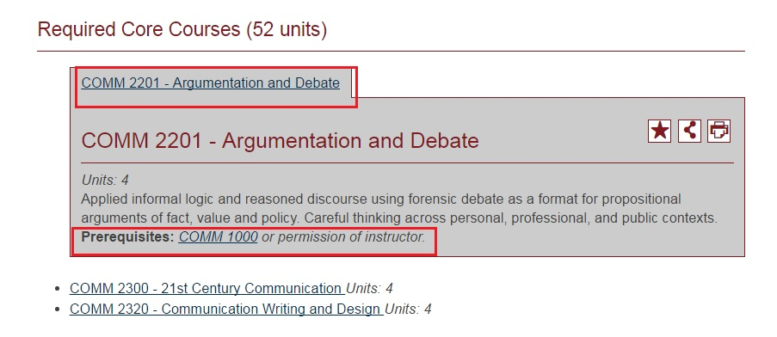

You can see the courses you have completed in your Degree Audit Report, if that is available. You can also view them in your Course History. I recommend keeping a tracking sheet of your major requirements if they are not listed in your DAR. Major sheets are available from most department offices or you can make your own by copying and pasting your major requirements from the University Catalog into a word document.
To view your course history, select Course History from the drop down menu in your Student Center.
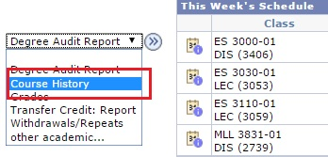
You will then see a list of all the courses you have taken at CSUEB or transferred in. You can see the course numbers, the quarter you took the class, the grade you got and if it meets any area of GE.
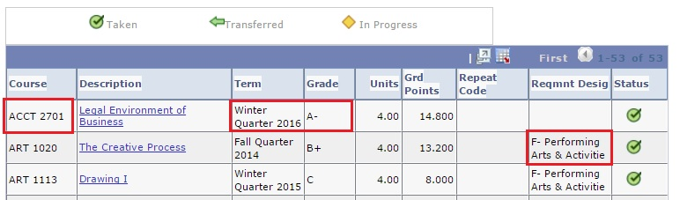
Note that courses taken with your major prefix will NOT count for GE. (This means all COMM courses if you are a Communications major or all CRJA courses if you are a Criminal Justice Major)

Step Three – Finding and Enrolling in classes
The next thing you will do is to search for classes. (see Searching for Classes handout for detailed instructions on these different methods)
For GE classes – search by GE Category (B2, C3 etc)
For major classes – it can help to see an overview of everything that is offered. You can get this by searching for subject only (ie: Communications) or using the greater than or equal to search to select upper division classes only (greater than or equal to 3000 will pull all the upper level courses in a subject)
If you know you want to take one particular class, you can search by the exact course number.

Step Four – Add Classes to your Shopping Cart
Add all the classes you are considering into your shopping cart. If they are in your shopping cart, you will be able to see them on the search results page so you can compare times.
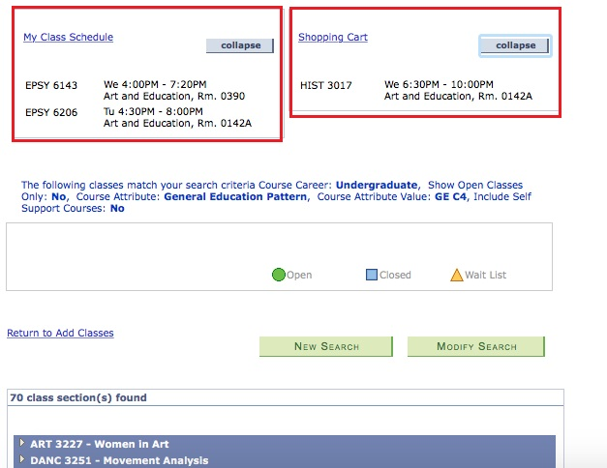

Step Five – Consider Balance, Professors etc
Choosing professors
Once you reach the end of your junior year, it is not wise to avoid classes because they are not being taught by your favorite professors. Prioritize making progress with your degree and taking the classes you NEED to graduate. However, earlier on, and with all your GE classes, it’s reasonable to take a look at what other students have said about professors.
You can use www.ratemyprofessor.com to get an idea of what students have said. Don’t simply look at the number! Read the reviews – especially looking for comments about the class you are considering taking with them. Think about the things that are important to you and read critically! Many students write bad reviews when they didn’t put in enough work – so be careful. Read for comments that hint at things you know will make the class easier or harder for you. Was the professor available during office hours? Did they respond to email quickly? Did they provide access to power points? Did they use BlackBoard well?
Balancing your Course load
I recommend that starting in your sophomore year you begin taking a combination of major and GE classes. It is possible that some major requirements may also count toward GE (ones without the major prefix). It is also the best way to achieve balance. Aim for 1-2 major classes and 1-2 GE classes if possible.
Electives vs Required Courses
Elective courses are usually 3 or more classes you take as part of your major. You can usually choose these 3+ classes from a long list of major courses. Because of this, elective units are flexible. Always prioritize completing required courses first. Think about it – with a required course, you only have one option to meet that major requirement. With an elective course, you will always have many. Saving elective courses gives you more flexibility towards the end of your degree.

Step Six – ENROLL!
Don’t forget to actually enroll in classes! Having a course in your shopping cart does not guarantee you a place in that class! Be sure to go back in on your enrollment date and FINISH ENROLLING!
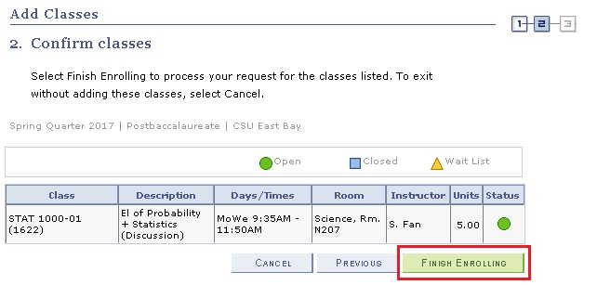
Only when you classes appear in your course schedule are you officially enrolled.

