Reviewing Your Degree Audit Report
Your Degree Audit Report, or DAR, provides lots of valuable information about your pathway to graduation. It lets you know what GE requirements you have remaining as well as, for most majors, what major requirements you have left. Like with all tools, sometimes courses don’t populate correctly, so if you think you fulfilled a requirement but it’s not on your DAR, be sure to check with Project IMPACT’s Academic Adviser or your Major Adviser.

How do I access my DAR?
- Log into MyCSUEB
- Navigate to your Student Center
- From the Drop Down Menu on the Left, Select Degree Audit Report
- Click the small arrows
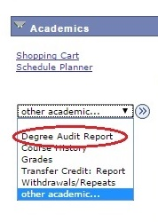
So, what is all this??
At the very top you see
Information about your degree – your major and any option or minor is listed here
Your GPA - both your Overall (cumulative) and CSUEB GPAs are listed. This is important for probationary status – especially for Juniors and Seniors. If your CSUEB GPA falls below 2.0, you will be on probation even if your cumulative GPA is above a 2.0
Your Graduation and/or Transfer Evaluation Status
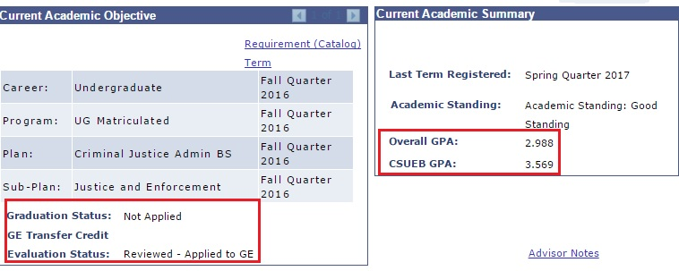
Some important messages you may see in this section are:
Application for Graduation Received – this means your graduation application has been received. It is not a guarantee of graduation. It does mean that you will not have access to enrollment after the date listed (for example: Graduation Spring 2017 means you would not have access to Summer courses unless you changed your graduation date)
Major Check Received – This means your major adviser has submitted your graduation check to the office of the registrar
Transfer Credit Evaluated – Applied to GE – This means all your applicable transfer credits have been applied to your GE on the DAR. You should now be able to get an accurate sense of any remaining GE requirements.

Unit Totals
The next section of the DAR is all about UNIT TOTALS. In addition to major and GE requirements, you have to take a certain number of units to graduate from this university. For Native Freshman, this area is pretty accurate. For Transfer Students, I do not recommend following the numbers here – check with an adviser or review your unofficial transcript to get an accurate total unit count. (I’ll cover how to review your Unofficial Transcript at the bottom of this document.
The main number to watch is the 180 units needed for graduation.

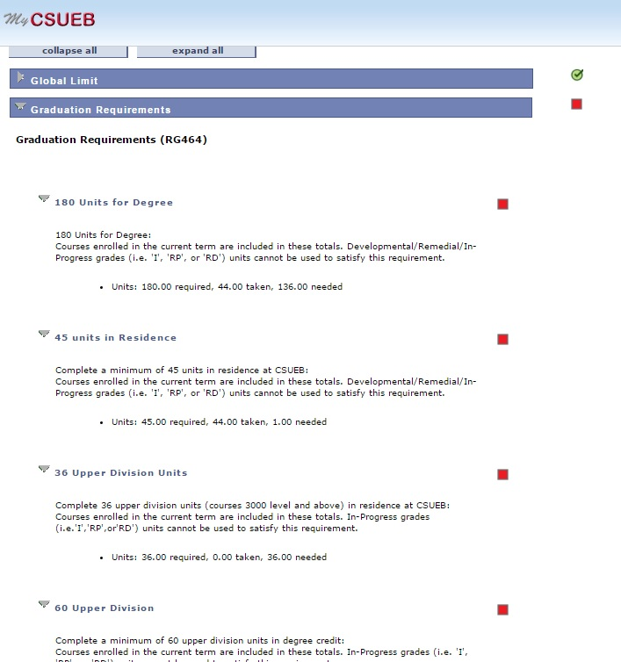
General Education Requirements
The third section of the DAR will have all of the General Education Requirements. ALL students are required to meet these and there are many classes offered each term that meet each category. You can search by GE category when you are looking for classes.
Be sure to read the small print in each section – some sections require a grade of C- or better (A2 and B4) some sections can only be fulfilled after you’ve reached 90 units (B6, C4, D4).
If you are currently enrolled in a class that meets a requirement you will see a yellow triangle.

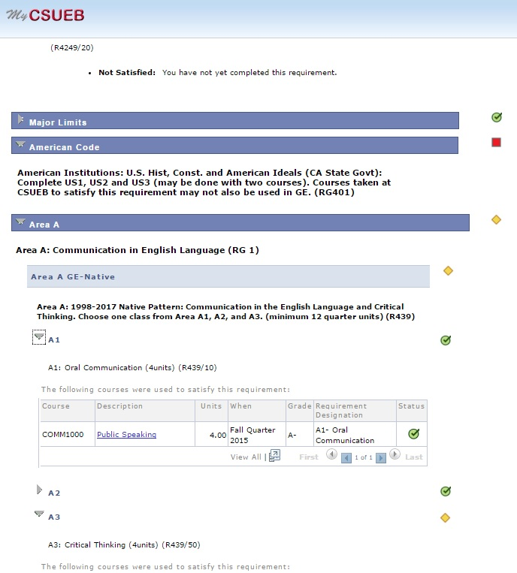

Major Requirements
Most majors have their requirements available to view in the DAR. If you believe you met a major requirement with transfer credit and it is not showing up – talk to your major adviser. Since this is a new part of the system, it is wise to continue to cross reference your DAR with any materials given to you by your major adviser.
