Viewing your Unofficial Transcript
Your unofficial transcripts are available to you at any time and they are a great way to keep track of your total units toward graduation.
From your Student Center, select View Unofficial Transcripts from the drop down menu on the left.
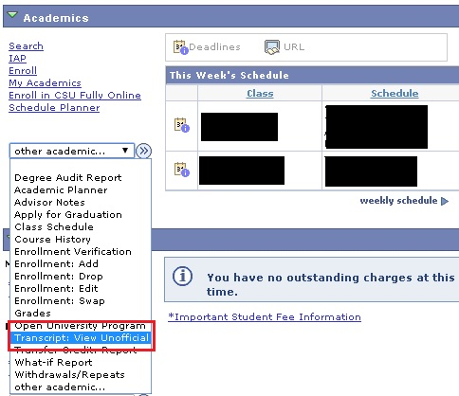
Select CSU East Bay as the Academic Institution and Student Unofficial Transcript as the Report Type.
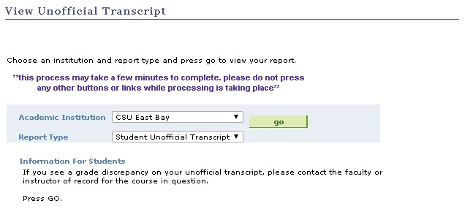

When you view your transcript, you will see your total units at the bottom. This is your total completed units. To get a sense of your current units, you add the number of units you are currently taking to the number on your transcript. For example below, this student is taking 12 units in winter. 98.5 completed units + 12 in progress units = 110.5 projected units after winter.
