Searching for Classes
There are many ways to use the search feature on MyCSUEB to make your enrollment process much easier! I’m going to go over them here. If you every want additional support with enrollment, reach out to Project IMPACT any time! It’s also a great idea to get feedback on your class selections from the Project IMPACT Academic Adviser - just email them a screenshot of your shopping cart or schedule and they can share their thoughts.

Navigating to the Search Screen
I recommend that you search through the ENROLL tab of your Student Center. This will automatically set the quarter for the search, rather than selecting it manually each time. It also means that when you find classes you want to take, there will be a SELECT button available to easily add the class to your shopping cart.
- Log in to MyCSUEB
- Navigate to your Student Center
- Click the small ENROLL link to the left of your course schedule
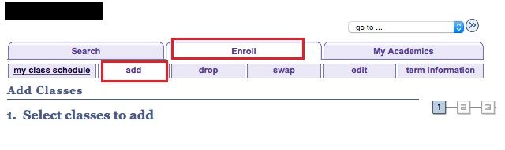
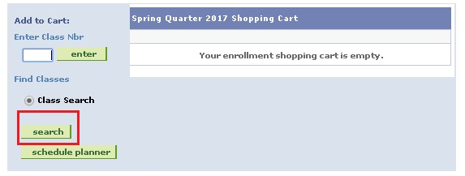

Note – it is important to use only the buttons within the page, not the browser buttons. Using the browser buttons will return you to the beginning of the process and is confusing.
Searching for an Exact Course
This is helpful if you know exactly what course you need to take, for example, BIOL 1401
- Select the quarter (this will be automatically filled if you use the Enroll tab).
- Select the Subject
- Enter the Course Number in the box
- Optional: Select ‘Show Open Classes Only.’ This is helpful later in the advising period when many courses are waitlisted or full.

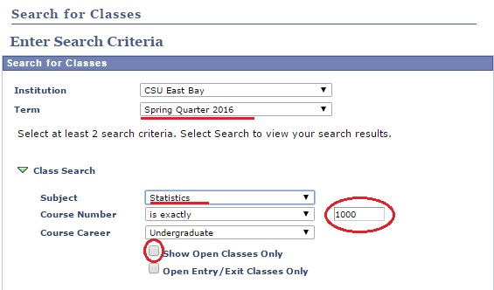

Searching for a Course Range
This is helpful if you want to search for all the upper division courses in your major. Upper division courses will all be 3000 level and above

- Select the Quarter
- Select the Subject (ex: Sociology)
- In the Course Number Drop Down select ‘greater than or equal to’ or ‘less than or equal to’ as needed.
- Enter the course number you want to be above or below. (For example, if you select ‘greater than or equal to’ and enter 3000 the system will pull up all Sociology courses offered that are 3000 level and above.)
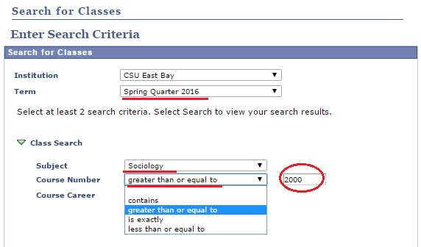

Searching for General Education (GE) course
This is helpful if you know (from viewing your Degree Audit Report) what areas of GE you still need (ex: B2 or C4 etc)
- Select the Quarter
- Leave the Class Search section blank, instead focus on the Additional Search Criteria Section
- From the Course Attribute Menu select ‘General Education Pattern’
- From the Course Attribute Value menu select the GE Area you are looking to fill

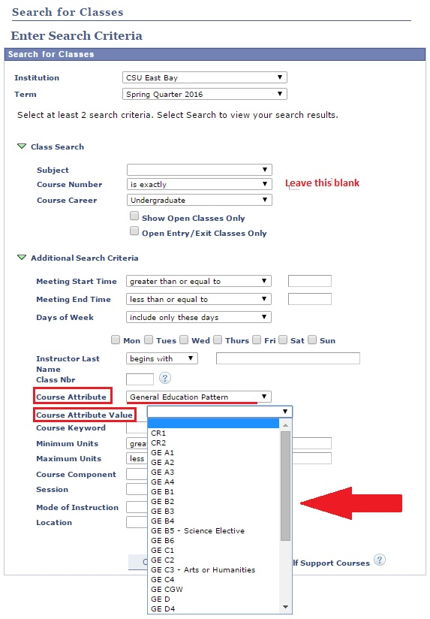

Viewing Courses
Once you search, you will be presented with a list of courses. You can click the small triangle to open up basic course information. Then you click on the section number to see course detail.
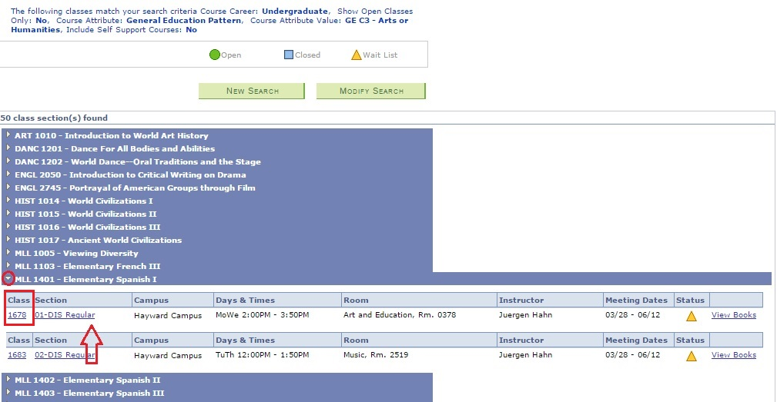
Course Elements to Review
There a number of elements to check to make sure you can take the course. Are there any restrictions to the class? Are there any prerequisites? These will be listed in the course detail page.
- Course Status - If there is a yellow triangle, it means the course is waitlisted. In the Course Availability box you can see that the Wait List Total is 10. If there are 10 or more students on the waitlist, it is highly unlikely you will get into the class. If there are just a few students on the waitlist and it is early in the enrollment period, the chances of being added to the class are higher. Remember – waitlisted classes do not count towards your full time status for Financial Aid etc.
- Class Attributes - In Class Attributes you can confirm if the course applies to any GE Areas. This is also where it will be notated if the class is a Freshman Cluster Course, or Freshman Leaning Community.
- Description - In the Description you will find any prerequisites listed. Be aware, while the system sometimes enforces prerequisites, it often does not. Therefore, it is possible for students to enroll in courses they are not yet qualified to take.

Remember – use the View Search Results button to go back to the search page. Do not use your browser’s back button – you will have to start all over!
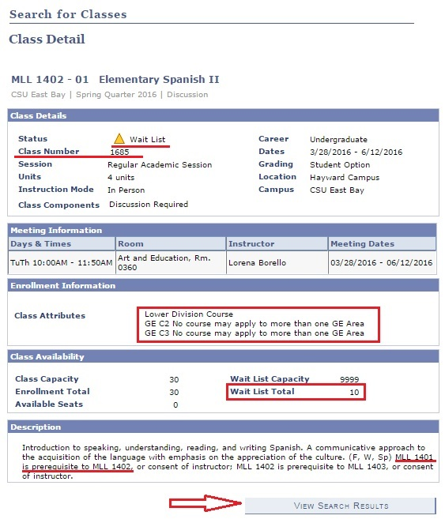
*Note the Class Number, 1685, underlined above. This is unique for each section of a course and can be used to quickly add a course to your shopping cart. It is different than the course number (MLL 1402)

Once you select a course, it will add it to your shopping cart. IMPORTANT: having a course in your shopping cart does NOT hold a place in that course for you. You do not have a place in the class until you finish enrolling and the course shows up in your class list (outlined in orange in the image below). To finish enrolling you click Proceed to Step 2 of 3 and then Finish Enrolling.
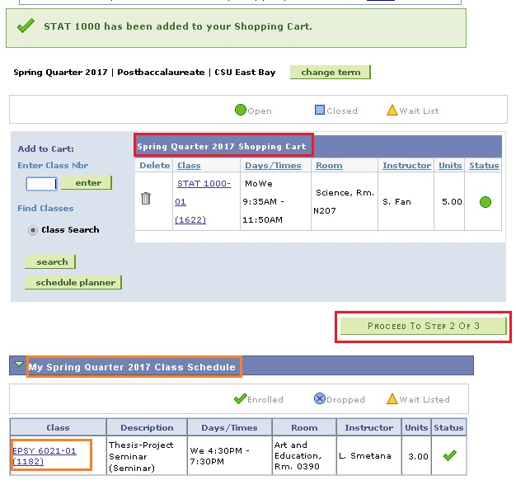
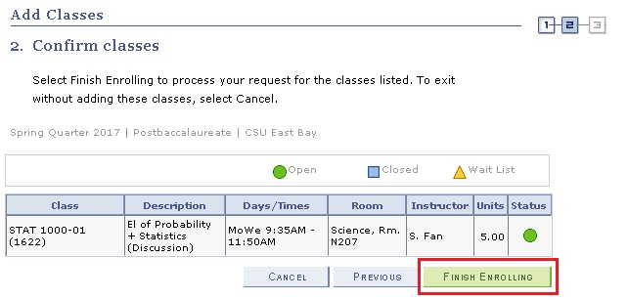

Swapping Courses
When you are enrolled but want to take a different class to replace one of your selections, swapping is the best way to accomplish the switch. From the Enroll Tab, select the Swap option from the sub tabs:
They will then see this detail:
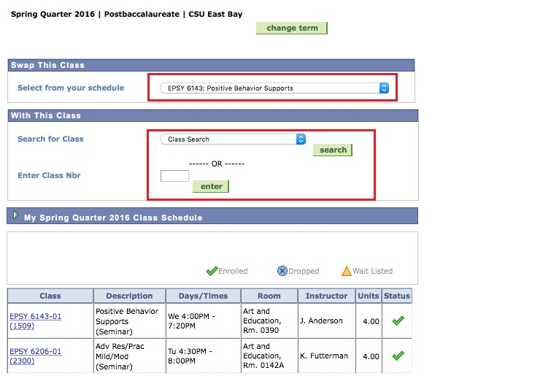

From this page you first select the course tyou would like to REPLACE. You then enter the course you would like to replace it with. You can click Search or enter the Class Number (NOT the Course Number – see note re: Class Number above)You then confirm the swap and the change will be reflected in your Class Schedule.

Dropping Courses
There are times when you will want to drop a course. From the Enroll Tab, students select the Drop option from the sub tabs:
They will then see this detail:
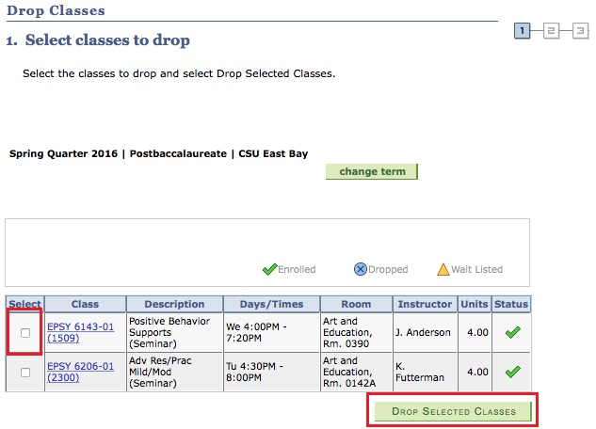

You select the course to drop and then click ‘drop selected classes.’
Things to consider before dropping:
- Unit totals – will you still be meeting full time course loads (12 units) required for Financial Aid?
- Frequency the course is offered – is this course offered every quarter? Or only once per year?
- Series Courses – is this course a prerequisite or the first of a series that the you must complete?

