THE BAY ADVISOR – APPOINTMENT cancelation GUIDE

- Go to the Bay Advisor – Cal State East Bay using the link: https://www.csueastbay.edu/aps/the-bay-advisor.html
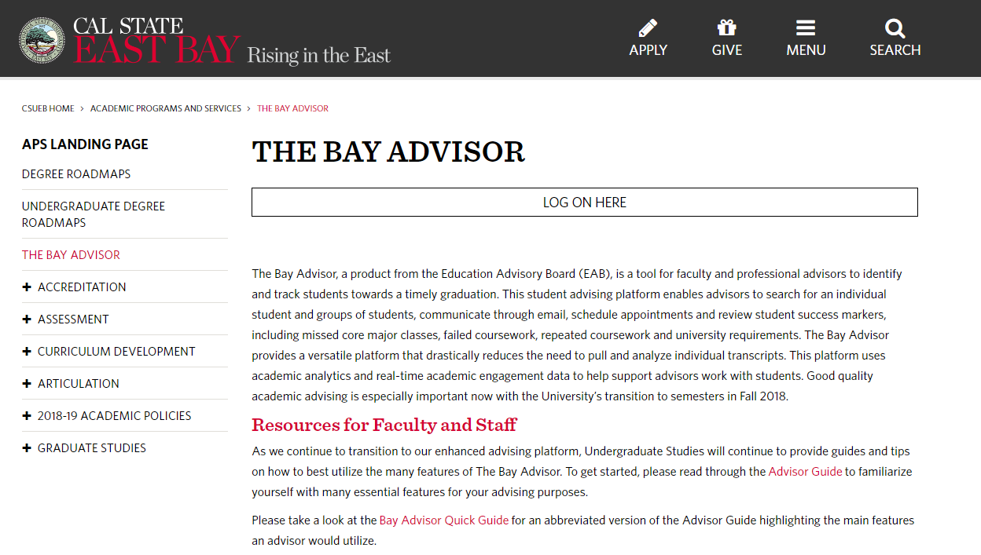

Click on LOG ON HERE.

- Enter your netid and password to login.

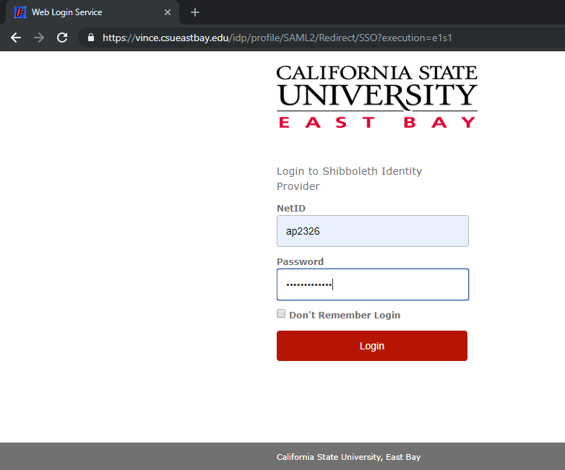

- Once you see the Bay Advisor page, click on the Appointment you wish to cancel.

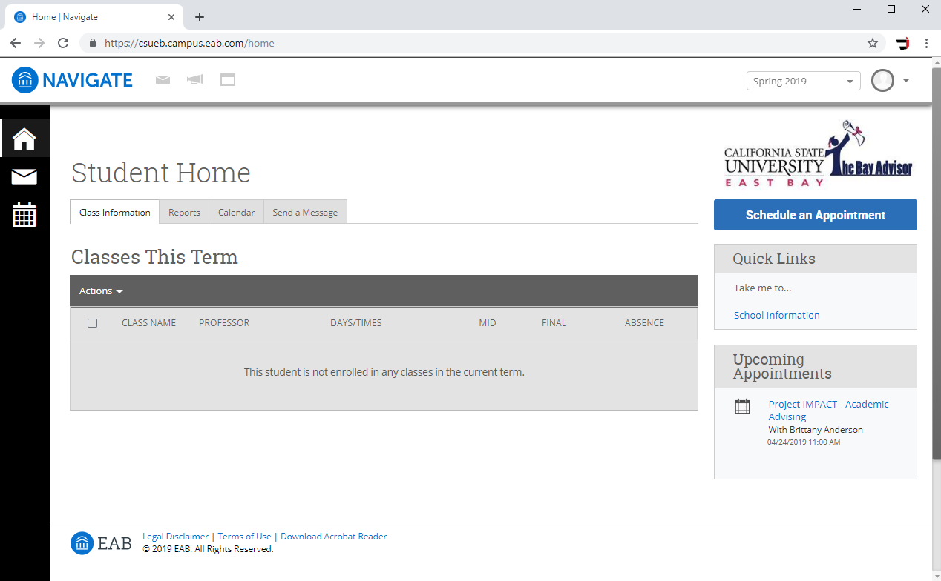

- Click on Cancel My Attendance in the Manage Appointment section.

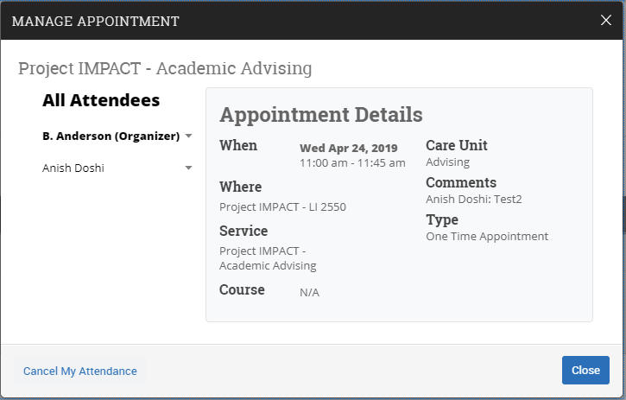

- Select the appropriate reason for cancellation from the drop-down list.

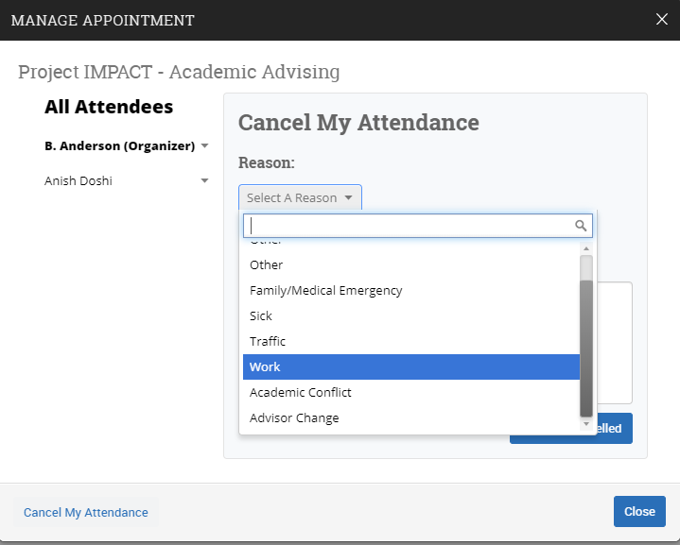

- Type any additional comments about the appointment cancellation & click MARK AS CANCELLED.

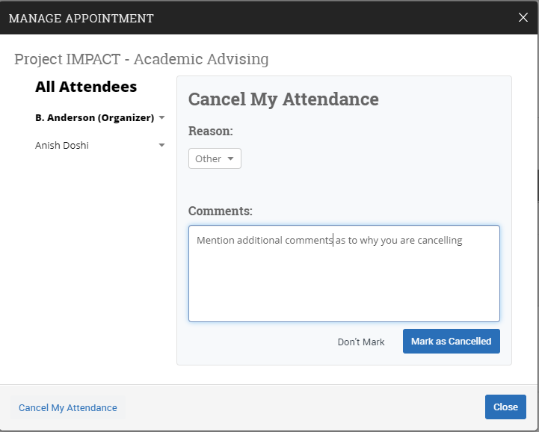

- You will now see a confirmation about the appointment cancellation. Click CLOSE.

