CYBER SECURITY- PRIVACY: ARE WE ALL LIVING IN GLASS HOUSES? CAN I GET SOME PRIVACY, PLEASE?

Cyber security, cyberwar, hacking, privacy, and governmental/personal data breaches… We keep hearing these with increasing frequency over and over again. This creates a cyber anxiety everywhere. And on top of that we, as ordinary people started to learn that corporations and governments all around the world keep track of our personal data. For example, mobile phones constantly provide information about our location to service providers. Google knows what we are thinking about from our personal online searches. Facebook can see who our friends are. Yahoo knows the type of news we are interested in. Our online shopping patterns are recorded. Governments are launching surveillance programs to collect our personal data on the cyber space. And the list goes on... It is as if we are all living in glass houses in which we don’t have any privacy or can’t keep any secrets anymore. Cyber security issues affect everyone. Most of all they affect us individuals. That is why ignorance is not bliss in cyber security. Every day we face new questions, new challenges from our rights and responsibilities as citizens of the cyber world to how to protect ourselves, if we can, from new types of security threats. In this talk, I will try to explain vulnerabilities and security issues in the cyber space along with what we can and cannot do to protect ourselves.

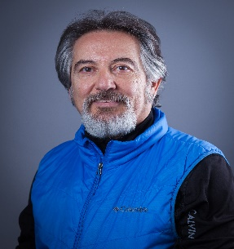

Dr. Levent Ertaul is a full-time professor at the California State University, East Bay, USA. He received a Ph.D. degree from Sussex University, UK in 1994. He specializes in Network Security. He has more than 85 refereed papers published in the Cyber Security, Network Security, Wireless Security and Cryptography areas. He also delivered more than 80 seminars and talks and participated in various panel discussions related to Cyber Security. He published a book titled “ Computer and Network Security Essentials. In the last couple of years, Dr. Ertaul has given Privacy and Cyber Security speeches at US universities and several US organizations. He also gave interviews related to Cyber Security in NBC, FOX2, ABC7 news. This year Dr. Ertaul received an Outstanding Achievement Award for Research Contributions to the Field of “Cyber Security & Privacy” and an Achievement Award for Research Contributions to the Field of Network Security from American Counsel of Science and Education. He also received a fellowship to work at the Lawrence Livermore National Laboratories (LLNL) in the Cyber Defenders program for last 5 years. He participated in several hacking competitions nationwide. His current research interests are Wireless Hacking Techniques, Wireless Security, and Security of IoTs. For more details, please visit www.mcs.csueastbay.edu/~lertaul.

