Drafted by Evelyn T. López-Muñoz and Facilities Development and Operations

**Summer 2014**

**CSU EAST BAY**

**WATER CONSERVATION PLAN**

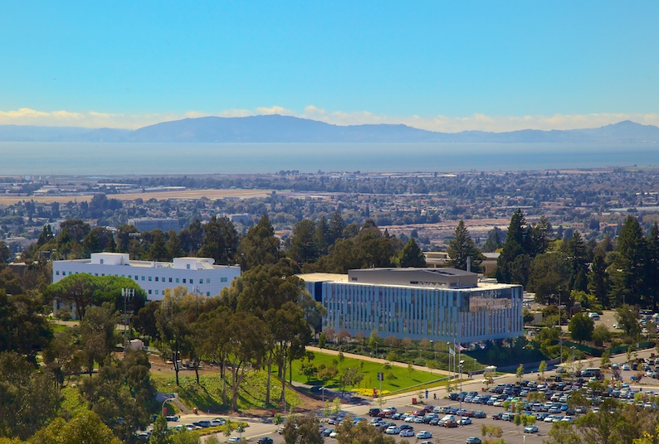

**California State University, East Bay**

**25800 Carlos Bee Boulevard**

**Hayward, California 94542**

**INTRODUCTION:**

In 2009, Senate Bill 7, required that the State of California reduce 20% per capita urban water use by 2020. With the current status of the drought of California, on February 4, 2014, the California State University has mandated that campuses reevaluate water usage and implement strategies to reduce water consumption by 20% by 2020. The statewide CSU Sustainability Policy has set goals of water reduction of 10% by 2016 and 20% by 2020.

To achieve this ambitious goal, CSUEB has developed a conservation plan that consists of water monitoring accounting, as well as best management practices (BMP) for water management. Short term conservation measures are currently being implemented, such as reduced irrigation usage, abandoning of turf areas, planting of native drought tolerant material, and installing low flow toilets and faucets. These and other conservation efforts will be necessary to not only address the impacts of the current drought but to meet the demands of future campus growth and expansion of the university.

**ATIVITIES CURRENTLY BEING IMPLEMENTED TO ADDRESS DROUGHT PERIODS AND CONSERVATION EFFORTS:**

* Evaluate turf areas that can be eliminated and/or re-planted with drought tolerant or ground cover that will reduce water usage. Immediate goal is (36%) irrigation reduction through landscaping improvements.
* Reduce watering schedules of large turf areas to 2 -3 days a week and all irrigation. watering zone area schedules by (25%). These schedules are being phased in during the summer of 2014, at which time the impacts will be evaluated and any adjustments made.
* Evaluate centrally controlled weather based irrigation controls and upgrade areas that can utilize this system.
* Installation of 42 irrigation meters to monitor water usage.
* Replacement of old restroom fixtures in the Library, Physical Education, Science, Art and Education, and Music buildings with 1.28 gallon flush toilets.
* Replacement of 250+ faucet aerators rated at 1.5 gallons per minute (gpm) with 0.5 gpm aerators.
* Old toilets, faucets and shower heads in Student Housing will be replaced with high efficiency toilets, low gpm faucet aerators, and low flow shower heads.
* Evaluate irrigation sprinklers/nozzles and consider upgrading to water efficient models.
* Review suggestions achieved through joint Facilities Development & Operations / Environmental Sustainability Studies courses that have investigated water saving measures on campus.
* Education and outreach by use of instruction, flyers, social media, mass mailings via email, and posting/signage on turf areas being eliminated, explaining why areas are not being watered.
* Stickers on sinks to remind users to turn off running water.
* Shower sand timers to promote 5 minute or less shower use in all Student Housing units.
* Provide water usage updates monthly to campus community.

**WATER MONITORING**

The following water information is monitored monthly from the City of Hayward’s billings. Campus buildings are also read on a monthly basis at each supply line into each campus building. Irrigation will be separately metered on a monthly basis once all of the new meters are installed. However, presently, the assumption is that the total campus water consumption minus building usage is currently considered as irrigation and/or potential campus leaks. CSU East Bay does not have a sewer meter with the City of Hayward, therefore, building metering is charged at a sewer rate. Many building meters are antiquated and evaluation for replacement of these meters to compound style low flow registering meters is being reviewed as part of the maintenance program.



The following information reflects the Concord campus water usage which is monitored by the Contra Costa Water District on a bi-monthly basis. There are three meters on site; building, irrigation and a small meter that is used by a cattle rancher that only uses the location during seasonal visits and water usage is a small amount. This campus site also needs to be evaluated and strategies are needed to meet conservation goals.



**Identification of Campus Wide Water Conservation Strategies:**

1. **Revise Irrigation Schedules**

***Issue:***

Currently, most irrigated grounds around the campus are watered using the Rainmaster Central irrigation controls system. This is a reliable and water efficient system, and campus staff utilize this system to control watering schedules of 41+ controllers of large turf areas, shrubs and plantings in the surrounding areas. Beginning in the summer of 2014, all irrigation zones are being reduced by 25%. At that time the campus will determine what the appropriate amount of water is needed to sustain current plant materials and decide on future areas to refrain from watering. In addition, approximately 36% of the current turf areas on campus are to be removed/replaced with native drought resistant plantings and/or ground cover or leave dormant until future renovations budgets are available.

***Examples:***

* Turf areas are watered 3 -5 times a week and shrubs on a 1-3 time a week schedule.
* Turf areas are visually inspected and watering schedules are based upon grounds crew experience with locations.

***Recommendations:***

* Reduce all irrigation schedules (25%) to assist reduction and/or help meet reduction targets.
* Upon weather stationer pair, integrate global system changes slowly to evaluate how percentage drops to the system affect plantings and turfs. Also review/change schedule water times to reflect optimal watering needs for plantings and remaining turfs based upon climate, evapotranspiration and season.
* Prioritize irrigation zones on campus
  + High profile areas vs low profile areas.
  + Continue to list areas to abandon and erect signage noting “California Drought – Doing our Part”

1. **Audit, retrofit existing irrigation zones or include/explore better turf maintenance programs**

***Issue:***

Campus has installed various types of sprinkler systems over the years and does not have data base or gpm information on older sprinkler heads. An evaluation of type of sprinklers supported was completed in 2013 but still requires implementation. This process can lead to a working data base to change out older models for newer water efficient systems. This information can also be jointly tied into our new water control software program already owned, and reports can be generated to provide gallons used in a specific location based upon sprinkler type and schedule run times. Also, soil maintenance should be incorporated twice a year to maintain healthy soil material.

***Recommendations:***

* Inventory all sprinkler systems on campus for data base record and input gpm on those systems that have readily available data.
* Information will assist irrigation crew with list of old systems to replace.
* Incorporate a turf management program based upon best management practice research done by University of California on “Managing Turf grasses during drought” by M. Ali Harivandi.
* Reduce lawn mowing to allow grass blades to grow a little taller and incorporate a soil maintenance program where aeration is done at least twice a year.

1. **Continue plant and turf evaluation or replacements:**

***Issue:***

In 2013/14 the campus installed new drought resistant plant material at the Science, Library, VBT, and Robinson Hall buildings. This process will help us assess the most efficient campus plant materials to use at other locations on campus. Those areas where turf has been taken off the watering schedule to meet goals will have signage stating that the location was chosen to assist in our efforts to meet state goals.

***Recommendations:***

* Remove turf areas that are hard to maintain and replace with drought tolerant plants, ground cover plants, mulch or decorative decomposed granite.

1. **Continue installation of low flow toilets:**

***Issue:***

Several campus toilets are outdated, high water usage models.

***Recommendations:***

* Maintain current practice of replacing/upgrading old, high gpm toilets with Higher Efficiency Toilets.

1. **Install limiting aerators on all campus faucets:**

***Issue:***

Current practice is to replace / upgrade restrooms to meet ADA requirements and meet building codes. This includes replacing out dated high flow water faucets with 0.5 gpm devices. .

***Recommendations:***

* Install new standard of .05 gpm in all new renovations.
* Those areas already retrofitted with new 1.5 gpm flow faucets will be re-retrofitted with .05 gpm aerators.
* Completion September 2014.

1. **Install Low Flow Misers on Shower Head in all showers in Student Housing Dorm Units and locker rooms:**

***Issue:***

Many of the showers on campus have shower heads that are outdated and exceed the recommended 2.5 gpm.

***Recommendation:***

* Install water miser reduction connections to all Student Housing units. New shower head will provide 1.5 gpm flows while supplying the same pressure as a 2.5 gpm flow shower head.
* Replace all shower fixtures in locker rooms that are not able to be retrofitted with a water miser with a 2.5 gpm or less shower head.

1. **Initiate notification to Energy Manager/Coordinator regarding leaks, repairs, and changes to water schedules, etc.**

***Issues:***

Currently there is no notification process regarding leaks, broken pipes, and/or changes to watering schedule. This not only involves the Grounds department but also the Engineering and Plumbing Departments that frequently get work orders for repairs, or have leaks within mechanical rooms that often are not high priorities to repair but no notification is given to reference small increases in building water usage.

In the summer of 2013, the campus used an outside contractor to review/seek and identify potential campus leaks in the current water distribution system. This review identified one significant leak, which was subsequently corrected, but also (10) potential leaks in the irrigation system. Communication process for reporting indicated stronger need to cross report leak information.

***Recommendation:***

* Installation of new metering and back-flow devices to monitor irrigation system (will be completed September 2014.)
* Confirm and prioritize extent of leaking irrigation zones for correction.

1. **Education and Awareness**

***Issue:***

Currently there is not a sufficient campus notification for the 20% water reduction goal to be met by the California State Universities. Education and notification to the entire campus community is needed so all individuals are involved and actively take part and ownership in helping conserve water on campus.

***Recommendations:***

* Web site notification of water goals
* Ask campus community to report leaks.
* Identify reduction targets.
* Training for grounds workers who deal with the watering schedules, irrigation, and plantings.
* Signage on turf areas that have been eliminated from watering schedule. Signage should provide information on why area is dry/dead and future plans for planting alternatives.
* Stickers placed by faucets promoting “Don’t leave the water running. Every drop counts”.
* Provide 5 minute sand timers in both Housing dorm units and athletic showers to promote saving and faculty/staff/student participation.
* Initiate a student run contest in Student Housing to see which buildings can save the most.

California State University East Bay is committed to a sustainable water reduction process. Our goal is promote active campus participation for each individual to assist meeting our reduction goals.