ACCESSIBILITY SERVICES
CALIFORNIA STATE UNIVERSITY EAST BAY
Hayward: 510-885-3868 | Concord: 925-602-6716 | Online: www.csueastbay.edu/as

ACCOMMODATE | SEMESTER/TESTING REQUEST FOR ACCESSIBLE TESTING

To submit an Accessible Testing Request, you must first submit a Semester Request for testing
(Steps 1-9 below), at the beginning of each term.

- Log in to your Accommodate Student Portal (https://c43-shib.symplicity.com/sso/) using your
existing Net ID and Password.

- From the Home screen, click on “Accommodations Information” from the Navigation Menu.

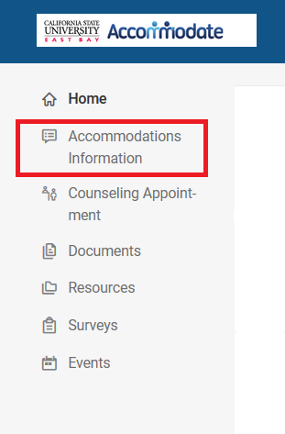

3. Select “Semester Request” from the drop-down menu.
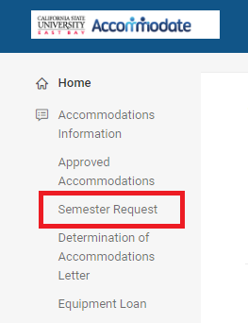

- Click on the “Add New” button.
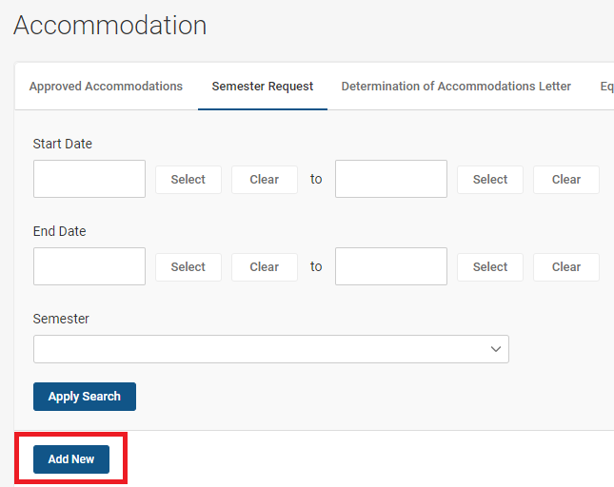

- Select the appropriate semester from the “Semester” drop-down menu.

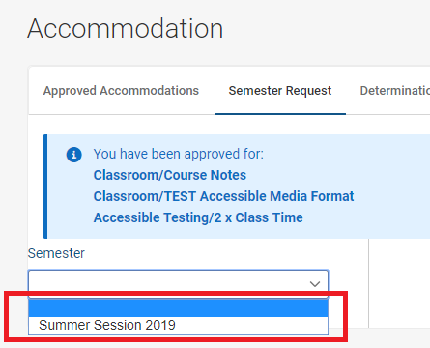

- Click on the “Review The Renewal” button.
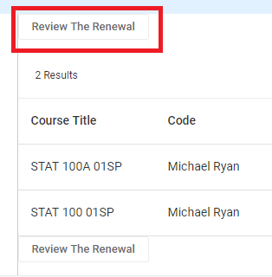

- If applicable, deselect the courses for which you will NOT need your testing accommodations.

- If applicable, deselect the courses for which you will NOT need your testing accommodations.

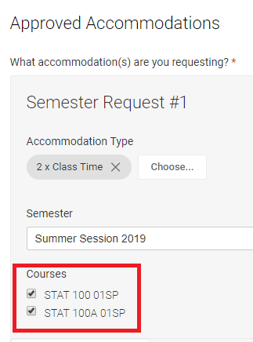

- Click on the “Submit” button.

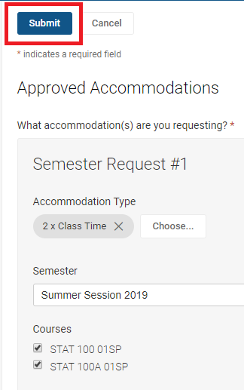

It may take up to 48 hours for your Semester Request to be approved. Once approved “Accessible Testing Request” appears in the Navigation Menu on the Home screen. Follow steps 10-18 to schedule individual Testing Requests for each of your courses.

How to Submit a Testing Request

- After logging in to your Accommodate Student Portal, click on “Accessible Testing Request” from
the menu.

- Click on the “New Booking Request” button under Pending Booking Requests.

- Select the appropriate course from the “Course” drop-down. Please pay close attention to
the course you are selecting, as "Dropped" courses may still appear.

13. Use your test date for both of the “Date Range” fields.

14. Select the appropriate campus location for your test from the “Campus” field.

- Click on the appropriate date, time, and location of your test.

- Confirm the details of your test and whether or not you are able to take the test at the same date and time as your class, due to your extended time accommodation.
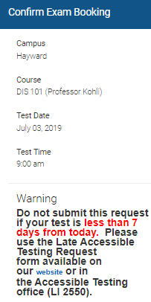

- If you answer “no” to “Considering your extended time accommodation, are you available to take
the test at the above date and time?”, you will be prompted to provide an explanation and an alternative date and time.

- If needed, you may provide additional information about your test request. To complete the
request, click on the “Submit Request” button.

- You will receive an email confirming that your accessible testing request has been received.

- You will receive another email 24 hours in advance of your test, confirming the date, time,
and location.

- To make any changes to your request after submission, please contact the Accessible Testing Coordinator immediately at astesting@csueastbay.edu or 510-885-4503.

