HOW TO MAKE AN APPOINTMENT

Logging in to the Student Portal

- Enter the following address into your web browser: https://c43-shib.symplicity.com/sso/
(Note: You may want to bookmark the link for easy access)

- Enter your CSUEB NetID and Password and click on the Login button.

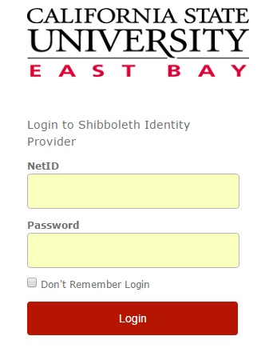

- You will be directed to the home page of your student portal within Accommodate.

Scheduling a Counseling Appointment

- After logging into the Student Portal, click on the “Counseling Appointment” tab or the “Request a Counseling Appointment” link under Shortcuts.

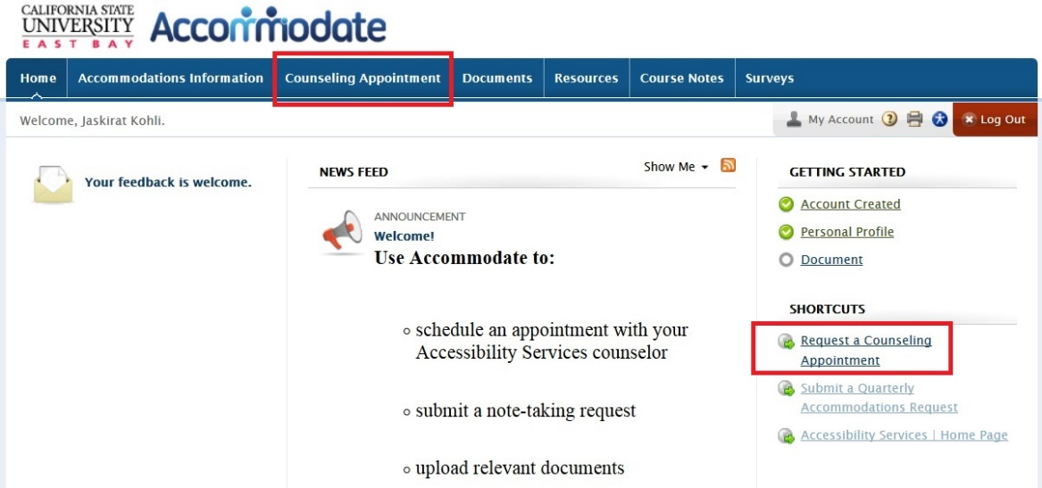

- Click on the “Request New Appointment” button.

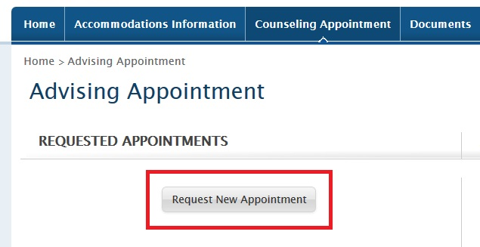

- Select a date range, time range, location, counselor, and/or days of the week. Once you have made your selections, click on the “Refine Results” button.

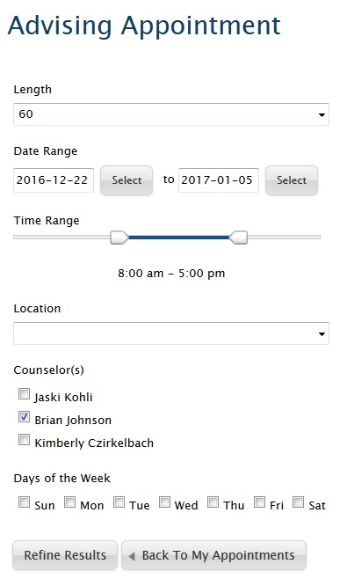

- To make a selection, click on the counselor’s name next to your preferred appointment time.

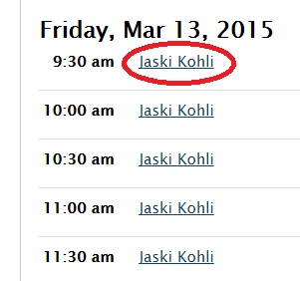

- Confirm the appointment details, enter any additional notes you would like to provide your counselor with regarding the appointment,
and click on the “Submit Request” button.

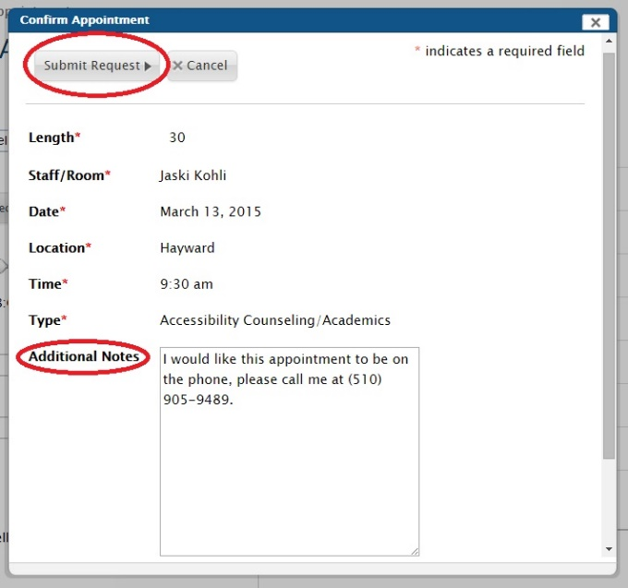

- Once you submit the request, you will see the approved appointment in the “Counseling Appointment” tab under “Approved Appointments”.

