SEMESTER REQUEST FOR COURSE NOTES

To request Course Notes, you must first submit a Semester Request at the beginning of each term.

- Log in to your Accommodate Student Portal (https://c43-shib.symplicity.com/sso/) using your
existing Net ID and Password.

- From the Home screen, click on “Accommodations Information” from the Navigation Menu.

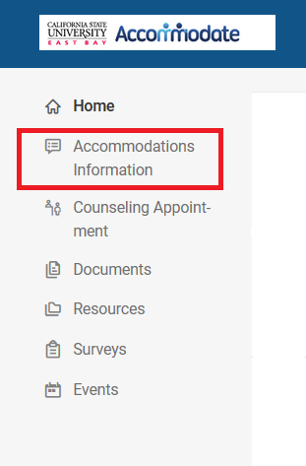

3. Select “Semester Request” from the drop-down menu.
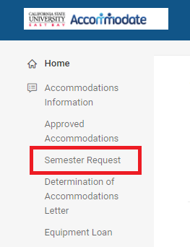

- Click on the “Add New” button.

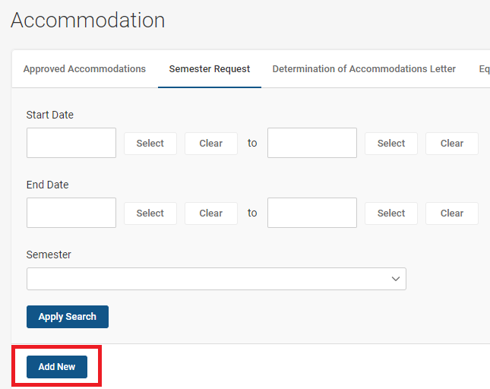

- Select the appropriate semester from the “Semester” drop-down menu.

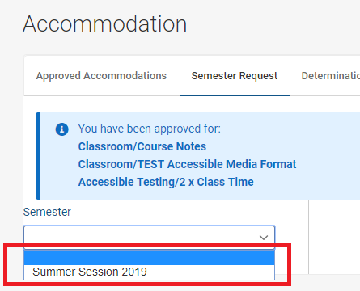

- Click on the “Review The Renewal” button.

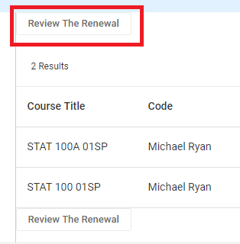

- If applicable, deselect the courses for which you will NOT need course notes. Typically, students
do not need notes for online or activity-based courses.
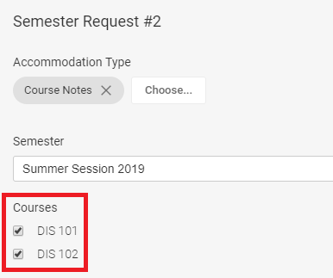

- Click on the “Submit” button at the bottom of the page.

- Once your request has been approved by Accessibility Services, you will see “APPROVED” next to your semester request.
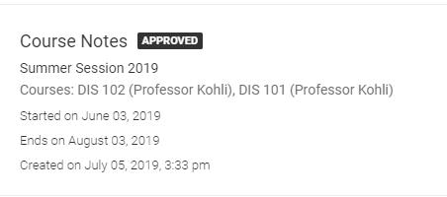

- Wait for an email from Note Taking Express with instructions on how to upload your audio files to receive notes.

11. If you have any questions or concerns regarding course notes, please contact notetaking@csueastbay.edu.

