ACCOMMODATE | ACCESSIBLE TESTING REQUEST

- After a student submits an Accessible Testing Request through their Accommodate Student Portal, you will receive an email with the subject, “Need Approval for Accessible Testing Request”.

- Log into your Accommodate Faculty Portal (https://c143-shib.symplicity.com/sso/) using your existing Net Id and Password.

- From the Home screen, click on the Courses tab.

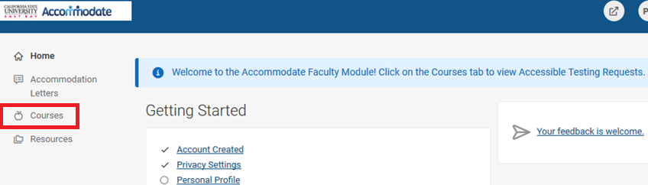

4. Click on the course name.

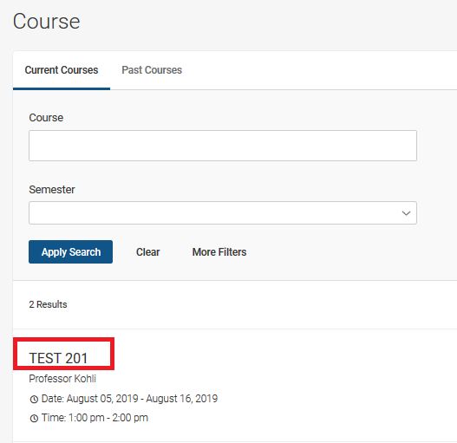

5. Click on the Accessible Testing Requests tab.

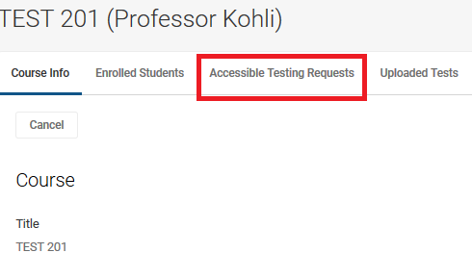

6. Click on Pending Tab.

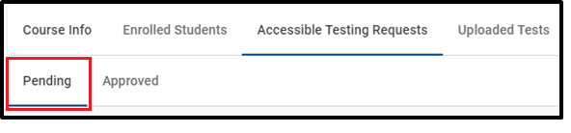

7. Click on the Student’s name.

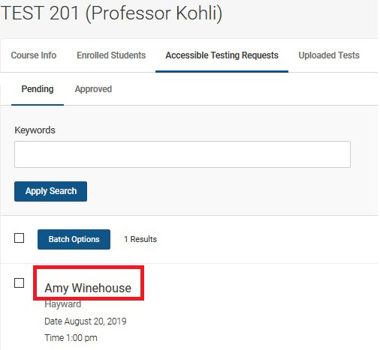

8. Review the Test Information submitted by the student, as well as the explanation for the Alternative Date and Time (if applicable). Due to a possible conflict in their schedule, some students need to take tests at a different date and time than the class.
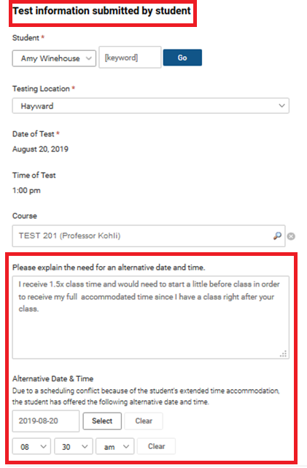

9. Complete the Testing Conditions section. All fields are required.
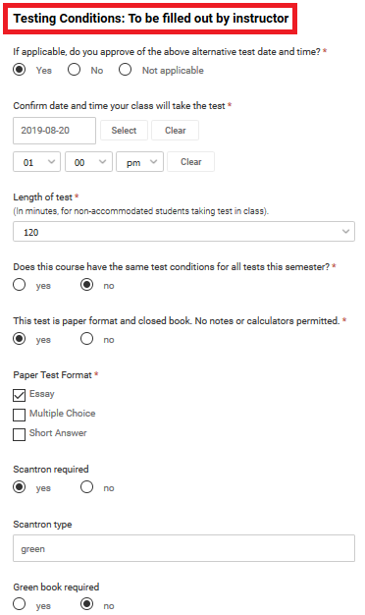

10. If the testing conditions are the same for all tests for the semester select “yes” on the below question. A Google From link will then appear. If you have already submitted the testing conditions for a previous request, type “completed” in the text box.

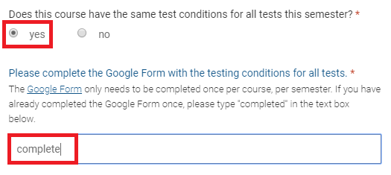

11. If the course does not have the same testing conditions for all exams, select “no” on the below question and answer the questions regarding the testing conditions.
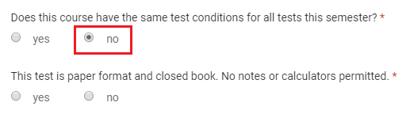

12. Complete the Test Delivery information.

13. If you have an exam ready, you are able to upload the exam. Click on Upload New Exam.

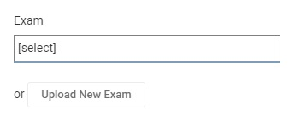

14. Complete the Test Information.

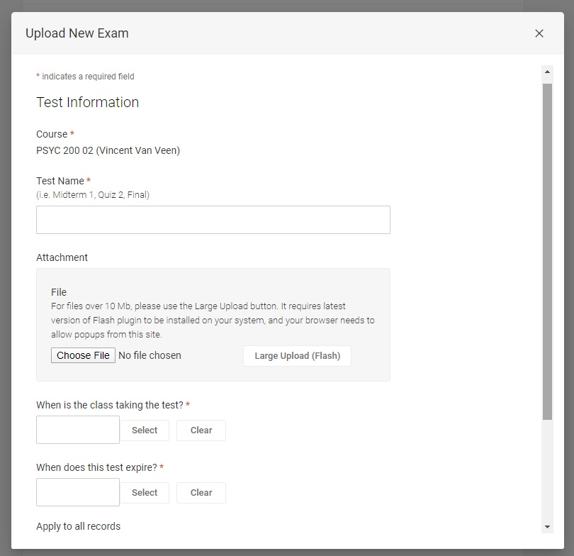

15. Provide any other information regarding the test in Comments & Acknowledgement. Once the request is complete and ready to be scheduled, click the SUBMIT button.
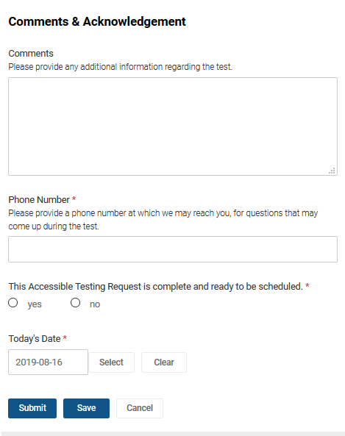

Please note:
- Clicking on Submit takes you back to the pending request for the respective course.
- Clicking on Save stills submits the request but leaves on the current student’s testing request. To approve additional test requests you will need to return to a different screen, refer to page 15.

14. Once the request has been submitted, it will go from the course’s Pending sub-tab to the Approved sub-tab, and no further action is necessary.
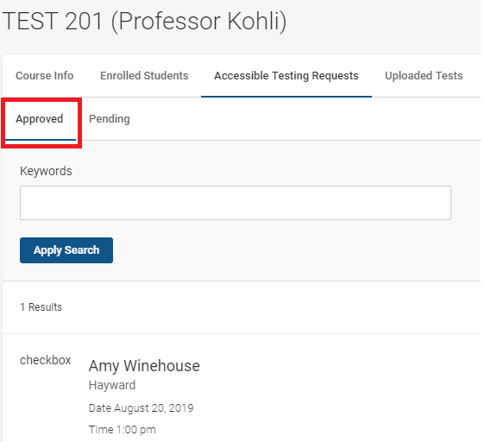

How to Upload an Exam

1. To upload an exam, click on the Uploaded Tests tab.
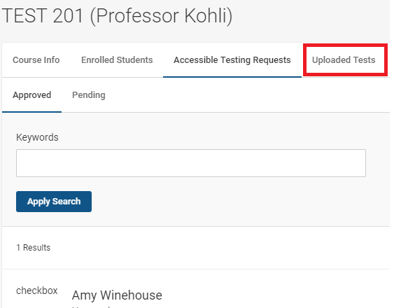

2. Click on the “Add New Exam” button.

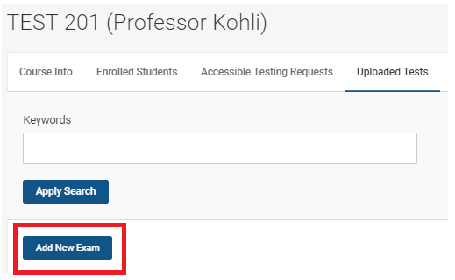

3. Fill out Test Information and once complete then hit the Submit button.

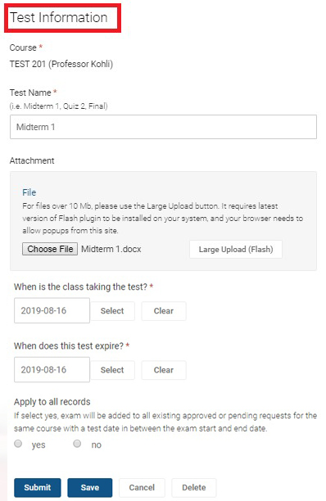

4. This is what will appear if the test has been correctly submitted.

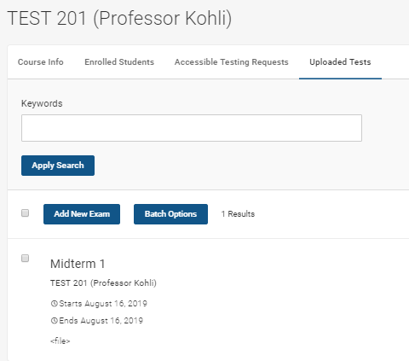

5. If any changes need to be made to the request, please contact Accessible Testing immediately at astesting@csueastbay.edu or 510-885-4503.

