SEMESTER REQUEST FOR

SIGN LANGUAGE INTERPRETING and REAL-TIME CAPTIONING

Prior to each term, submit a Semester Request to request Sign Language Interpreting or Real-Time Captioning for your courses.

- Log in to your Accommodate Student Portal (https://c43-shib.symplicity.com/sso/) using your
existing Net ID and Password.

- From the Home screen, click on “Accommodations Information” from the Navigation Menu.
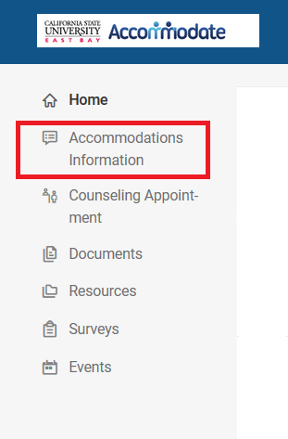

- Select “Semester Request” from the drop-down menu.
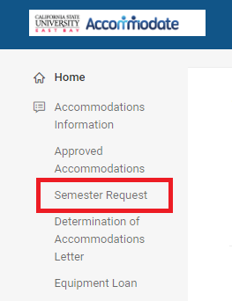

- Click on the “Add New” button.
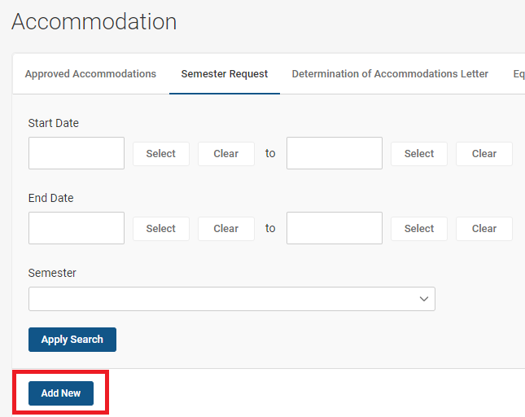

- Select the appropriate semester from the “Semester” drop-down menu.
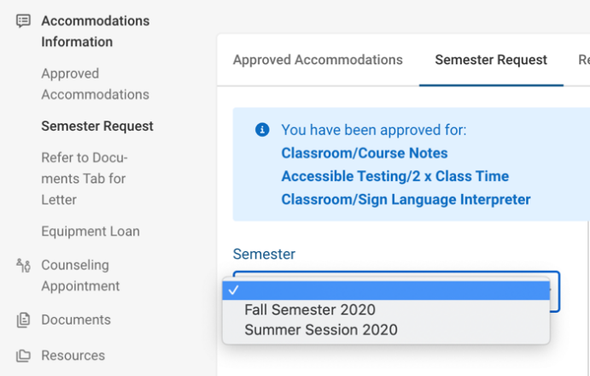

- Click on the “Review the Renewal” button.

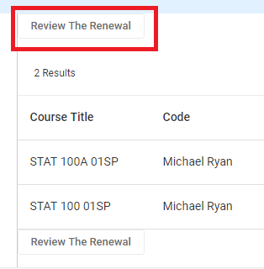

- If applicable, deselect the courses for which you will NOT need services.

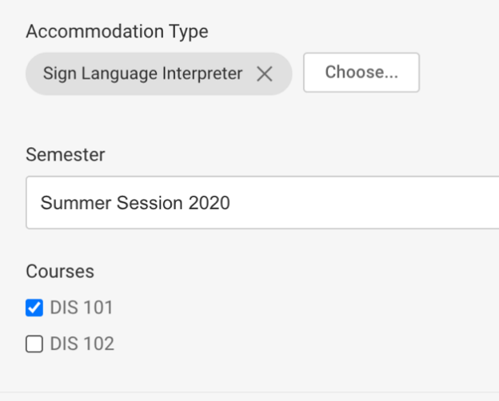

- Click on the “Submit” button at the bottom of the page.
- Once your request has been approved by Accessibility Services you will see “APPROVED” next to your semester request.
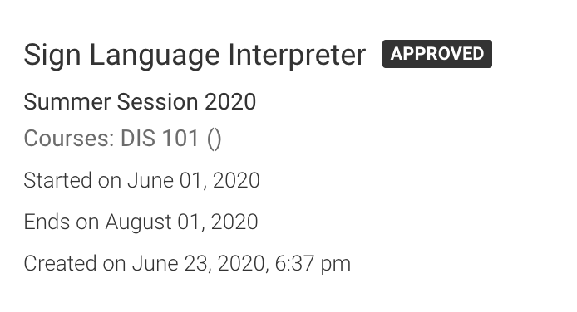

- The Interpreting Office will begin searching for service providers for your courses.
- If you have any questions or concerns regarding services, please send an email to interpreting@csueastbay.edu.

