SEMESTER REQUEST FOR ACCESSIBLE FURNITURE

To request Accessible Furniture, you must first submit a Semester Request at the beginning
of each semester.

- Log in to your Accommodate Student Portal (https://c43-shib.symplicity.com/sso/) using your
existing Net ID and Password.

- From the Home screen, click on “Accommodations Information” from the Navigation Menu.

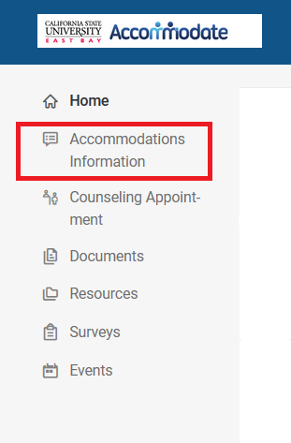

3. Select “Semester Request” from the drop-down menu.
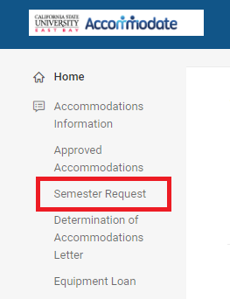

- Click on the “Add New” button.
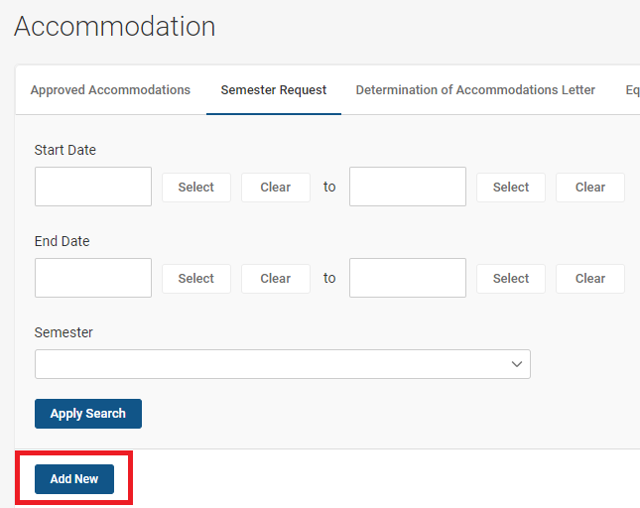

- Select the appropriate semester from the “Semester” drop-down menu.

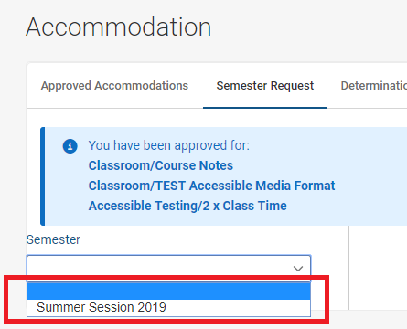

- Click on the “Review The Renewal” button.
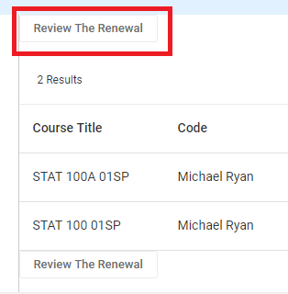

- If applicable, deselect the courses for which you will NOT need furniture. Typically, students do not need accessible furniture for online or activity-based courses.

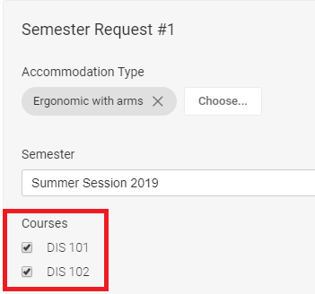

- Click on the “Submit” button at the bottom of the page.

- Once your request has been approved by Accessibility Services you will see “APPROVED” next to your semester request. Please allow up to one week for your furniture to be in place.

10. When you attend class, a reserved sign with your initials on it will be attached to the appropriate
furniture.

11. If you have any questions or concerns regarding your furniture, please send an email to asfurniture@csueastbay.edu.

