Educational Effectiveness Council Agenda
April 5, 2018
SA 3200A 10:00am - 11:00am

- Connecting faculty’s Semester Conversion work to the classroom in fall 2018
  - What resources should be common to all college sites?
  - What resources should be added or discontinued?
  - Who owns which sites? Which sites link to owner?
  - In what way should resources be “connected” to each other? How do we make them relatively easy for faculty and the publics to understand, use, and to navigate?

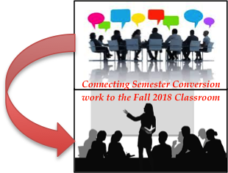

- ILO Long-term Assessment Plan
  - Status of senate approval
  - Planning for ILO Assessment Written Communication & Information Literacy ILO assessment for 2018-19

