Commitment to Excellence with Diversity

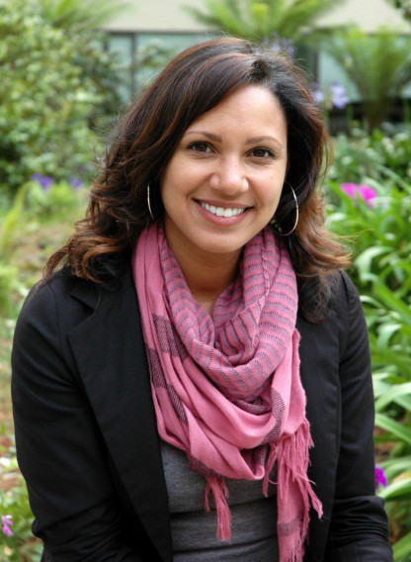
2013-14 Scholar,
San Francisco State University

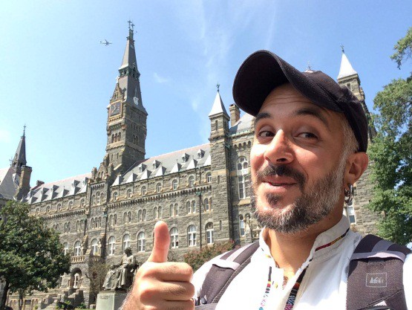
2013-14 Scholar, San Jose State University

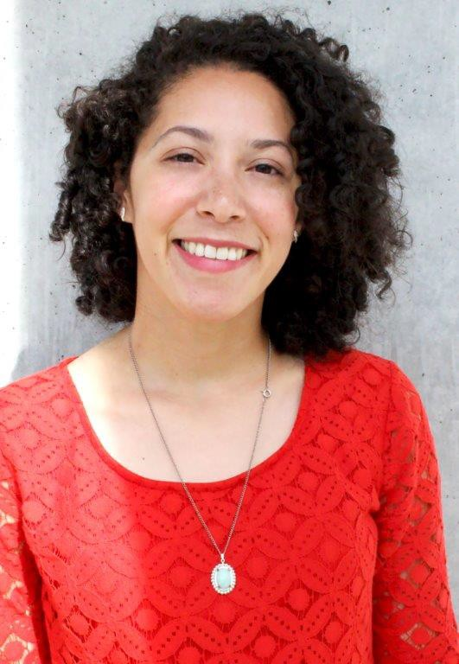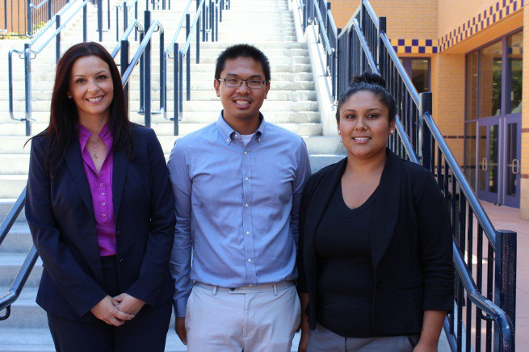2014 Summer Research Experience- UC Irvine
2009-10 Scholar, Cal Poly Pomona
CSU Fullerton, San Francisco State University, CSU Northridge
www.calstate.edu/predoc/apply/

TABLE OF CONTENTS

DUE DATES 9
APPLICATION SUBMISSION 9
CAMPUS COORDINATOR CONTACT INFORMATION 9
7
5
2021-22 CA PRE-DOCTORAL PROGRAM APPLICATION ……...…….
FACULTY LETTER OF RECOMMENDATION ………………………….....
4
4
PARTICIPANT ELIGIBILITY ……………………………………….…………….
SELECTION CRITERIA ……………………………………..……………………………
CALIFORNIA PRE-DOCTORAL PROGRAM OVERVIEW 3
PROGRAM DETAILS 3

THE CALIFORNIA STATE UNIVERSITY 2021-22
2

CALIFORNIA PRE-DOCTORAL PROGRAM

The California State University (CSU) announces its California Pre-Doctoral Program for the 2021-22 academic year.

In 2021-22, the California Pre-Doctoral Program will award funds to approximately 75 juniors, seniors, and graduate students in the CSU. These funds are designed to enable these students to explore and prepare to succeed in doctoral programs in their chosen field of study. Awards are based on competitive review of student applications and given to current upper-division or graduate students who, in the judgment of the review panel, demonstrate academic excellence while having experienced economic or educational disadvantage, and who are committed to a career in teaching and research at the university level. All matriculated upper division and graduate students, with the exception of International students, are encouraged to apply.

PROGRAM DETAILS

The California Pre-Doctoral Program is designed to increase the diversity of the pool from which the California State University draws its faculty. It does so by supporting the doctoral aspirations of CSU students who have experienced economic and educational disadvantages. A special emphasis is placed on increasing the number of CSU students who enter doctor of philosophy (Ph.D.) programs at one of the University of California campuses.

Each of the applicants selected will be designated a Sally Casanova Pre-Doctoral Scholar and will work closely with a CSU faculty mentor to develop an overall plan that leads to enrollment in a doctoral program. The plan should be tailored to the specific goals and career objectives of the student.

In addition the program provides:

- Travel Funds for the student to visit U.S. doctoral-granting institutions and/or to attend professional meetings appropriate to the student's development.

- Development Funds for other related activities, such as student membership in professional organizations, subscriptions to academic journals, graduate school applications and test fees, GRE preparation, and the cost of minor research materials, for example.

- A Summer Research Experience opportunity at a University of California campus or other U.S. major research university, fully funded by the Pre-Doctoral Program, so that the scholar can participate in doctoral-level research prior to applying to a Ph.D. program.

THE CALIFORNIA STATE UNIVERSITY 2021-22
3

PARTICIPANT ELIGIBILITY

Applicants to the California Pre-Doctoral Program must be matriculated upper-division or master's degree students who are enrolled at a CSU institution as of Spring 2021 and who will also be enrolled at a CSU campus for at least the fall semester (or quarter term) of the academic year 2021-22.

All CSU students, with the exception of CSU international students, are eligible to apply. Current or previous Pre-Doctoral Scholars are not eligible to re-apply. Each applicant must have a faculty mentor from the student’s home campus who will be available for the duration of the plan specified in the application. The program is designed for students interested in obtaining research doctorates. Students interested in obtaining professional masters or doctoral degrees (law, medicine, dentistry, pharmacy, or an MBA degree, for example) are not eligible.

SELECTION CRITERIA
Applicants will be selected on the basis of three major criteria: potential for success in completing a doctoral program, probable effectiveness of the student/faculty plan, and level of economic and educational disadvantage.

If you are interested in applying, you must immediately contact your campus Pre-Doctoral Coordinator for further information. Your approved online application, including transcripts, projected budget, letter of recommendation from your faculty mentor and your essays, must be submitted electronically by no later than 5:00 P.M. on Friday, February 19, 2021, or the date set by your campus coordinator (whichever comes first). You can only gain access to the online submission process after being approved by your campus coordinator. Be sure to check with your Campus Pre-Doctoral Program Coordinator for the internal campus deadline.

THE CALIFORNIA STATE UNIVERSITY 2021-22
4

2021-22 CALIFORNIA PRE-DOCTORAL PROGRAM APPLICATION

****You MUST meet with the Pre-Doc Campus Coordinator prior to submitting your application****
****Your application MUST be submitted electronically****
I. General Information

Name:
Last First Middle
Address:
Street City Zip Code
Sex:
Drop down menu

Telephone: ( ) Email:
Please include area code | Please provide an email, this is our main form of communication.

Are you currently enrolled at a CSU:
Yes No
First Generation College Student?
Yes No

Did you receive an A.A. or A.S. degree at a Community College? Ethnic Identity (for statistical purposes only)
Yes
No Name of CC:

African American Chicano(a)/Mexican American Other Hispanic/Latino(a)

Asian American Filipino American Indian

Pacific Islander White/Caucasian
Other (specify):

Campus Student Identification Number (nine digits):
1. II. Personal Information
- What is the primary language spoken in your home?

- Please identify which family situation best identifies your upbringing: Drop down menu

- Please indicate your parents’ level of education:
Parent 1: No College Some College College Graduate Some Graduate School Completed Graduate School
Parent 2: No College Some College College Graduate Some Graduate School Completed Graduate School
- Please describe any disabilities you may have:

- As an undergraduate, are/were you eligible for need-based financial aid? Yes No
- Are you treated as an independent student for financial aid purposes? Yes No
- If yes to question F: What is your personal yearly income?
Less than $12,000 $12,001 - $21,000 $21,001 - $35,000 More than $35,000
- If no to question F: What is your family’s yearly income?
Less than $30,000 $30,001 - $40,000 $40,001 - $45,000 More than $45,000
- How many hours per week do you work during school? 0 – 10 11-20 21-30 31+
- Did your spouse or family provide major help with the cost of your undergraduate education? Yes No

III. Educational Information

CSU campus you are now attending:

Your class level as of spring 2021: Junior Senior Masters
Major: Minor (if any):

Date you expect to receive your CSU degree:

If you are a graduate student, when did you receive your bachelor’s degree? Planned date of entry into a doctoral program:
Discipline in which you intend to pursue doctoral study:

G.P.A (Grade Point Average, 4.0 = A):
Undergraduate GPA | GPA in Major | Graduate GPA
Please provide your GRE scores:
Verbal | Math | Analytical | Subject
If you do not have GRE scores, when will they be available?
IV. Essays
The following three essays will be used to assess your written communication skills as well as your readiness for and commitment to doctoral study. Please think carefully about what you would like to say, and compose your essay with care. Each essay should be approximately 300 – 600 words in length.
- Describe the field of study in which you would like to pursue a doctoral degree and the research questions or theoretical perspectives that interest you in this field. Please be specific.

- What elements of your educational, research, community service and/or personal experience have contributed to your interest in and preparation for pursuing doctoral study, and your determination to succeed in it?

- Many professionals with doctoral degrees enter careers to serve as college and university faculty, and most faculty serve a diverse student body. Describe your interest in such a career and experience that would prepare you for it.

Please upload your transcripts to the online application site. One (1) copy of your transcripts (official or unofficial) must be submitted with your application. Graduate students must include a copy of both undergraduate and graduate transcripts from all institutions, including the CSU.

Please read the statement below and sign where indicated:
The information I have submitted in my 2021-22 Pre-Doctoral Application is true and accurate to the best of my knowledge. You have my permission to provide my name, address, transcripts, and the information in this application to other educational institutions that may be interested in having me enroll in their graduate schools or summer research programs.
Name of Applicant:

Signature of Applicant: | Date:

Student Budget Plan Student Name:

Please provide details on the components of the plan and assign a tentative dollar amount to each. An award of $3,000 is made to each Scholar. Please note that travel is permitted only within the U.S., and visits to doctoral degree-granting institutions are limited to those universities that are accredited. Summer research experiences are funded separately from this budget.

Activities | Dates Activities Will Occur |  | Estimated Cost
1. Visits to University of California campuses (specify):
2. Visits to other doctoral-granting institutions (specify):
3. Attendance at professional meetings, symposia, seminars, colloquia (specify):
4. Graduate school applications (all UC campuses waive application fees for Sally Casanova Scholars) and/or admission test fees, e.g. GRE (specify):
5. Student memberships in professional organizations; subscriptions to professional journals; special software, minor upgrades of computer capacity, research materials, etc. NOTE: Research related expenditures (for example, computer software, computer memory upgrades, laboratory supplies) are limited to a total of $500 (specify):
Total Estimated Cost (Must add up to $3,000):

THE CALIFORNIA STATE UNIVERSITY 2021-22
7

Letter of Recommendation (To be completed by the Faculty Mentor)

On your campus or college letterhead, please provide details of the abilities, skills, mastery of theory and method, accomplishments, and motivation that are likely to contribute to this student’s ability to succeed in doctoral study. If the student’s undergraduate grade-point average is below 3.0, please explain why you believe this student should be considered.

Please identify at the bottom of your letter whether you will be on a sabbatical or other leave during the 2021-22 academic year. Also, please identify if you are willing to allow the California Pre-Doctoral Program to provide your name/department/title to doctoral granting institutions on behalf of your student mentee.

DUE DATES

Final applications are due electronically by February 19, 2021. Please check with the Pre-Doctoral Program coordinator on your campus, to whom the preliminary application will be submitted, for your campus specific deadline. Many campuses require applicants to submit their preliminary application for review prior to the final application deadline.

APPLICATION SUBMISSION

Please submit all documents in the application online in the appropriate areas provided. Note your application must be pre-approved by the campus coordinator where you are enrolled. All attached supporting documentation (transcripts, faculty letter of support, budget plan, and three essays) must be saved as a pdf and titled by your last name, first initial and document title (i.e. Gomez R essay 2) Documents must be submitted by the deadline set by the campus to which you submit, or February 19, 2021, whichever comes first.

Your application can only be fully submitted after all areas are completely filled out, all attachments are included and you have received approval from your campus coordinator. Successfully submitted online applications are final. Once you submit your application online, you cannot go back in and make changes.

CAMPUS COORDINATOR CONTACT INFORMATION
If you have any questions about this application process please contact your Campus Pre-Doctoral Coordinator by visiting this link: http://www.calstate.edu/predoc/coordinators

APPLICATION CHECKLIST
⎕ Met with Campus Coordinator for Review of Application
⎕ General Information
⎕ Personal Information
⎕ Educational Information
⎕ Three Essays
⎕ Student Budget Plan
⎕ Faculty Mentor Recommendation Letter
⎕ Transcripts
⎕ Final Approval of Campus Coordinator to Submit Application Online

