Quick Guide
www.csueastbay.edu/bayadvisor

SEARCHES

Quick Search
There are two types of searches in The Bay Advisor, a quick search or an advanced search. As an advisor, you can do a quick search from the notification bar at the top of any page. Click on the magnifying glass and enter either a student’s first name or NetID.

Performing a quick search allows you to easily search for a student and view their academic performance information if you know their name or NetID. You will be able to view their Student Profile, any notes from other advisors, current and previous enrollment information, and much more.

Advanced Search
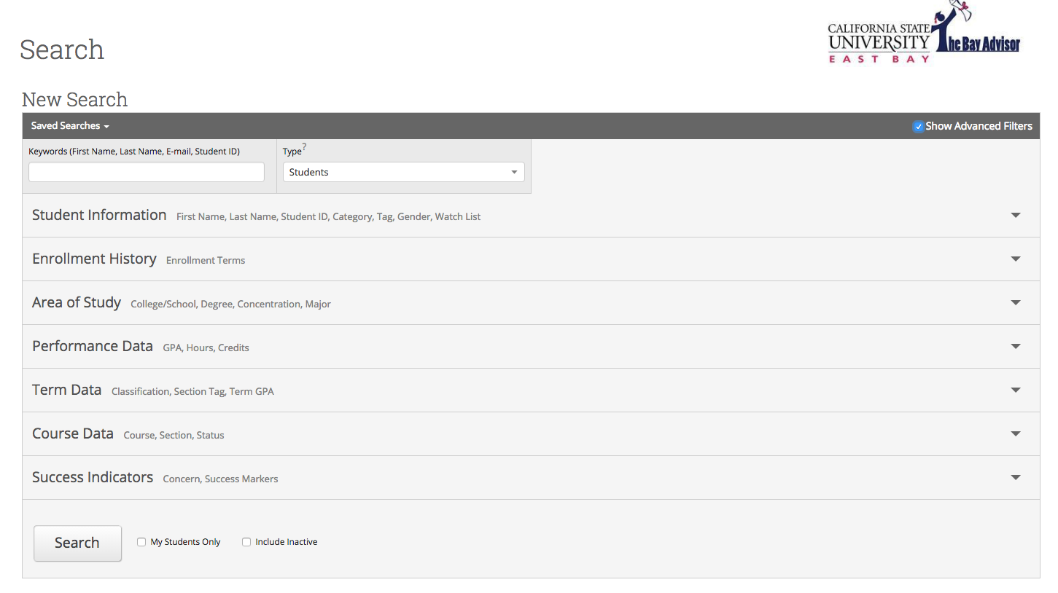
Advanced Search gives you as an advisor the ability to search for groups of students through various characteristics. You can control how specific or general of a search you intend to do with the criteria selected through the advanced search feature. Click the “advanced search” button to display all searchable characteristic drawers.

Examples of searchable characteristics include:
∗Student Information ∗Enrollment History ∗Area of Study ∗Performance Data
∗Term Data ∗Course Data ∗Success Indicators

STUDENT PROFILE

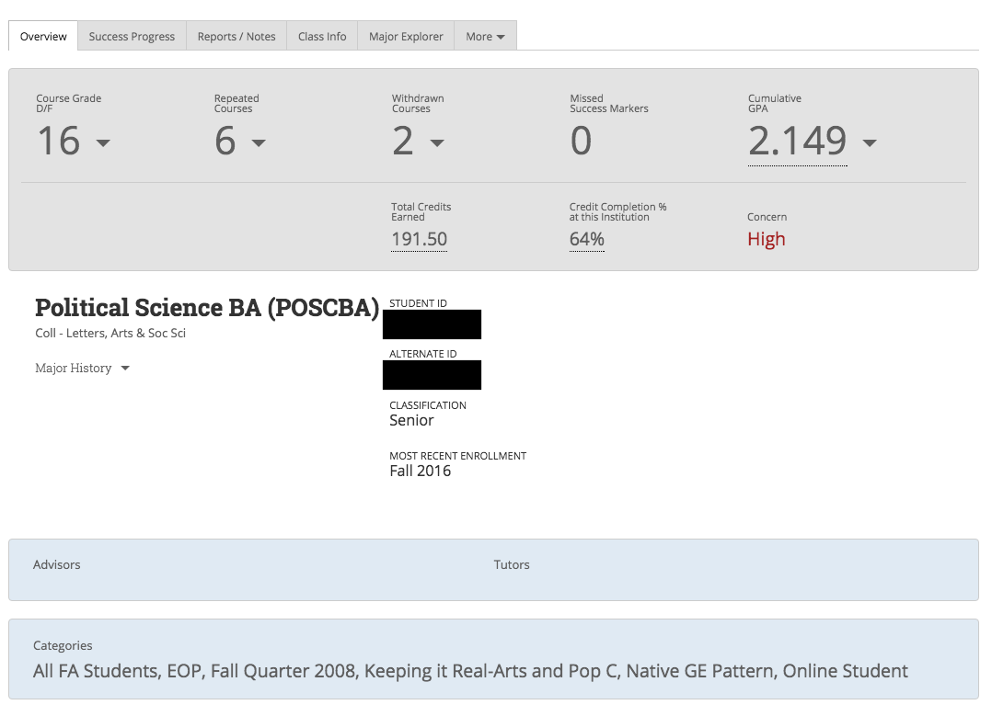
Overview
To view a student’s profile, either from Quick Search or Advanced Search, click their name (or right-click their name and open in new tab if from Advanced Search). This will bring you to the student’s overview.

This overview is also referred to as the 30 Second Gut-Check. It is in this overview that you can quickly assess how a student is performing academically. You are able to view important information, such as courses a student received a D/F/WU/IC, repeated courses, withdrawn courses, missed success markers, GPA, concern level, and more, all in one centralized location. You can also view all categories a student has been assigned. Categories designate specific characteristics of individual students, such as the term they entered, their Freshmen Cluster, if they are a Transfer or Native Students, and if they belong to any special programs or sports teams.

To view more details, expand your selection by clicking the arrow next to each number or hover over underlined information to view more details.
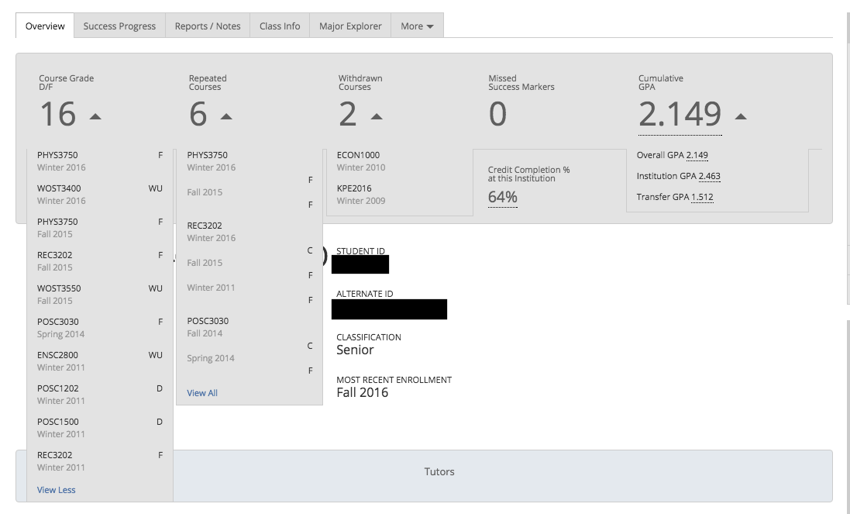

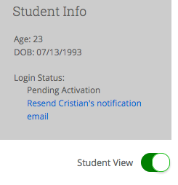
*Pro-Tip - When working with a student, you may be inclined to use the various pieces of information The Bay Advisor offers advisors. While meeting with a student, make sure you use “Student View” when showing a student information with The Bay Advisor. Student view removes private advising information, such as personal identifying information and concern level, regarding a student.

NOTES

Advising Summary Reports/Advising Notes give you the ability to record accurate notes regarding an advising session. While in a student’s profile, you have the ability to create either an Advising Summary Report or an Advising note. Simply click “Add a Note on this Student” (Advising Note), or “Report on Advising” (Advising Summary Report) in the upper right hand box in a student’s profile.
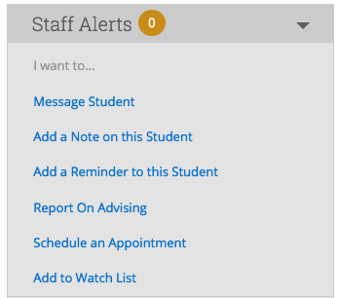

Advising Summary Report
An Advising Summary Report allows you to record a detailed summary of an advising appointment. It is important to document advising sessions and include direct academic information given to a student and any follow-up asked of the student. Remember, this report can be seen by other advisors, so the more specific you are, the better. Within the Advising Report, you have the ability to even attach files (PDF or Doc) to a student report. A student cannot view information in an Advising Summary Report. Always make sure to include a reason(s) within the appointment details.

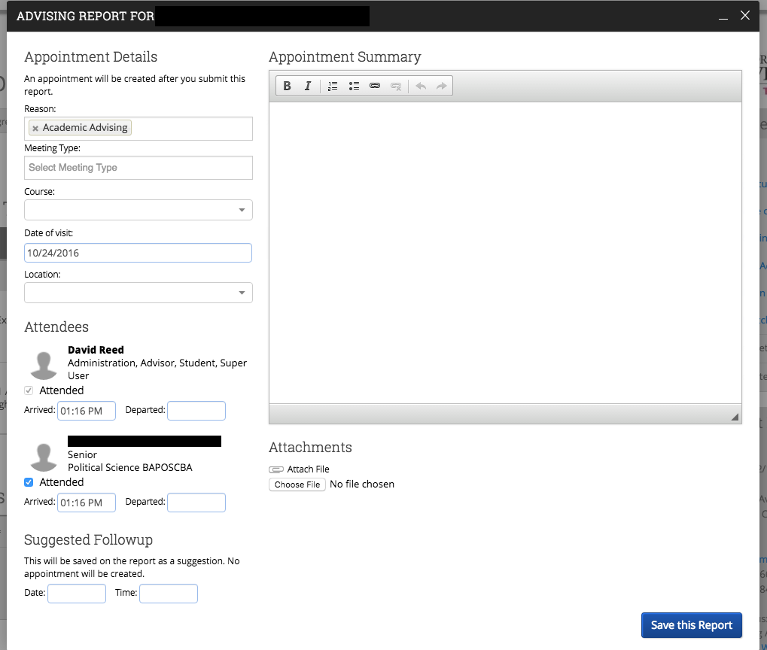

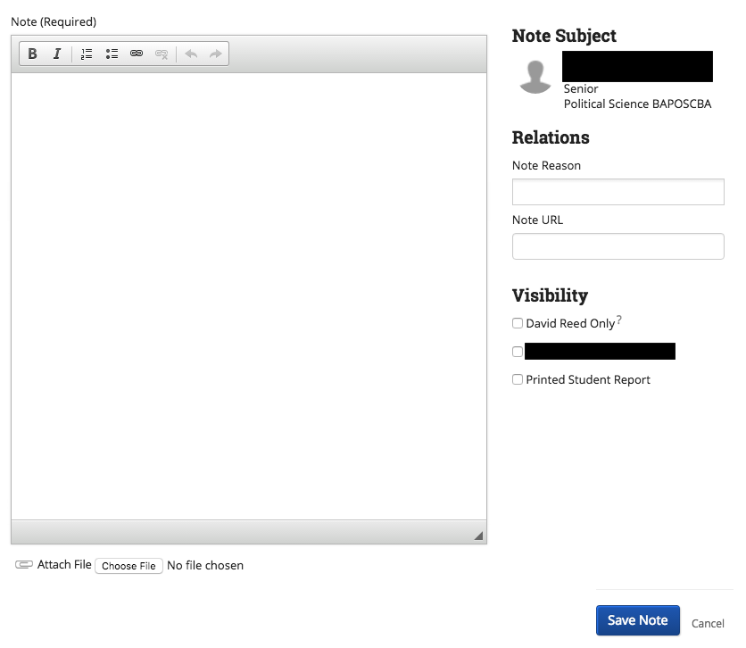
Advising Notes
Advising Notes are a great way to document any additional information to a student’s record outside of a traditional advising appointment. For example, you may want to attach a note to a student if you happen to run into the student on campus, and have a conversation that warrants a record. You must always add a Note Reason to an Advising Note for the note to be properly recorded.

*Pro-Tip – If you want to make the note private and only viewable by you, select only your name under Visibility.

OTHER FEATURES

- Mass E-Mail Capabilities
- Calendar Syncing
- Watch List/Saved Searches

For questions or concerns, please contact David Reed – david.reed@csueastbay.edu or
510-885-2966

