University Affairs Committee Meeting Agenda
Louie C. Ramos, Vice President of University Affairs & Chair
9:00am – 10:00am
Thursday, March 2nd, 2017| ASI Board Room, 2nd Floor, New UU Building

Conferencing Instructions:
Dial in the access telephone number 888-935- 1819
Enter participant pass code 5084625 followed by # sign

- CALL TO ORDER
- ROLL CALL
- ACTION ITEM - Approval of the Agenda
- ACTION ITEM – Approval of the Minutes of 2-17-17
- PUBLIC COMMENT – Public Comment is intended as a time for any member of the public to address the committee on any issues affecting ASI and/or the California State University, East Bay.

- UNFINISHED ITEMS:
- NEW BUSINESS:
- DISCUSSION ITEM – SPRING QUARTER MEETING TIMES
The committee will discuss potential University Affairs Committee meeting times and dates for the Spring 2017 Quarter.

- DISCUSSION ITEM – TUNNEL OF OPPRESSION TASKFORCE
Senator Patterson, Senator of Diversity, will discuss with the committee the creation of a Tunnel of Oppression taskforce.

- DISCUSSION ITEM – CONCORD DIVERSITY EVENT
Senator Patterson, Senator of Diversity, will discuss a Concord Diversity event with the committee.

- DISCUSSION ITEM – 90’S FIELD DAY
The committee will discuss potential “90’s field day” event.

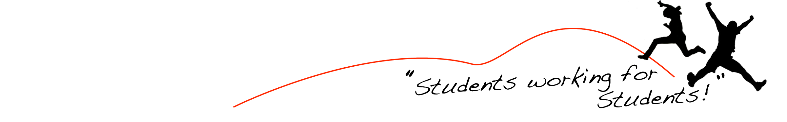

- ROUND TABLE REMARKS
- ADJOURNMENT
