How to scan and send the receipt with RICOH copy machine:

- From the HOME menu select the SCANNER option. Some models may have these options as physical button keys.
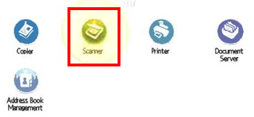
- At the top and center of the screen you will find the SEARCH DESTINATION button. Select it to continue.
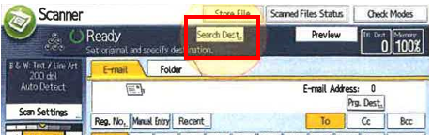
- With the ADDRESS BOOK condition selected at the top, you may search for accessible media (alternate.media@csueastbay.edu).
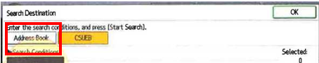

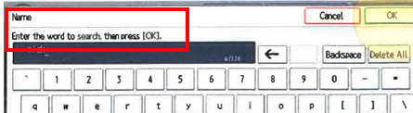
- Press the START SEARCH button to begin searching for the account.
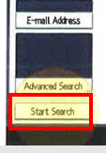
- Your name and email should appear. Select your user account pfrom the results and press the OK button to continue.
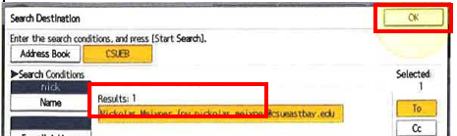
- With your documents set on the machine and the account selected, press the START button to begin scanning. Your email will be sent automatically.
