“Read Aloud” Chrome extension to Read documents online

The “Read Aloud” Chrome extension is astonishingly easy to use, yet it’s very powerful. The extension works on almost every web page, including web apps like Google Docs. Just open up the document, and click on the extension button to start reading text aloud. You also don’t need to select text, Read Aloud will automatically recognize text that should be read aloud.
Just follow these simple steps:
Step 1:
To add this extension you can go on the following link:
https://chrome.google.com/webstore/detail/read-aloud-a-text-to-spee/hdhinadidafjejdhmfkjgnolgimiaplp?utm_source=gmail

After clicking on the above link the following window will open up. Where you would have to click on a blue button on the side saying “Add to chrome”.
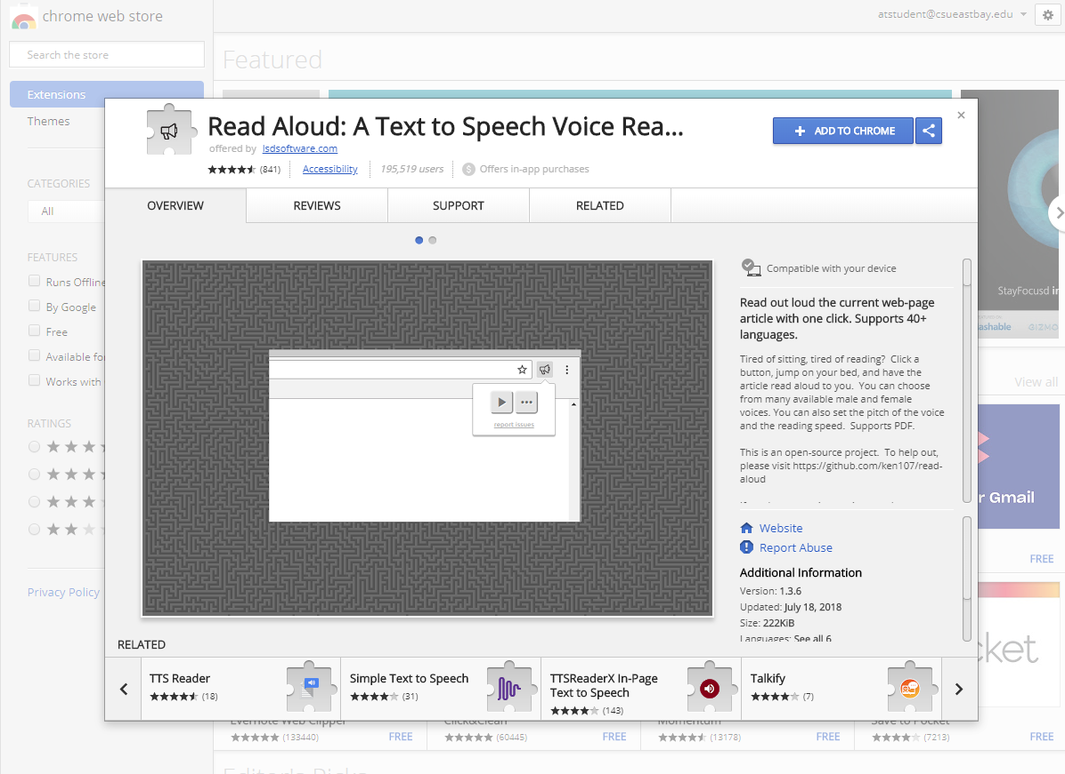
Step 2:
After clicking on “Add to chrome” button, you will get a confirmation pop up message asking if you want to add the extension to your chrome. Just click on “Add extension” as shown in the pic below:

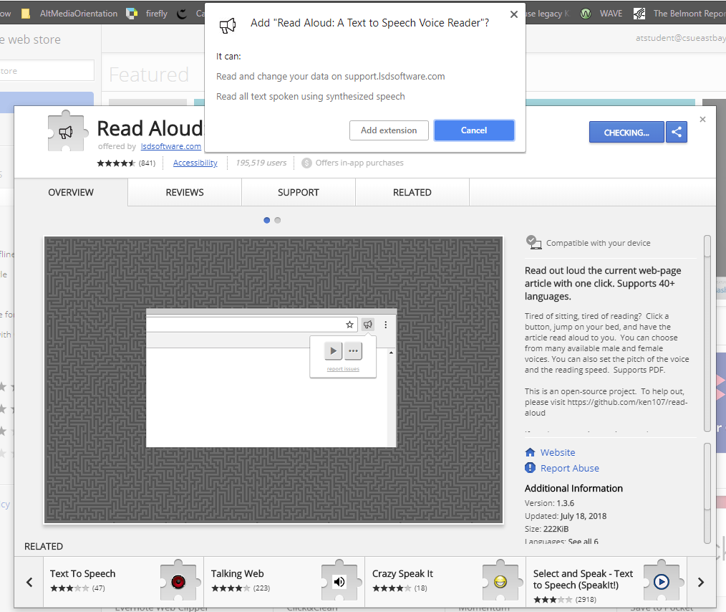

Step 3:
After adding this extension you would see a volume symbol on the top right corner of your computer which means that the extension has been successfully added and you can just open up any google document or web document and click on that symbol and it would start reading it aloud.

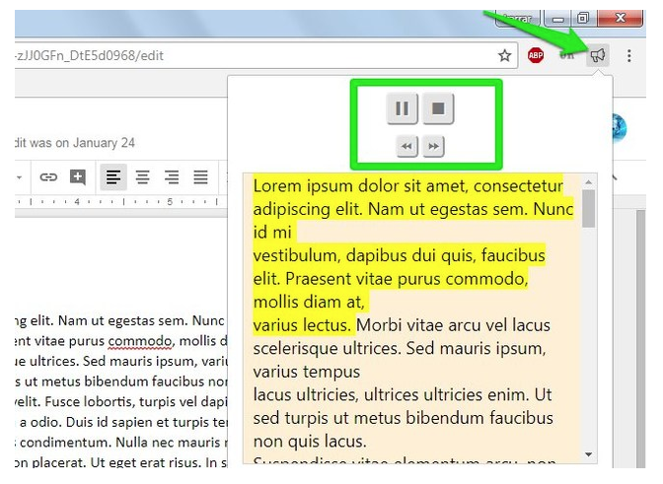

Step 4
If you want you can even change the settings as per your wish. All you have to do is “ Right click” on the Read Aloud symbol and then select “Options” in the drop down menu and the following window would open where you can change the settings as per your choice.
