Introduction to the
Finance Data Warehouse
Student Activity Guide

Last Revised: 07/16/10

REVISION CONTROL
Document Title: Finance Data Warehouse Student Activity Guide
Author: Enterprise Reporting and Data Warehouse Services
File Reference: Finance DW Student Activity Guide_20100716.docx

Date | By | Action | Pages
5/1/10 | ERDWS | New Document | All
7/16/10 | ERDWS | Version 2 | All

Review/Approval History
Date | By | Action | Pages
Confidentiality Statement
This document has been checked and screen shots do not contain any confidential information (staff names, addresses, social security numbers).
Please add a new line, verifying that screen shots have been checked each time this document is published.
Publishing Date | Name of Individual Checking Screen Shots
Table of Contents Page

Chapter 1—Getting Started 4
Activity 1: Log into the Warehouse 4
Chapter 2—Introduction to the Dashboards 5
Activity 2A: Move through the Dashboards 5
Activity 2B: Set Dashboard Defaults 5
Activity 2C: Using the Multi-Select Feature 5
Activity 2D: Select Criteria and Generate a Report 6
Chapter 3— Getting a Different Perspective on your Data 7
Activity 3A: Select Different Report Views 7
Activity 3B: View Content by Section 7
Activity 3C: Change Report Content with Column Selectors 7
Chapter 4— Working with Tables and Drills 8
Activity 4A: Drill through Numeric Data 8
Activity 4B: Drill and Sort 8
Chapter 5— Action Links 9
Activity 5A: Download Data from Drill Down 9
Activity 5B: Print Individual Report to PDF 9
Chapter 6—Personalizing Report Options 10
Activity 6A: Create a Saved Selection 10
Activity 6B: Create a Second Saved Selection 10
Activity 6C: Apply Saved Selections 11
Activity 6D: Change Page Default 11
Chapter 7 – Organizational Reporting 12
Activity 7A: Report at the Organizational Level (Manage My Budget) 12
Activity 7B: Report on a Specified Range 12
Chapter 8 – The Operations Dashboard 13
Activity 8A: Set Dashboard Defaults 13
Activity 8B: Exclude Funds as Needed 13
Activity 8C: Generate a Trial Balance 14
Chapter 9— Extra Features 15
Activity 9: Change Default Dashboard (Optional) 15

Chapter 1—Getting Started
The training environment contains CMS data from the SLO database, including transactions, department tree, org structure. The transaction numbers are scrambled.

Activity 1: Log into the Warehouse
1. The CSU Portal is the site that will provide campus access to system wide applications and information. Inform users when CSU Portal will be available.
2. Follow your instructor’s directions to access the Finance Data Warehouse training environment.
http://137.145.20.104:9704/analytics/saw.dll?Dashboard
3. Login with your username and password as provided by your instructor.
4. Click on Login.

Bookmark the Data Warehouse Homepage (Optional)
1. From your browser add a bookmark to the data warehouse.
2. Add it to your favorites for this training session.

Chapter 2—Introduction to the Dashboards

Activity 2A: Move through the Dashboards
1. Switch back and forth between Manage My Budget and Operations. Notice that there are unique pages (tabs) in each dashboard.
2. Click on Manage My Budget.
3. Click on the pages (tabs) within Manage My Budget.
4. Go to the Home page and move to dashboard pages via the Report Index.
5. Return to the Manage My Budget Home page.

Activity 2B: Set Dashboard Defaults
1. Go the Manage My Budget Home page.
2. Select the following values:
Primary business unit | SLCMP – San Luis Obispo
Primary budget | Operating Budget
Budget scenario | Blank
3. Click Go to execute your selection.

Save your Settings as Default
1. Click the Page Options button.
2. Click Save Current Selections followed by For Me . . . By default the name of the selection will include some of the prompt values.
3. Choose Make this my default for this page.
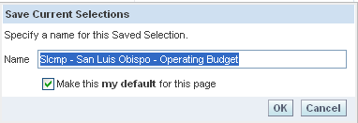
4. Click OK. These settings are saved as your dashboard defaults.

Activity 2C: Using the Multi-Select Feature
In this activity, you will use learn how to filter items using the Multi-Select Match feature. Select available individual or multiple items to use as report filters.
1. Go to the Department page.
2. Click the Department multi-select icon.
3. In the Match field, do a “begins with” search on 125. Click Go.
4. Move individual and multiple departments back and forth from the Match side to the selected side.
5. Do a “contains” search on any of the following criteria:
admin
pres
human
Match is case-sensitive.
Hit “Go” to start the match process.
Do not click on anything while Match is gathering choices because you may interrupt the Match process.

Activity 2D: Select Criteria and Generate a Report
In this exercise you will use the Multi-Select feature to select report criteria and execute the report request using the following Fund and Department report filters.
1. Go to the Department page.
2. From the Multi-select window, set the following report filters.
Page | Department
Page Prompts:  Fiscal Year = 2009  Period (as of) = current  Fund = SL001  Department = 115100 | 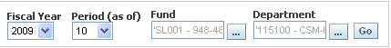
3. Click Go to execute the request. All requests on the page are generated with criteria selected in the report filter.
4. Study the report results.

Chapter 3— Getting a Different Perspective on your Data

Activity 3A: Select Different Report Views
Select a view at the top of a requested box to change the request to that specific view.
1. From the Select Report View dropdown, select the Standard view.
Notice the different data columns.
2. Try the other Report Views:

Activity 3B: View Content by Section
Add another department to your report so that you can view the results by each department.
1. Add an additional department to the report filter.
Page Prompts:  Fiscal Year = 2009  Period (as of) = current  Fund =SL001  Department = 115100  Department = 125100 | 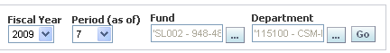
2. Execute the request.
3. View the data by department using the section drop down.

Activity 3C: Change Report Content with Column Selectors
1. Using columns selectors, select the following columns:
Column Selectors 2:  Column 1 = Acct Cat Fdescr  Column 2 = Acct Fdescr | 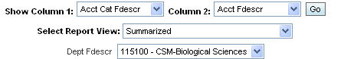
2. Click Go. The columns you selected will appear on the report.

Chapter 4— Working with Tables and Drills

Activity 4A: Drill through Numeric Data
Page | Department
Page Prompts:
Fiscal Year = 2009
Period (as of) = current
Fund = SL002
Department = 115100
Column Selectors 3:  Column 1 = Fund Fdescr  Column 2 = Acct Cat Fdescr  Column 3 = Acct Fdescr | 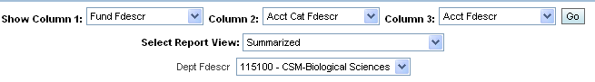
1. Go to the Department page and set your page up indicated above.
2. Drill down on Supplies and Services.
3. At the bottom of the screen use the icons to move forward and back through the returns results.
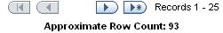
4. Click on the Back button to drill back up and close the bottom branch.
5. Click on the Return button to drill back to the original request.
Clicking the Back button on your browser may cause problems so clicking the Return link is the best option.

Activity 4B: Drill and Sort
1. Drill down on Postage and Freight Tot Actuals.
2. Look at number of records.
3. Confirm drill down total.
4. Sort on Date and Actuals amount.

Chapter 5— Action Links

Activity 5A: Download Data from Drill Down
1. With the Actuals drilldown on screen, download to Excel or Excel 2000. Study format results.
2. From the same drill down, choose the Download Data link. Study the results.
How would you use these two different formats?

Activity 5B: Print Individual Report to PDF
1. Click on the Print hyperlink immediately below the report.
2. Select PDF.
Another window will open up with the report to be printed.
3. Click on the Print icon. Select PDF.
4. Notice the additional content that is included in the full page PDF.

Chapter 6—Personalizing Report Options

Activity 6A: Create a Saved Selection
Page | Fund
Page Prompts:
Fiscal Year = 2009
Period (as of) = current
Fund = SL002
Column Selectors 2:  Column 1 = Dept Fdescr  Column 2 = Acct Cat Fdescr | 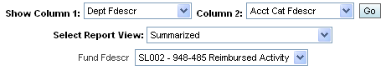

1. Go to the Fund page.
2. Generate a report based on the criteria above.
3. After the results display, click the Page Options button.
4. Click Save Current Selections followed by For Me . . .
By default the name of the selection will include some of the report filter values.
5. Enter a different name for the selection: Fund by Dept by Acct Cat
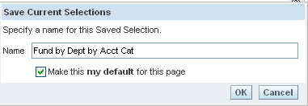
6. Choose Make this my default for this page.
7. Click OK.

Activity 6B: Create a Second Saved Selection
1. Change the column selectors as indicated below:
2. Click Go to execute the request.
3. After the results display, click the Page Options button.
4. Click Save Current Selections followed by For Me . . .
5. Enter a different name for the selection: Fund by Dept Only. Do NOT choose the “my default” checkbox.
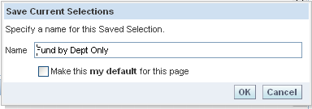
6. Click OK.

Activity 6C: Apply Saved Selections
1. Click Page Options > Apply Saved Selections > Fund by Dept by Acct Cat
The selection saved as the page default appears in bold.
- A default saved selection will be activated the first time that you access a page within an OBIEE session OR when moving back and forth between dashboards.
- Saved selections are specific to an individual dashboard PAGE.
- There is no limit to the number of saved selections per page.
2. Switch back and forth between the two saved selections you created in this exercise.

Activity 6D: Change Page Default
1. Click the Page Options button.
2. From the Save Current selections option, select Edit Saved Selections and Defaults.
The Edit Saved Selections and Defaults dialog will display.
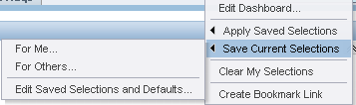
3. Change the page default to Fund by Dept Only
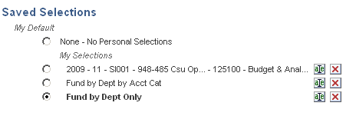
4. Click OK to save your changes.

Chapter 7 – Organizational Reporting

Activity 7A: Report at the Organizational Level (Manage My Budget)
Page | Organization
Report Filters:  Fiscal Year = 2009  Period (as of) = 12  Fund = SL002  Department = 120000 | 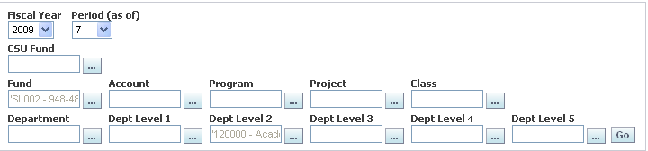

1. Go to the Organization page.
2. Using the report filters indicated above, generate a Revenue and Expense Summary by Organization (3 Columns) report.

Column Selectors 3:
Column 1 = Lvl 2
Column 2 = Lvl 3
Column 3 = Lvl 4
3. Set the column selectors indicated above.
4. Click Go to generate the report.

Activity 7B: Report on a Specified Range
Page | Organization
Report Filters:
Fiscal Year = 2009
Period Between = 3 and 6
Fund = SL001
Department = 125100

1. Go to the Organization Between Fiscal Periods page.
2. Using the report filters indicated above, generate a Revenue and Expense Summary by Organization (3 Columns) report.

Column Selectors 3:
Column 1 = Lvl 2
Column 2 = Lvl 3
Column 3 = Lvl 4
3. Set the column selectors indicated above.
4. Click Go to generate the report.

Chapter 8 – The Operations Dashboard

Activity 8A: Set Dashboard Defaults
Dashboard defaults must be set individually for each dashboard.
1. Go the Operations Home page.
2. Select the following values:
Primary business unit | SLCMP – San Luis Obispo
Primary budget | Operating Budget
Budget scenario | Blank
3. Click Go to execute your selection.

Activity 8B: Exclude Funds as Needed
Page | Organization
Report Filters:  Fiscal Year = 2009  Period (as of) = 11  Fund = SL001  NOT Account Category  601, 602, 603  Department = 125000 | 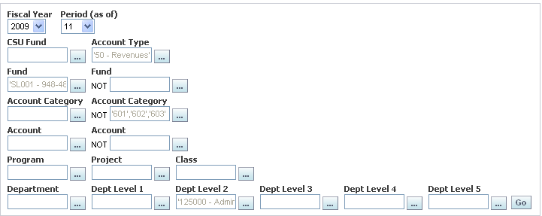
1. Go to the Organization page (Operations dashboard).
2. Set the Report Filters indicated above.
3. In the NOT Account Category multi-select, choose 601, 602, and 603.
4. Click Go to generate a Ledger Summary by Organization (3 Columns) report.
5. Set the column selectors as desired.
6. Click Go to generate the report.
7. Select desired Report View.

Activity 8C: Generate a Trial Balance
Page | Organization
Report Filters:
Fiscal Year = 2009
Period Between = 3 and 6
CSU Fund = 485
1. Go to the Organization Between Fiscal Periods page.
2. Using the report filters indicated above, generate a Trial Balance report.
3. In the Show Column, select State GL Acct Fdescr.
4. Hit Go.
5. Select Report View – Summary by CSU Fund Pivot.

Chapter 9— Extra Features

Activity 9: Change Default Dashboard (Optional)
If you prefer to have a different dashboard display when you first start an OBIEE session, you can change your default dashboard.
1. Select My Account.
2. Select the default dashboard dropdown.
3. Select desired dashboard.
4. Select Finished to save your settings.
5. Log out of OBIEE when finished.

