CFS Data Warehouse
Labor Cost Distribution (LCD)
Dashboard Guide v. OAC

Last Revised: | 03/01/2023

REVISION CONTROL
Document Title: | Labor Cost Distribution Dashboard Guide
Author: | Business Intelligence / Data Warehouse (BI/DW)
File Reference: | LCD Dashboard Guide ver OAC

Date | By | Action | Pages
8/11/2016 | BI/DW | DRAFT LCD Dashboard Guide | All
8/30/2016 | BI/DW | Updated Glossary Section | 17-29
6/18/2018 | BI/DW | New LCD Column Selector Fields; Class and Program Tree Updates to Advanced Filters and Column Selectors | All
12/17/2018 | BI/DW | Updated for version 12C | All
03/01/2023 | BI/DW | Updated for version OAC

Table of Contents
Page
About this Document 4
1.0 Getting Started with the Labor Cost Distribution (LCD) Dashboard 5
1.1 CFS Security Role 5
1.2 Data Warehouse Department Security 5
2.0 Getting Started 6
2.1 Logging in to the Data Warehouse 6
2.2 The Data Warehouse Home Page and Dashboards Menu 7
3.0 LCD Dashboard 10
3.1 Labor Cost Distribution Dashboard Home Page 10
3.2 LCD Dashboard Report Index 12
4.0 Employee Detail 13
4.1 Report Elements 13
4.2 Using this Report 13
5.0 Payroll Detail 16
5.1 Report Features 16
5.2 Using this Report 17
6.0 Payroll Summary 20
6.1 Report Features 20
6.2 Using this Report 20
7.0 Payroll Expenditure Actuals and Projection 22
7.1 Report Features 22
7.2 Using this Report 22
7.3 Report Views 23
8.0 Budget Scenario Look Up Page 25
8.1 Report Features 25
APPENDIX A – Glossary 27

About this Document
The Labor Cost Distribution (LCD) Dashboard Guide provides detailed information about the LCD dashboard reports and features.
Audience
This document is intended for all users of the CFS Data Warehouse LCD dashboard.
Related Documentation
    - CFS Data Warehouse Common Features Guide
    - CFS Data Warehouse Financial Reporting Dashboard Guide
    - CFS Data Warehouse Transaction Inquiry Dashboard Guide
    - CFS Data Warehouse Tree Reporting and Configuration Guide

Getting Started with the Labor Cost Distribution (LCD) Dashboard
This section describes how to configure CFS security in support of the Labor Cost Distribution (LCD) dashboard and data access. For comprehensive information on using the features in the Finance Data Warehouse, go to the Finance Data Warehouse Common Features Guide.

CFS Security Role
Access to the LCD dashboard is granted through a unique CFS role. This role must be added to the source Production CFS database to access the LCD dashboard in the production Data Warehouse. The role must be added to the non-production CFS database indicated below to access the LCD dashboard in the test Data Warehouse.
PS ROLE | Role Description | Production  CFS Instance | Test CFS  Instance
CFSCSU_FS_DWReporting_13 | This role is designed to grant access to the LCD Dashboard only | FCFSPRD | FCFSPSC

Data Warehouse Department Security
Department level security is optional and will be a campus decision to implement. If a campus implements department level security, all delivered finance data warehouse reports will support department security access, including the LCD dashboard.
For detailed information about Department Security, see the Finance Data Warehouse Security Guide at Finance Data Warehouse User Documentation on CSYou.

Getting Started
This section provides a brief overview of accessing the CFS Data Warehouse (sometimes also referred to as the Finance Data Warehouse). For comprehensive information on using the features in the CFS Data Warehouse, go to the CFS Data Warehouse Common Features Guide.

Logging in to the Data Warehouse
The CFS Data Warehouse can be accessed through CSYou and is available as a button in the Quick Links section.
https://csyou.calstate.edu/Divisions-Orgs/bus-fin/it/BI-DW/CFSDW/Pages/default.aspx
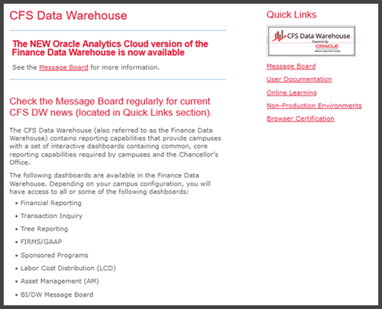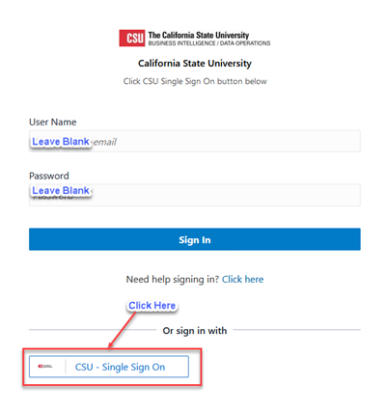
Login to the CFS Data Warehouse
Access to the CFS Data Warehouse is provided via SSO (single sign-on). The steps for accessing the data warehouse at your campus might be different. Follow your campus guidelines to log into the data warehouse.
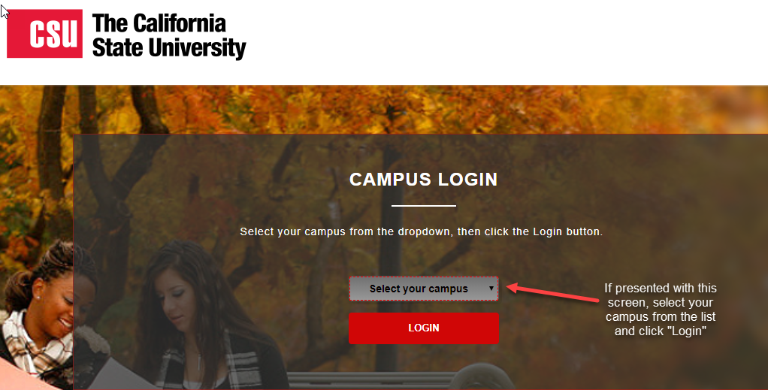
Choose your Campus, if Prompted

The Data Warehouse Home Page and Dashboards Menu
Once you have successfully logged in to the CFS Data Warehouse, you will be directed to the main Home page. This page contains links to the individual dashboards and your most recently accessed reports. The CFS Data Warehouse contains multiple dashboards. A dashboard allows multiple reports to be displayed in a tabbed interface.
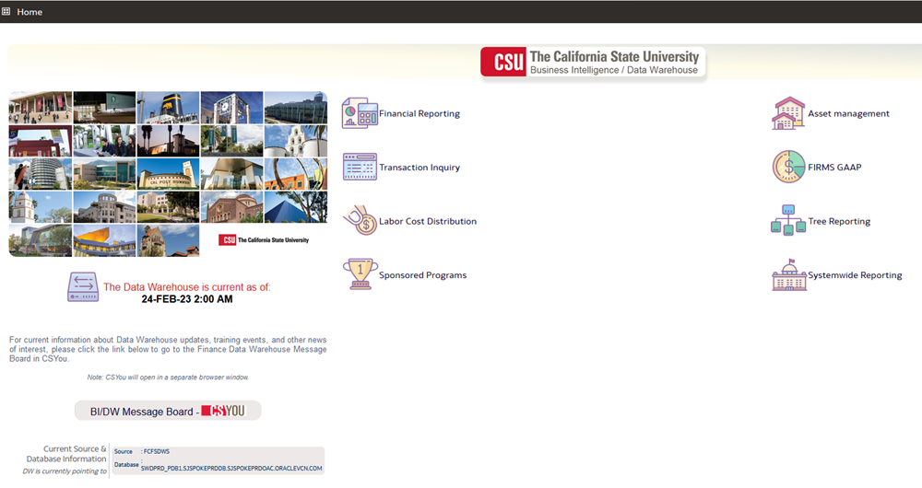
Data Warehouse Main Home Page (Landing Page)
Depending on your security profile, you will have access to some or all of the following dashboards.
- Asset Management
- Financial Reporting
- FIRMS/GAAP
- Labor Cost Distribution
- Sponsored Programs
- Systemwide Reporting (restricted to CO only)
- Transaction Inquiry
- Tree Reporting
Additional Features on the Home Page
Additional features on the Data Warehouse Home Page include:
- The CFS Data Warehouse Home page displays the date and time of the current data refresh.
- The BI/DW Message Board button will take you to the Message Board in CSYou.
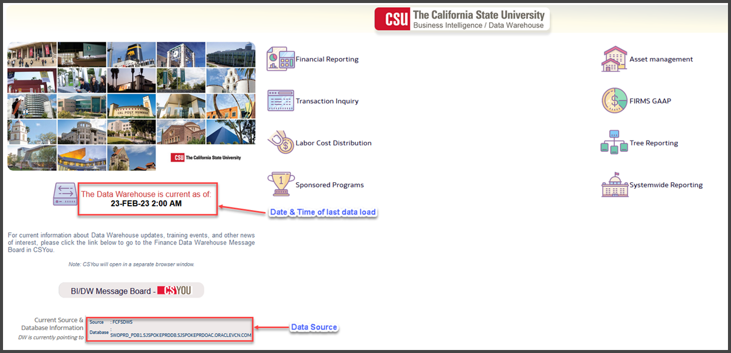
Enhanced Functionality on the New CFS Data Warehouse Home Page
Accessing a Dashboard
1. Click on the Labor Cost Distribution button to go to the associated dashboard.
You can also choose the Dashboards drop down menu to display a list of available dashboards.
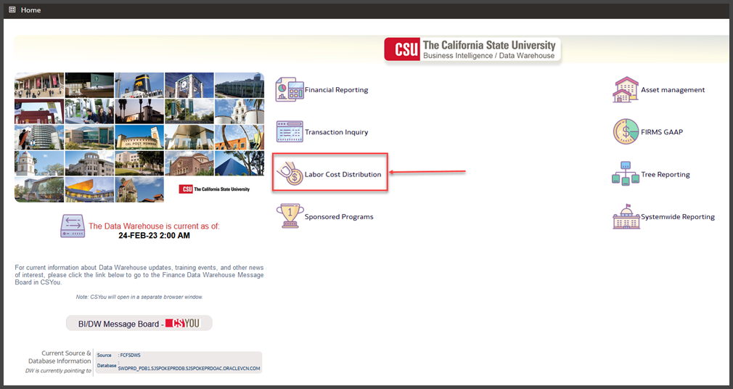
Access a Dashboard by Clicking the Dashboard Button
Navigating through the Data Warehouse
1. From anywhere in the Data Warehouse, you can click the Home link to return to the main Home page.
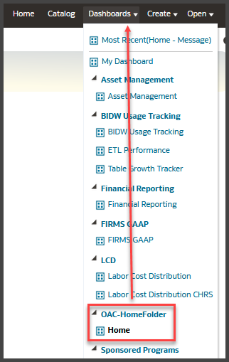
Click the Home Button to return to the Landing Page
2. You can also move through the dashboards by using the Dashboards drop down menu to display a list of available dashboards.
The Dashboards Menu is Available Throughout the Data Warehouse

LCD Dashboard
The Labor Cost Distribution (LCD) dashboard provides reporting using the payroll data stored in the CFS Labor Cost Distribution reporting table. Some values were manually translated as these translations are stored in HR. When HR is available in the CSU Data Warehouse, these translations will come directly from there.
For users who are unfamiliar with the data stored within the CFS Labor Cost Distribution Reporting table, please refer to Appendix A, LCD Glossary.
Audience
The LCD Dashboard is designed for:
Internal Users
Staff within the financial areas who require various financial analysis using payroll data
Departmental Users
Campus end users who are responsible for managing a budget that include payroll costs

Labor Cost Distribution Dashboard Home Page
Access the Labor Cost Distribution Dashboard
1. From the data warehouse main Home page, click the button for the Labor Cost Distribution dashboard.
The New Data Warehouse 12C Home Page displays a Button for Every Dashboard
You can also choose the Dashboards drop down menu to display a list of available dashboards.
2. From the LCD dashboard Home page, select your primary campus business unit:
Primary  Business Unit | 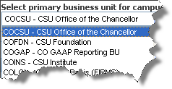
3. Click Apply to apply the dashboard filters.
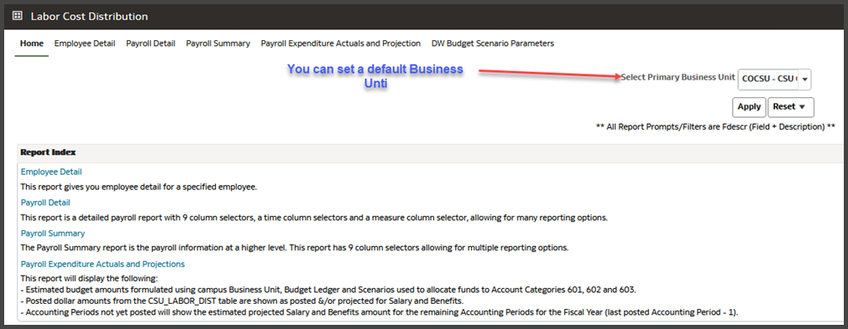
LCD Dashboard Home Page
Save Dashboard Settings as a Default Customization
Using Save Customizations, you can store the dashboard settings as a default so that you do not have to reset them every time you log into the data warehouse.
1. From the Page Options menu, choose Save Current Customization.
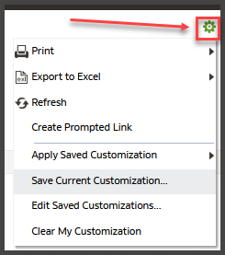
The Page Options Feature
2. Enter a descriptive customization name.
3. Choose Make this my default for this page.
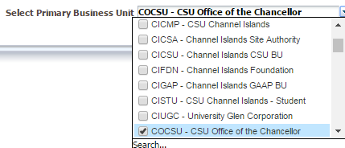
Saving the Primary Business Unit as a Dashboard Default
4. Click OK.
This setting will now apply to all reports within the active dashboard.

LCD Dashboard Report Index
The following pages/reports are available within the LCD dashboard:
Page Name | Page / Report Description
Employee Detail | Displays a one-page report for a single employee with various position and payroll elements
Payroll Detail | Report for advanced analytics, including nine column selectors, a measures selector, and a time selector
Payroll Summary | Report for the Campus Departments to use to monitor payroll cost at a summary or detail level
Payroll Expenditure Actuals and Projections | This report will display the following:  - Estimated budget amounts formulated using campus Business Unit, Budget Ledger, and Scenarios used to allocate funds to Account Categories 601, 602 and 603  - Posted dollar amounts from the CSU_LABOR_DIST table are shown as posted &/or projected for Salary and Benefits  - Accounting periods not yet posted will show the estimated projected Salary and Benefits amount for the remaining Accounting Periods for the Fiscal Year (last posted Accounting Period minus 1)
Budget Scenario Look Up Page | This report is designed to produce a look-up by Set ID of Scenario(s) used in the Payroll Expenditure Actuals and Projection Budget calculation

Employee Detail
The Employee Detail report provides public payroll information for a single employee. This report provides information to assist with personnel transactions.

Report Elements
There are no column selectors or report views in the Employee Detail report. The report displays static columns that reflect criteria set in the report filters.
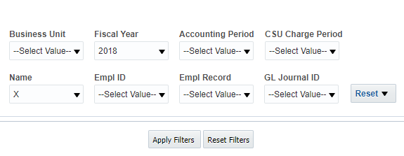
Employee Detail Report Filters

Using this Report
Report Results
The report results display static information associated with the employee(s) identified in the report filters search. Due to the complex layout of the report results format, it is best to use this report for only one employee at a time.
Report Views
There are no report views in the Employee Detail report. The report filters that were used to generate the report display below the report results area.
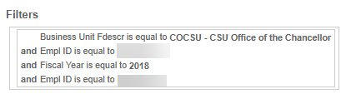
Report Filters Appear Below Report Results
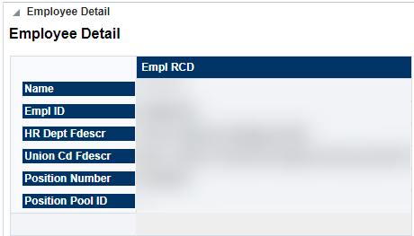
Employee Detail Report Results (Partial)
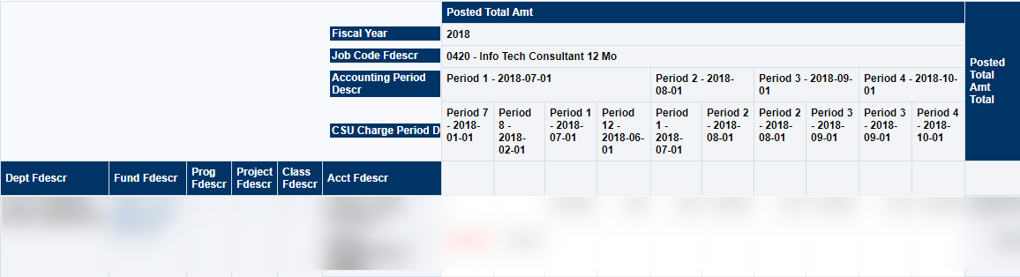
Employee Detail Report Results (Partial)
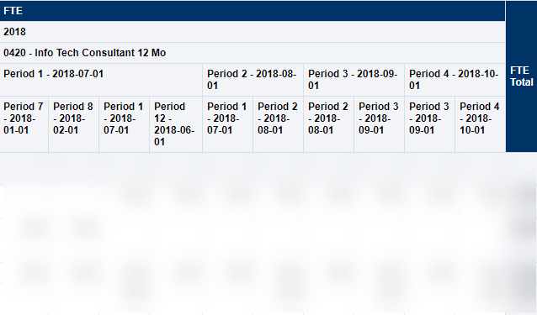Employee Detail Report Results (Partial)

Payroll Detail
The Payroll Detail report is designed to answer various analytic business questions. This report has nine independent column selectors to allow users to set up finance chartfields as well as LCD attributes in a single report.

Report Features
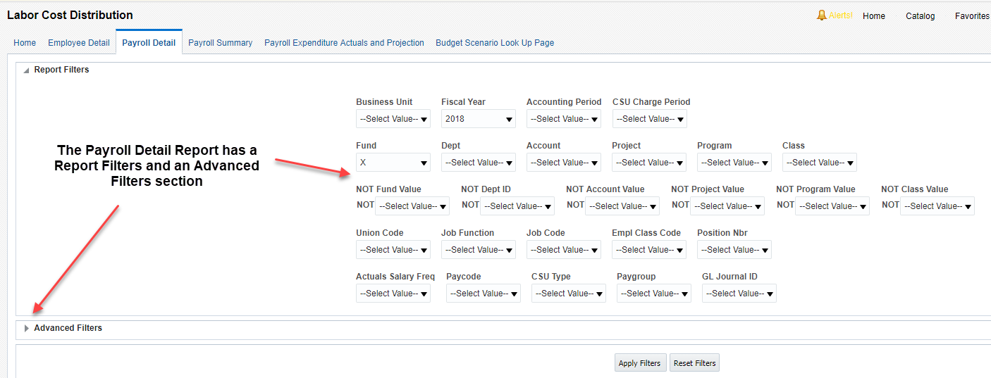
Report Filters and Advanced Filters
- The Labor Cost Distribution contains two sections for filters: Report Filters and Advanced Filters.
- The report supports chartfield tree reporting for all chartfields: Dept, Fund, Account, Project, Program, and Class.
- There are nine standard column selectors plus a Show Time and a Show Measure column. The additional column selectors.
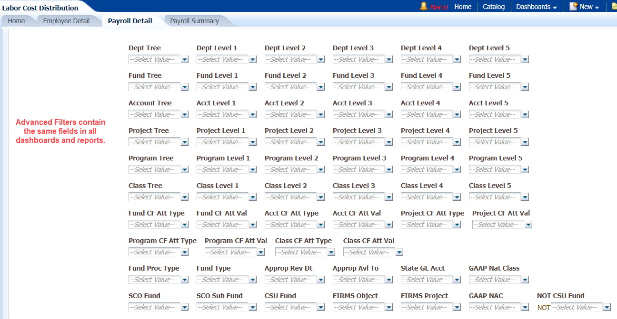
Advanced Filters Section on the Payroll Detail Report

Using this Report
The Payroll Detail Report contains nine column selectors. The first three columns are always visible. The subsequent six columns plus Show Time and Show Measure can all be hidden to produce desired report results. The Payroll Detail report can be used to answer various analytic business questions. These reports require the user to have a good understanding of the data elements.
Scenario Example 1: Pay by Bargaining Unit by Fund by Accounting Period
This scenario is good for estimates on salary increases. Replace the values below with your campus values. Apply the Report Filters and set the Column Selectors. Experiment using different column selectors in your report results.
REPORT FILTERS | EXAMPLE
HOME: Primary business unit | COCSU – CSU Office of the Chancellor
Fiscal Year | 2018
Accounting Period | 4;5;6
Fund
Paycode | REG
ADVANCED FILTERS | EXAMPLE
CSU Fund | 485 – TF-CSU Operating Fund
COLUMN SELECTORS | EXAMPLE
Column 1 | Dept Fdescr
Column 2 | Acct Cat Fdescr
Column 3 | Acct Fdescr
Show Time | Accounting Period Descr
Show Measure | LCD Posted Total Amount
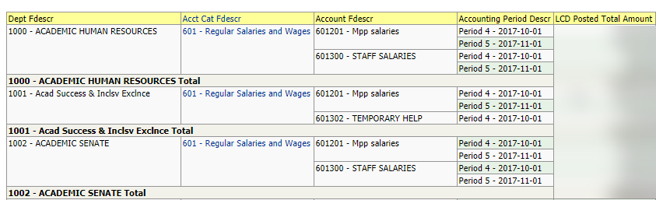
Scenario 1 Example
Scenario Example 2: Salary and Benefits by Bargaining Unit by Fund
Indicates salary and benefit costs by bargaining unit so one can determine the benefit percentage. Can do for whole bargaining unit and then do by fund.
REPORT FILTERS | EXAMPLE
HOME: Primary business unit | COCSU – CSU Office of the Chancellor
Fiscal Year | 2018
CSU Type | ERN
ADVANCED FILTERS | EXAMPLE
Dept Tree | COCSU_DEPT_ROLLUP
COLUMN SELECTORS | EXAMPLE
Column 1 | LCD Union Cd Fdescr
 | Fund Fdescr
Column 2 | Dept Level 3 Fdescr  (Remove subtotal)
Show Time | Accounting Period Descr
Show Measure | LCD Posted Total Amount

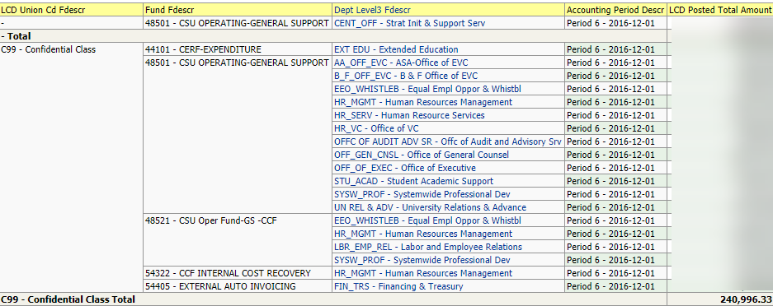
Scenario 2 Example
Scenario Example 3: Non Salary Employees / Pay Rate and Hours Worked
This scenario will display pay rate and hours worked for non-salaried employees. This report takes advantage of eight user-defined column selectors, plus the Show Time and Show Measures columns.
REPORT FILTERS | EXAMPLE
HOME: Primary business unit | COCSU – CSU Office of the Chancellor
Fiscal Year | 2017
CSU Type | ERN
Paygroup | POS, STU
COLUMN SELECTORS | EXAMPLE
Column 1 | Dept Fdescr
Column 2 | Fund Fdescr
Column 3 | LCD Empl ID
Column 4 | LCD Position Fdescr
Column 5 | LCD Paygroup
Column 6 | Comp Frequency
Column 7 | LCD CSU Paycheck Nbr
Column 8 | LCD CSU Comprate
Show Time | LCD Paid Hrs
Show Measure | LCD Posted Total Amount

Payroll Summary
The Payroll Summary report is designed to provide a detailed listing of employees using various attributes related to the employee with salary and benefit information. This report provides data to help users manage to a budget and to project salary costs.
Note: The primary difference between the Payroll Detail and Payroll Summary reports are the fixed columns on report results containing all the needed attributes.

Report Features
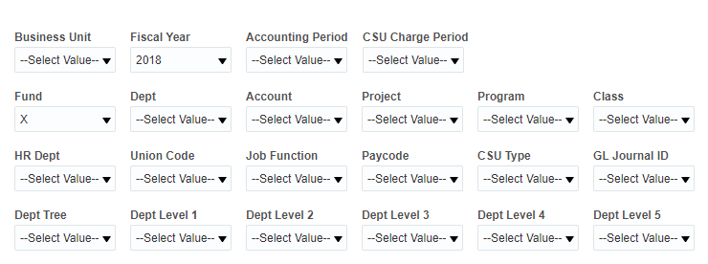
Payroll Summary Report Filters
- The Payroll Summary report contains one Report Filters section
- The report supports chartfield tree reporting for Department only
- The report contains nine standard column selectors

Using this Report
Scenario Example 4: Department Analytics by Job Function Code for Single Accounting Period
This report can be used by department budget managers for department salary analytics.
REPORT FILTERS | EXAMPLE
HOME: Primary business unit | COCSU – CSU Office of the Chancellor
Fiscal Year | 2015
Accounting Period | 2
Dept | 1004 – Student Academic Services
COLUMN SELECTORS | EXAMPLE
Column 1 | Dept Fdescr
Column 2 | LCD Job Function Code
Column 3 | LCD Empl Class Fdescr
Scenario Example 5: Includes Retro Pay (prior CSU Charge Periods)
Add additional column selectors to report results from Scenario 4 for a more granular report.
REPORT FILTERS | EXAMPLE
HOME: Primary business unit | COCSU – CSU Office of the Chancellor
Fiscal Year | 2015
Accounting Period | 2
Dept | 1004 – Student Academic Services
COLUMN SELECTORS | EXAMPLE
Column 1 | Dept Fdescr
Column 2 | LCD Job Function Code
Column 3 | LCD Empl Class Fdescr
Column 4 | LCD CSU Comprate
Column 5 | LCD CSU Paycheck Nbr

Payroll Expenditure Actuals and Projection
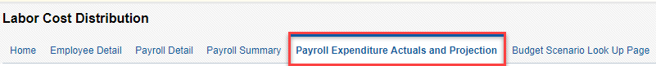
The Payroll Expenditure Actuals and Projection report can be helpful for estimating Fiscal Year spend on Payroll (Salary and Benefits) Expenditures. It is also can be used to forecast annual Payroll activity.

Report Features
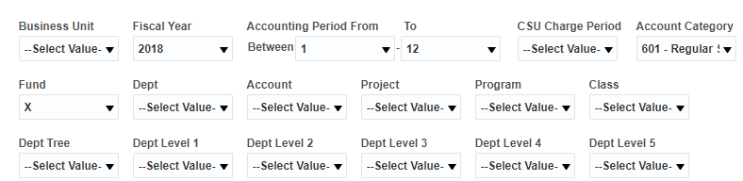
Payroll Expenditure Actuals and Projection Report Filters
- The Payroll Summary report contains one Report Filters section
- The report supports chartfield tree reporting for Department only
- The report contains nine standard column selectors

Using this Report
The Payroll Expenditure Actuals and Projection report uses Budget amounts from and Salary and Benefits amounts from the CSU_LABOR_DIST table from CFS as well as a calculated Projected Salary Amount.
In CFS – budget amount (BUDGET) are loaded by Business Unit, Budget Ledger, Scenario & chartfield for account category 601, 602 & 603 only on each campus. The report is using these components from the Budget Ledger tables in the Finance Data Warehouse with CFS as the source data to create the formulated budget amount.
The report shows the formulated budgeted amount (BUDGET), the Salary and Benefits amounts from the CSU_LABOR_DIST table (ACTUALS) and a Projected Salary Amount ( BUDGET – ACTUALS = PROJECTED SALARY AMT).
FYI: Rules for Salary Projection
- Project data using previous period for period’s From running period + 1 to 12.. eg if campus has LCD data for period 1 and 2. Populate projections for period 3 to 12 using period 1 data.

Exceptions
- No projections for business_unit’s ('FRSNO' ,'NRCMP')
- No projection if latest period is 1 or 12
- No projection if latest period and previous period not belongs to same fiscal year. ( eg campus has LCD data for 2018 Aug ( period 2) and no data for 2018 July(period 1) won’t have any to project data so we wont project until 2018 September (period3) data available.

Report Views
This report has two report views:
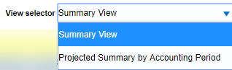
Report Views: Payroll Expenditure Actuals and Projection
Summary View
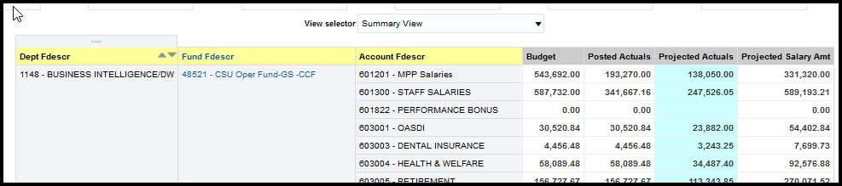
The Summary View defaults to Dept Fdesr, Fund Fdescr, and Account Fdescr in Columns 1-3. The report view displays column selectors plus
- Budget
- Actuals
- Projected Actuals
- Project Salary Amt

Projected Summary by Accounting Period
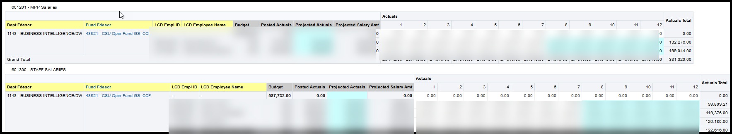
Report View: Projected Summary by Accounting Period
The Projected Summary by Account Period report view defaults to Dept Fdesr, Fund Fdescr, and Account Fdescr in Columns 1-3. The report is broken into sections by Account Fdescr.
The report view displays column selectors plus
- Budget
- Posted Actuals
- Projected Actuals
- Projected Salary Amt

RECOMMENDATION: Use column selectors listed below to recreate the HR Expenditure Report. Save this format as a customization for re-use.
COLUMN SELECTORS | EXAMPLE
Column 1 | Dept Fdescr
Column 2 | Fund Fdescr
Column 3 | LCD Empl ID
Column 4 | LCD Name

DW Budget Scenario Parameters Look Up Page
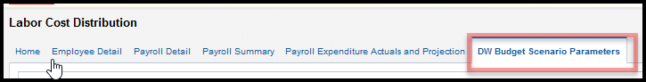
The Budget Scenario Look Up Page is designed to produce a report by Set ID of Scenario(s) used in the Payroll Expenditure Actuals and Projection Budget calculation.
An analysis was done over the last 5 year using Budget, Ledger Description, Scenario(s) for Account Categories 601, 602 and 603. This report allows campuses to search by Campus Set ID, Scenario, and
Broad search by Campus Set ID and Scenario will show all scenarios. The include flag indicates (Y) that the scenario has been applied to the payroll expenditure Actuals and Projection budget calculation. “N” indicates that the scenario is not included.
To make changes to Set ID, Ledger and/or Scenario to be included or not included in the budget calculation, please open a ticket to the Finance Data Warehouse team using Service Now.

Report Features
DW Budget Scenario Parameters Look Up Page Report Filters
An analysis was done over the last five year period using Budget, Ledger Description, and Scenario(s) for Account Categories 601, 602, and 603. Search by Campus Set ID to produce a list of all scenarios associated with the Campus Set ID.
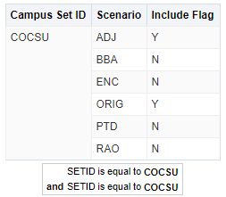
Search Results Based on Campus Set ID
Report Results
A search on Campus Set ID will produce a list of all scenarios. The Include Flag value “Y” indicates that the associated scenario has been applied to the Payroll Expenditure Actuals and Projections budget calculation. The Include Flag value “N” indicates that the scenario is not include.
Note: To make changes to Set ID, Ledger, and/or Scenario(s) to be included or not included in the budget calculation, please open a ServiceNow incident and assign it to the Finance Data Warehouse.
For More Information
Additional CFS Data Warehouse documentation can be found at:
https://csyou.calstate.edu/Divisions-Orgs/bus-fin/it/BI-DW/CFSDW/Pages/BI-DW-User-Documentation.aspx
For further information on the features covered in this Guide or other CFS Data Warehouse issues, please open a ServiceNow request or contact: FDW-SUPPORT@LISTS.CALSTATE.EDU,
* * *

APPENDIX A – Glossary
This Glossary contains CFS Data Warehouse and LCD-specific fields.
FIELD | Same As | DEFINITION
Account | Same as Acct Fdescr as it is used in Column Selectors | Column Selector: Account chartfield value where the payroll was posted to the GL.  Filter: Account value and full description
Account Tree or  Acct Tree Name |  | Account Tree Name
Accounting Period |  | Accounting period numeric value
Accounting Period Descr |  | Accounting period numeric value and description
Acct Cat |  | Account category value. Summarizes Account chartfields into higher level categories.
Acct Cat Fdescr |  | Account Category Value and Description. Summarizes Account Chartfields into higher level categories with description.
Acct CF Att Type |  | Account Chartfield Attribute Type
Acct CF Att Val |  | Account Chartfield Attribute Value.
Acct CF Att Val Descr |  | Account Chartfield Attribute Value and Description.
Acct CF Att Val Fdescr |  | Account Chartfield Attribute Value and full description.
Acct CF Att Val Fld Name |  | Account Chartfield Attribute Value Field Name.
Acct Fdescr | Same as Account as it is used in Report Filters | Account value and full description.
Acct Level 1 or  Acct Level 1 Fdescr |  | Account Level 1 value and full description.
Acct Level 2 or  Acct Level 2 Fdescr |  | Account Level 2 value and full description.
Acct Level 3 or  Acct Level 3 Fdescr |  | Account Level 3 value and full description.
Acct Level 4 or  Acct Level 4 Fdescr |  | Account Level 4 value and full description.
Acct Level 5 or  Acct Level 5 Fdescr |  | Account Level 5 value and full description.
Acct Type |  | Account Type Value. Summarizes Account chartfields into a higher level type
Acct Type Fdescr |  | Account Type value and full description. Summarizes Account Chartfields into a higher level type with description
Actuals Salary Freq |  | Determines the rate at which a salary is paid to employee
Approp Avl To |  | SCO State Fund appropriation available from/to
Approp Rev Dt |  | SCO State Fund appropriation reversion date
Bus Unit |  | Business Unit value
Business Unit |  | Business Unit value and full description.
Campus Set ID |  | Set ID that rolls up to a Business Unit
Charge Period Descr |  | Month (period) in which LCD activity occurred.
Class | Same as Class Fdescr as it is used in Column Selectors | Column Selector: The Class chartfield code where the payroll was posted to the GL  Report Filter: The class value with class full description where the payroll was posted to the GL
Class CF Att Type |  | Class Chartfield Attribute Type
Class CF Att Val |  | Class Chartfield Attribute Value.
Class CF Att Val Descr |  | Class Chartfield Attribute Value and Description.
Class CF Att Val Fdescr |  | Class Chartfield Attribute Value and full description.
Class CF Att Val Fld Name |  | Class Chartfield Attribute Value Field Name.
Class Fdescr | Same as Class as it is used in Report Filters | The class value with class full description where the payroll was posted to the GL
Class Level 1 or  Class Level 1 Fdescr |  | Class Level 1 code plus description
Class Level 2 or  Class Level 2 Fdescr |  | Class Level 2 code plus description
Class Level 3  or Class Level 3 Fdescr |  | Class Level 3 code plus description
Class Level 4 or  Class Level 4 Fdescr |  | Class Level 4 code plus description
Class Level 5 or  Class Level 5 Fdescr |  | Class Level 5 code plus description
Class Tree or  Class Tree Name |  | The name of the Class Tree
CSU Charge Period | LCD CSU Charge Period | Concatenated year / month (YYYYMM) representing the year and the month for which the employee earned their pay. (Not the same as the Accounting Period, which is the period in which the pay was issued)
CSU Charge Period Descr |  | Concatenated year / month (YYYYMM) plus description of the year and the month for which the employee earned their pay. (Not the same as the Accounting Period, which is the period in which the pay was issued)
CSU Fund |  | CSU Fund value.
CSU Fund Fdescr |  | CSU Fund value with full description
CSU Fund Type |  | System-wide grouping of funds based on their attributes
CSU Paid Days |  | If an employee is hired on a daily basis the number of day for which he is paid will be in this data element. For all non-daily employees this field will be blank
CSU Type |  | Deductions, earnings, or tax. This code groups Paycode Fdescr values
Dept or  Dept Fdescr |  | The Dept chartfield code plus description where the payroll was posted to the GL
Dept ID |  | The Dept chartfield where the payroll was posted to the GL
Dept Level 1 or  Dept Level 1 Fdescr |  | Department Level 1 code plus description. Top level department based on active department tree
Dept Level 2  or Dept Level 2 Fdescr |  | Department Level 2 code plus description. Top level department based on active department tree
Dept Level 3 or  Dept Level 3 Fdescr |  | Department Level 3 code plus description. Top level department based on active department tree
Dept Level 4 or  Dept Level 4 Fdescr |  | Department Level 4 code plus description. Top level department based on active department tree
Dept Level 5 or  Dept Level 5 Fdescr |  | Department Level 5 code plus description. Top level department based on active department tree
Dept Tree or  Dept Tree Name |  | The name of the Department Tree.
Empl Class Code | LCD Empl Class Fdescr | A code that describes the nature of the employee’s appointments. Sample values mean Regular, Temporary, Hourly, Rehired Annuitant, FERP, and Student
Empl ID | LCD Empl ID | Employee ID Number; employee 11-digit identification number assigned when hired within the PS Human Resource application
Empl Record |  | The code assigned to each employee’s ID that represents a unique job. If an employee has two concurrent jobs, s/he will have two Empl Records. The combination of the employee ID plus the Empl record represents a unique value for a single job.
FIRMS Obj Cd Fdescr |  | FIRMS Object Code and full description.
FIRMS Object |  | CSU account level that represents a grouping of campus accounts
FIRMS Proj Cd Fdescr |  | FIRMS Project Code and full description.
FIRMS Project |  | CSU system-wide assignment to track various activities at the CSU level
Fiscal Year |  | The fiscal year in which the payroll was posted to the GL
FTE |  | The time base of the employee’s appointment
Fund | Same as Fund Fdescr as it is used in Column Selectors | The Fund chartfield where the payroll was posted to the GL
Fund CF Att Type |  | Fund Chartfield Attribute Type.
Fund CF Att Val |  | Fund Chartfield Attribue value
Fund CF Att Val Descr |  | Fund Chartfield Attribute Value and Description.
Fund CF Att Val Fdescr |  | Fund Chartfield Attribute Value and full description.
Fund CF Att Val Fld Name |  | Fund Chartfield Attribute Value Name
Fund CF Status |  | Fund Chartfield Status (active / inactive)
Fund Fdescr | Same as Fund as it is used in Report Filters | The Fund chartfield plus description where the payroll was posted to the GL
Fund Level 1 or  Fund Level 1 Fdescr |  | Fund Level 1 value and full description
Fund Level 2 or  or Fund Level 2 Fdescr |  | Fund Level 2 value and full description
Fund Level 3 or  Fund Level 3 Fdescr |  | Fund Level 3 value and full description
Fund Level 4 or  Fund Level 4 Fdescr |  | Fund Level 4 value and full description
Fund Level 5 or  Fund Level 5 Fdescr |  | Fund Level 5 value and full description
Fund Proc Type Fdescr |  | Fund Processing Type Field and full description.
Fund Tree or  Fund Tree Name |  | The name of the Fund tree
GAAP NAC |  | GAAP Net Asset Category which is assigned at the Fund level. Used for GAAP reporting.
GAAP Nat Class |  | GAAP Natural Class is a high-level classification assigned to the account chartfield.
GL Journal ID | Journal ID  Jrnl ID | The Journal ID posted to the GL
HR Dept or  HR Dept Fdescr | LCD Dept Fdescr | The LCD Dept chartfield and description
Job Code | LCD Job Code Fdescr | The Job Code and Job Code Description the employee is assigned on job data
Job Function | LCD Job Function Code | A categorization of the job code. Sample include TEN – Tenure, LEC – Lecturer, STF – Staff, COA – Coach, MPP – Management, etc
Journal ID or  Jrnl ID | GL Journal ID | The Journal ID posted to the GL
LCD Account Cd |  | The HR Account Code used for labor distribution
LCD Actuals Salary Freq |  | A code defining the frequency how the time an employees pay is based. Samples include Monthly, Hourly and Daily
LCD Base Salary Amount |  | The full time value of the base salary rate for the employee. Base salary amount is the CSU_EARNINGS field from CSU_LABOR_DIST.
LCD Benefits |  | Posted actuals for any transactions with the Type of DED or TAX
LCD CSU Account Cd Level |  | Labor distribution has 11 hierarchical levels from which the LCD process can obtain the Chart Fields to post payroll. The level, which was used for this employees pay will be indicated in this field. 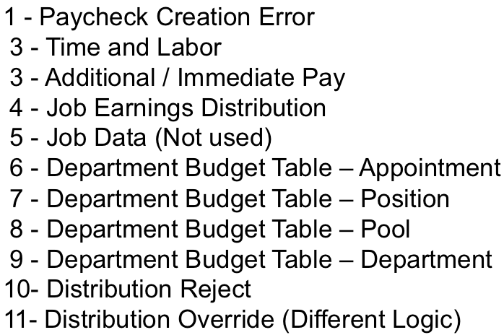
LCD CSU Charge Period | CSU Charge Period | Concatenated year / month (YYYYMM) representing the year and the month for which the employee earned their pay. (Not the same as the Accounting Period, which is the period in which the pay was issued)
LCD CSU Charge Period |  | Indicates the month and year of the work performed, not the Accounting Period which is the month and year the payroll was posted to the ledger.
LCD CSU Comprate |  | Corresponds to compensation rate on the Job Date Compensation tab in HR. If you are a salaried employee, Comprate and Comprate Used will match.
LCD CSU Comprate Used |  | Positive pay for student and non-salaried employees.
LCD CSU Paycheck Nbr | CSU Paycheck Nbr | Paycheck number
LCD CSU Type | CSU Type  LCD Type | Indicates whether the payroll is one of 3 types ERN – Earnings, DED – Deductions or TAX – Taxes. The total of DED plus TAX = Benefits as defined by the CSU. ERN would be salary only. These values were used to create 2 new fields “Salary” and “Benefits”
LCD Dept Fdescr |  | The LCD Dept chartfield and description
LCD Dept ID |  | The Department Code assigned to the employee’s job data (not the department chartfield used for labor distribution)
LCD Empl Class Fdescr | Empl Class Code | A code that describes the nature of the employee’s appointments. Sample values mean Regular, Temporary, Hourly, Rehired Annuitant, FERP, and Student
LCD Empl ID |  | Employee ID Number: Employees 11 Digit identification number assigned when hired within the PS Human Resource application
LCD Empl Record |  | The code assigned to each employee’s id that represents a unique job. If an employee has 2 concurrent jobs they will have 2 Empl records. The combination of the employee ID plus the Empl record represents a unique value for a single job.
LCD Job Code Fdescr | Job Code | The Job Code and Job Code Description the employee is assigned on job data
LCD Job Function Code or  LCD Job Function Code Fdescr | Job Function | A categorization of the job code. Sample include TEN – Tenure, LEC – Lecturer, STF – Staff, COA – Coach, MPP – Management, etc
LCD Name | Name | The employee’s name (First Name, Middle Initial, Last Name)
LCD Pay Grade Fdescr | Pay Grade Fdescr | Further defines the LCD Job Code Fdescr, i.e., 12-month vs 10-month job
LCD Paycode Fdescr | Paycode Fdescr | Indicates the PeopleSoft Earnings Code or Tax Code or Deduction Code and its description based on whether the transaction is earnings, taxes or deductions.
LCD Paygroup | Paygroup | The payroll group this employee’s job is assigned to. Samples include Master (MST), which is a 12-month employee, Academic (ACD), which is an employee who works 10 months but is paid 12, or Student (STU) and Positive Pay (POS)
LCD Position Fdescr |  | The employees position number concatenated with the description assigned to that position number within the PS Human Resource application
LCD Position Number |  | The employee position number within the PS Human Resource Application
LCD Position Pool ID | Position Pool ID | The pool ID assigned to the position, which is used to assign labor distribution chartfields at the pool level within the Department Budget Table
LCD Posted Total Amt | Posted Total Amt | The actual amount posted for all transactions
LCD Salary |  | Posted actuals for any transactions with the Type = ERN
LCD Type | CSU Type  LCD CSU Type | Indicates whether the payroll is one of 3 types ERN – Earnings, DED – Deductions or TAX – Taxes. The total of DED plus TAX = Benefits as defined by the CSU. ERN would be salary only. These values were used to create 2 new fields “Salary” and “Benefits”
LCD Union Cd Fdescr | Union Cd Fdescr | The bargaining union code plus the description concatenated
Name | LCD Name | Employee name
Net Asset Cat |  | Net Asset Category.
Net Class Fdescr |  | Natural Class Value and Description.
Paid Hours |  | For an employee hired on an hourly basis the number of hours for which he is paid will be in this data element. For all non-hourly employees this field will be blank
Pay Grade Fdescr | LCD Pay Grade Fdescr | Further defines the LCD Job Code Fdescr, i.e., 12-month vs 10-month job
Paycode | LCD Paycode Fdescr | Indicates the PeopleSoft Earnings Code or Tax Code or Deduction Code and its description based on whether the transaction is earnings, taxes or deductions.
Paygroup | LCD Paygroup | The payroll group this employee’s job is assigned to. Samples include Master (MST), which is a 12-month employee, Academic (ACD), which is an employee who works 10 months but is paid 12, or Student (STU) and Positive Pay (POS)
Period |  | The Accounting Period when the payroll was posted to the GL (Not when the payroll was earned)
Position Number or  Position Nbr | LCD Position Number | Position Number
Position Pool ID | LCD Position Pool ID | The pool ID assigned to the position, which is used to assign labor distribution chartfields at the pool level within the Department Budget Table
Posted Total Amt | LCD Posted Total Amt | The actual amount posted for all transactions
Prog Fdescr | Same as Program as it is used in Report Filters | Program chartfield and description where the payroll was posted to the GL
Program | Same as Prog Fdescr as it is used in Column Selectors | Column Selector: The Program chartfield where the payroll was posted to the GL  Report Filter: Program chartfield and description where the payroll was posted to the GL
Program CF Att Type |  | Program Chartfield Attribute Type
Program CF Att Val |  | Program Chartfield Attribute Value
Program CF Att Val Descr |  | Program Chartfield Attribute Value and Description
Program CF Att Val Fdescr |  | Program Chartfield Attribute Value and full description
Program CF Att Val Fld Name |  | Program Chartfield Attribute Value Field Name
Program Level 1 or  Program Level 1 Fdescr |  | Program Level 1 code plus description
Program Level 2 or  Program Level 2 Fdescr |  | Program Level 2 code plus description
Program Level 3  or Program Level 3 Fdescr |  | Program Level 3 code plus description
Program Level 4 or  Program Level 4 Fdescr |  | Program Level 4 code plus description
Program Level 5 or  Program Level 5 Fdescr |  | Program Level 5 code plus description
Program Tree or  Program Tree Name |  | The name of the Program Tree
Project | Same as Proj Fdescr as it is used in Column Selectors | Column Selector: The Project chartfield value where the payroll was posted to the GL  Filter: Project chartfield value and full description
Project CF Att Type |  | Project Chartfield Attribute Type
Project CF Att Val |  | Project Chartfield Attribute Value
Project CF Att Val Descr |  | Project Chartfield Attribute Value and Description
Project CF Att Val Fdescr |  | Project Chartfield Attribute Value and full description
Project CF Att Val Fld Name |  | Project Chartfield Attribute Value Field Name
Project Fdescr | Same as Project it is used in Report Filters | Project chartfield value and full description
Project Level 1 or  Project Level 1 Fdescr |  | Project Level 1 code plus description
Project Level 2 or  Project Level 2 Fdescr |  | Project Level 2 code plus description
Project Level 3  or Project Level 3 Fdescr |  | Project Level 3 code plus description
Project Level 4 or  Project Level 4 Fdescr |  | Project Level 4 code plus description
Project Level 5 or  Project Level 5 Fdescr |  | Project Level 5 code plus description
Project Tree or  Project Tree Name |  | Name of the Project Tree
SCO Fund |  | SCO Fund Value with description. Used for State Reporting.
SCO Fund Fdescr |  | SCO Fund Value with description. Used for State Reporting.
SCO Subfund |  | SCO Subfund. Used for State Reporting.
SCO Subfund Fdescr |  | SCO Subfund value with description. Used for State Reporting.
State GL Acct Fdescr |  | State GL Account Field and Description. Used for SW and State Reporting.
Union Code |  | The bargaining union code value
Union Code Fdescr | LCD Union Cd Fdescr | The bargaining union code value with full description

