 | ERFA Newsletter  Emeritus and Retired Faculty Association  California State University, East Bay  Fall 2023  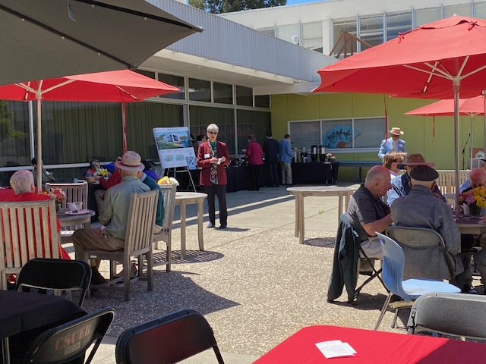  Jodi Servatius welcoming us to our last Spring lunch May 2023  Fall Lunch October 13, 2023, 11:30 a.m.  Our next ERFA Luncheon meeting will take place on Friday, October 13th at 11:30 a.m. in the Zen Garden on campus. Please RSVP, mark your calendar and consider calling a couple of friends you have been missing and would love to see there.  The speaker will be Dr. Chandra Kahn, AVP Office of Research and Sponsored Programs. She will be give a presentation on “Exciting Research Happening on Campus.” This will be a great opportunity to learn about current faculty research. As noted in the last ERFA Newsletter, CSUEB is now a Research II University. Dr. Khan received her Ph.D. in Chemistry from Loyola University, Chicago. She came to CSUEB from Fullerton.  Although the luncheon is hosted, we ask that you consider making a gift in support of our Renaissance Scholars Program students. We look forward to seeing you there.
    - Board Members
  Jodi Servatius, President
  Jane Lopus, Vice-President
  John Giles, Treasurer
  Carl Bellone, Newsletter Editor
  James Ahiakpor
  Bill Reuter
  Alan Smith
  Jeff Seitz
  Judy Stanley
  Donna Wiley
President’s Message

Jodi Servatius, Professor Emerita, Educational Leadership
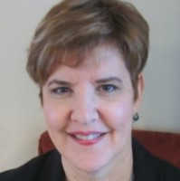
​One of the things I hear from retired faculty is that they really want to stay connected to the university and keep up to date with the wonderful things happening on campus. Naturally, belonging to ERFA is a great way to do this, as our Newsletter and our meetings provide a strong connection for us.
Another really good resource is the campus website, csueastbay.edu. Here are some suggestions for using it.

To find contact information for colleagues. Click the MENU tab. There is a grey bar just under the university title and seal, on which you will find a link to the Directory. This is a quick, easy and reliable tool for connecting with someone you’re looking for. And, if you are emeriti and do not find yourself there, or do not have the correct information posted, you can have this corrected by emailing helpdesk@csueastbay.edu .

To learn what’s new. On the MENU page, there is an ABOUT column, in which you will find a link to the News Center. There are always some interesting stories presented. As I write this, there is a feature article about a collaboration between our campus and the Smithsonian, which is fascinating.

To make a gift. The MENU page’s top banner has a GIVE tab, that takes you to a page where you can use a drop down menu to select a place to direct your donation. There are many options for programs to which to direct your gift, one of which is our wonderful Renaissance Scholars Program.

To follow our Pioneer teams. On the list on the MENU page under ABOUT, there is a link to Athletics. You will find there information on how our Pioneer sports teams are doing.

To purchase Pioneer merchandise. On the list on the MENU page under ABOUT, there is a link to the bookstore. If you’ve been hankering for a new CSUEB sweatshirt, or want to buy a Pioneer item for a gift, you can do that here.

The campus website is a treasure trove. Click around and you are sure to find something of interest.
Our ERFA Board is also seeking treasures - new members. We are particularly looking for members who are recent retirees and bring some diversity to our ranks. If you would like to offer your own or someone else's name in nomination, please email me.

As summer winds down and we move into fall, we are looking forward to gathering once again for lunch and camaraderie at our upcoming luncheon, October 13th. We hope you will be able to join us. Consider calling one or two of your friends and inviting them to meet you there! As has become the custom, the luncheons are hosted by the President and Provost, in recognition of our key contributions to building the university over these many years, so there is no charge for attendance. Please consider making a gift to the Renaissance Scholars Program at our meeting. I will look forward to seeing you there.

Join ERFSA

Are you a member of State-wide ERFSA (Emeriti and Retired Faculty and Staff Association)?
If not, please consider joining. Our local CSUEB ERFA Chapter gets its funding based upon the number of our emeriti faculty who belong to the State-wide ERFSA. The funding enables our chapter to make twice yearly donations to the Renaissance Scholars Program. ERFSA lobbies in Sacramento to protect our pensions and other retirement benefits. Dues are $10/month for most people. For more information and to join go to https://www.csuerfsa.org/

Catching Up With….

Bill Reuter, Professor Emeritus, History
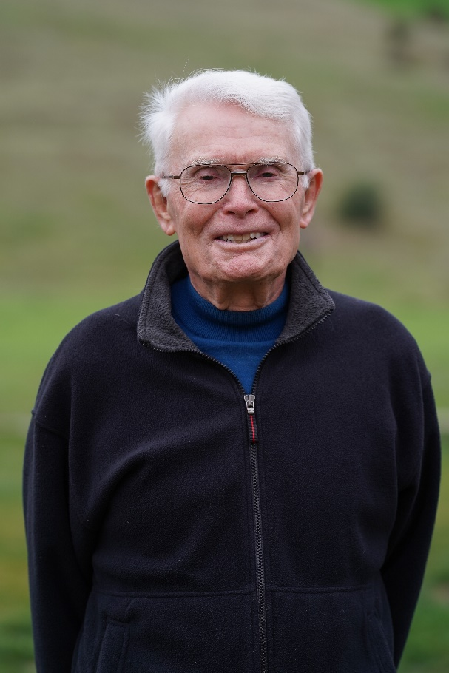
I retired from CSUH (Now CSUEB) in 1995 and faced that important question: what to do post professing? One of the best answers I came up with, along with other good ones I’ve pursued, was getting involved in life-long learning programs. Among early ones was Herb Eder’s Scholar program, and then with OLLI, after Herb and Bette Felton engineered a graceful merger with the Bernard Osher Life-Long Learning Institute. Until last December, I chaired the Curriculum Committees for these programs. It was volunteer work that gave as good as was given.

Working with program coordinators like Kathleen Bryant and a lively committee able to use personal and professional networks to advertise the program and find strong presenters was a pleasure. Good results also pleased me. OLLI offered from the start a remarkable variety of courses, lectures, field trips and special programs. Arts, sciences, popular culture, history, politics, and many other subjects get attention and draw scores of senior learners. A gift to me from all this was meeting a remarkable crew of scholar/teachers. I met them both in person and via telephone conference calls. When the Covid Pandemic hit, it was Zoom meets with prospects from across California, in other states, and even overseas. I’ll mention just two out-of-staters: Richard Bell, Professor of History is at the Maryland University, who writes and teaches with distinction, and David Peritz, currently offering a two-course series titled “Thinking about Thinking”, a fascinating journey from Plato’s Cave to A.I. It was a pleasure to recruit them, and, as with many I’ve recruited, to take their courses.

Three cheers for life-long learning! Now it’s off to Kauai in August with family to celebrate my 90th birthday and swim with giant sea turtles. Both family and turtles have things to teach me.

Michael Hedrick, Professor Emeritus, Biological Sciences
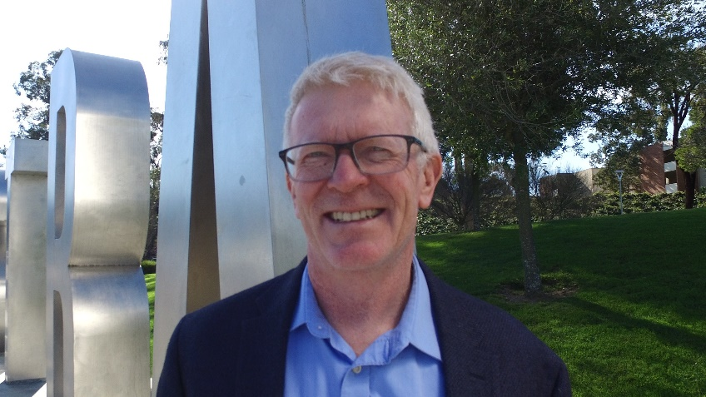
I retired in December, 2022 after 28 years in the Department of Biological Sciences. When I retired I was teaching full-time, but will enjoy the reduced teaching load when I FERP starting in
Fall, 2023. I taught a variety of Physiology and neuroscience courses for the department and enjoyed many years of conducting research with a number of undergraduate and MS students. I had previously served as Department Chair, Academic Senate Chair and Director of the Semester Conversion project, among other many committee assignments during my 28 years in the Department.

I am still active professionally with a current National Science Foundation grant that is a collaboration with a colleague at the University of North Texas (I spent 3 years at UNT as a Professor in Biological Sciences from 2011-2014). My role as PI on the grant is to recruit students from CSUEB for a summer research experience at UNT investigating the role of reduced oxygen levels during embryonic development in alligators and how this impacts the cardiovascular system for several months after hatching. The pandemic has delayed and impacted our ability to recruit students, but we hope to resume the grant in the coming year.

I currently serve as Editor-in-Chief for the journal Comparative Biochemistry and Physiology, Part A, a position I have held since 2013. I will continue in this role until at least the end of 2024. I have also provided service to the American Physiological Society, my professional ‘home’ since I completed my PhD in 1991. I served as a chair of the Comparative and Evolutionary Physiology Section of the APS from 2015-2018 and recently completed a 3 year term as a member of the leadership Council.

My main hobby and passion for retirement is playing the bass guitar. I started playing the bass about 8 years ago taking private lessons and courses at the Berkeley Jazz School. For the past two years I have been playing with the band ‘Take Cover’, an East Bay cover band; we play music mainly from the ‘80s, ‘90s and 00’s. We will be playing at the Castro Valley Fall Festival on Sept. 9 th ; you can also follow us on Instagram (@takecovertheband).

Aside from music, I plan to do some traveling when opportunities arise and family schedules permit. We just returned from a very fun family vacation in New York City in July and I am attending a scientific workshop in Kruger National Park (South Africa) in March, 2024; I have never traveled to Africa and I am very much looking forward to it.

Emeriti in the News….

Recently two emeriti faculty have appeared in the news.

Frank La Rocca, Professor Emeritus, Music

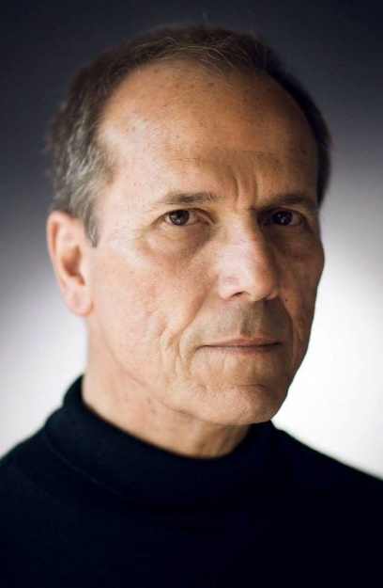
Another fascinating example [of liturgical music] emerges in recent works of composer Frank La Rocca of the Benedict XVI Institute. Mr. La Rocca’s “Mass of the Americas” draws on distinctly American Catholic religious themes. The work is a tribute to Our Lady of the Immaculate Conception, patroness of the U.S., and Our Lady of Guadalupe, patroness of all the Americas. Musically, the “Mass of the Americas” incorporates Mexican folk hymns into the fabric of contemporary high-church sacred music, while showing due respect for its sources. It also includes possibly the first Ave Maria ever set in Nahuatl, the Aztec language in which Our Lady of Guadalupe spoke to San Juan Diego.
As with great Masses composed during the Renaissance, the Mass of the Americas has won new audiences—in packed celebrations in churches and cathedrals in Houston, New York, San Francisco and Washington, as well as Canada and Mexico. Prof. Michael Linton recently dubbed the work “the best piece of liturgical music for the Mass since [the requiem of Maurice] Duruflé.” From the Wall Street Journal By Blanton Alspaugh

Arnie Stoper, Professor Emeritus, Psychology

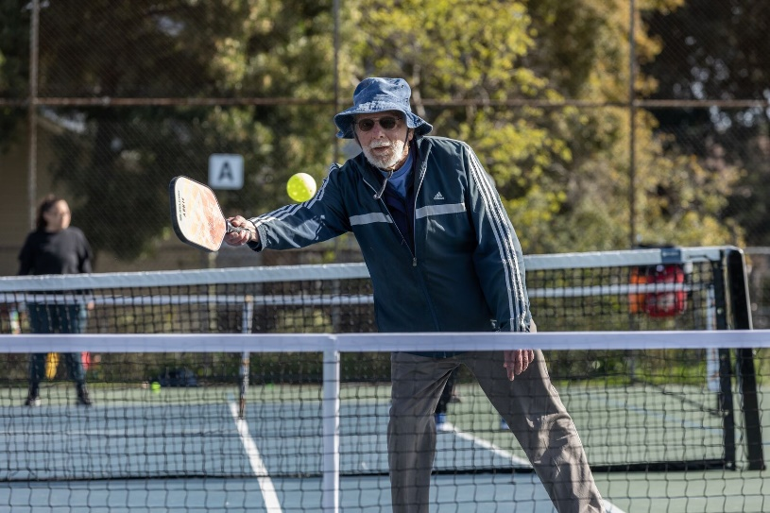
During his long career as a professor of psychology at Cal State East Bay in Hayward, Arnold Stoper was known for his research into visual perception. Now, the professor emeritus is known for something else: his underspin.
Stoper, who lives in Oakland, plays pickleball at least three times a week at Bushrod Park, the center of the city’s pickleball scene. For the 85-year-old, it’s the perfect sport: He can play with a missing rotator cuff. And while he can’t run for the ball like he used to, much of pickleball—a tennis-like sport played with hollow plastic balls and paddles instead of rackets—is played close to the net.
Known as Arnie, Stoper is considered an old-timer, in that he’s been playing the game at least seven years. “Now there are all these young, whippersnapper beginners,” Stoper joked. “It’s more fun than tennis ever was,” the former tennis player added. “You get way more hits in, and don’t spend as much time chasing the ball onto the other court.” From the Oaklandside April 5, 2023.

Renaissance Scholars Program
ERFA supports the Renaissance Scholars Program for students who were previously in foster care. Below is the story of Nicole Stillman, one of the Renaissance Scholars who benefited from our support.
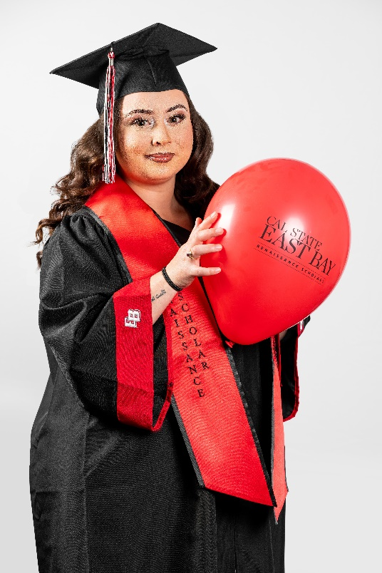
Growing up in the foster care system had a severe impact on my educational experience throughout high school. The combination of changing schools and the mental stressors
that were going on in my placements made it very challenging to excel in my school work. Once I graduated from high school I was hesitant about pursuing a college education because of my previous experiences in educational settings. It wasn't until I
was nineteen years old that I discovered my passion for supporting foster youth and their families who had experienced similar adversities similar to my own. Although I was deeply afraid I would fail in my college career, I decided to take a chance on myself. I enrolled in college with my heart and mind set on becoming a child welfare social worker.

Throughout my undergraduate years I experienced various challenges. As a first generation student, I felt like an imposter and had a difficult time navigating the higher education system. During my first semester at California State University, East Bay, I was connected to the Renaissance Scholars Program. The advisor, Roshawn Campbell, went above and beyond to support me throughout every step of my undergraduate degree.

With this program's support, I was able to confidently navigate my classes, career goals and be a part of an amazing community of supporters and peers who had also experienced the foster care system. The financial support I was able to receive from the program gave me the opportunity to focus on my studies without having to worry about how I would keep a roof over my head. In May of 2023, I graduated with my Bachelors of Arts Degree in Sociology with a 3.9 GPA. Furthermore, I was accepted into California
State University, East Bay’s Master of Social Work program for Fall 2023 where I will continue to pursue my dream of becoming a Child Welfare Social Worker. All in all, the Renaissance Scholars Program will always be a program that I hold dear to my heart. Without the consistent support of this program, I genuinely believe that I wouldn't have been as successful in my college career as I have been. I am deeply grateful for the guidance and support that has been given to me over the years and encourage every foster youth at CSUEB to take advantage of this program. It is truly an honor to be a CSUEB Renaissance Scholar Aluma!

Academic Senator Report
Donna Wiley, Emeritus Representative to the Academic Senate

Spring 2023 Academic Senate Report

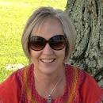
The 2022-2023 Academic Senate concluded a very busy year at its last meeting. A summary of all Senate activities may be found in Chair Sarah Nelson’s annual report. Its final major accomplishment was the finalization of the revisions to the Retention, Tenure and Promotion Policy and Procedures, and the approval of compensation for lecturer faculty who serve on Senate or standing committees. The new version of the RTP Policies and Procedures goes into effect for AY 23-24. There were a large number of changes, which include:

1. There will only be one Service category. (University Service and Community Service will be combined, resulting in only 3 main categories of Instructional Achievement, Professional Achievement, and Service).
2. The University Tenure and Promotion (UTP) Committee will be expanded from 5 to 7 members. New members this year will be a 2nd member from one of the larger colleges (a 2nd member from CSCI will be elected in the fall), and the DELO (Diversity and Equity Liaison Officer) or their delegate. The 7 members will include 2 from CSCI, 2 from CLASS, 1 from CBE, 1 from CEAS, and the DELO/delegate.
3. Tenure-track faculty members will need to have worked here for a minimum of 3 years before being eligible to apply for early tenure/promotion. In order to qualify for early tenure/promotion, faculty will be required to meet the same standards as faculty going up at the usual time (typically after working here for 5 years).

The incoming Senate chair is Christina Chin-Newman. Two of the important priorities of the 2023-2024 Senate will be the monitoring of the College of Health implementation and Academic Affairs rebalancing, and the monitoring of budget and enrollment status and impacts.

In Remembrance…
Dr. Renee Granados, Nursing
Renee Granados began teaching as part of the Cal State Hayward/ East Bay nursing faculty in 2002 as a part-time pediatric nursing instructor and in 2003 the Nursing Department brought her on as a full-time tenure track faculty member. She served as the Nursing Program's Pediatric Nursing clinical expert until her retirement in 2019, and in this role, helped to shape the careers of nearly 2,000 pre-licensure nursing students.

Herb Graw, Kinesiology and Physical Education

Herb Graw Joined the KPE faculty in 1965. In addition to teaching, he was the basketball coach from 1965 to 1971. He also served as the Associate Dean of the School of Education and Allied Studies, Chair of the Department of KPE, and Associate Vice-President of Continuing Education and Extension. Dr. Graw served as an elected Board member of the Castro Valley Unified School District for 8 years.

Daryl Wayne Preston, Physics

Daryl Preston was a professor of physics and astronomy. He became known especially for workshops that he gave to other physics professors from around the country – a series of experiments that they could use in their undergraduate student laboratories. He was elected a Fellow in the American Physical Society in 1998. His teaching was recognized with the George and Miriam Phillips Outstanding Professor Award for 1999-2000. He retired from teaching in 2001.

Marc Ratner, English

Mac Ratner taught English and American literature with a particular interest in American writers of the mid-20th century. He retired in 1992. His studies and teaching took him around the world. He taught on Fulbright grants in Germany, Brazil, Romania, Argentina, England and Paraguay. Upon retirement, he moved to Ashland and taught for many years at the OLLI (Osher Lifelong Learning Program) at Southern Oregon University.
Esther Railton Rice, Teacher Education

Dr. Esther Railton Rice taught in the Department of Teacher Education from 1960 until 1997. Esther was ahead of her time in educating students and colleagues about the importance of caring for the environment. She wrote several books and publications on the topic and truly appreciated and respected nature. She was a popular presenter on topics relating to ecology and was frequently called upon as a consultant for local, state, national, and international institutions.

Richard VrMeer, Public Administration

Richard VrMeer joined the faculty in the late 60s as the founding faculty member of the Department of Public Affairs and Administration. Under his leadership, the Masters of Public Administration Program became one of the largest in the state producing many public sector leaders. An avid environmentalist, he donated some farm land he owned in Brentwood to a public trust so it could remain as open space.

For more information on these and other deceased faculty members see https://www.csueastbay.edu/oaa/memorials/index.html

Comments and Suggestions
If you have any comments or suggestions for Newsletter items or for ERFA, please send them to Carl Bellone, carl.bellone@csueastbay.edu or Jodi Servatius, jodi.servatius@csueastbay.edu.

