 |   Fall 2025  You are Invited:  Holiday Gathering December 12, 11:30 a.m.  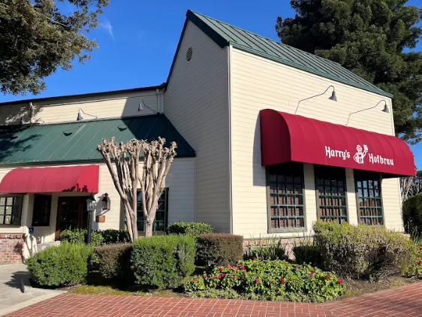  A survey of those attending the Spring 2025 ERFA luncheon at CSUEB indicated that many would like to continue having two luncheons a year, although University Advancement is unable to pay for both. Therefore, you are invited to join your colleagues for lunch at Harry’s Hofbrau in San Leandro for a casual non-hosted holiday gathering on Friday December 12. Harry’s is reasonably priced and cafeteria style, so everyone may order and pay for what they want. You are welcome to bring a guest. There is lots of free parking and Harry’s is disabled-friendly. There will not be a speaker, so this will be a purely social event.  Consider this as your formal invitation! You will not receive an individually mailed invitation.  Please email Donna.Wiley@csueastbay.edu to RSVP by 12/1/25 so we can confirm the reserved space.  Our contact list for retired faculty is imperfect so please get in touch with your colleagues and invite them to come.  See you at Harry’s!  Details:  Friday December 12, 11:30 AM to approximately 1:30 PM  Harry’s Hofbrau, 14900 East 14th Street, San Leandro.  We have the Front Room reserved - to your right when you enter.  Check out the menu and prices at https://www.harryshofbrau.com/
    - Board
    - Members
  Jane Lopus & Donna Wiley, Co-Presidents
  John Giles, Treasurer
  Carl Bellone, Newsletter Editor
  James Ahiakpor
  Stevina Euvelocha-Ugbah
  David Larson
  Michael Hedrick
  Hank Reichman
  Don Sawyer
  Jeff Seitz
  Jodi Servatius, Past President
  Richard Symmons
  Holly Vugia, Senator
Spring Luncheon
University Advancement will continue to sponsor a Spring Luncheon for retired faculty on campus. The 2026 luncheon will be held on Thursday June 4 in the New University Union Multi-Purpose Room. You will receive a written invitation to this event.
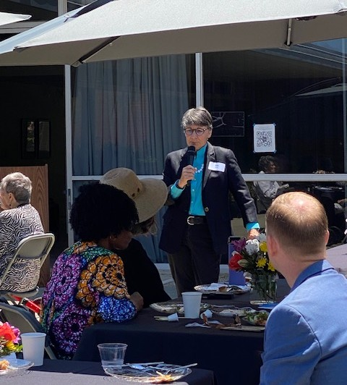

Dr. Kim Greer, Interim Provost, speaking at our Spring 2025 lunch.

Co-Presidents’ Message
Jane Lopus, Professor Emerita, Economics
Donna Wiley, Professor Emerita, Management

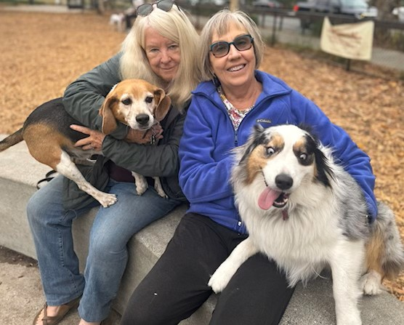
​ Welcome to all our CSUEB retired faculty from ERFA’s new Co-Presidents. We had such big shoes to fill when Jodi Servatius stepped down after many years of outstanding leadership that it has taken two of us to take her place! Many thanks to Jodi for her service, and we look forward
to her guidance as she remains on the ERBA Board.

The Board was happy to welcome several new members over the past year including Mike Hedrick, Dave Larson, and Holly Vugia. ERFA is planning a new format for our fall luncheon this year. Since University Advancement will be hosting only one event per year in the Spring, we’re pleased to announce that a Fall lunch gathering will be held on December 12th at Harry’s Hofbrau in San Leandro. See the article above in this Newsletter for details.

Please contact us if you have ideas for CSUEB ERFA!

Join ERFSA

Are you a member of State-wide ERFSA (Emeriti and Retired Faculty and Staff Association)?
If not, please consider joining. Our local CSUEB ERFA Chapter gets its funding based upon the number of our emeriti faculty who belong to the State-wide ERFSA. The funding enables us to make twice yearly donations to the Renaissance Scholars Program. ERFSA lobbies in Sacramento to protect our pensions and other retirement benefits. Dues are $10/month for most people. Even better, there is currently a half price offer. For more information and to join go to https://www.csuerfsa.org/

Catching Up With….

Dee Andrew, Professor Emerita, History

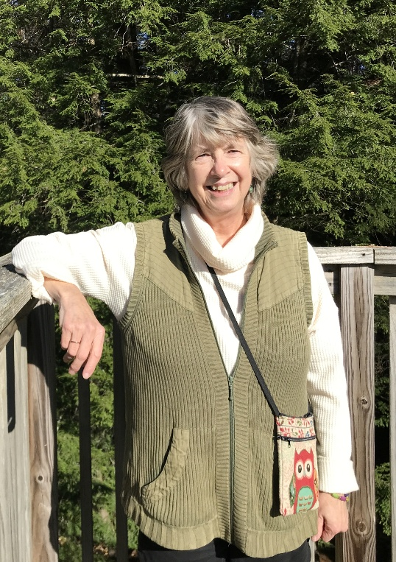
What have I been doing in retirement? It takes a little explaining! In my former life, in between teaching, department-chairing, committee-attending, and adjusting to online instruction with Covid, as we all had to, I also had a great post-doc year in Philadelphia and was able go on summer research trips to track down all manner of writings, printed and otherwise, by British abolitionist Thomas Clarkson. (Why Clarkson? It’s a long story…) Along the way, Classicist Christopher Parmenter at Ohio State University contacted me about Clarkson’s famous prize-winning Latin Essay, which started his 60-year career of writing against slavery and the Atlantic slave trade. The upshot? We just submitted our manuscript, Thomas Clarkson’s Latin Essay: The Making of an Abolitionist Author in the Age of Revolution, to an academic press in Philadelphia.

In April, I had a super time putting together a talk on campus, “Tangibles and Intangibles in Historical Research (especially in books),” based on Chris’s and my proposed book, for Linda Dobb’s speaker series at the University Library. A bunch of wonderful colleagues were there, as well as students. It was the highlight of my spring.

I truly miss being on campus, and especially teaching. I never get tired of working with our students and their amazing life journeys. I’m still in touch with several of our MA graduates. I hope to do more political work and maybe more teaching in the future. But it can’t be said often enough, and I know we ERFA people all agree, the great boon of retirement is having more time with family and friends. Nothing
is better or more important than that!

Rita Liberti, Professor Emerita, Kinesiology

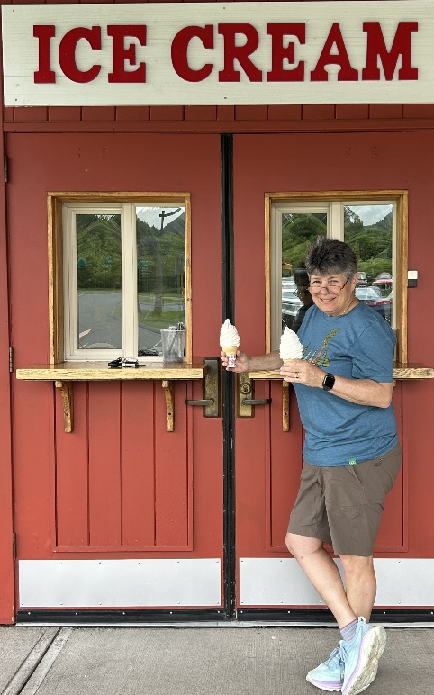
In August 2024, after 26 years at Cal State East Bay, I entered FERP. We (my partner Trudy and I) moved to Northampton, MA just at the start of COVID in 2020 and I
continued to teach, from 3000 miles away, until my retirement this past year. So, plenty of transitions for me over the last 5 years.

While I was born and raised on the east coast (Buffalo, NY), I didn’t spend too much time in New England, and it has been so much fun exploring this part of the world now. Several states (and NYC!) are within a 2 or 3 hour drive from our home which has made for some nice (and quite frequent) adventures. My favorite road trips are those through the Berkshires in the convertible Mini-Cooper I gave myself upon retiring. Destinations include art museums, concerts, antiquing, and (as is evident in the photo) ice cream. Much to my delight, there seems to be a creamery on every corner in this region.

In the summer you can often find me in my garden, where the challenge has been to keep my rose bushes healthy in this northeastern climate. Exercise has been a constant
in my life – and in retirement while my jogging / walking mile times are slower, they are no less enjoyable. I’m fortunate that the extensive “rail-trail” system in western Massachusetts makes for some beautiful paths on which to walk, jog, and bike.

California remains close to my heart, and I have enjoyed several visits since leaving the state 5 years ago. My most recent trip in May 2025 took me to some of my favorite Bay Area hiking spots, like the Dipsea Trail in Marin, as well as walks among the giant trees of Sequoia National Park. Most winters we spend several weeks in Pacific Grove, CA where I enjoy sitting by the sea. Who knows, maybe somebody I’ll see you there. I’d like that.

“Still Teaching After All These Years”
Alan Almquist, Professor Emeritus, Anthropology

Editor’s Note: Dr. Almquist is in his 54th year of teaching at Cal State Hayward/East Bay, probably a record. He began his career at then CSU Hayward in 1971. He retired in 2004 and entered the FERP Program. After FERP, he began teaching as a part-time lecturer, which he is currently doing. Alan’s specialty is Biological Anthropology which is difficult to replace in the curriculum. I asked him to reflect on his over half-century of teaching.

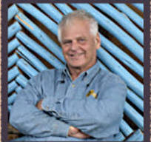
I have stayed on board at Cal State East Bay for several reasons. Probably first and foremost I am convinced that the subject matter I teach, essentially different courses with a general theme of human evolution, is critical to the higher education of our students. They need to know and appreciate the perspective of evolution in their everyday lives. If everyone did, we wouldn't see surges in anti-evolutionary misinformation about vaccines, the idea of "race," eugenics, etc. So, I want to continue to confront this ignorance in my small way.

I like CSUEB, it's a good university and it has been my privilege to know and interact with many fine faculty members, administrators, and especially our hardworking support staff in many different fields over the years. So that certainly has been a plus during my tenure here. Our student body is also special. As we have seen at commencement, many of our graduates are the first in their families to graduate from college, and that's important because it starts the cycle of generational repeats which is so necessary for a well-educated public. Many students that I have had over the years have gone on to earn higher degrees, and I am pleased to know that I might have played a small role in stimulating them to pursue higher education. Others who have attended lectures I would hope will be able to use what I "preach" in whatever direction they choose to go in. Having taught for so many years I have encountered now and then the children of past students who enrolled in my courses because their parents thought what they had learned was important to them.

What I miss now in teaching is the face-to-face interaction I have had with students in the past. I realize that online education is important, especially for students who also must work, sometimes full-time, just to get by. But in many cases the message is lost in translation and not only the message, but the experience of what you and I remember it was to be an undergraduate college student. Technology has made it too easy to communicate with someone else through a machine: cell phone, text messaging, even emails are useful, but they shouldn't be thought of as replacements for face-to-face dialogue with other people. That's a skill set that is also learned, and we are falling down on the job when we ignore this fact and uncritically embrace all the technology that keeps being thrust upon us. I think today it is harder to get the message across using online technology and consequently harder to assess how well we are doing as teachers.

If I could go back to my undergraduate years and reconsider my decision to pursue a career in Biological Anthropology I probably would have come to the same conclusion that I reached: that this was a field that continually offers surprises, certainly has an interesting array of colleagues whom I have worked with both on campus and in the field in Africa. It’s stimulating work that seems in many ways to not be work at all, but an opportunity to do something that has been a lot of fun. And I got paid for it at the same time! One example I always cite in lectures is about the fun of human evolution: by knowing something about the field you can use Anthropology to enrich your life. I have a very close friend who I have known along with his family for decades. While he was active in his field as an attorney, he oversaw the entire real estate empire of Wells Fargo Bank. He was extremely successful in his job, but what he loves is Anthropology, and took every vacation moment he had to explore the world and do fieldwork with professional anthropologists. After his retirement he has pursued this love in many ways and is certainly happier now that he doesn't have to "work."

I tell my students that while you may not earn a living being an anthropologist, you can still live the dream. That's what I wish for all my students and the goal I pursue in teaching them the subject matter.

Academic Senator Report

Holly Vugia, Emeritus Representative to the Academic Senate
Fall 2025 Academic Senate Report

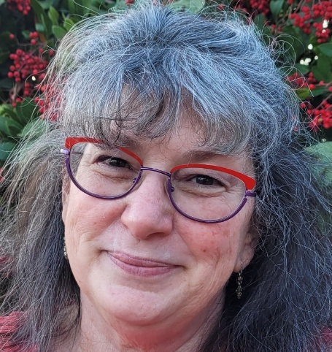
The Academic Senate started the 2025-26 year by welcoming our new Provost and the College Deans:

- Provost Anthony Muscat
- Dean Keri O’Neal, College of Letters, Arts, and Social
Sciences (CLASS)
- Dean Carmen Bustos-Works, College of Science (CSCI)
- Interim Dean Ching-Lih Jan, College of Business and Economics (CBE)
- Dean Sonja Lenz-Rashid, College of Health (COH)
- Dean Kristin Hart, University Libraries

Senate Leadership: The 2025-26 Academic Senate leaders include: Chair Jenny O, Kinesiology,
COH; Vice-Chair, Maureen Scharberg, Chemistry and Biochemistry, CSCI; and Secretary Michael
Rowley, Kinesiology, COH. Senate meeting agendas and minutes can always be found by
searching the website for Academic Senate Meetings.

College Restructure Plan: President Sandeen’s College restructuring plan has been
implemented, forming a College of Health, and moving most of the College of Education and
Allied Studies to CLASS. The new COH includes Kinesiology, Nursing, Public Health, Speech
Language and Hearing Science (SLHS), and Social Work. Thus, the Colleges at CSUEB are now:
CLASS, COH, College of Science (CSCI), and the College of Business and Economics (CBE).

WASC Concerns: The Senate held a brief discussion of feedback from the Spring 2025 Western
Association of Schools and Colleges (WASC) accreditation visit. CSUEB received commendation
for evidence of mission alignment, the work of the Institutional Effectiveness and Research
Department, and for its high ranking in the California Mobility Index (student upward
social/economic mobility). However, WASC placed CSUEB on Notice of Concern, citing among others the
issues related to budget and financial sustainability, as well as shared governance. Responses to
“Areas of Development” are required, along with a special follow-up WASC visit in the Fall of
2027. Responding to WASC concerns is expected to require significant Senate time and effort
over the year. The two-page WASC action letter, describing the Notice of Concern, can be found
in the 8/26/25 Senate meeting Minutes, under item #10.

Graduation Rates: In Provost Muscat’s 9/9/25 report, he noted that the CSUEB graduation rate
for transfer students is among the best in the CSUs (at 74%), while the first-time freshman four-year graduation rate falls behind other CSUs, at 24%. Interdisciplinary ideas on how to advance student success are being explored.

Program/Concentration Discontinuation Plans: In July, President Sandeen announced the
results of the University’s Focused Program Review (search Focused Program Review Results),
sharing a chart of planned majors and concentrations to be ended, most in the Spring of
2026. Some concentrations in Geography, Theater Arts, Hospitality and Tourism, Philosophy,
Business Administration MBA, and Art BFA will be discontinued. The complete majors of the
Spanish BA and the Interdisciplinary Studies BA and BS, along with the graduate credential of
Professional Administration Services will be discontinued. Senate members met the news with
solemnity and several expressed concerns.

AI Syllabus Statement Policies: The Curriculum and Instruction Committee (CIC) is working on
an updated syllabus policy that addresses options for generative AI guidelines and wording. This
is in process.

In sum, a year of change and challenge seems to be unfolding, and I will do my best to keep you
informed. Please keep in mind that the Senate general meetings are held virtually, every other
Tuesday afternoon and are open to any member of the University community. The Zoom links
are always listed on the posted agenda on the Academic Senate Meetings webpage.

MICROSOFT EMAIL MIGRATION

Over the next 18 months CSUEB will be migrating email from Google to Microsoft 365. This will include migrating to MS email (Outlook), calendar, storage, etc. At this time, we do not have information about when emeriti faculty who still use their CSUEB accounts will be migrated (if by home faculty departments or as a group). We will update everyone as soon as we have more information. In the meantime, please feel free to review the Getting Started website, where there are also FAQS.

https://www.csueastbay.edu/its/microsoft365/training.html

STAY IN TOUCH WITH CSUEB ERFA!
Please let us know your email address or the best way to contact you! Send your preferred contact information to Donna.Wiley@csueastbay.edu. Many thanks!

SUGGESTIONS FOR THE NEWSLETTER

Do you have a suggestion for a Newsletter article, notice of a recent publication, or someone for the “Catching Up With…” feature? If so, send them to Carl Bellone at carl.bellone@csueastbay.edu. Self-nominations are welcome.

In Remembrance…
Basil Sherlock, Professor Emeritus, Sociology

Dr. Sherlock passed away on May 27, 2025. He joined the faculty in 1971 and retired in 2000. Dr. Sherlock earned a B.S. in Biology from the University of Illinois, an M.A. in Psychology from Southern Illinois University, and a Ph.D.in Sociology from the University of Colorado. Basil’s research soon came to focus on medical sociology studying doctors and nurses with addiction problems at the Federal Hospital in Lexington, Kentucky. He taught at UCLA and Cal State Northridge and was involved in a study of dentists and subsequently published a book named Becoming a Dentist. In 1970-71 he was a postdoctoral fellow with the “Adult Transition Study” at the University of California, San Francisco Medical School. There he developed plans for a study on adult transitions in the early years of marriage. The results of this study on adult transitions were published a few years later together with his wife Ingrid as co-author: Newlyweds: The First Two Crucial Years of Marriage. Later Basil’s interest turned to Urban Sociology and a study of the Bay Area as a Megalopolis, comparing it to similar urban structures around the world. His book, From Missions to Megalopolis: El Camino Real, appeared in 2024. During his long career he published more than 40 articles and papers in various sociological magazines or presented them at professional meetings.

Emails for Contacting the Board
James Ahiakpor, james.ahiakpor@csueastbay.edu; Carl Bellone, carl.bellone@csueastbay.edu; Stevina Evuleocha, pendaityo@gmail.com;
John Giles, jcdggiles@gmail.com; David Larson, david.larson@csueastby.edu; Michael Hedrick, michael.hedrick@csueastbay.edu; Jane Lopus, jane.lopus@csueastbay.edu; Hank Reichman, henry.reichman@csueastbay.edu; Don Sawyer, don.sawyer@csueastbay.edu; Jeff Seitz, jeff.seitz@csueastbay.edu; Jodi Servatius, jodi.servatius@csueastbay.edu; Richard Symmons, richard.symmons@csueastbay.edu; Holly Vugia, holly.vugia@csueastbay.edu; Donna Wiley, Donna.Wiley@csueastbay.edu

