 | ERFA Newsletter  Emeritus and Retired Faculty Association  California State University, East Bay  Spring 2023  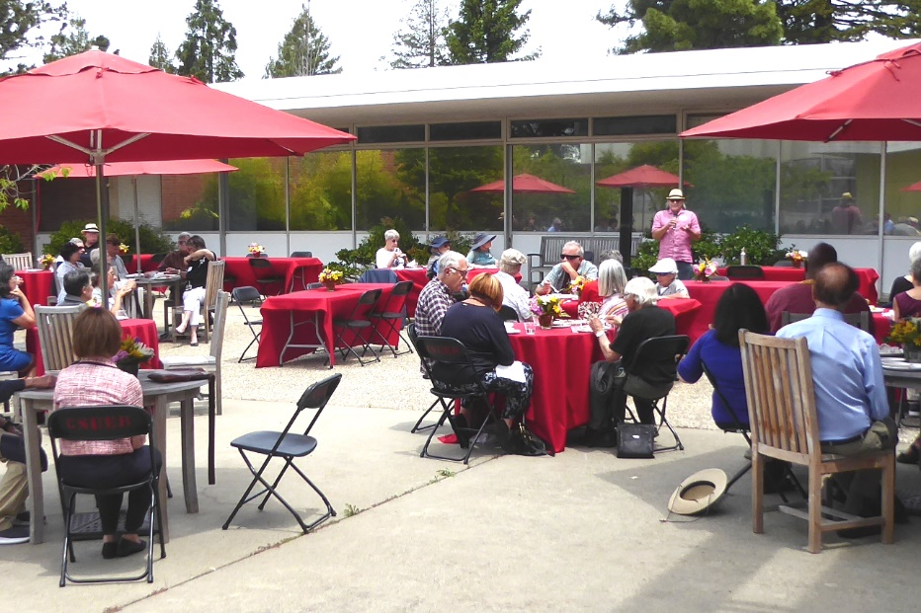Our last Spring lunch May 2022  Spring Lunch May 19, 2023, 11:30 a.m.  Our next ERFA Luncheon meeting will take place on Friday, May 19th at 11:30 a.m. in the Zen Garden on campus. Please RSVP, mark your calendar and consider calling a couple of friends you have been missing and would love to see there.  The speaker will be Jason Singley, Dean of Science. He will be addressing the shifts in enrollment patterns by major over the past few years, the new Applied Science Center, for which the groundbreaking has already occurred, and giving an update on the proposed College of Health. Although the luncheon is hosted, we ask that you consider making a gift in support of our Renaissance Scholars Program students. We look forward to seeing you there.
    - Board Members
  Jodi Servatius, President
  Jane Lopus, Vice-President
  John Giles, Treasurer
  Carl Bellone, Newsletter Editor
  James Ahiakpor
  Eileen Barrett
  Bill Reuter
  Alan Smith
  Jeff Seitz
  Judy Stanley
  Donna Wiley
President’s Message
Jodi Servatius, Professor Emerita, Educational Leadership
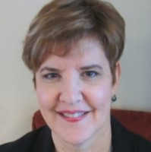
​As I write this we are coming out of a Winter of record-breaking rainfall and seeing signs of Spring all around us. As retirees, we have more time to appreciate the natural world around us. And, just think, we don’t have to be concerned whether a student actually wrote that paper or it was produced by ChatGPT! Isn’t retirement wonderful? We are fortunate to have our ERFA chapter to help us keep connected to each other, to the University and, through our work with the Renaissance Scholars Program, to current students. Our ERFA board has had a good deal of turnover recently, and we have been delighted to welcome some new members. If you might have an interest in serving on the board, please let me know. It’s especially important that we have a representative group.

One of our ERFA chapter’s recent efforts has been to upgrade our newsletter. You can see here that it has a different look and feel. We are also planning to profile one or two members in each edition, beginning with this one. We are thrilled to welcome our new editor, Carl Bellone.

The campus has been abuzz with activity. The new CORE (library) building is open and supporting student collaboration. All frosh now receive computers or tablets. The five goal areas of the Future Directions planning process are being fleshed out, the creation of a new College of Health is being explored and a new science building is beginning to take shape. We are deeply grateful to President Cathy Sandeen and Provost Walt Jacobs for hosting our events. We also appreciate the assistance with the production and distribution of our newsletter and our invitations that we receive from University Advancement. This does not happen on every campus. We happen to have a campus administration that clearly values us and the contributions we have made.

East Bay is Now a Research 2 University
Jeff Seitz, Emerit Professor, Earth and Environmental Sciences
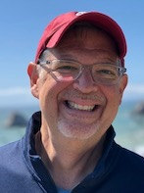
Based on a review of institutional data in 2021, Cal State East Bay was classified In 2022, as a Research 2 (R2) University according to the Carnegie classification of institutions of higher education. The reclassification as a R2 institution elevates CSUEB from a regional master’s level university to a national doctoral university with high research activity. Cal State East Bay is one of seven CSU campuses to be reclassified to R2; the other CSU campuses are Cal State San Bernardino, Cal State Fresno, Cal State Fullerton, Cal State Long Beach State, San Francisco State and San Diego State. There are only 133 R2 institutions in the country making Cal State East Bay a member of a prestigious group of universities.

According to the Carnegie criteria, a R2 university must award at least 20 research/scholarship-based doctoral degrees and have least $5 million dollars in total research expenditures (as reported to the National Science Foundation) during the review year. Cal State East Bay met these requirements with the Ed.D. program in Educational Leadership and robust research expenditures. In fact, annual grant awards from external sponsors have nearly doubled in the last 5 years from ~$10 million in 2017-18 to nearly $18 million in 2021-22. In addition, Cal State East Bay has significantly increased its institutional investment in research through intramural research grants, research-based assigned time, start-up funds, etc.

Cal State East Bay’s classification as a R2 university reflects the dedication of faculty to research and scholarly activities. A hallmark of research at Cal State East Bay is involvement of students in faculty-mentored research and scholarly activities that has been shown to be a high-impact practice that improves student retention, academic performance, and graduation rates. Thus, the award of an external grant to a faculty member provides significant value to our students as well.

Jeff Seitz was the former Associate Vice-President for Research and Sponsored Programs

OLLI Honors Its Retired Faculty Founders

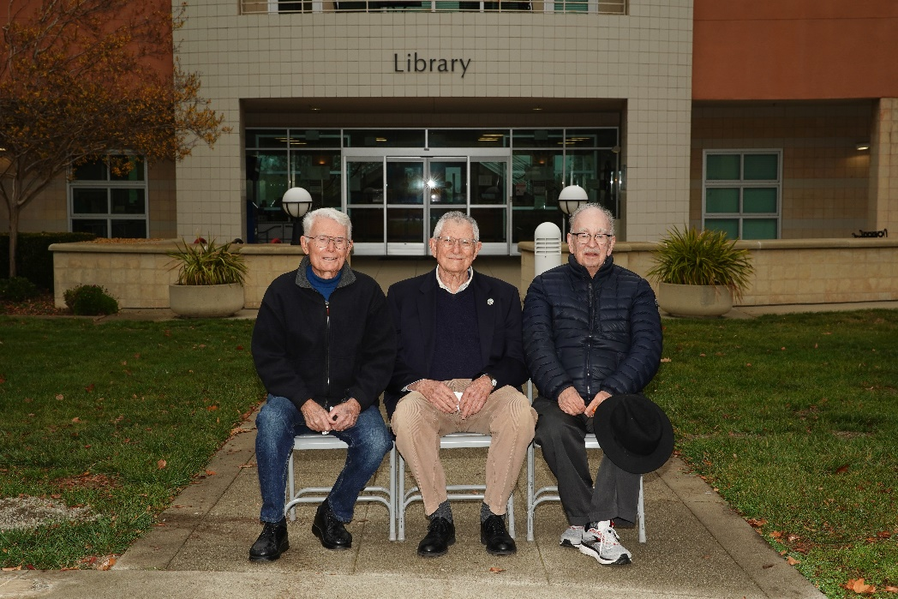
OLLI Founders L to R, Bill Reuter, Herb Eder, Alan Smith, (Judy Stanley, not pictured)

OLLI recently honored its founders, Herb Eder, Bill Reuter, Alan Smith and Judy Stanley on the occasion of the 20th Anniversary of CSUEB Osher Lifelong Learning Institute (OLLI). Herb Eder got the idea for OLLI when he was Associate Dean of CLASS, and read an article from his alma mater, UCLA regarding a Senior Center they had offering college level classes to adults. He thought why can’t we do that here? So he got together with Alan, Judy, and Bill and with the support of President Rees and Herb Graw in Extension, Scholar (as it was called then) was launched with monthly lectures in the Biella Room. By 2002, however, ADA accessibility and parking were causing problems. Upon learning of this, Bette Felton, who was the head of the Concord Campus at that time, said come out to Concord.

By 2003 Scholar was at Concord offering not only lectures but also courses for adult learners. Jim Kelly became AVP of Extension and suggested applying to the Osher Lifelong Learning Institute for funding. The request was successful and Scholar became OLLI. CSUEB OLLI now has a two million dollar endowment from the Osher foundation and is one of the most successful of the 140 OLLIs in the U.S. With the pandemic OLLI pivoted to offering online courses. Currently OLLI offers a mix of over 100 in-person and online courses per year. Herb Eder said he is most proud of feedback he gets from the faculty who say our OLLI students are curious lifelong learners who ask the best questions.

Among the upcoming OLLI courses/lectures are: Highlights of Mexican Art, Our Pandemic Future, The Golden Age of Musical Theater, Under the Covers of Undercover Operations, and When Hope and History Rhyme: Poets Take on Injustice. For information and to register go to olli.csueastbay.edu.

Catching Up With….
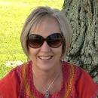
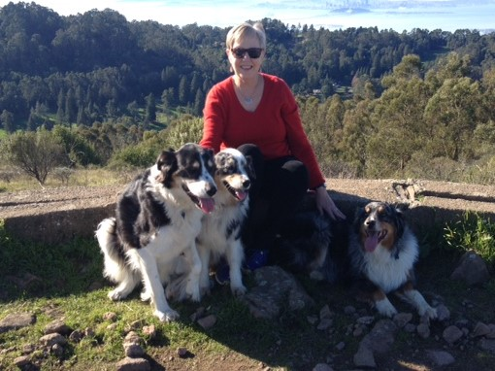
Donna Wiley
Professor Emerita, Management

I retired in August 2018 after 35 years at CSUEB. At that time, I was serving as Interim Associate Vice President and Director of Graduate Studies in Academic Programs and Graduate Studies, and I’m an Emerita Faculty in the Department of Management. I spent my last two years working on curriculum and policy changes in preparation for the conversion to semesters.

Since retirement I have kept busy with a variety of hobbies, travel and volunteer work. My main hobby is playing the bassoon. I played all through school, but hadn’t played in 25 years. I started taking private lessons a few years before I retired, and now play in two orchestras (Community Women’s Orchestra and College of Marin Symphony Orchestra) and a variety of chamber music ensembles (woodwind trio, quintet and octet). I also subscribe to the San Francisco Symphony Open Rehearsal series with my dear colleague Jodi Servatius.

My other main hobby is spending time with my dog. Sadly, I lost two beloved dogs in the past two years, but now have a crazy 1 ½ year old Aussie who requires many hours at the dog park to keep her from being completely insane!

We were fortunate to be able to take a couple of wonderful trips to Italy and Cuba before Covid hit. Since then we have mainly stayed pretty close to home, with short trips to Santa Cruz, Cambria and the Eastern Sierra, with one trip to Hawaii between surges. I have many places on my bucket list when it is a bit safer to travel.

Since retirement I have volunteered to serve on the WASC Substantive Change Committee, which involved reviewing new programs and university structural changes. I also served on a reaffirmation team to review United Arab Emirates University. I am now serving on the ERFA Board, was the ERFA representative on the Honorary Doctorate Committee and am newly appointed as the ERFA representative to the CSUEB Academic Senate.

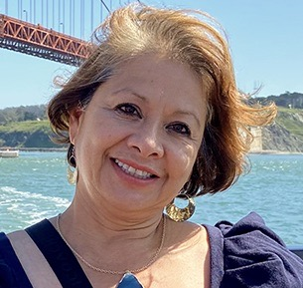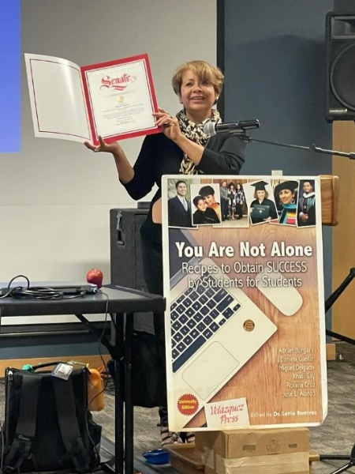

Lettie Ramirez
Professor Emerita, Teacher Education

I retired two years ago, March 1, 2021. At that time, I had had several large grants, and I was working full time in the Provost’s Office. My titles were Special Assistant to the VP and Provost, and Director of STEP: Sophomore Transition Enrichment Program. My original faculty position was in the Department of Teacher Education, teaching Psychology to teacher candidates.

I am originally from the desert town of El Paso, Texas and living close to the ocean has always been a dream. Since my retirement, I live now in Capitola, a town I had always loved to visit. It is beautiful here, although we are currently dealing with the devastation of being so close to the ocean during an unprecedented storm. I had never thought about the disasters that can happen near a beach. My home and immediate community are doing fine, and I am and trying to help out with the cleanup efforts in the town, which has been severely impacted.

Besides living near the beach, another dream of mine has been traveling the world. Retirement is definitely helpful in attaining that goal! I recently counted and I have been to at least 75 countries. In a few weeks, I intend to add Ireland to my list.

Recently, I have been busy working on a book for high school students to encourage college attendance. After talking to teachers, it seems that high school students are more lost now than ever. My past books have been well received because they are basically short stories that give real examples and strategies to the students.

Since joining the campus 30 years ago this year, I have had the privilege of working in several positions that allowed me to meet and work with numerous departments and their faculty. This was very helpful as I was working on our last book for undergraduate students on college success. Numerous current and past faculty members participated. Now I hope some of the retired faculty may be interested in submitting their stories for the new book. If you have a personal story to share that you think might be encouraging or inspirational for a first generation student of color trying to navigate college, please contact me so I can consider it for inclusion in the next edition. lettie.ramirez@csueastbay.edu

Academic Senator Report
Donna Wiley, ERFA Representative to the Academic Senate

Winter 2023 Academic Senate Report

The main topic of discussion at the two meetings of the Academic Senate this semester has been the possibility of impending budget cuts from the CSU Chancellor’s Office caused by low enrollments across the CSU system. The system is not meeting the state’s enrollment targets, and is facing possible funding cuts from the state. The tentative CO’s plan appears to be cutting the budgets of under-enrolled CSU campuses, including East Bay. While there has been pushback on this plan by both CSU Presidents and some Board of Trustee members, the EB administration is currently developing strategies to increase enrollment that counts towards its target (i.e. FTE undergraduate enrollment). East Bay strategies include ways to boost recruiting and admission, but the most discussed strategy is the move of self-support summer classes to state support, and the possible move of some self-support degree programs to state support. The implications of these changes were discussed at the Senate meetings, including questions related to the impact on faculty recruiting and retention if the additional salary opportunities
from teaching self-support courses were reduced. FAQs and implementation details are available online.

There has been limited discussion on the potential creation of a health-related college. The task force delivered its report in Spring 2022, and an Implementation Task Force has been created, but no action seems to have been taken.

Faculty Profiles

To increase the visibility of emeriti at Cal State East Bay, it would be great for each of us to have
an official profile on the university’s website. If you do not currently have a profile, you can
request a blank profile by submitting a Service Desk Ticket. Creating or updating your faculty
profile is easy; the university’s website has instructions for faculty at https://www.csueastbay.edu/directory/profiles/instructions/index.html

To help people access your profile, make sure that you are included in your department’s list of
faculty members on their website with a link to your profile.

Join ERFSA

Are you a member of State-wide ERFSA (Emeriti and Retired Faculty and Staff Association)?
If not, please consider joining. Our local CSUEB ERFA Chapter gets its funding based upon the number of our emeriti faculty who belong to the State-wide ERFSA. The funding enables our chapter make twice yearly donations to the Renaissance Scholars Program. ERFSA lobbies in Sacramento to protect our pensions and other retirement benefits. Dues are $10/month for most people. For more information and to join go to https://www.csuerfsa.org/

In Remembrance
Gene Poschman
Dr. Gene Poschman, Emeritus Professor of Political Science joined the faculty in the mid-1960s. He passed away in 2021. He was a man of great intellect, energy, and humor. Gene was intensely interested in faculty governance, and for over three decades he worked to assure that the Cal State faculty had a strong voice in how the university was run. He served more than one term as Chair of the Academic Senate and sought assiduously to recruit colleagues to the cause of having the faculty’s voice heard. When he was present at a meeting, he always meticulously researched the issues at hand so as to ensure good decisions were made. But Gene didn’t believe in solemn, boring meetings. Any faculty meeting where he was present was lively and full of laughter. He saw no conflict between doing serious business and having a jolly time. After retirement, he was an important figure in Berkeley city government, serving for many years on the Zoning Adjustments Board and the Planning Commission

Doris Yates

Dr. Doris Yates, Professor Emerita in Department of Hospitality, Recreation and Tourism, passed in December, 2022. She joined the Department of Hospitality, Recreation and Tourism (then Department of Recreation) as an Assistant Professor in 1983, where she taught multiple courses in the bachelor’s degree program. Dr. Yates dedicated her career to community upliftment through recreation and leisure activities. Dr. Yates was a Gang Prevention and Intervention Specialist with the National Gang Crime Research Center. She was certified as a Mental Health First Aid responder, a Gang Resistance Education and Training specialist, and had specialized training in Female Gangs/Female Gang Member management and supervision.

Bruce Edward Trumbo
Dr. Bruce E. Trumbo, Professor Emeritus of Statistics and Biostatistics, and of Mathematics passed away on July 8, 2022 at his home in Hayward, CA. He was 84 years old. Dr. Trumbo was a nationally and internationally recognized expert in many areas of Statistics. He was the author/coauthor of two books on statistics and probability, pioneered several methods of computer presentation in the field and taught both undergraduate and graduate courses in statistics over the span of 7 decades. Dr. Trumbo also served as the Program Director for Statistical Research for three terms at the National Science Foundation (NSF) in Washington D.C for the Division of Mathematical Science. He was a fellow of both the America Statistical Association (ASA) and the Institute of Mathematical Statistics (IMS).
Gary Lippman
Dr. Gary Lippman, Professor Emeritus in Department of Mathematics and Computer Science passed away on December 17, 2022. He taught full-time at CSU East Bay for 45 years, retiring in 2015 when he was 75 years old. Gary worked actively in the civil rights movement in the 1960s. In the 1970s, he somehow juggled his time as a professor while earning a law degree from University of San Francisco and then working as a public defender. Gary had a special lifetime love of attending live music performances.

For more information on these and other deceased faculty members see https://www.csueastbay.edu/oaa/memorials/index.html

Comments and Suggestions

If you have any comments or suggestions for Newsletter items, please send them to Carl Bellone, at carl.bellone@csueastbay.edu

