 |  Spring 2025  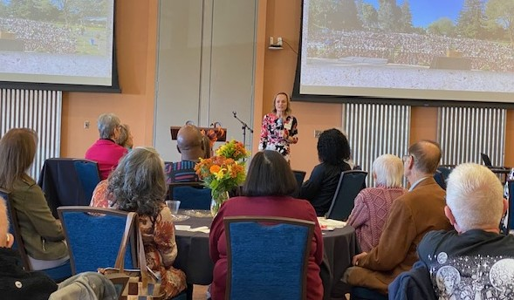  Dr. Michelle Rippy, Director of the Forensic Science Research Center and Assoc. Professor of Criminal Justice speaking at our Fall 2024 lunch.  Spring Lunch June 24, 11:30 a.m.  Our next ERFA Luncheon meeting will take place on Tuesday, June 24 at 11:30 a.m. in the Multi-Purpose Room in the University Union. Please RSVP, mark your calendar and consider calling a couple of friends you have been missing and would love to see there.  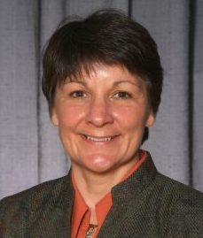  The speaker will be Dr. Kim Greer, Interim Provost. Dr. Greer will speak to us on the College reorganizations to be implemented in Fall 2025. She will also update us on the recent WASC accreditation visit that took place in the Spring.  Although the luncheon is hosted, we ask that you consider making a gift in support of our Renaissance Scholars Program students. We look forward to seeing you.
    - Board Members
  Jodi Servatius, President
  Jane Lopus, Vice-President
  John Giles, Treasurer
  Carl Bellone, Newsletter Editor
  James Ahiakpor
  Stevina Euvelocha-Ugbah
  Hank Reichman
  Don Sawyer
  Jeff Seitz
  Richard Symmons
  Holly Vugia
  Donna Wiley
President’s Message
Jodi Servatius, Professor Emerita, Educational Leadership

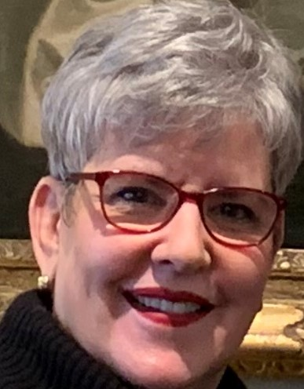
​ Serving as President of our ERFA these past four years has been a privilege. Our distinguished founding faculty have retired from board service now and we have grown the board with six new members during my tenure. We have recommitted ourselves to our three-part mission: to connect our members with each other, preserve their connection with the university, and support students directly (currently, the Renaissance Scholars). We have completely revamped our newsletter to highlight members and their activities. Our treasury is sound.

Universities all over the country are in turmoil, with grant funding disappearing unexpectedly. Enrollments are down almost everywhere, our campus being in steeper enrollment decline than many. As a result, there is major belt-tightening going on. We have recently been notified that the President/Provost will be able to sponsor only one luncheon for us in the next year, not two, as we have been accustomed to having. The ERFA board will be meeting soon to discuss our options.

A new slate of officers for next year will be presented at the next board meeting and will be introduced at the luncheon in June. The ERFA board voted to endorse the candidacy of Holly Vugia for Academic Senate, representing the retired/emeriti faculty. Holly is now a member of the ERFA board and will have the group as sounding board for ideas. Our newsletter provides a perfect conduit for her written reports. We encourage all retired members to consider voting for Holly Vugia. (We are indebted to Donna Wiley for her outstanding service for this past two-year term.)

Our luncheon will be held on Tuesday, June 24th in the Multi-purpose Room of the New University Union. We are delighted that Interim Provost Kim Greer will be our speaker. She is completing her interim service as we are preparing to welcome a new Provost this summer. Kim has agreed to update us on the reorganization of the Colleges and the results of the WASC accreditation visit.

We look forward to seeing each of you at the luncheon!

Join ERFSA

Are you a member of State-wide ERFSA (Emeriti and Retired Faculty and Staff Association)?
If not, please consider joining. Our local CSUEB ERFA Chapter gets its funding based upon the number of our emeriti faculty who belong to the State-wide ERFSA. The funding enables our chapter to make twice yearly donations to the Renaissance Scholars Program. ERFSA lobbies in Sacramento to protect our pensions and other retirement benefits. Dues are $10/month for most people. Even better, there is currently a half price offer. For more information and to join go to https://www.csuerfsa.org/

Catching Up With….

Steve Davies Ugbah, Professor Emeritus, Business

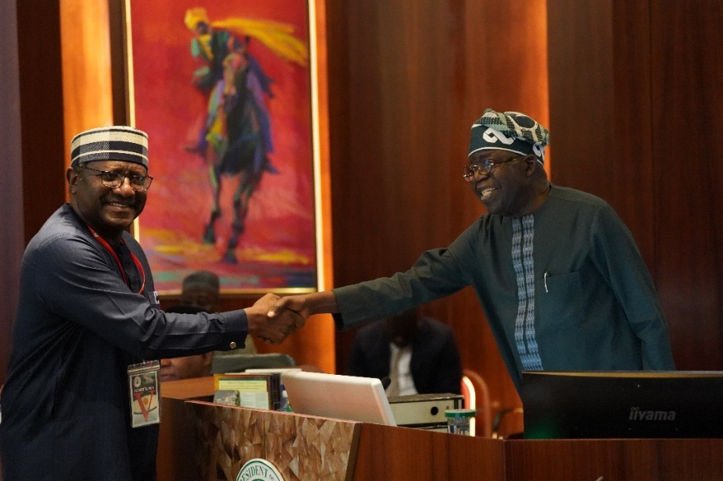
Life after retiring from California State University East Bay (CSUEB), after 33 years of service, has been a remarkable journey. As I have journeyed – and aged-I’ve come to appreciate Professor Emerita Jodi Servatius’ quote of Mark Twain, who said “Age is a matter of mind over matter. If you don’t mind it, it doesn’t matter.” Age has never been a limiting factor in any of my activities in retirement.

Before retiring from CSUEB, my pre-retirement journey began when I unsuccessfully ran to become Governor of Benue State, Nigeria in 2011. Benue State, in the North Central region of the county, is one of the 36 states of the Federal Republic of Nigeria. Undeterred by the outcome of my initial foray into partisan politics, I persisted and was rewarded with an appointment by His Excellency, President Mohammadu Buhari, to represent Nigeria as the Ambassador Extraordinary and plenipotentiary to the Russian Federation and the Republic of Belarus (2017 to 2020). I had previously taught in Moscow as part of the College of Business and Economics’ international programs. While serving as Nigeria’s top diplomat in Moscow, I met and interacted with distinguished personalities such as, Jon Meade Huntsman Jr., the 16th governor of Utah, who served as U.S. Ambassador to the Russian Federation during my tenure. Professor Emerita Stevina Evuleocha-Ugbah, my dear and remarkable spouse, and I attended a few exciting events at the residence of Ambassador Huntsman.

Upon returning from our tour of duty in Russia, Stevina and I elected to give back by setting up the Johnny Ashby Ugbah Memorial Scholarship at Ohio University established to honor the memory of my immediate younger brother Johnny Ashby Ugbah, (1958-1983) who was tragically killed in Nigeria in August 1983, because of election violence. The endowment will be fully funded by December 2026.

My political activity did not end when my tenure was over as an ambassador in Moscow. I stayed actively engaged in politics, working assiduously to elect the current Rev. Fr. Dr. Hyacinth Iormem Alia as the Governor of Benue State, and Senator Bola Ahmed Tinubu, as the Executive President of the Federal Republic of Nigeria. President Bola Ahmed Tinubu appointed me to serve as a Federal Commissioner of Revenue Mobilization, Allocation, and Fiscal Commission (RMAFC). I’m currently one of 37 RMAFC Federal Commissioners, representing all the states in Nigeria, including the Federal Capital Territory (FCT) Abuja. RMAFC has the unenviable task of overseeing the revenues accruing to and disbursement of such funds from the Federal Account; it also ensures that there is conformity and equity in the national revenue allocation formulae among other tasks.

The enormous responsibilities of serving on RMAFC notwithstanding, I travel back and forth from the U.S. to spend quality time with Professor Emerita Stevina Evuleocha-Ugbah, my darling spouse of 36 years, and our five children. I look forward to going hiking around Lafayette Reservoir again with my family when I come home next.

Richard Symmons, Professor Emeritus, Biological Sciences

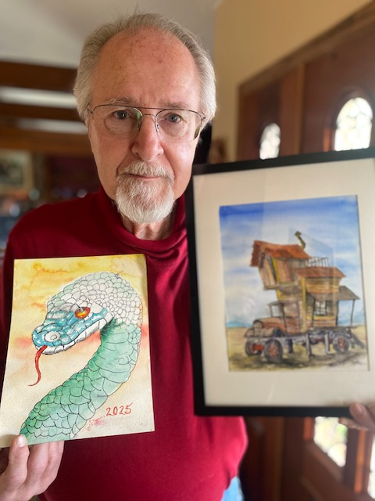
The prospect of retiring was quite frightening to me. I had been in school, either as a student or as a teacher, since kindergarten! That meant that my time had largely been
tightly prescribed by either attending or instructing classes. Virtually my entire life had been time regimented. No need to find an internal driving force, as might be required to
run a small business or enterprise. The path was largely determined, not requiring a wide range of talents or skills, nor a broad band of self-motivation.

Fortunately, ever since my youth I have had a bunch of hobbies. Stamp and coin collecting, model car building, toy trains, car rallies and auto repair. In my 20s and 30s, fly tying and fishing, motorcycles, body bag workouts and stained-glass art were passing phases. Other than my ocean fishing gear, most of that’s gone now. But the clutter of recently adopted hobbies remains an issue.

Teaching has been my passion throughout. Since retiring after nearly 45 years, and 16,000 students later, I’m still at it! For years I’ve volunteered weekly at my nearby Senior Coastsiders Center in Half Moon Bay teaching a group of elders how to solve puzzles (Sudoku, KenKen, and crossword). Notably, THEY solve the puzzles with gentle guidance from me. A brain kept on a Learning Curve is a healthier brain, regardless of
other ongoing deteriorating processes. My regular attendees, some stroke survivors, are faster, more accurate and have more sophisticated strategies than they had upon arrival, and their improvement continues! In another class, other oldsters join me to play rhythm on my large African drums, which I cart to the East Bay Center for the Blind. Because the basic rhythm can be FELT, we are expanding participation to deaf folks. Leading 80+ year old folks in rhythm, seeing them Rock Out is an uplifting experience!

Though biology isn’t my emphasis anymore, teaching of science is. For many years, I have taught in a grade school program called “Science is Elementary” where 3 or 4 Ph.D. scientists descend upon a 4th or 5th grade classroom once a month to teach a lesson, usually in Physics. For example, we collect data on pendulums, noting how changes in length and weight influence the swings. The data are plotted and analyzed with conclusions drawn. Young minds are hungry for such experiences. Electricity and magnetism are especially alluring. When several fifth graders claim that their favorite subject is science, a certain warmth of satisfaction washes over.

My major hobby these days is painting in watercolor. It’s much more challenging than the oil painting I did in my 30’s. With oil and acrylic painting, highlights are done last, a rather natural progression of a piece. In watercolor, one must envision and represent highlights at the outset. That is, you must perceive the end BEFORE you begin! About 1 of every 10 pieces is satisfying. But when it’s done well, it’s magical!

Had I realized that my current weekly schedule is as busy as it was back in my teaching career, I should not have feared retiring at all. Perhaps a surprise, I had no idea I would still be engaged in teaching, with a renewed view that it would be my lifelong pleasure.

Best part of retirement? I don’t have to report to anyone else!

The Braddock Center for Science & Innovation
Jason Singley, Professor of Physics and Former Dean, College of Science

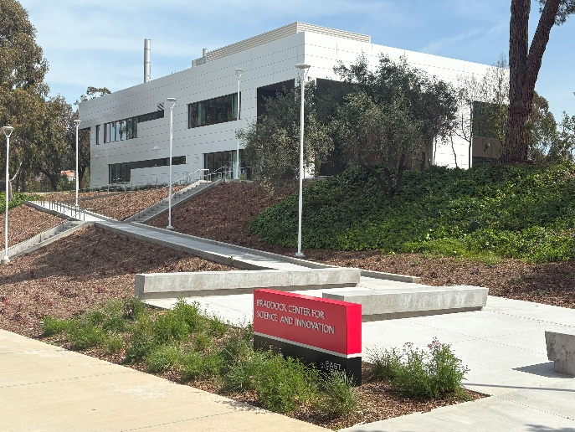
Last Fall Cal State East Bay opened its newest academic building - the Braddock Center for Science and Innovation (BSCI). The building provides modern facilities for the College of Science with a focus on providing engaged learning opportunities for students from freshmen through graduate students. The building includes 1) student support services, 2) classrooms designed for active learning, and 3) state-of-the-art student-faculty research labs.

The Braddock Center for Science & Innovation houses STEM LAB, which is the college’s flagship program for supporting students in introductory STEM courses. The heart of the STEM LAB is the Learning Assistant Program which places experienced undergraduate students (near-peers) in introductory classes to support active learning. In addition, the Learning Assistants are also available to provide academic support in the STEM LAB, which is a community learning space.

New classrooms in the BSCI are highly sought after by our faculty because they were intentionally designed to support instructional practices that use active learning. The rooms have whiteboards on all walls and moveable chairs and tables to facilitate student engagement and collaborative group work. A new computer science laboratory will be used for instruction and research into virtual reality and artificial intelligence/machine learning.
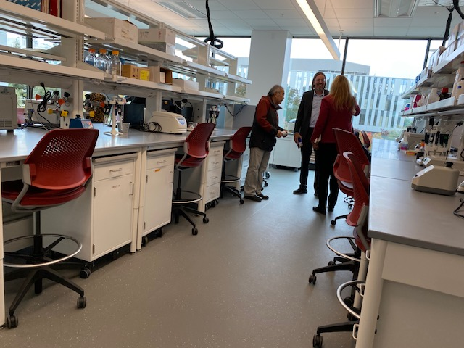
About half of the BSCI is dedicated to modern, multidisciplinary research laboratories. In each of these labs, faculty members work with teams of students on thematically related research projects, fostering interdisciplinary research opportunities and learning communities. Laboratories include the Green Biome Institute, a lab focused on biotechnology with faculty from Biological Sciences and Chemistry and Biochemistry, and another lab focused on “hard-tech” research with faculty from Engineering and Computer Science. Each of these spaces is visible from the hallways, shining light on our students and the opportunities they have to perform cutting-edge research mentored by our fabulous faculty.

Recent Emeriti Publications

Hank Reichman, Professor Emeritus, History recently published the second edition of his Understanding Academic Freedom. Since the publication of the first edition, the never-ending struggle to defend academic freedom has entered a demonstrably new phase. Academic freedom, long heralded as a core value of American higher education, may now be in as much danger as at any time since the 1950s.

Karl Schonborn, Professor Emeritus, Sociology recently published Privileged Killers. This classic true-crime work focuses on his experiences with several sociopathic individuals. Four of them, ironically white males, committed monstrous violent crimes. And because each of them was privileged – blessed with brilliance, wealth, talent, or charm – Lady Justice only slapped their wrists despite their homicidal attacks.

Academic Senator Report
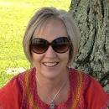
Donna Wiley, Emeritus Representative to the Academic Senate

Spring 2025 Academic Senate Report

The Academic Senate spent the bulk of its Spring meetings discussing the President’s proposed college restructuring plan, with the President’s goal of creating a College of Health. Early in the semester, there was a faculty resolution to the Senate to delay the planned reorganization, which was set to take place in Fall 2025.
Another resolution came from the Senate Executive Committee that proposed a process for collecting faculty opinions campus-wide regarding the possible college reorganization models to determine which of these models faculty most preferred. This resolution moved forward, and Senate solicited faculty input through town halls and surveys and conducted a ranked-choice vote on preferred models.

One of the biggest issues regarding the reorganization was the location of programs in the College of
Education and Allied Studies. There was considerable discussion about possible negative effects
on teacher education programs, the potential breaking up of programs within CEAS departments,
etc. At the end of the process, the model that received the most faculty votes was the one that incorporated all the CEAS programs in a new College of Health, Wellness and Education. The benefits of this model include keeping all the current CEAS departments together, ensuring alignment with accreditation requirements, and fostering interdisciplinary collaboration. This recommendation was sent to President Sandeen. The President announced, however, that the new college would move forward as the College of Health, with the original departments proposed for the college (i.e. Nursing, Health Sciences, Speech Pathology, Social Work and Kinesiology). In this model, the remaining CEAS departments will move to CLASS as the School of Education.

The second major topic of discussion this semester was the university’s financial situation. The
university is currently facing an approximately $13 million budget deficit. This deficit is caused by
several factors: including declining enrollments resulting in declining revenues; increasing costs such as salaries, energy costs, etc.; upcoming CSU cuts to the CSUEB allocation due to its failure to meet its enrollment targets; and finally, CSUEB’s share of state cuts to the overall CSU budget. The Senate has heard reports about this budget deficit from COBRA (Committee on Budget and Resource Allocation) and from the Vice President of Administration. The Senate has also discussed various actions to take to address the budget crisis. The Layoff Committee was convened. A task force is being convened to review low enrolled programs. Despite these large issues dominating much of the Senate time, the Senate continued its regular work of approving curriculum revisions, developing faculty affairs policies, etc. It is also prepared for the WASC visit on March 19th.

In Remembrance…
Alex Cassuto, Professor Emeritus, Economics.

Dr. Cassuto passed away on October 13, 2024. He joined the faculty in 1971 and retired in 2004. Dr. Cassuto earned a B.A. in 1965 and an M.A. in 1967 from Queens Collee in New York and a Ph.D. in Economics in 1973 from UCLA. He was Department Chair of Economics from 1978 to 1983. He served as Assistant Vice President from 1983 to 1985 as well as Deputy Provost. Dr. Cassuto was an excellent teacher and was awarded the Outstanding Professor Award for 1988/89. He served as Academic Senate Chair from 1996 to 1998. Dr. Cassuto had many career accomplishments including serving as an economist for the International Monetary Fund, Washington, 1969; Visiting Professor, University of California-Berkeley, 1981; Visiting Professor, University of Rome, 1983 and 1986; AMPART, United States Information Service, 1986; Consultant, California State University Chancellor’s Office, Long Beach, 1982-1983; Consultant, Far West laboratories, San Francisco, 1982; Consultant, Diablo Systems, Incorporated., Hayward, 1980-1982, and Consultant, R. Beck and Associations, Seattle, 1976-1977.

Sandra Gilbert, Assistant Professor, English
Dr. Sandra Gilbert was an Assistant Professor of English at CSU Hayward from 1968 to the mid-1970s.
After publishing a study of D.H. Lawrence’s poetry, Acts of Attention, in 1972, she taught for two years at Indiana University in Bloomington and then UC Davis. Iin 1973, she met her longtime collaborator Susan Gubar, and over the next several years they wrote their groundbreaking study of 19th century women’s literature The Madwoman in the Attic. Published in 1979, the book has become a classic of feminist literary criticism and was followed by several other works co-authored with Gubar, including a monumental three-volume study of 20th century women’s writing, No Man’s Land (1988-1994); the academic spoof Masterpiece Theatre (1995); and most recently Still Mad (2021), on contemporary feminist writing. Together they also edited The Norton Anthology of Literature by Women (1985), now in its third edition, and Feminist Literary Theory and Criticism (2007).

Armando Gonzales, Lector, Economics and Associate Vice President
Armando Gonzales, Associate Vice President, Academic Resources, and Lecturer Emeritus in Economics passed away on September 17, 2024. Armando studied Economics at the University of Texas, El Paso where he was born. He joined the Air Force in 1961 at a young age and bravely served his county on various dangerous missions, contracting injuries that would plague him later in life. In addition to teaching Economics, he also taught in the Department of Public Administration. As an administrator, he could always be counted on to give a straightforward honest answer to any question asked of him. He retired in 2009.

Emails for Contacting the Board

James Ahiakpor, james.ahiakpor@csueastbay.edu; Carl Bellone, carl.bellone@csueastbay.edu; Stevina Evuleocha, pendaityo@gmail.com; John Giles, jcdggiles@gmail.com; Michael Hedrick, michael.hedrick@csueastbay.edu; Jane Lopus, jane.lopus@csueastbay.edu; Hank Reichman, henry.reichman@csueastbay.edu; Don Sawyer, don.sawyer@csueastbay.edu; Jeff Seitz, jeff.seitz@csueastbay.edu; Jodi Servatius, jodi.servatius@csueastbay.edu; Richard Symmons, richard.symmons@csueastbay.edu; Holly Vugia, holly.vugia@csueastbay.edu; Donna Wiley, dlcoyote@comcast.net.

