 |   Spring 2026  You are Invited:  SPRING LUNCH JUNE 4, 11:30 a.m.  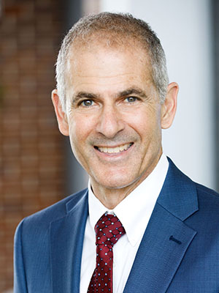  The new University Provost, Anthony Muscat, will speak to us at our Spring Lunch on Thursday, June 4, at 11:30 a.m. in the University Muli-Purpose Room on the Hayward Campus.  Provost Muscat will provide information on the current state of the University including the $50 million MacKenize Scott award.  University Advancement will be hosting the lunch, but we encourage you to contribute $20 or more to the Renaissance Scholars Program.  You will receive an invitation from University Advancement, please RSVP, mark your calendar and consider calling a couple of friends you have been missing and invite them to attend.  We hope to see you on June 4.
    - Board
    - Members
  Jane Lopus & Donna Wiley, Co-Presidents
  James Ahiakpor, Treasurer
  Carl Bellone, Newsletter Editor
  Stevina Euvelocha-Ugbah
  David Larson
  Michael Hedrick
  Hank Reichman
  Don Sawyer
  Jeff Seitz
  Jodi Servatius, Past President
  Richard Symmons
  Holly Vugia, Senator
Co-Presidents’ Message
Jane Lopus, Professor Emerita, Economics
Donna Wiley, Professor Emerita, Management

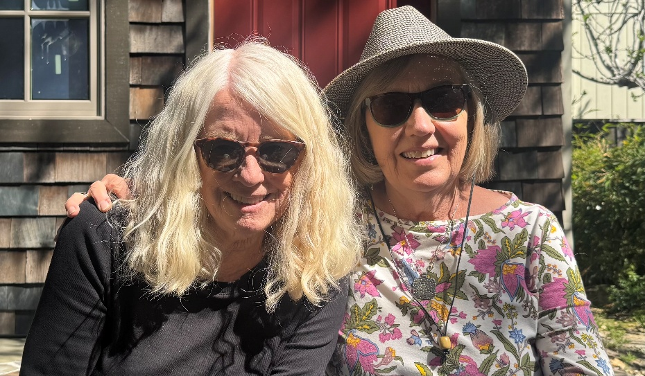
​First, heartfelt thanks to John Giles (Physics) for his many years of service as our treasurer. John handled the bank accounts, receipts (primarily from CSUEB memberships in the statewide CSU-ERFSA), and gifts to the CSUEB Renaissance Scholars, our designated donation recipients. We wish John all the best and thank James Ahiakpor (Economics) for stepping in as the new treasurer.

A great time was had by all at our first annual holiday lunch at Harry’s Hofbrau in San Leandro on December 5, 2025. We were able to see old friends and meet colleagues we may have missed while on campus. (Name tags helped!) It was a lively gathering and a great turnout. Plan to attend our second-annual holiday lunch in December 2026 – we will circulate information in the fall. And we look forward to seeing everyone at the June 4 luncheon on campus hosted by University Advancement.

Ben Bowser (Sociology) recently brought a potentially concerning issue to our attention. Ben
has a forthcoming book and discovered that his link on his department webpage had been
removed, which meant that he was unable to host materials there related to his publication.
This was done without his knowledge or consent and was not done by his department. Kudos
to Amara Miller, Chair of Sociology and Duke Austin (Sociology), Chair of FAC for their herculean
and successful efforts to have Ben’s link restored.

Related to the issue that Ben raised, information was copied to us implying that all emeriti
faculty may no longer be able to be listed on their department webpages, but may instead be
listed “all in one place,” implicitly on a webpage for retired faculty. In the past, CSUEB departments appeared to have made their own decisions about if and how to list emeriti faculty, frequently listing
them after active tenure-track faculty and active lecturers and adjunct faculty. A quick survey of
other CSU campuses (and other universities) reveals that listing emeriti faculty with their academic departments is common practice. No CSU campus reports that emeriti faculty cannot be listed with their academic departments.

We recognize that some retired faulty may not wish to be listed with their departments (or with the university at all). But for those who do, we strongly oppose the idea of taking away our ability to identify with our academic departments by only listing us on a retiree webpage. Most of us taught and published in our academic disciplines. Those of us who continue to be active in academia through publishing and consulting list our academic departments as our affiliation. Former students find us through our academic departments, where they met us and knew us.

We have therefore made a request to the provost to provide emeriti faculty the option of being listed with their academic departments on department websites and to link to professional information as appropriate. Holly Vugia (Social Work), our emeriti representative on the Academic Senate, is taking up this issue with the Senate. We are grateful to Duke Austin and FAC for incorporating our request into Draft 24-25 FAC 24 Policy on Emeriti Faculty.

And finally, we hope that the transition from Gmail to Outlook went smoothly for everyone. We are grateful to IT for sharing their email list of retired faculty with us so that we could contact our colleagues directly, and for the information sessions and follow-up sessions related to the transition.

See you on June 4!

Join ERFSA
Are you a member of State-wide ERFSA (Emeriti and Retired Faculty and Staff Association)?
If not, please consider joining. Our local CSUEB ERFA Chapter gets its funding based upon the number of our emeriti faculty who belong to the State-wide ERFSA. The funding enables us to make twice yearly donations to the Renaissance Scholars Program. ERFSA lobbies in Sacramento to protect our pensions and other retirement benefits. Dues are about $10/month for most people. For more information and to join go to https://www.csuerfsa.org/

Catching Up With….

Ben Bowser, Professor Emeritus, Sociology

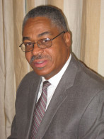
Since 2011, retirement has been the sabbatical leave I never had. My retirement was from teaching, not from my profession. Deborah and I didn’t need to go on a cruise since we had been chartering Moorings sailboats and river barges all over the world since 1992. The first thing I did was list all the research and writing projects I wanted to pursue but didn’t have the time or circumstances to work on while teaching and chairing the Sociology Department and then I got to work.

As a Visiting Professor at the University of Paris in 2005, I was invited to serve as an advisor on the UNESCO Slave Route Project. We met in Brazil, Barbados, Martinique, Costa Rica, and Canada to consult with local experts and social service organizations to isolate and explore the contemporary legacies of slavery in the West. I collaborated with the renowned African historian Paul Lovejoy to produce a UNESCO series: Lovejoy and Bowser (eds.) The Transatlantic Slave Trade and Slavery (2013), and with Martinique’s Head of Psychiatry, Aimé Charles-Nicolas, to edit: L’eslavage: Quel Impact Sur La Psychologie Des Populations? (2018) and The Psychological Legacy of Slavery: Essays on Trauma, Healing, and the Living Past (2021).

I finally finished a project I have wanted to do since the 1970s in New York City. My closest friend and colleague, Walter Stafford, left a small grant to fund the project: Bowser and Devadutt (eds.). Racial Inequality in New York City Since 1965 (2019). Duke Austin and I edited the third edition of Impacts of Racism on White Americans (2021). With an ERFSA small grant, I contributed to understanding the COVID-19 epidemic through “Social‑Economic Backgrounds to US County‑Based COVID‑19 Deaths: PLS‑SEM Analysis,” in the Journal of Racial and
Ethnic Health Disparities (2023). This was a very challenging statistical project that our late
colleague Bruce Trumbo assisted me with.

Finally, I am pleased to announce that my book When Black People Lived in Oakland has been completed and will be published by the University of California Press this year. I discovered at least five remarkable books written about Oakland, all focused on either the struggle for Black control of
the city or the Black Panther Party. My book traces changes at the community level while the
dramas unfolded downtown. The focus is on the period after 1950, up to the present-day dispersal of African Americans to Antioch, Tracy, and Stockton. I planned to write this book when I joined the CSUEB faculty in 1987.

I am still the Board Chair of Cal-Pep, the East Bay’s oldest health and drug-abuse street outreach program, and I have recently been invited to serve on the Board of the Felton Institute, the largest social service organization in Northern California. My Wiki page is: https://en.wikipedia.org/wiki/Benjamin_P._Bowser

Grace Munakata, Professor Emerita, Art

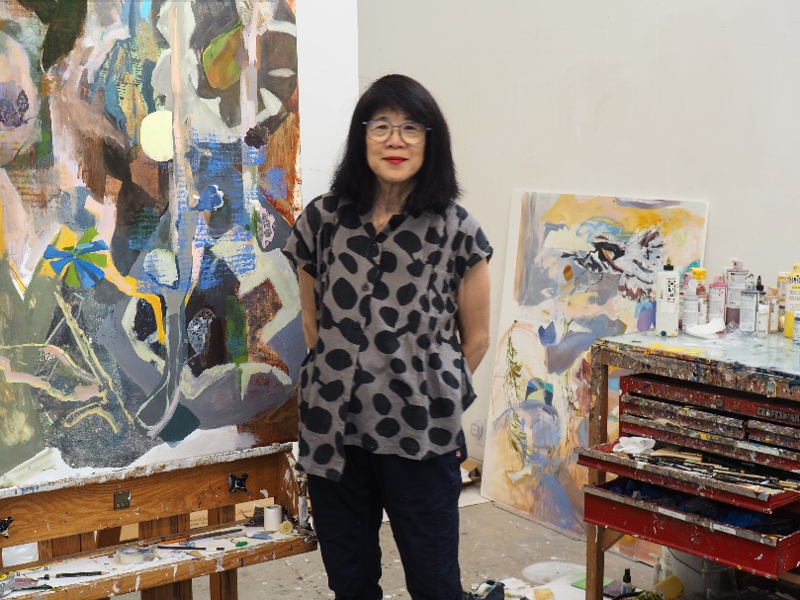
Our third-grade teacher assigned an essay, what would we become? I wrote maybe a teacher, an artist, a secretary or veterinarian. Three out of four? I loved teaching painting/ drawing at Hayward. Some students hadn’t had any art; others knew they wanted to become artists. Freely making marks was unfamiliar to many, but they learned how gestures can become touch and strokes journeying on canvas. And later, that intuitive and reflective choice of color and shapes construct a personal, expressive structure inseparable from subject matter. Their shared stories of family, humor and perseverance blew us away. Art needs comrades and companions, and I so miss being part of the classroom. Now hurray, painting in my studio, hiking, obsessing about native plants, birds, invertebrates etc. Plant it and they WILL come!

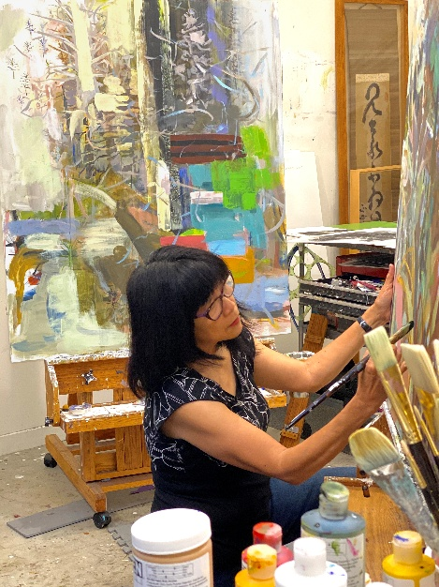
Since FERP, I have participated in four artist residencies whose landscapes still resonate: East Iceland fiords; Oregon Cascade Head biosphere; an old growth forest in Humboldt County, and Maine’s Lake Hebron. I have exhibited at several galleries and had a recent solo show at Anglim/Trimble, a three person show at Anne Loucks Gallery, plus14 other group shows and two upcoming this summer and fall. See https:www.gracemunakata.com/

My work is “abstract” with stories inside stories, increasingly focused on ecology. What still exists? What is happening to species and habitats caught in transition? My paintings refuse despair, positing a possible alternative. Writer Ed Yong believes it’s more important than ever to be outside in the natural world. “We need to replenish ourselves, and it matters, because for those of us who care about biodiversity and diversity and the environment and equality, we need to be connected to the thing that we are fighting for.” As Tony Morrison wrote, “Birth, life and death-each took place on the hidden side of a leaf.”

Cheer, photosynthesis and joy to all of you!

Karl Schonborn, Professor Emertius, Sociology, Criminology

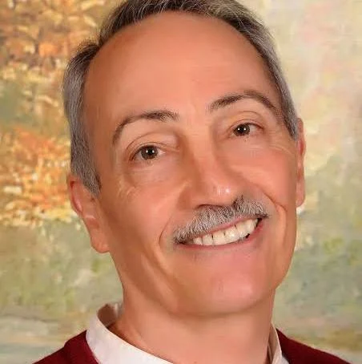
I recently wrote – with mixed feelings given my love for Cal State – a book that features our university. It’s called Privileged Killers and includes a heinous crime committed by a faculty member at CSUEB in 1970’s and the university’s management of the case with some repercussions into the 2010s.

As a criminologist, I couldn’t ignore forever what happened right under our noses. My nonfiction book involved interviewing many colleagues, administrators, and criminal justice personnel knowledgeable about the case. I changed some names and identifying details and locations (including that of CSUEB) to protect the privacy of individuals and the reputation of our campus.
Of note is the fact that this story will soon be widely available for a song since my publisher is putting my e-books on sale for 99 cents –and maybe even giving Privileged Killers and travel-laden Cleft Heart away for free for a week –starting on tax day. Simply check the titles on Amazon on April 15.

That being said, it’s hard summarizing 18 retirement years in the space remaining, so just let me say I’ve been fortunate enough to:

- welcome six grandchildren into the world, now ranging from 6 months to 6 years
- spend every few weekends hanging out with former CSUEB faculty colleagues
- paint numerous canvases, especially those of my ecumenical “Cardinal Sins” and life-size “Heroes, Villains, and Fools” series. (My criminology bent bleeds through into my Warho-lesque efforts.) Painting, unlike writing, slows down time for me, and I love doing it…and
- travel much of the length and breadth of five continents, with the remaining ones too far for this healthy but aging body. Favorite countries visited: Myanmar, Morocco, and India.

My wife Leslie, no surprise, has been with me every step of the way and is the “wind beneath my wings.”

Academic Senator Report

Holly Vugia, Emeritus Representative to the Academic Senate
Spring 2026 Academic Senate Report

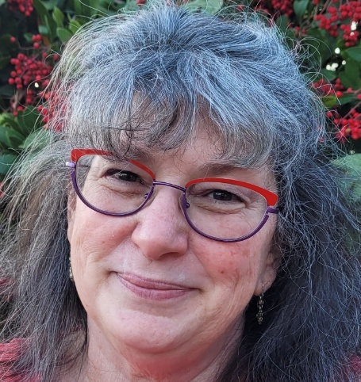
The Academic Senate jumped into the spring semester with several important topics of significant interest to ERFA members. Full meeting minutes and other information are available digitally on the Academic Senate’s website. See
https://www.csueastbay.edu/senate/index.html. Numerous curricular changes have been approved in the context of the estimated $8-13 million structural deficit and last year’s Focused Program Review, which explored low degree conferring programs. These changes, recommended by home departments and the Committee on Instruction & Curriculum (CIC), included discontinuations of the following: the photography minor; two concentrations in the recreation BS (sustainability and youth development); four concentrations in the theatre arts BA (cross-disciplinary performance, dance and inclusive performance, stage technology and design, and theatre performance).

The creation of the Department of Music and Performing Arts was approved, representing a merger of the Department of Music and the Department of Theatre and Dance. Various other curriculum and program changes can be found in the minutes. Significant advocacy to save the Spanish B.A. has resulted in a one-year extension while its review continues.

The President’s office shared the Gift Allocation Framework, outlining the plan to manage the $50
million MacKenzie Scott Award, placing 82% in permanent endowment and assigning 18% to current projects.

The Senate has also been engaged with Provost Muscat’s efforts to design workable academic
calendar models, outlining three possible options. The challenge has been to establish scheduling priorities and a calendar that addresses issues such as start and end dates, duty days, an adequate window for semester grading, and the ability to hold a winter intersession.

The Microsoft 365 Transition is underway across campus in waves. Help and information can be
found at Getting Started with Microsoft 365. The San Francisco Bay Region Network (SFBRN) has
been launched, sharing many administrative workforce assignments between CSUEB, SF State, and Sonoma State. Additionally, the Senate continues to receive timely reports from the University Diversity Officer, our Statewide Academic Senators, Student Government, and the California Faculty Association, which are linked in the Senate minutes.

I will continue to represent us at the Senate and please feel free to contact me with questions or concerns.

SUGGESTIONS FOR THE NEWSLETTER

Do you have a suggestion for a Newsletter article, notice of a recent publication, or someone for the “Catching Up With…” feature? If so, send them to Carl Bellone at carl.bellone@csueastbay.edu. Self-nominations are welcome.

In Remembrance…
Asoke Basu, Professor Emeritus, Sociology
BASU, ASOKE K. (1968), Professor of Sociology: B.A., 1961, West Virginia University; M.A., 1963, Ph.D., 1966, Oklahoma University. Emeritus, 2000. Dr. Basu passed way in late 2025. He served as Department Chair of Sociology, 1992-1995, visiting scholar Harvard University. 1973; and Visiting Scholar at the Hoover Institute, Stanford, California, 1981-1983. He was the author of Culture, Politics and Critical Academics and Co-Author, Poverty in America: The Welfare Dilemma (Contributions in Sociology). Asoke was a believer in comparative sociology and a member of the Indian Sociological Association and International Society Association. He normally taught Political Sociology, Introduction to Sociology, and Research Methods.

William Langan, Professor Emeritus, Philosophy
LANGAN, WILLIAM J. (1969), Professor of Philosophy: B.A., 1965, University of Notre Dame; M.A., 1967, Ph.D., 1969, Northwestern University. Emeritus, 2004. Dr. Langan passed away on October 27, 2022. Dr. Jennifer Egan, Professor of Philosophy and Religious Studies, commented, “I feel lucky to have had Bill Langan as my department chair when I made my start in philosophy. I learned so much from him: the importance of an inclusive approach to philosophy, the need to craft and work towards a positive vision for what philosophy could do for our students, and an understanding of the faculty's role in what higher education could and should be. He was a true educator.

Al Mathews, Professor Emeritus, Kinesiology and Physical Education
MATHEWS, AL, (1963), Professor of Kinesiology and Physical Education: A.B., 1954, M.A., 1958, Ed.D., 1966, University of California, Berkeley. Emeritus, 1992. Dr. Mathews passed away on December 19, 2025. Al Mathews began his tenure at Cal State Hayward in 1963 as an assistant men's basketball coach. In 1964, he launched the university's baseball program and served as its head coach for nine seasons, compiling a record of 147–161. Under his leadership, the Pioneers captured back-to-back Far Western Conference titles in 1971 and 1972. As Athletic Director, he guided the University through a period of remarkable success, overseeing six NCAA national championships, 64 conference titles, and numerous All-Americans. Mathews was inducted into the Pioneers Hall of Fame in 1998. His legacy continues through the Alfred "Al" R. Mathews Scholarship in Baseball, to support student-athletes who excel on the field and in the classroom.

Richard Rivenes, Professor Emeritus, Kinesiology and Physical Education
RIVENES, RICHARD S. (1964), Professor of Kinesiology and Physical Education: B.S., 1960, Washington State University; M.S., 1961, Ph.D., 1964, Pennsylvania State University. Emeritus, 1999. Dr. Rivenes’ area of expertise was sensorimotor control. His teaching inclued a breadth of undergraduate and graduate courses in the behavioral sciences. During his tenure, Dr. Rivenes was responsible for developing curriculum and establishing the core undergraduate classes taken by all majors. Dr. Rivenes’ inimitable life passions extended beyond the University, wholeheartedly devoted to his family, and an avid sailor who plied his craft in San Francisco Bay.

Mary Stevens, Professor Emerita, Nursing
STEVENS, MARY E. (1974), Professor of Nursing: B.S., 1960, M.S., 1970, University of California, San Francisco. Emerita, 1992. Professor Stevens passed away in late 2025. Dr. Bette Felton commented that “Mary Stevens began as a public health nurse in Alameda County. She showed students how to see and care for the community from a patient’s perspective. She was a generalist, caring for individuals and families of all types. She related in a soft but powerful way to encourage safe and healthy living at home. Mary was one of the best -- a persistent teacher for her students and clients, and her faculty colleagues. She lived and breathed social justice. Mary came from Calistoga and claimed the mud baths provided longevity…. Here’s to your long and valued life Mary!”

Emails for Contacting the Board
James Ahiakpor, james.ahiakpor@csueastbay.edu; Carl Bellone, carl.bellone@csueastbay.edu; Stevina Evuleocha, pendaityo@gmail.com;
John Giles, jcdggiles@gmail.com; David Larson, david.larson@csueastby.edu; Michael Hedrick, michael.hedrick@csueastbay.edu; Jane Lopus, jane.lopus@csueastbay.edu; Hank Reichman, henry.reichman@csueastbay.edu; Don Sawyer, don.sawyer@csueastbay.edu; Jeff Seitz, jeff.seitz@csueastbay.edu; Jodi Servatius, jodi.servatius@csueastbay.edu; Richard Symmons, richard.symmons@csueastbay.edu; Holly Vugia, holly.vugia@csueastbay.edu; Donna Wiley, Donna.Wiley@csueastbay.edu

