Accommodations & Transportation

Hotel
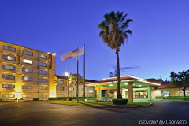
Crowne Plaza Silicon Valley-Union City
Address: 32083 Alvarado-Niles Road, Union City, CA 94587
Phone: (510) 489-2200
Website: https://www.ihg.com/crowneplaza/hotels/us/en/union-city/sfouc/hoteldetail

Distance to CSU East Bay Campus – 15 minutes
- Complimentary Wi-Fi | - Fitness Center
- Free parking | - Bar/ Lounge
- Bar/ Lounge | - Dry Cleaning Service
- Pool | - Laundry Facilities

Transportation

Arrival Day/ Orientation
Sunday, June 17

Location | Crown Plaza | CSU East Bay
Shuttle Departure | 4:00 pm | 7:00pm

Training Schedule
Monday, June 18 – Friday, June 22 | Monday, June 25 – Thursday, June 28

Location | Departure | Arrival
Hotel Shuttle | 7 am | 7:20 am
Campus Shuttle | 5:45 pm | 6:10 pm

Graduation Day
Friday, June 29

Location | Crown Plaza | CSU East Bay
Shuttle Departure | 7 am | 12 pm

