THE BAY ADVISOR – APPOINTMENT SCHEDULE GUIDE

- Go to the Bay Advisor – Cal State East Bay using the link: https://www.csueastbay.edu/aps/the-bay-advisor.html
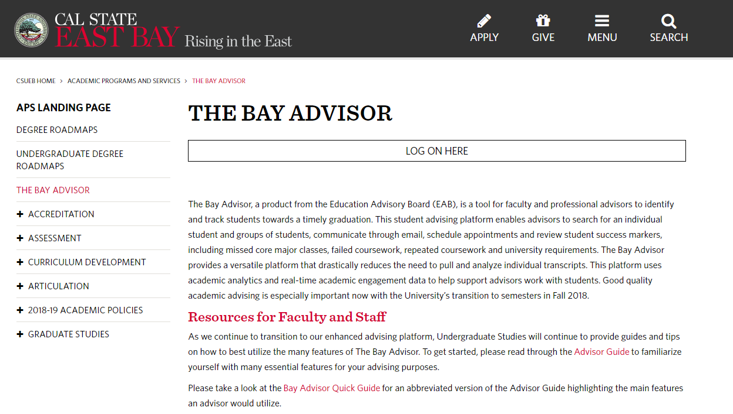

Click on LOG ON HERE.

- Enter your netid and password to login.

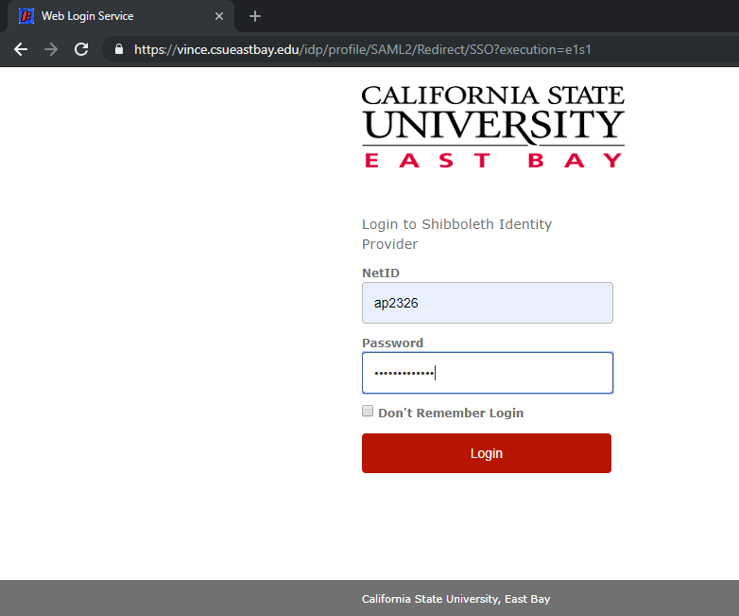

- Once you see the Bay Advisor page, click on Get Assistance.

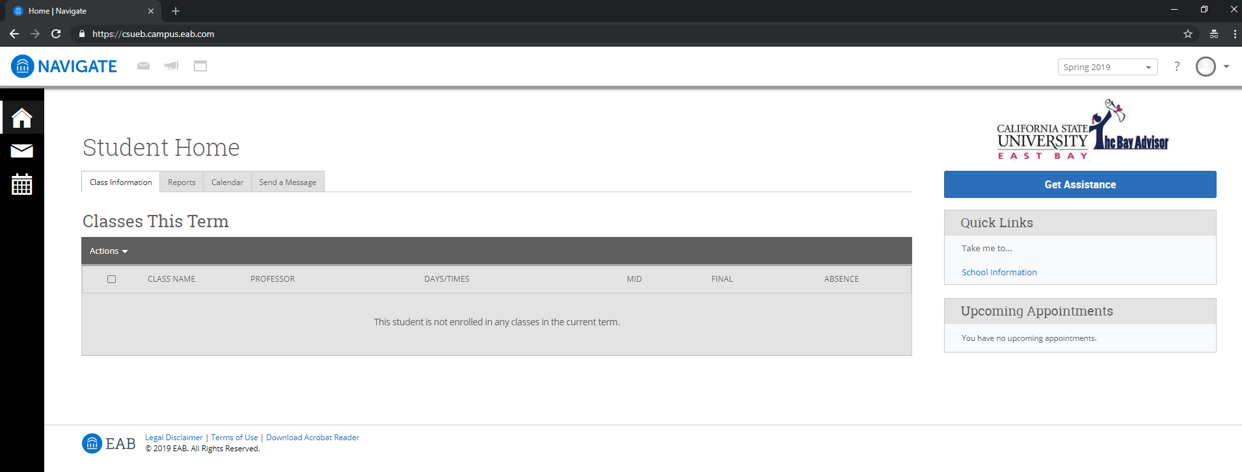

- Select the appointment type as Advising.

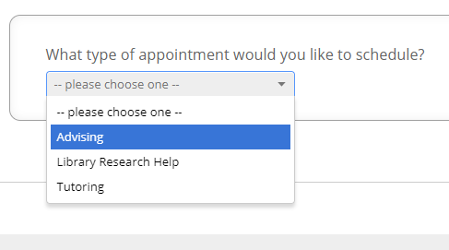

- Pick the service category as Project IMPACT Advising.

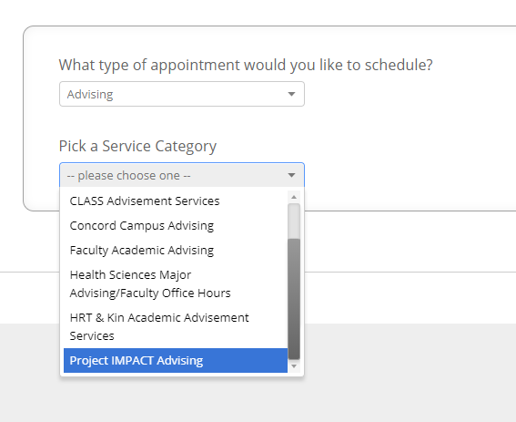

- Pick one of the service of your appointment from Academic Advising, Financial Aid Counseling and Wellness Counseling.

- Academic Advising:
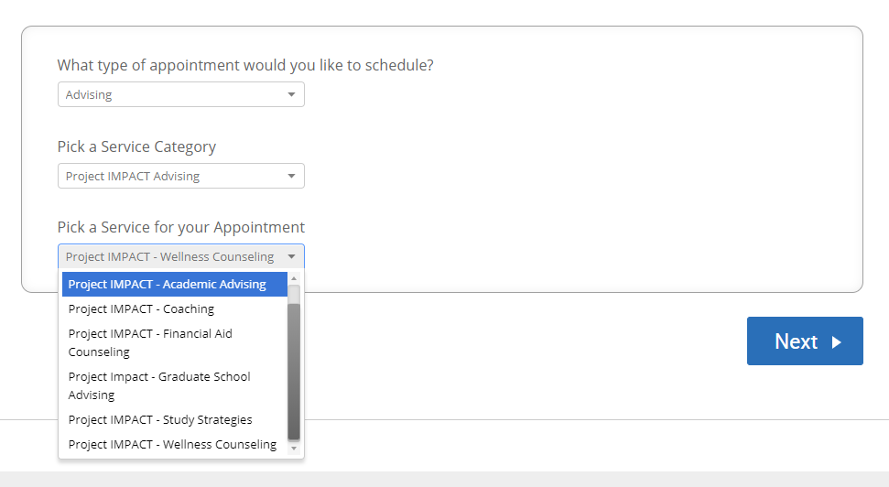

Select Academic Advising and click Next.

- Financial Aid Counseling:

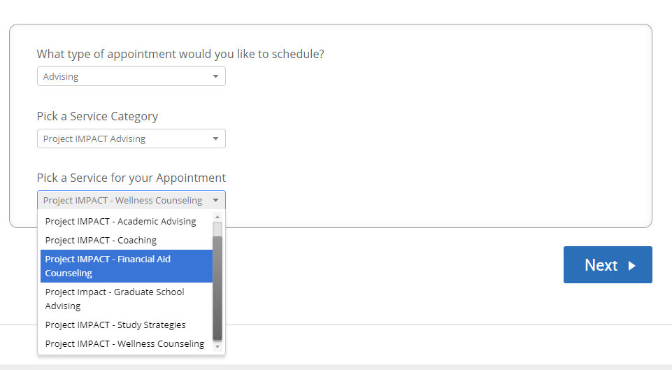

Select Financial Aid Counseling and click Next.

- Wellness Counseling:

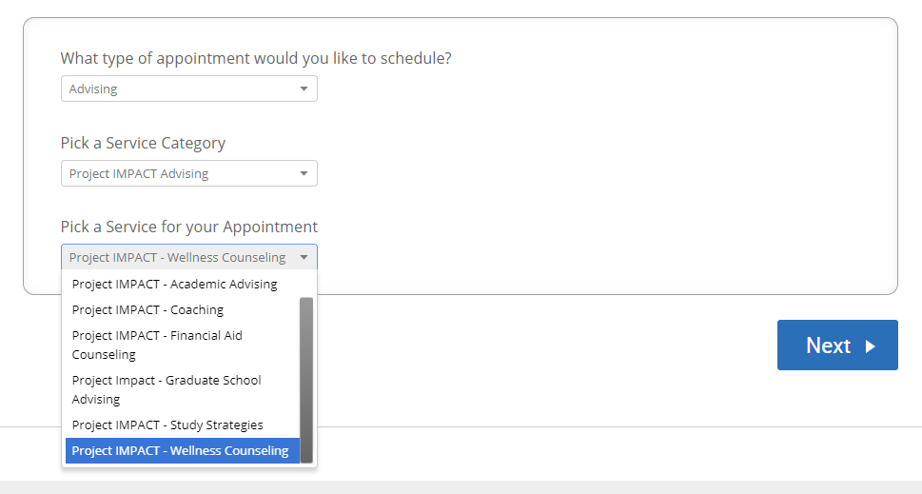

Select Wellness Counseling and click Next.

- Pick the location for your appointment as Project IMPACT – LI 2550.

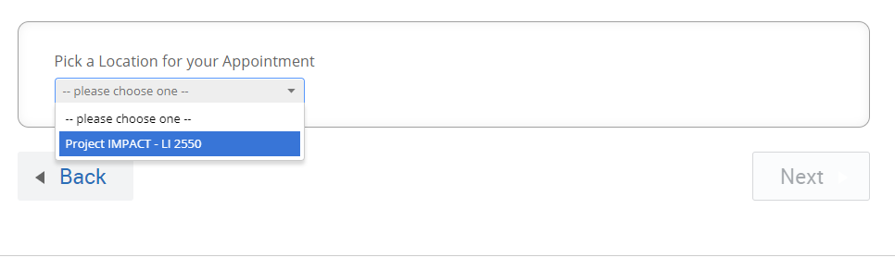

Select location and click Next.

- Select the timing that suits you best per your availability.

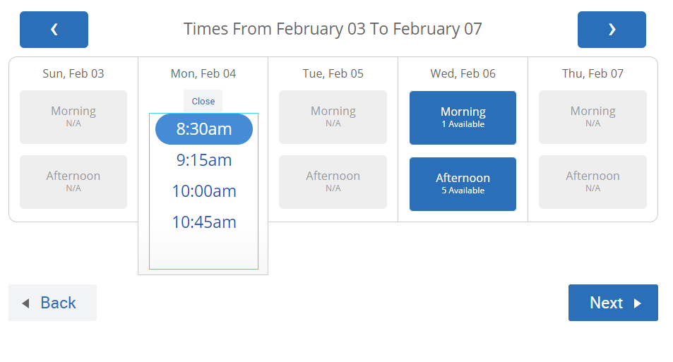
Select the day and the time and click Next.

- Review your appointment details, mention any comment for the staff if you want to, choose the meeting notification way via email/text, provide your contact number for getting the text.

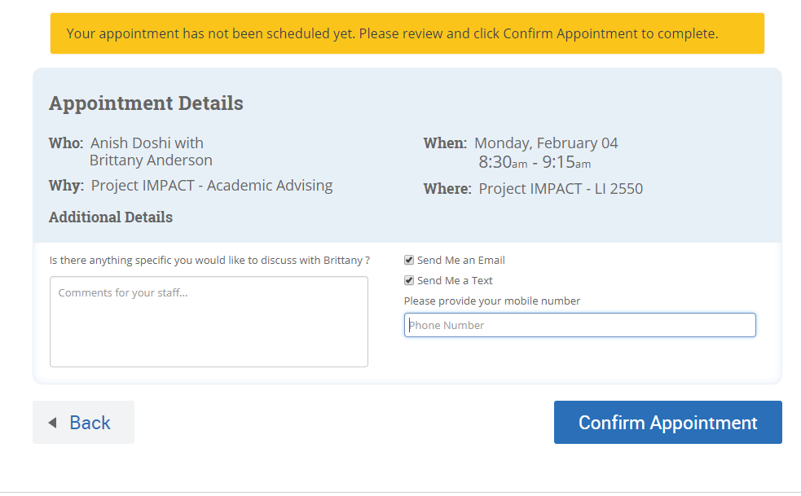

Click on Confirm Appointment once done with reviewing.

You will receive an appointment confirmation message on your screen follows:

